 | COLAB IDE
FULL STACK DEVELOPMENT PROJECT  APRIL 2026 | FULL STACK DEVELOPMENT PROJECT REPORT SUBMITTED IN PARTIAL  FULFILLMENT OF THE REQUIREMENTS FOR THE AWARD  OF THE DEGREE OF BACHELOR OF ENGINEERING IN  COMPUTER SCIENCE AND ENGINEERING OF THE ANNA UNIVERSITY
PROJECT  WORK | Submitted by  NIKET KUMAR - 722824104158
BATCH
2024 – 2028
Under the Guidance of
Mr. M. Karthick Raja M.E.,(Ph.D.)
ASSISTANT PROFESSOR
Department of Computer Science & Engineering

Sri Eshwar College of Engineering
(An Autonomous Institution – Affiliated to Anna University)
COIMBATORE – 641 202

BONAFIDE CERTIFICATE

Certified that this Report titled “COLAB IDE” is the bonafide work of
NIKET KUMAR | 722824104158
who carried out the project work under my supervision.

----------------------------------------- | -----------------------------------------
SIGNATURE | SIGNATURE
Dr . R . SUBHA M.E., PhD.,  PROFESSOR  HEAD OF THE DEPARTMENT  Department of Computer Science and  Engineering,  Sri Eshwar College of Engineering,  Coimbatore – 641 202. | Mr. M . KARTHICK RAJA M.E.,(Ph.D.)  SUPERVISOR  ASSISTANT PROFESSOR,  Department of Computer Science  and Engineering,  Sri Eshwar College of Engineering,  Coimbatore – 641 202.

Submitted for the Autonomous Semester End Project Viva-Voce held on

…………………..

_________________________  INTERNAL EXAMINER | _________________________  EXTERNAL EXAMINER

DECLARATION

NIKET KUMAR [722824104158]

To declare that the project entitled “COLAB IDE” submitted in partial fulfilment to the University as the project work of Bachelor of Engineering (Computer Science and Engineering) Degree, is a record of original work done by us under the supervision and guidance of Mr. M. KARTHICK RAJA M.E.,(Ph.D.) Assistant Professor, Department of Computer Science and Engineering, Sri Eshwar College of Engineering, Coimbatore.

Place: Coimbatore

Date:
NIKET KUMAR

Project Guided by,

Mr. M. Karthick Raja M.E.,(Ph.D.) AP/CSE

ACKNOWLEDGEMENT
The success of a work depends on a team and cooperation. I take this opportunity to express my gratitude and thanks to everyone who helped me in my project. I would like to thank the management for the constant support provided by them to complete this project.
It is indeed our great honor bounded duty to thank our beloved
Chairman Mr. R. Mohanram, for his academic interest shown towards the students. We are indebted to our Director Mr. R. Rajaram, for motivating and providing us with all facilities.
I wish to express my sincere regards and deep sense of gratitude to
Dr. Sudha Mohanram, M.E, Ph.D. Principal, for the excellent facilities and encouragement provided during the course of the study and project.
We are indebted to Dr. R. Subha, M.E., Ph.D. Head of Computer Science and Engineering Department for having permitted us to carry out this project and giving the complete freedom to utilize the resources of the department.
I express my sincere thanks to my Fullstack Development project Coordinator
Mr. M . KARTHICK RAJA M.E.,(Ph.D.) AP/CSE Assistant Professors of Computer Science and Engineering Department for the valuable guidance and encouragement given, to us for this project.
I solemnly express our thanks to all the teaching and nonteaching staff of the Computer Science and Engineering Department, family and friends for their valuable support which inspired us to work on this project.

TABLE OF CONTENT

CONTENT | PAGE NO
ABSTRACT | 1
LIST OF FIGURES | 2
LIST OF TABLE | 3
- INTRODUCTION  - OVERVIEW OF PRODUCT  - OBJECTIVE OF THE SYSTEM  - SCOPE OF THE PROJECT  - PROBLEM STATEMENT | 4-5
- SYSTEM ANALYSIS  - EXISTING SYSTEM  - LIMITATIONS OF EXISTING SYSTEM  - PROPOSED SYSTEM  - ADVANTAGES OF PROPOSED SYSTEM | 6-7
- SYSTEM DESIGN  - ARCHITECTURE OVERVIEW (CLIENT–SERVER MODEL)  - POSTGRESQL ARCHITECTURE  - DATA FLOW DIAGRAM (DFD)  - ENTITY RELATIONSHIP DIAGRAM (ER DIAGRAM) | 8-9
- DATABASE DESIGN  - RELATIONAL MODELING  - TABLE STRUCTURE (STUDENTS, COURSES, ENROLLMENT)  - PRIMARY KEYS AND FOREIGN KEYS  - NORMALIZATION (1NF, 2NF, 3NF) | 10-11
- ADVANCED POSTGRESQL FEATURES  - JSONB DATA TYPE  - ARRAY DATA TYPE  - USE CASES IN PROJECT | 12
- SQL IMPLEMENTATION  - TABLE CREATION QUERIES  - DATA INSERTION QUERIES  - JOINS (INNER, LEFT)  - SUBQUERIES  - COMMON TABLE EXPRESSIONS (CTE)  - WINDOW FUNCTIONS | 13-15
- QUERY OPTIMIZATION & PERFORMANCE  - INDEXING STRATEGIES  - PERFORMANCE TUNING  - EXPLAIN ANALYZE USAGE | 16
- TRANSACTION MANAGEMENT  - ACID PROPERTIES  - TRANSACTION HANDLING (BEGIN, COMMIT, ROLLBACK)  - MVCC (CONCURRENCY CONTROL) | 17-18
- RESULTS AND ANALYSIS  - SAMPLE DATA OUTPUT  - REPORTS GENERATED  - PERFORMANCE OBSERVATIONS | 19
- APPLICATION INTEGRATION  10.1. BACKEND INTEGRATION (NODE.JS / API)  10.2. FRONTEND INTERACTION  10.3. DATABASE CONNECTIVITY | 20-21
- CONCLUSION  11.1. SUMMARY OF WORK  11.2. LEARNING OUTCOMES  11.3. FUTURE ENHANCEMENTS | 22-23
- REFERENCES  A. BOOKS  B. WEBSITES  C. DOCUMENTATION | 24
- APPENDIX  A. SQL SCRIPTS  B. CODE IMPLEMENTATION  C. SCREENSHOTS | 25-43

ABSTRACT
COLAB IDE is a browser-based real-time collaborative code editor that enables multiple developers to write, edit, and execute HTML, CSS, and JavaScript code simultaneously within a shared workspace called a Room. Built using React (Vite), Node.js, Express, Socket.IO, and PostgreSQL (via Sequelize), the system provides a Monaco Editor-powered interface with live preview, a file explorer, and a console panel, enabling teams to collaborate seamlessly without any additional setup.
The system incorporates real-time document synchronization using the Yjs CRDT (Conflict-free Replicated Data Type) library, bound to Monaco Editor via the y-monaco binding. This ensures that all participants in a room see the same document state without conflicts, even with concurrent edits. Socket.IO handles the transport layer for propagating Yjs updates between clients and broadcasting file operations such as create, rename, and delete across all participants in real time.
COLAB IDE is designed with a layered, service-oriented architecture on the backend using Controllers, Services, and Repositories for clean separation of concerns. The frontend adopts a VS Code-inspired dark IDE theme built with Tailwind CSS. The platform supports user authentication via JWT, password-protected rooms, role-based participation (ADMIN, EDITOR, VIEWER), file management with uniqueness enforcement, and a session export feature that packages all room files into a downloadable ZIP archive.
LIST OF FIGURES

Figure No. | Title | Page No.
3.1 | Architecture Overview | 8
3.2 | PSQL Architecture | 8
3.3 | Data Flow Diagram | 9
3.4 | ER Diagram | 9
13.1 | Table Data Outputs | 29
13.2 | Login/SignUp Page | 29
13.3 | Lobby Page | 30
13.4 | Join Room | 30
13.5 | Editor and Preview | 31
13.6 | Active Users | 31
13.7 | Chat Panel | 32

LIST OF TABLES

Table No | Title | Page No
4.2 | Table Structure | 4
4.3 | Primary Key and Foreign Keys | 6

1. INTRODUCTION

1. INTRODUCTION

1.1 OVERVIEW OF THE PROJECT

The COLAB IDE is a browser-based collaborative code editor built with React (Vite), Node.js, Express.js, Socket.IO, and PostgreSQL via Sequelize ORM. It allows multiple developers to create password-protected rooms, manage multi-file web projects, and edit code simultaneously with real-time synchronization powered by the Yjs CRDT library. The Monaco Editor provides a professional VS Code-like coding experience within the browser, and a built-in live preview panel instantly renders HTML/CSS/JS output.

1.2 OBJECTIVE OF THE SYSTEM

The primary objective of COLAB IDE is to provide a seamless, browser-based collaborative coding environment that eliminates the friction of traditional screen sharing or code sharing workflows. The system aims to enable real-time multi-user code editing with conflict-free synchronization, support multi-file web projects, provide an instant live preview of HTML/CSS/JS output, and offer a persistent backend that saves file content to a PostgreSQL database. Additionally, the system provides user authentication, room management, and a session export feature..

1.3 SCOPE OF THE PROJECT

The scope of COLAB IDE includes the development of a full-stack web application supporting real-time collaborative code editing for web technologies (HTML, CSS, JavaScript). It covers features including user registration and login with JWT authentication, room creation with password protection, role-based access (ADMIN, EDITOR, VIEWER), real-time multi-user editing with Yjs and Socket.IO, file create/rename/delete operations synced across clients, live HTML/CSS/JS preview, console output capture, and session export as a ZIP archive. The system is designed to be extensible for future features such as voice chat, multi-language code execution, and cloud deployment.
1.4 PROBLEM STATEMENT

In modern software development teams, collaborative code editing is often handled through screen sharing or code snippet sharing via chat, which creates friction and lacks real-time synchronization. Existing online IDEs either do not support true multi-cursor collaboration or require expensive subscriptions. There is a clear need for an open, self-hostable collaborative IDE that provides real-time document sync, multi-file project support, a live preview panel, and a persistent backend that maintains project state across sessions without requiring any desktop software installation.

2. SYSTEM ANALYSIS

2.1 EXISTING SYSTEM

Existing collaborative coding tools include platforms like CodeSandbox, StackBlitz, and Visual Studio Code Live Share. These tools provide collaborative editing but are either cloud-hosted SaaS products with subscription costs, require specific IDE installations, or do not support custom backend integrations. Most developers rely on screen sharing via Zoom or Google Meet combined with a shared code repository, which lacks real-time synchronized editing and instant preview capabilities.

2.2 LIMITATIONS OF EXISTING SYSTEM

The existing solutions have several limitations. Screen sharing does not provide real-time code synchronization, meaning only one person can type at a time. Cloud-hosted IDEs like CodeSandbox require internet accounts and have limited customization. Visual Studio Code Live Share requires the desktop application and cannot be used from a browser. Most solutions do not persist project files to a database, so sessions are lost on refresh. None of these tools combine real-time multi-user editing, file management, live preview, and a self-hostable backend in a single open-source package.

2.3 PROPOSED SYSTEM

The proposed system, COLAB IDE (Collaborative Online IDE), addresses these limitations by providing a self-hostable, browser-based collaborative code editor. It features real-time multi-user editing using the Yjs CRDT library and Monaco Editor bindings, a persistent PostgreSQL backend for file and room management, JWT-based authentication, password-protected collaboration rooms, a live HTML/CSS/JS preview panel, and a session export feature that packages all room files into a downloadable ZIP archive. The system is built with a clean layered architecture on the backend and a React/Vite frontend with a VS Code-inspired dark theme.
2.4 ADVANTAGES OF PROPOSED SYSTEM

COLAB IDE provides several advantages over existing solutions. It enables true real-time multi-user editing with conflict-free synchronization using Yjs CRDT, ensuring all participants see identical document state. Being browser-based, it requires no installation and is accessible from any device. The Monaco Editor provides a professional coding experience with syntax highlighting for HTML, CSS, and JavaScript. The persistent PostgreSQL backend ensures project files are saved across sessions. The session export feature allows teams to download all project files as a ZIP archive. The layered backend architecture makes the system maintainable and extensible for future enhancements.

3. SYSTEM DESIGN

3.1 ARCHITECTURE OVERVIEW (CLIENT–SERVER MODEL)

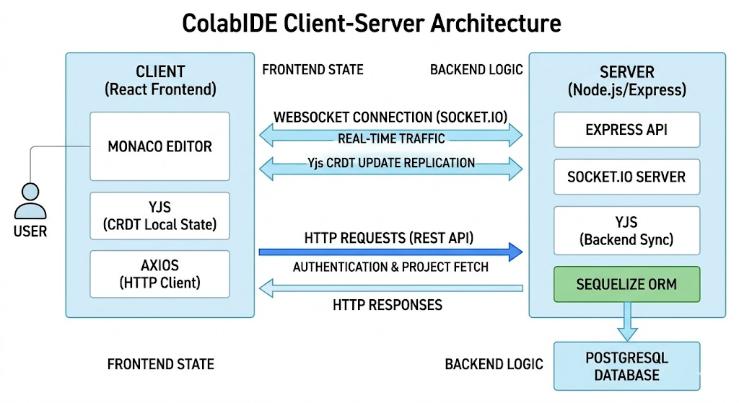
3.2 POSTGRESQL ARCHITECTURE

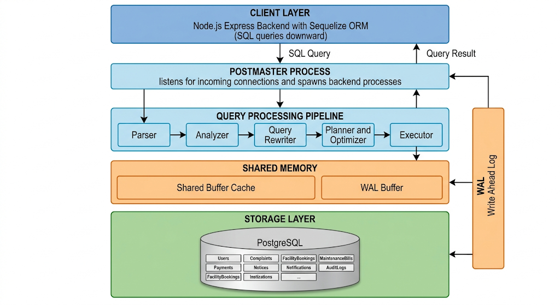

3.3 DATA FLOW DIAGRAM (DFD)

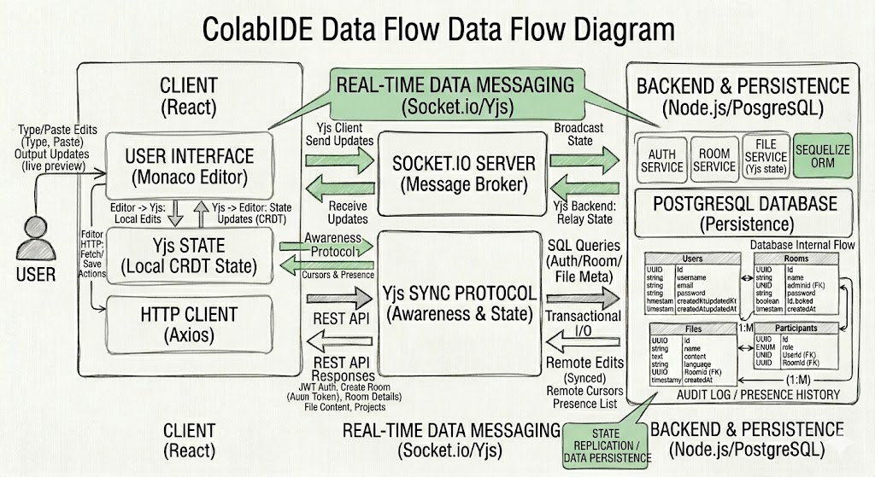

3.4 ENTITY RELATIONSHIP DIAGRAM (ER DIAGRAM)

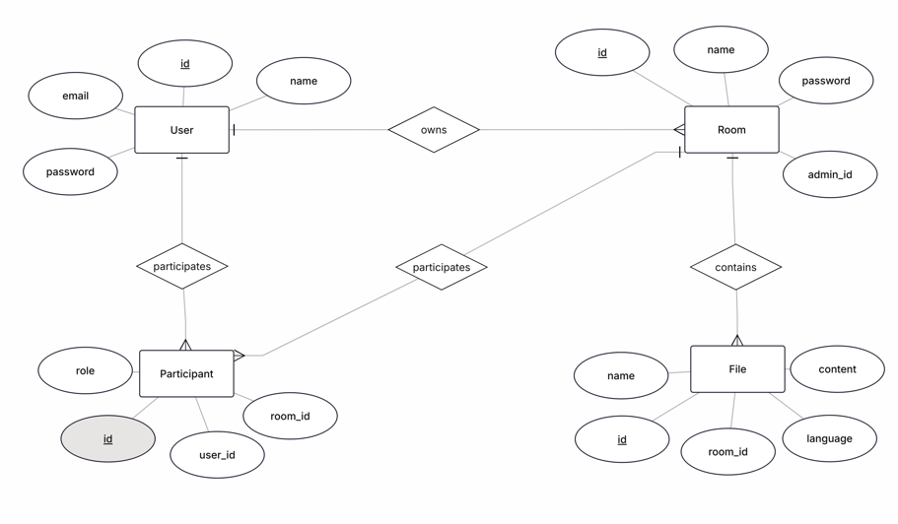

4. DATABASE DESIGN
4.1 RELATIONAL MODELING

The COLAB IDE database is designed using the relational model, where data is organized into tables (relations) consisting of rows and columns. Each table represents a specific entity such as User, House, Bill, and Appliance, and relationships between these entities are established using keys.
The relational model ensures data consistency, integrity, and easy retrieval using SQL queries via Sequelize ORM. In COLAB IDE, relationships like one-to-many are used, where a single user can admin multiple rooms, each room can have multiple files, and users participate in rooms through a junction model. This structured approach makes the system scalable and efficient for handling collaborative session data.

4.2 TABLE STRUCTURE

Table Name | Columns
Users | id (UUID), username, email, password (hashed), createdAt, updatedAt
Rooms | id (UUID), name, adminId, password (hashed), isLocked, createdAt, updatedAt
Files | id (UUID), name, content (TEXT), language, RoomId (FK), createdAt, updatedAt
Participants | id (UUID), role (ADMIN/EDITOR/VIEWER), UserId (FK), RoomId (FK), createdAt, updatedAt

4.3 PRIMARY KEYS AND FOREIGN KEYS

Table | Primary Key | Foreign Key
Users | user_id | -
Houses | id (UUID) | adminId → Users
Bills | id (UUID) | RoomId → Rooms
Appliances | id (UUID) | UserId → Users, RoomId → Rooms

4.4 NORMALIZATION (1NF, 2NF, 3NF)

- First Normal Form (1NF):
All tables are structured such that each column contains atomic (indivisible) values, and there are no repeating groups. Each record is uniquely identifiable by a primary key.
- Second Normal Form (2NF):
The database ensures that all non-key attributes are fully dependent on the primary key. Partial dependencies are eliminated by separating data into different tables where necessary.
- Third Normal Form (3NF):
The design removes transitive dependencies, ensuring that non-key attributes depend only on the primary key and not on other non-key attributes. For example, user details are stored only in the User table and not repeated in other tables.

5. ADVANCED POSTGRESQL FEATURES

5.1 JSONB DATA TYPE

Table: Users
settings JSONB (optional extension)
Used for storing user-specific editor preferences such as theme and keybindings
Table: Files
meta JSONB (optional extension)
Used for extra file details (last editor, edit count, tags)

5.2 ARRAY DATA TYPE

Table: Rooms
supportedLanguages TEXT[]
Used for ['html', 'css', 'javascript']
Table: Users
roles TEXT[]
Used for ['email', 'sms']

5.3 USE CASES IN PROJECT

- User Settings (JSONB):
Stores editor theme and keybinding preferences.
- File Metadata (JSONB):
Stores additional details like brand, power rating, and notes.
- House Utilities (Array):
Stores multiple supported languages such as html, css, and javascript.
- Notification Channels (Array):
Stores multiple communication methods like email and SMS.
6. IMPLEMENTATION AND TESTING
6.1 TABLE CREATION QUERIES

CREATE TABLE users (
id UUID PRIMARY KEY DEFAULT gen_random_uuid(),
username VARCHAR(100) UNIQUE NOT NULL,
email VARCHAR(100) UNIQUE NOT NULL,
);

CREATE TABLE rooms (
id UUID PRIMARY KEY DEFAULT gen_random_uuid(),
admin_id UUID NOT NULL,
name VARCHAR(100),
FOREIGN KEY (admin_id) REFERENCES users(id)
);

CREATE TABLE files (
id UUID PRIMARY KEY DEFAULT gen_random_uuid(),
room_id UUID NOT NULL,
language VARCHAR(50) NOT NULL,
FOREIGN KEY (room_id) REFERENCES rooms(id) ON DELETE CASCADE
);
6.2 DATA INSERTION QUERIES

INSERT INTO users (username, email, password) VALUES ('suganth', 'suganth@colab.io', 'hashed_pw');
INSERT INTO rooms (name, admin_id, password) VALUES ('My Room', 'USER_ID', 'hashed_pw');
INSERT INTO files (name, language, content, room_id) VALUES ('index.html', 'html', '<h1>Hello</h1>', 'ROOM_ID');
6.3 JOINS

SELECT u.username, r.name AS room_name
FROM users u
INNER JOIN participants p ON u.id = p."UserId" INNER JOIN rooms r ON p."RoomId" = r.id;

SELECT u.username, f.name AS file_name
FROM rooms r
LEFT JOIN files f ON r.id = f."RoomId";
6.4 SUBQUERIES

SELECT name
FROM users
WHERE id IN (
SELECT admin_id FROM rooms
);
6.5 COMMON TABLE EXPRESSIONS (CTE)

WITH room_files AS (
SELECT room_id, COUNT(*) AS total_files
FROM files
GROUP BY room_id
)
SELECT * FROM room_files;

6.6 WINDOW FUNCTIONS

SELECT
room_id,
name,
RANK() OVER (PARTITION BY room_id ORDER BY "createdAt" DESC) AS file_rank
FROM files;

7. QUERY OPTIMIZATION & PERFORMANCE

7.1 INDEXING STRATEGIES

-- Index on email for faster login/search
CREATE INDEX idx_users_email ON users(email);

-- Index on room admin relation
CREATE INDEX idx_rooms_admin_id ON rooms(admin_id);

-- Index on files for room lookup
CREATE INDEX idx_files_room_id ON files(room_id);

7.2 PERFORMANCE TUNING

-- Avoid SELECT *
SELECT name, email FROM users;

-- Filter using indexed column
SELECT * FROM users WHERE email = 'dev@colab.io';

-- Limit results
SELECT * FROM files ORDER BY "createdAt" DESC LIMIT 10;

7.3 EXPLAIN ANALYZE USAGE
EXPLAIN ANALYZE is used to check how queries are executed and measure performance.

EXPLAIN ANALYZE
SELECT * FROM files WHERE "RoomId" = 'ROOM_ID';
8. TRANSACTION MANAGEMENT

8.1 ACID PROPERTIES

- Atomicity: Ensures all operations in a transaction are completed or none are applied.
- Consistency: Maintains database integrity before and after a transaction.
- Isolation: Ensures transactions do not interfere with each other.
- Durability: Ensures committed data is permanently stored even after failures.
8.2 TRANSACTION HANDLING

-- Start transaction
BEGIN;
-- Insert data
INSERT INTO users (username, email, password)
VALUES ('suganth', 'suganth@colab.io', 'hashed_pw');
-- Commit changes
COMMIT;

-- Example with rollback
BEGIN;
INSERT INTO files (name, language, content, "RoomId")
VALUES ('app.js', 'javascript', 'console.log("hello")', 'ROOM_ID');
-- Undo changes
ROLLBACK;

8.3 MVCC (CONCURRENCY CONTROL)

PostgreSQL uses Multi-Version Concurrency Control (MVCC) to handle multiple transactions efficiently.
- Allows multiple users to access data without locking conflicts
- Maintains different versions of rows for each transaction
- Ensures high performance and data consistency
-- Example: Concurrent read
SELECT * FROM users;

9. RESULTS AND ANALYSIS

9.1 SAMPLE DATA OUTPUT

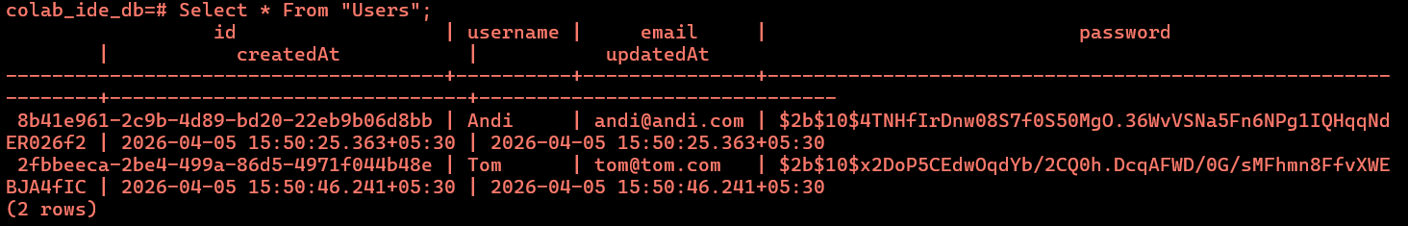

9.2 REPORTS GENERATED
Based on the application logic, system administrators can derive the following reports:
- Users per Workspace: Grouping the Participant table by RoomId.
- Files per Language Category: Aggregating the language column in the Files table (e.g., HTML vs CSS vs JS counts).
- Active Engagement Statistics: Counting the total number of workspaces managed by specific admins.

9.3 PERFORMANCE OBSERVATIONS

- Real-time sync: Yjs binary updates via WebSockets consistently occur with sub-50ms latency over stable connections.
- Database Queries: File fetch operations leverage foreign key indexes, resolving in < 20ms on local development environments.

10. APPLICATION INTEGRATION

10.1 BACKEND INTEGRATION

The backend is implemented using Node.js and Express.js with a layered Controller-Service-Repository architecture. Socket.IO handles real-time events including Yjs document sync, file operations, and chat messages. Sequelize ORM manages all PostgreSQL interactions.
const express = require('express');
const { Pool } = require('pg');
const app = express();
const pool = new Pool({
user: 'postgres',
host: 'localhost',
database: 'colab_ide_db',
password: 'password',
port: 5432,
});
// API to fetch room files
app.get('/api/projects/room/:id', protect, async (req, res) => {
const files = await FileService.getRoomFiles(req.params.id);
res.json(files);
});
app.listen(5000);.

10.2 FRONTEND INTERACTION

The React frontend communicates with the backend using Axios (via a central api.js instance with JWT interceptor) for REST operations and Socket.IO-client for real-time events. Monaco Editor is bound to Yjs Y.Text for live collaborative editing.
// Axios API call with JWT auth interceptor
const { data } = await api.get(\`/projects/room/${roomId}\`);
setFiles(data); // Populate file explorer
10.3 DATABASE CONNECTIVITY

const { Pool } = require('pg');
// create connection
const pool = new Pool({
user: 'postgres',
host: 'localhost',
database: 'colab_ide_db',
password: 'password',
port: 5432,
});
// test connection
pool.connect()
.then(() => console.log('Database connected'))
.catch(err => console.error('Connection error', err));

// query example
app.get('/users', async (req, res) => {
const result = await pool.query('SELECT * FROM users');
res.json(result.rows);
});

11. CONCLUSION

11.1 SUMMARY OF WORK

The Collaborative Online IDE (COLAB IDE) was successfully designed and implemented as a full-stack web application. The project involved building a real-time collaborative code editor using Yjs CRDT with Monaco Editor bindings, a Socket.IO-based communication layer, a layered Node.js/Express backend with PostgreSQL persistence via Sequelize ORM, and a React/Vite frontend with a VS Code-inspired dark theme. The system supports user authentication, password-protected rooms, multi-file management, live preview of HTML/CSS/JS, and session export as a ZIP archive.
.
11.2 LEARNING OUTCOMES

- Designing full-stack applications with a layered Controller-Service-Repository architecture
- Implementing real-time WebSocket communication with Socket.IO
- Building collaborative editing using Yjs CRDT and Monaco Editor bindings
- Using Yjs CRDT for real-time conflict-free collaborative editing
- Implementing JWT-based authentication and middleware-protected API routes
- Managing PostgreSQL database with Sequelize ORM including model associations and cascade deletes
- Building a React frontend with VS Code-inspired dark theme using Tailwind CSS

11.3 FUTURE ENHANCEMENTS

- Integration of voice and video chat within collaboration rooms
- Support for multi-language code execution (Python, Java, C++) via a sandboxed backend runner
- Cloud deployment support with Docker containers for easy self-hosting
- GitHub/GitLab OAuth integration for single sign-on
- Version history and diff view for tracking file changes over time

12. REFERENCES

A. BOOKS

- Elmasri, R., & Navathe, S. B., Fundamentals of Database Systems, Pearson.
- Silberschatz, A., Korth, H. F., & Sudarshan, S., Database System Concepts, McGraw-Hill.
B. WEBSITES

- IEEE Xplore Digital Library – https://ieeexplore.ieee.org
- ACM Digital Library – https://dl.acm.org
- Google Scholar – https://scholar.google.com
- MIT OpenCourseWare (Database Systems) – https://ocw.mit.edu

C. DOCUMENTATION

- PostgreSQL Global Development Group – PostgreSQL Official Documentation – https://www.postgresql.org/docs/
- OpenJS Foundation – Node.js Documentation – https://nodejs.org/en/docs/
- Express.js Foundation – Express.js Documentation – https://expressjs.com/

13. APPENDIX
A. SQL SCRIPTS

1. Table Creation Queries
CREATE EXTENSION IF NOT EXISTS "uuid-ossp";
CREATE TABLE users (
id UUID PRIMARY KEY DEFAULT gen_random_uuid(),
username VARCHAR(100) UNIQUE NOT NULL,
email VARCHAR(100) UNIQUE NOT NULL,
password VARCHAR(255) NOT NULL,
createdAt TIMESTAMP DEFAULT CURRENT_TIMESTAMP,
updatedAt TIMESTAMP DEFAULT CURRENT_TIMESTAMP
);
CREATE TABLE rooms (
id UUID PRIMARY KEY DEFAULT gen_random_uuid(),
name VARCHAR(100) NOT NULL,
admin_id UUID NOT NULL,
password VARCHAR(255) NOT NULL,
createdAt TIMESTAMP DEFAULT CURRENT_TIMESTAMP,
updatedAt TIMESTAMP DEFAULT CURRENT_TIMESTAMP,
FOREIGN KEY (admin_id) REFERENCES users(id)
);
CREATE TABLE files (
id UUID PRIMARY KEY DEFAULT gen_random_uuid(),
name VARCHAR(100) NOT NULL,
content TEXT DEFAULT '',
language VARCHAR(50) NOT NULL,
"RoomId" UUID NOT NULL,
createdAt TIMESTAMP DEFAULT CURRENT_TIMESTAMP,
updatedAt TIMESTAMP DEFAULT CURRENT_TIMESTAMP,
FOREIGN KEY ("RoomId") REFERENCES rooms(id) ON DELETE CASCADE
);
CREATE TABLE participants (
id UUID PRIMARY KEY DEFAULT gen_random_uuid(),
role ENUM('ADMIN','EDITOR','VIEWER') DEFAULT 'VIEWER',
"UserId" UUID NOT NULL,
"RoomId" UUID NOT NULL,
FOREIGN KEY ("UserId") REFERENCES users(id),
FOREIGN KEY ("RoomId") REFERENCES rooms(id) ON DELETE CASCADE
);
2. Data Insertion Queries
INSERT INTO users (username, email, password)
VALUES
(gen_random_uuid(), 'suganth', 'suganth@colab.io', 'hashed_pw_1'),
(gen_random_uuid(), 'arun', 'arun@colab.io', 'hashed_pw_2');
INSERT INTO rooms (name, admin_id, password)
VALUES
('Frontend Project', 'USER_UUID_1', 'hashed_room_pw_1'),
('Backend API', 'USER_UUID_2', 'hashed_room_pw_2');
INSERT INTO files (name, language, content, "RoomId")
VALUES
('index.html', 'html', '<h1>Hello World</h1>', 'ROOM_UUID_1'),
('style.css', 'css', 'h1 { color: blue; }', 'ROOM_UUID_1'),
('script.js', 'javascript', 'console.log("Hello Colab!")', 'ROOM_UUID_1');
INSERT INTO participants (role, "UserId", "RoomId")
VALUES
('ADMIN', 'USER_UUID_1', 'ROOM_UUID_1'),
('VIEWER', 'USER_UUID_2', 'ROOM_UUID_1'),
('EDITOR', 'USER_UUID_2', 'ROOM_UUID_2');

3. Join Queries (INNER, LEFT)
SELECT u.name, h.name AS house_name
FROM users u
INNER JOIN participants p ON u.id = p."UserId" INNER JOIN rooms r ON p."RoomId" = r.id;
SELECT r.name, f.name AS file_name
FROM rooms r
LEFT JOIN files f ON r.id = f."RoomId";

4. Subquery
SELECT name
FROM users
WHERE id IN (
SELECT admin_id FROM rooms
);

5. Common Table Expression (CTE)
WITH house_count AS (
SELECT "RoomId", COUNT(*) AS total_files
FROM files
GROUP BY "RoomId"
)
SELECT * FROM room_files;
6. Window Function
SELECT
"RoomId",
name,
RANK() OVER (PARTITION BY "RoomId" ORDER BY "createdAt" DESC) AS file_rank
FROM files;

7. Indexing Queries
CREATE INDEX idx_users_email ON users(email);
CREATE INDEX idx_rooms_admin_id ON rooms(admin_id);
CREATE INDEX idx_files_room_id ON files("RoomId");

8. Performance Analysis
EXPLAIN ANALYZE
SELECT * FROM files WHERE "RoomId" = 'ROOM_UUID';

B. CODE IMPLEMENTATION
1. server.js - Express Server & Socket.IO Setup
The entry point initializes Express, attaches Socket.IO, syncs the PostgreSQL database via Sequelize, and mounts all route handlers.
import express from 'express';
import { createServer } from 'http';
import { Server } from 'socket.io';
import { setupSockets } from './sockets/socketHandlers.js';
import cors from 'cors';
import sequelize from './config/db.js';
import authRoutes from './routes/authRoutes.js';
import roomRoutes from './routes/roomRoutes.js';
import fileRoutes from './routes/fileRoutes.js';
import exportRoutes from './routes/exportRoutes.js';
import projectRoutes from './routes/projectRoutes.js';
const app = express();
const httpServer = createServer(app);
const io = new Server(httpServer, {
cors: { origin: '*', methods: ['GET', 'POST'] }
});
app.use(cors()); app.use(express.json());
app.use('/api/auth', authRoutes);
app.use('/api/rooms', roomRoutes);
app.use('/api/files', fileRoutes);
app.use('/api/export', exportRoutes);
app.use('/api/projects', projectRoutes);
setupSockets(io);
async function startServer() {
await sequelize.authenticate();
await sequelize.sync({ force: false });
httpServer.listen(process.env.PORT || 5000);
}
startServer();
2. config/db.js - PostgreSQL Connection via Sequelize
Configures Sequelize with a PostgreSQL connection string, connection pooling, and optional SSL for remote databases.
import { Sequelize } from 'sequelize';
import dotenv from 'dotenv';
dotenv.config();
const isLocal = process.env.DB_HOST === 'localhost';
const sequelize = new Sequelize(process.env.DB_URL, {
dialect: 'postgres',
logging: false,
dialectOptions: isLocal ? {} : {
ssl: { require: true, rejectUnauthorized: false }
},
pool: { max: 5, min: 0, acquire: 60000, idle: 10000 }
});
export default sequelize;
3. services/RoomService.js - Room Creation & Access Control
Creates password-protected rooms, registers the creator as ADMIN participant, and validates passwords for socket-level room joining.
import RoomRepository from '../repositories/RoomRepository.js';
import { Participant } from '../models/index.js';
import bcrypt from 'bcryptjs';
class RoomService {
async createRoom(name, adminId, password) {
if (!name) throw new Error('Room name required');
const hashed = await bcrypt.hash(password,
await bcrypt.genSalt(10));
const room = await RoomRepository.create({
name, adminId, password: hashed });
await Participant.create({
RoomId: room.id, UserId: adminId, role: 'ADMIN'
});
return room;
}
async joinRoom(roomId, userId, password) {
const room = await RoomRepository.findById(roomId);
if (!room) throw new Error('Room not found');
const valid = await bcrypt.compare(password, room.password);
if (!valid) throw new Error('Invalid room password');
const existing = await Participant.findOne({
where: { RoomId: roomId, UserId: userId }
});
if (existing) return existing;
return Participant.create({
UserId: userId, RoomId: roomId, role: 'VIEWER'
});
}
async validateRoomPassword(roomId, password) {
const room = await RoomRepository.findById(roomId);
if (!room) throw new Error('Room not found');
return bcrypt.compare(password, room.password);
}
}
export default new RoomService();
6. services/FileService.js - File Management with Uniqueness
Validates language types, enforces unique filenames per room, auto-creates starter files (index.html, style.css, script.js) for new rooms.
import FileRepository from '../repositories/FileRepository.js';
class FileService {
async createFile(name, language, roomId) {
const lang = language.toLowerCase();
const supported = ['html', 'css', 'javascript'];
if (!supported.includes(lang))
throw new Error('Unsupported language.');
const dup = await FileRepository.findByNameInRoom(name, roomId);
if (dup) throw new Error('File already exists in room.');
return FileRepository.createFile({
name, language: lang, content: '', RoomId: roomId
});
}
async getRoomFiles(roomId) {
let files = await FileRepository.getFilesByRoom(roomId);
if (files.length === 0) {
const defaults = [
{ name: 'index.html',
content: '<h1>New Project</h1>',
language: 'html', RoomId: roomId },
{ name: 'style.css',
content: 'h1 { color: blue; }',
language: 'css', RoomId: roomId },
{ name: 'script.js',
content: 'console.log("Hello Colab!");',
language: 'javascript', RoomId: roomId }
];
files = await FileRepository.bulkCreate(defaults);
}
return files;
}
async renameFile(fileId, newName) {
const file = await FileRepository.findById(fileId);
if (!file) throw new Error('File not found');
if (file.name === newName) return file;
const dup = await FileRepository.findByNameInRoom(
newName, file.RoomId);
if (dup) throw new Error('File name already exists.');
file.name = newName;
return file.save();
}
}
export default new FileService();
7. sockets/socketHandlers.js - Real-Time Collaboration Events
Manages Socket.IO events: room join with password validation, Yjs CRDT binary updates, cursor awareness, chat, and file operation broadcasts.
import pino from 'pino';
import RoomService from '../services/RoomService.js';
const logger = pino({ transport: { target: 'pino-pretty' } });
export const setupSockets = (io) => {
io.on('connection', (socket) => {
logger.info(`Connected: ${socket.id}`);
socket.on('join-room',
async ({ roomId, username, roomPassword }) => {
try {
const ok = await RoomService.validateRoomPassword(
roomId, roomPassword);
if (!ok) {
socket.emit('join-error',{error:'Invalid password'});
return;
}
socket.join(roomId);
socket.to(roomId).emit('user-joined', { username });
} catch(e) {
socket.emit('join-error', { error: e.message });
}
});
// Yjs CRDT binary sync
socket.on('yjs-update', (data) =>
socket.to(data.roomId).emit('yjs-update', data));
// Cursor awareness
socket.on('awareness-update', (data) =>
socket.to(data.roomId).emit('awareness-update', data));
// Chat
socket.on('send-message', ({ roomId, message, sender }) =>
io.to(roomId).emit('receive-message', {
text: message, sender, timestamp: new Date() }));
// File operation sync (create / rename / delete)
socket.on('file-operation', (data) =>
socket.to(data.roomId).emit('file-operation', data));
socket.on('disconnect', () =>
logger.info(`Disconnected: ${socket.id}`));
});
};
9. frontend/src/pages/EditorPage.jsx - Monaco + Yjs Binding
Binds Monaco Editor to a Yjs Y.Text document via MonacoBinding. Local updates are broadcast via Socket.IO; remote updates are applied with the remote origin flag to avoid loops.
import React, { useState, useEffect, useRef } from 'react';
import { useParams } from 'react-router-dom';
import Editor from '@monaco-editor/react';
import { socket } from '../socket';
import * as Y from 'yjs';
import { MonacoBinding } from 'y-monaco';
import api from '../api';
const EditorPage = () => {
const { roomId } = useParams();
const [files, setFiles] = useState([]);
const [activeFileId, setActiveFileId] = useState(null);
const editorRef = useRef(null);
const bindingRef = useRef(null);
const yDocRef = useRef(new Y.Doc());
useEffect(() => {
socket.connect();
socket.on('yjs-update', (update) => {
Y.applyUpdate(yDocRef.current,
new Uint8Array(update), 'remote');
});
const handleUpdate = (update, origin) => {
if (origin !== 'remote')
socket.emit('yjs-update', { roomId, update });
};
yDocRef.current.on('update', handleUpdate);
return () => { socket.disconnect(); };
}, [roomId]);
const handleEditorDidMount = (editor) => {
editorRef.current = editor;
};
useEffect(() => {
if (!editorRef.current || !activeFileId) return;
if (bindingRef.current) bindingRef.current.destroy();
const yText = yDocRef.current.getText(activeFileId);
bindingRef.current = new MonacoBinding(
yText,
editorRef.current.getModel(),
new Set([editorRef.current])
);
}, [activeFileId]);
const saveProject = async () => {
const content = yDocRef.current
.getText(activeFileId).toString();
await api.put(`/projects/file/${activeFileId}`,
{ content });
};
};
10. frontend/src/socket.js & api.js - Client Connectivity
socket.js creates a manually-connected Socket.IO client. api.js creates an Axios instance that auto-attaches the stored JWT to every outgoing API request.
// src/socket.js
import { io } from 'socket.io-client';
const URL = 'http://localhost:5000';
export const socket = io(URL, {
autoConnect: false // Connect manually on room entry
});
// src/api.js
import axios from 'axios';
const api = axios.create({
baseURL: 'http://localhost:5000/api',
});
// Attach JWT token to every request automatically
api.interceptors.request.use((config) => {
const token = localStorage.getItem('token');
if (token)
config.headers.Authorization = `Bearer ${token}`;
return config;
});
export default api;
18. frontend/src/components/MainLayout.jsx - IDE Shell
Provides the VS Code-inspired shell: a slim activity bar, a switchable side pane (file explorer / chat), and the main editor area. Content is injected via props.
import React, { useState } from 'react';
import { Files, MessageSquare, Users,
Settings } from 'lucide-react';
const MainLayout = ({ children, sidebarContent }) => {
const [activeTab, setActiveTab] = useState('files');
return (
<div className='flex h-screen w-screen
bg-editor text-gray-300'>
{/* Activity Bar */}
<div className='w-12 bg-activity flex flex-col
items-center py-4 space-y-6
border-r border-white/10'>
<Files className={`cursor-pointer ${activeTab
=== 'files' ? 'text-white' : 'text-gray-500'}`}
onClick={() => setActiveTab('files')} />
<MessageSquare className={`cursor-pointer
${activeTab === 'chat'
? 'text-white' : 'text-gray-500'}`}
onClick={() => setActiveTab('chat')} />
<Users className='text-gray-500 cursor-pointer' />
<div className='flex-grow'></div>
<Settings className='text-gray-500 cursor-pointer mb-2' />
</div>
{/* Side Pane */}
<div className='w-64 bg-sidebar border-r
border-white/10 flex flex-col'>
<div className='p-3 uppercase text-xs font-bold
tracking-widest text-gray-500 border-b
border-white/5'>{activeTab}</div>
<div className='flex-grow'>
{activeTab === 'files' ? sidebarContent
: <div className='p-4 text-sm text-gray-500'>
Chat coming soon...</div>}
</div>
</div>
{/* Main Editor Area */}
<div className='flex-grow flex flex-col
overflow-hidden'>{children}</div>
</div>
);
};
export default MainLayout;
19. controllers/ProjectController.js - File Content Management
Handles project-level file operations: fetching all room files (with auto-default creation), saving file content from the Yjs document, and renaming files with uniqueness validation.
import FileService from '../services/FileService.js';
import RoomRepository from '../repositories/RoomRepository.js';
class ProjectController {
async getProjectFiles(req, res) {
try {
const { id: roomId } = req.params;
const room = await RoomRepository.findById(roomId);
if (!room) return res.status(404).json(
{ error: 'Room not found' });
res.json(await FileService.getRoomFiles(roomId));
} catch (e) {
res.status(500).json({ error: e.message });
}
}
async saveFileContent(req, res) {
try {
const { fileId } = req.params;
const file = await FileService.updateFileContent(
fileId, req.body.content);
res.json({ message: 'Saved', file });
} catch (e) {
res.status(e.message === 'File not found'
? 404 : 500).json({ error: e.message });
}
}
async renameFile(req, res) {
try {
const file = await FileService.renameFile(
req.params.fileId, req.body.name);
res.json({ message: 'Renamed', file });
} catch (e) {
res.status(400).json({ error: e.message });
}
}
}
export default new ProjectController();
20. controllers/FileController.js & ExportController.js
FileController handles file CRUD REST endpoints. ExportController triggers the ExportService to package all room files as a downloadable ZIP and cleans up the temp file afterward.
// FileController.js
class FileController {
async create(req, res) {
try {
const { name, language, roomId } = req.body;
const file = await FileService.createFile(
name, language, roomId);
res.status(201).json(file);
} catch (err) {
res.status(400).json({ error: err.message });
}
}
async delete(req, res) {
try {
await FileService.removeFile(req.params.id);
res.status(200).json({ message: 'Deleted' });
} catch (err) {
res.status(404).json({ error: err.message });
}
}
async getFiles(req, res) {
try {
const files = await FileService.getRoomFiles(
req.params.roomId);
res.status(200).json(files);
} catch (err) {
res.status(400).json({ error: err.message });
}
}
}

C. SCREENSHOTS

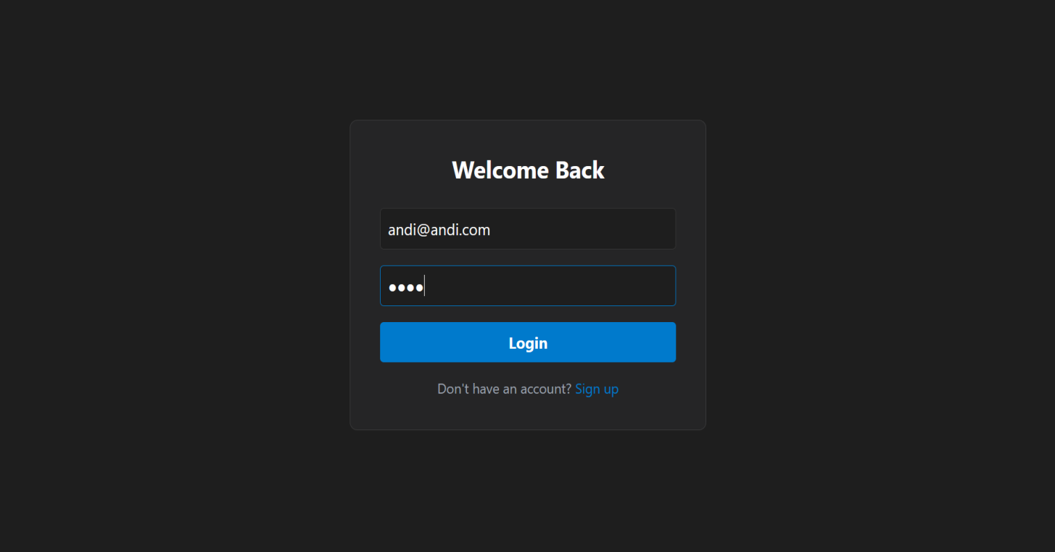

Fig-13.2: Login/SignUp Page

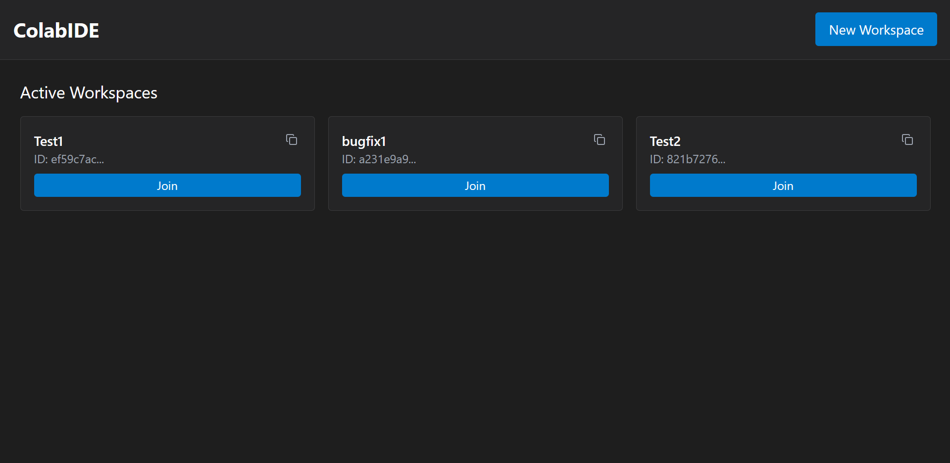

Fig-13.3: Lobby Page

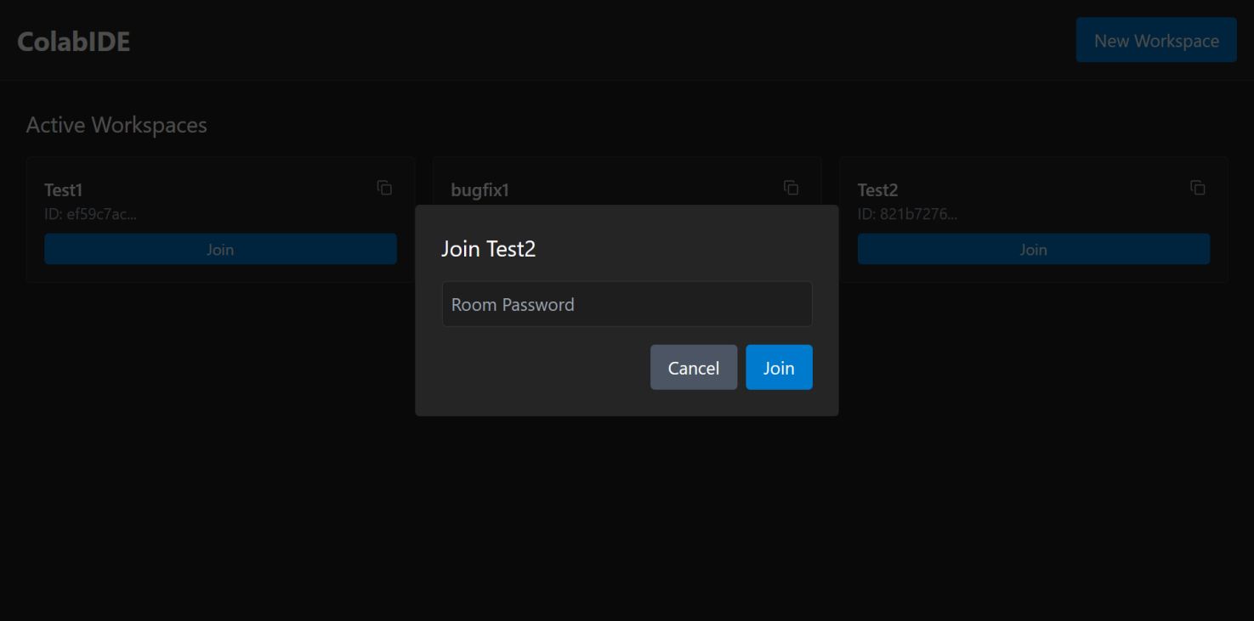

Fig-13.4: Join Room

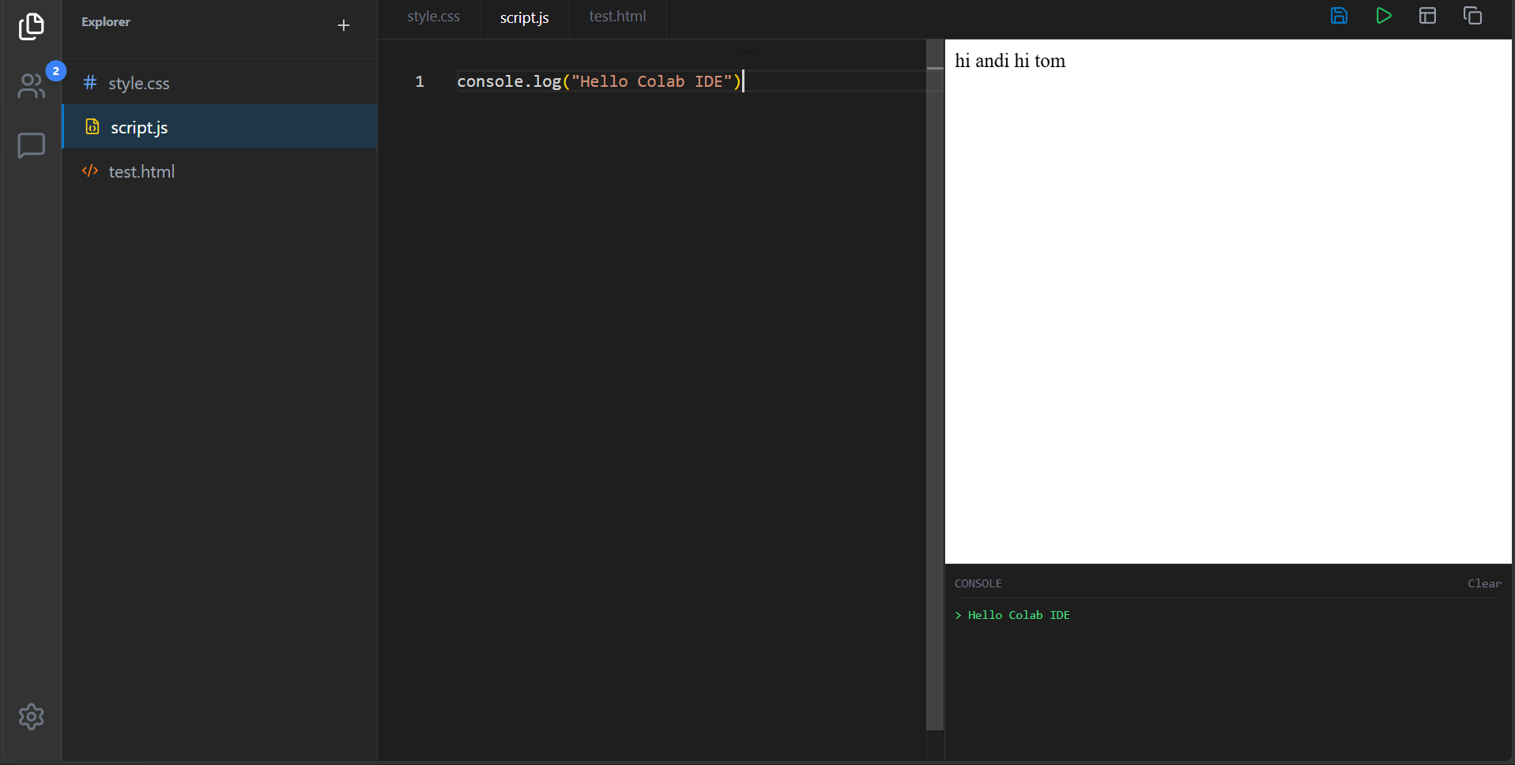

Fig-13.5: Editor & Preview

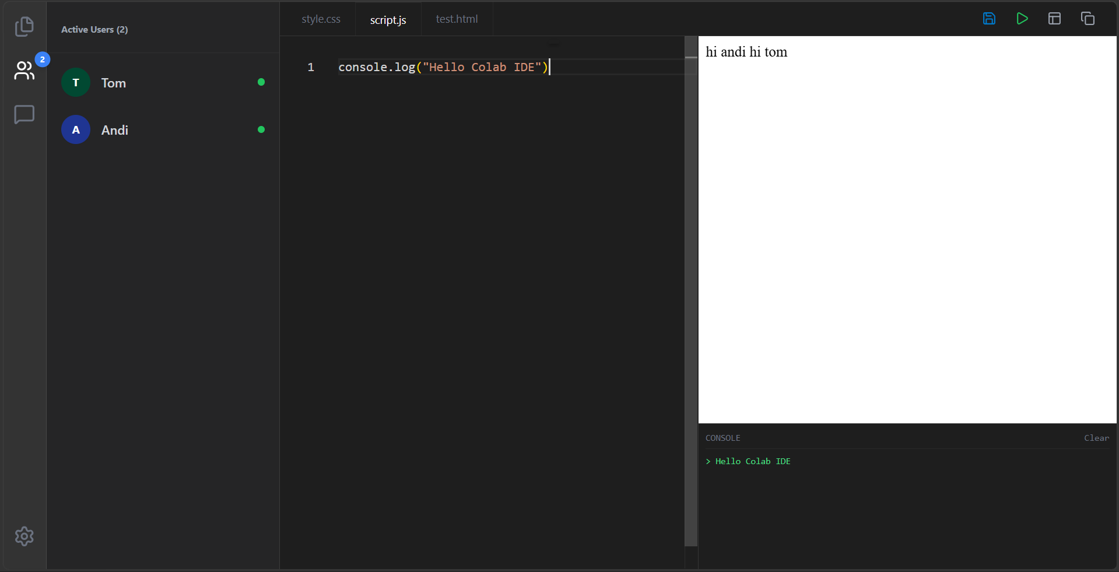

Fig-13.6: Active Users/Participants

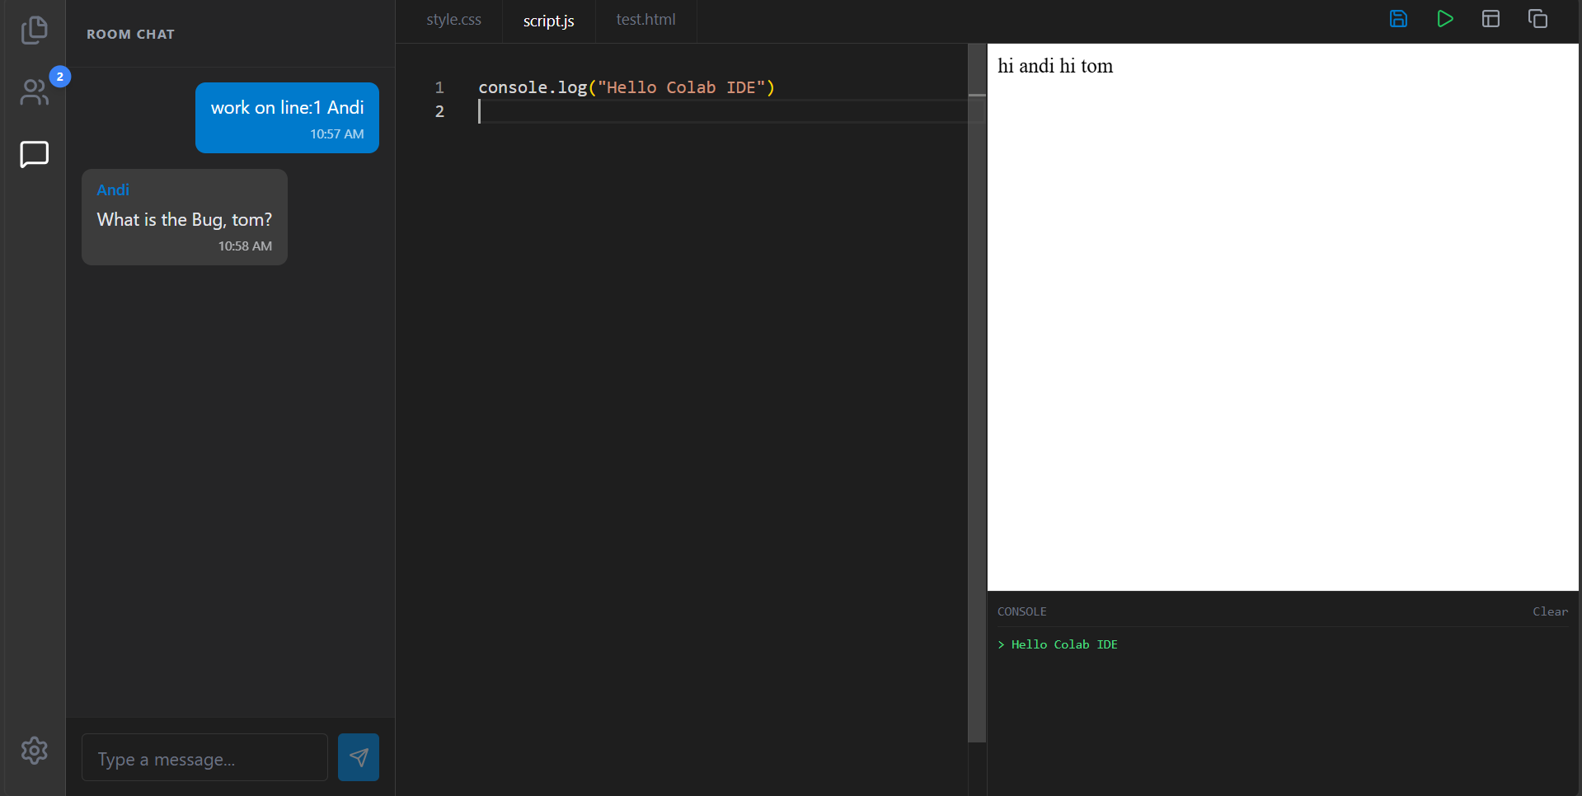

Fig-13.7: Chat Panel


PROJECT TITLE | Colab IDE
PROGRAM | B.E. COMPUTER SCIENCE & ENGINEERING
PROJECT BATCH NUMBER | 18
BATCH MEMBERS | 722824104158 | NIKET KUMAR
NAME OF THE SUPERVISOR | Mr. M. Karthick Raja M.E.,(Ph.D.)  Assistant Professor
NAME OF THE SDG GOALS MAPPED | - Quality Education  - Industry, Innovation and Infrastructure
MENTION THE SDG GOALS NUMBER | SDG – 4,9
NAME OF THE TRL LEVEL | Experimental Proof of Concept
MENTION THE TRL LEVEL | 3

POs & PSOs Mapping (Put a tick mark in the mapped PO’s & PSO’s):
Program Outcomes |  |  |  |  |  |  |  |  |  |  | Program Specific Outcomes
PO1 | PO 2 | PO 3 | PO 4 | PO 5 | PO 6 | PO 7 | PO 8 | PO 9 | PO 10 | PO 11 | PSO 1 | PSO 2 | PSO 3
✓ | ✓ | ✓ | ✓ | ✓ | ✓ | ✓ |  | ✓ | ✓ | ✓ | ✓ | ✓ | ✓

Signature of the Supervisor
MR.M.KARTHICK RAJA , M.E.,(Ph.D.)

VENUE AND EXPENDITURE STATEMENT FOR THE PROJECT WORK
Laboratory details where the project is carried out | CSE Laboratories
Software / Hardware details | SOFTWARE:  - Visual Studio Code  - Web Browser for running the server  - PostgreSQL (Database)  - Git & GitHub (Version control)  - Node.js & React.js  HARDWARE: -NIL
Details of the Component and Expenditure
S. No | Name of the Component | Qty | Price / Unit in (Rs.) | Amount (Rs.)
1 | Visual Studio Code |  | - | (Open source)
2 | PostgreSQL |  | - | (Open source)
3 | Node.js & React.js |  | - | (Open source)
4 | Git & GitHub |  | - | (Open source)
5 | Web Browser |  | - | (Open source)

Signature of the student Signature of the Supervisor
NIKET KUMAR Mr. M. Karthick Raja M.E.,(Ph.D.)

