 | WORKPING
FULL STACK DEVELOPMENT PROJECT  APRIL 2026 | FULL STACK DEVELOPMENT PROJECT REPORT SUBMITTED IN PARTIAL  FULFILLMENT OF THE REQUIREMENTS FOR THE AWARD  OF THE DEGREE OF BACHELOR OF ENGINEERING IN  COMPUTER SCIENCE AND ENGINEERING OF THE ANNA UNIVERSITY
PROJECT  WORK | Submitted by  MURARI DAHAL - 722824104146
BATCH
2024 – 2028
Under the Guidance of
Mr. M. Karthick Raja M.E., (Ph.D.,)
ASSISTANT PROFESSOR
Department of Computer Science & Engineering

Sri Eshwar College of Engineering
(An Autonomous Institution – Affiliated to Anna University)
COIMBATORE – 641 202

BONAFIDE CERTIFICATE

Certified that this Report titled “WorkPing” is the bonafide work of
MURARI DAHAL | 722824104146
who carried out the project work under my supervision.

----------------------------------------- | -----------------------------------------
SIGNATURE | SIGNATURE
Dr . R . SUBHA M.E., PhD.,  PROFESSOR  HEAD OF THE DEPARTMENT  Department of Computer Science and  Engineering,  Sri Eshwar College of Engineering,  Coimbatore – 641 202. | Mr . M . KARTHICK RAJA ME.,(Ph.D.)  SUPERVISOR  ASSISTANT PROFESSOR,  Department of Computer Science  and Engineering,  Sri Eshwar College of Engineering,  Coimbatore – 641 202.

Submitted for the Autonomous Semester End Project Viva-Voce held on

…………………..

_________________________  INTERNAL EXAMINER | _________________________  EXTERNAL EXAMINER

DECLARATION

MURARI DAHAL [722824104146]

To declare that the project entitled “WorkPing” submitted in partial fulfilment to the University as the project work of Bachelor of Engineering (Computer Science and Engineering) Degree, is a record of original work done under the supervision and guidance of Mr. M . KARTHICK RAJA M.E.,(Ph.D.,) Assistant Professor, Department of Computer Science and Engineering, Sri Eshwar College of Engineering, Coimbatore.

Place: Coimbatore

Date:
MURARI DAHAL

Project Guided by,

Mr. M. KARTHICK RAJA M.E., (Ph.D.,) AP/C

ACKNOWLEDGEMENT

The success of a work depends on a team and cooperation. I take this opportunity to express my gratitude and thanks to everyone who helped me in my project. I would like to thank the management for the constant support provided by them to complete this project.
It is indeed our great honor bounded duty to thank our beloved
Chairman Mr. R. Mohanram, for his academic interest shown towards the students. We are indebted to our Director Mr. R. Rajaram, for motivating and providing us with all facilities.
I wish to express my sincere regards and deep sense of gratitude to
Dr. Sudha Mohanram, M.E, Ph.D. Principal, for the excellent facilities and encouragement provided during the course of the study and project.
We are indebted to Dr. R. Subha, M.E., Ph.D. Head of Computer Science and Engineering Department for having permitted us to carry out this project and giving the complete freedom to utilize the resources of the department.
I express my sincere thanks to my Fullstack Development project Coordinator
Mr. M . KARTHICK RAJA M.E.,(Ph.D.,) AP/CSE Assistant Professors of Computer Science and Engineering Department for the valuable guidance and encouragement given, to us for this project.
I solemnly express our thanks to all the teaching and nonteaching staff of the Computer Science and Engineering Department, family and friends for their valuable support which inspired us to work on this project.

TABLE OF CONTENT

CONTENT | PAGE NO
ABSTRACT | 1
LIST OF FIGURES | 2
LIST OF TABLE | 3
- INTRODUCTION  - OVERVIEW OF PRODUCT  - OBJECTIVE OF THE SYSTEM  - SCOPE OF THE PROJECT  - PROBLEM STATEMENT | 4  5  5  5
- SYSTEM ANALYSIS  - EXISTING SYSTEM  - LIMITATIONS OF EXISTING SYSTEM  - PROPOSED SYSTEM  - ADVANTAGES OF PROPOSED SYSTEM | 6  6  7  7
- SYSTEM DESIGN  - ARCHITECTURE OVERVIEW (CLIENT–SERVER MODEL)  - POSTGRESQL ARCHITECTURE  - DATA FLOW DIAGRAM (DFD)  - ENTITY RELATIONSHIP DIAGRAM (ER DIAGRAM) | 8  9  9  10
- DATABASE DESIGN  - RELATIONAL MODELING  - TABLE STRUCTURE (STUDENTS, COURSES, ENROLLMENT)  - PRIMARY KEYS AND FOREIGN KEYS  - NORMALIZATION (1NF, 2NF, 3NF) | 11  11  12  12
- ADVANCED POSTGRESQL FEATURES  - GITHUB OAUTH AUTHENTICATION  - OPENAI API INTEGRATION  - USE CASES IN PROJECT | 13  13  14
- SQL IMPLEMENTATION  - FRONTEND IMPLEMENTATION (NEXT.JS)  - GITHUB API INTEGRATION  - OPENAI INTEGRATION  - AUTHENTICATION FLOW  - USAGE LIMITING | 15  15  16  16  16
- QUERY OPTIMIZATION & PERFORMANCE  - SECURITY PRACTICES  - DEPLOYMENT (VERCEL)  - ENVIRONMENT VARIABLES | 17
- TRANSACTION MANAGEMENT  - API ROUTE STRUCTURE  - STATE MANAGEMENT  - ERROR HANDLING | 18  18  19
- RESULTS AND ANALYSIS  - SAMPLE AI-GENERATED OUTPUT  - REPORTS GENERATED  - PERFORMANCE OBSERVATION | 20
- APPLICATION INTEGRATION  10.1. BACKEND INTEGRATION (NEXT.JS API ROUTES)  10.2. FRONTEND INTERACTION (REACT + TAILWIND)  10.3. DATABASE CONNECTIVITY (SUPABASE) | 21  21  22
- CONCLUSION  11.1. SUMMARY OF WORK  11.2. LEARNING OUTCOMES  11.3. FUTURE ENHANCEMENTS | 23
- REFERENCES  A. BOOKS  B. WEBSITES  C. DOCUMENTATION | 24
- APPENDIX  A. API INTEGRATION SCRIPTS  B. CODE IMPLEMENTATION  C. SCREENSHOTS | 25  30  44

ABSTRACT
WorkPing is a full-stack SaaS application designed to solve a common pain point faced by freelancers and developers — writing clear, structured weekly progress updates for clients. Developers frequently struggle with remembering what they worked on, translating technical work into non-technical language, and maintaining consistent client communication. WorkPing addresses this by automatically extracting real GitHub activity (commits and pull requests) and converting it into professional, client-ready progress updates using AI. Built using Next.js (App Router), React, Tailwind CSS on the frontend, and Supabase (Auth + Database), the GitHub REST API, and the OpenAI API on the backend, the platform is deployed on Vercel and follows a modern SaaS architecture.
WorkPing provides a simple and intuitive workflow: users log in via GitHub OAuth, select a repository, choose a time range (last 7 or 14 days), and the system fetches commits and merged pull requests. This raw activity data is then processed and sent to the OpenAI API, which generates a structured, professional, and client-safe update — avoiding technical jargon, assumptions, and overpromising. The generated content can be reviewed and edited by the user before being copied to clipboard or exported as Markdown. Tracking the number of updates generated and displaying an upgrade prompt upon reaching the limit.
WorkPing is designed with real-world problem-solving, end-to-end full-stack implementation, and SaaS architecture thinking in mind. The system gracefully handles edge cases such as empty repositories, no activity in the selected time range, GitHub API errors, rate limits, and AI failures. A landing page waitlist system collects early user emails for launch validation. Overall, WorkPing combines product thinking with strong engineering to deliver a tool that turns GitHub activity into clean, client-ready updates in seconds.
LIST OF FIGURES

Figure No. | Title | Page No.
3.1 | System Architecture | 8
3.2 | Supabase Architecture | 8
3.3 | Data Flow Diagram | 9
3.4 | ER Diagram | 10
9.1 | AI Summary Output | 20
13.1 | Sample Output | 44
13.2 | Landing Page | 44
13.3 | Demo View | 45
13.3 | Pricing Section | 45
13.4 | Login Page | 46
13.5 | Dashboard Page | 46
13.6 | Supabase Auth | 46

LIST OF TABLES

Table No | Title | Page No
4.2 | Database Table Structure | 11
4.3 | Primary and Foreign Keys | 12

1. INTRODUCTION

1. INTRODUCTION

1.1 OVERVIEW OF THE PROJECT

The WorkPing is a full-stack SaaS web application that automatically converts real GitHub activity into professional, client-ready progress updates. It is built using Next.js (App Router) and React with Tailwind CSS for the frontend, Supabase for authentication and database management, the GitHub REST API for activity extraction, and the OpenAI API for AI-powered summary generation. The platform is deployed on Vercel and follows a modern SaaS architecture. WorkPing solves a real-world pain point faced by freelancers and developers who struggle to write consistent, clear weekly updates for their clients from technical work..

1.2 OBJECTIVE OF THE SYSTEM

The primary objective of WorkPing is to eliminate the manual effort involved in writing client progress updates. The system aims to automatically extract commits and pull request data from GitHub repositories, process and summarize this data using AI, and generate structured, professional, and client-safe update text. It also seeks to provide an editable output interface, usage limiting to simulate a SaaS paywall, and a waitlist system for early user validation. Additionally, WorkPing focuses on delivering a simple, intuitive experience for developers and freelancers who need to maintain clear communication with clients..

1.3 SCOPE OF THE PROJECT

The scope of WorkPing includes the development of a full-stack SaaS web application that handles GitHub OAuth authentication, repository listing, commit and pull request extraction, AI-based text generation, and an editable output interface. It covers features such as time-based filtering (last 7 or 14 days), usage tracking with a simulated paywall, Markdown export, copy-to-clipboard functionality, and a landing page waitlist system. The project also covers edge case handling for empty repositories, API errors, rate limits, and AI failures, as well as security practices including server-side API key storage and Supabase Row Level Security. While the current version is a V1 SaaS product, the architecture is designed to support future enhancements such as Stripe integration, multi-repository support, scheduled updates, and team collaboration..
1.4 PROBLEM STATEMENT

Developers and freelancers frequently face the challenge of writing weekly client progress updates from their technical work. Recalling completed tasks, translating commits and pull requests into non-technical language, and maintaining consistent communication is a repetitive and time-consuming process. Most developers rely on memory or manually browse their GitHub history to compile updates, which is inefficient and error-prone. Existing tools either focus on project management or internal developer workflows and do not address the specific need for generating client-safe, structured progress reports. Therefore, there is a need for an automated, AI-powered tool that extracts real GitHub activity and converts it into professional, client-ready updates with minimal developer effort..

2. SYSTEM ANALYSIS

2.1 EXISTING SYSTEM

Currently, developers and freelancers handle client progress updates through manual methods such as browsing Git commit history, recalling completed tasks from memory, or using generic note-taking tools. Some use project management platforms like Jira or Trello to track work, but these are designed for internal team collaboration rather than generating client-facing summaries. Tools like GitHub itself provide commit logs and pull request histories, but these are highly technical and not suitable to share directly with non-technical clients. There is no dedicated, automated tool that bridges the gap between raw GitHub activity and professional client communication..

2.2 LIMITATIONS OF EXISTING SYSTEM

The existing approaches suffer from several significant limitations. Firstly, manually writing progress updates is time-consuming and mentally exhausting, requiring developers to recall and re-articulate their work after it is already done. Secondly, commit messages and pull request descriptions are typically written for technical audiences and cannot be directly shared with clients. Thirdly, project management tools like Jira or Notion do not integrate with GitHub activity in a way that generates client-ready summaries. Additionally, there is no mechanism to filter or tone-adjust technical language for non-technical stakeholders. The lack of automation in this area results in inconsistent communication, missed updates, and strained client relationships..

2.3 PROPOSED SYSTEM

The proposed system, WorkPing, addresses these limitations by providing a fully automated, AI-powered workflow for generating client progress updates from GitHub activity. The user simply logs in via GitHub OAuth, selects a repository and time range, and WorkPing fetches all relevant commits and merged pull requests. This data is then processed and sent to the OpenAI API, which generates a structured, professional, and client-safe summary. The output is fully editable, can be copied to clipboard or exported as Markdown, and the system tracks usage to enforce a SaaS-style paywall. WorkPing is built on a modern, scalable full-stack architecture and is designed for feedback-driven iteration..
2.4 ADVANTAGES OF PROPOSED SYSTEM

WorkPing provides several key advantages over existing approaches. It eliminates the manual effort of writing progress updates by automating the entire process from GitHub activity extraction to AI-generated summary. The integration of the OpenAI API allows for professional, structured, and client-safe language that avoids technical jargon and overpromising. Being a web-based SaaS tool, it requires no installation and is accessible from any device. The editable output interface ensures users retain full control over the final content before sharing. Its scalable architecture, built on Next.js and Supabase, supports future enhancements such as Stripe subscriptions, multi-repository support, scheduled updates, and team collaboration features..

3. SYSTEM DESIGN

3.1 ARCHITECTURE OVERVIEW (CLIENT–SERVER MODEL)

. 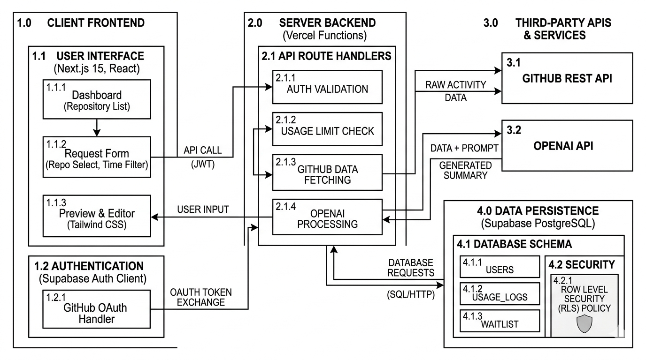
Fig-3.1: Architecture Overview
3.2 SUPABASE ARCHITECTURE

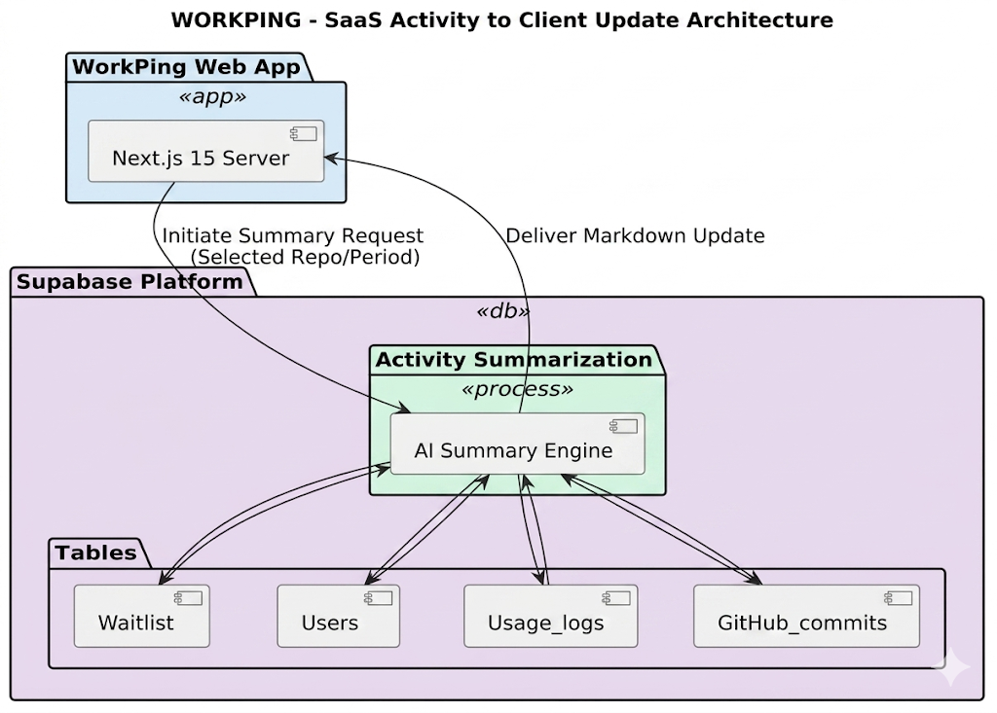
3.3 DATA FLOW DIAGRAM (DFD)

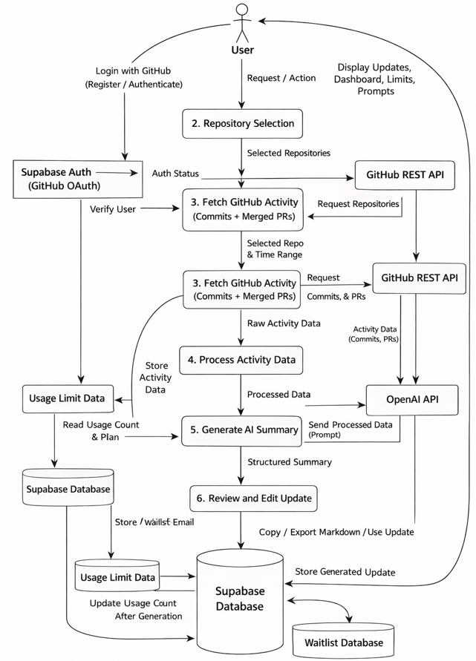
Fig-3.3: data flow diagram
3.4 ENTITY RELATIONSHIP DIAGRAM (ER DIAGRAM)

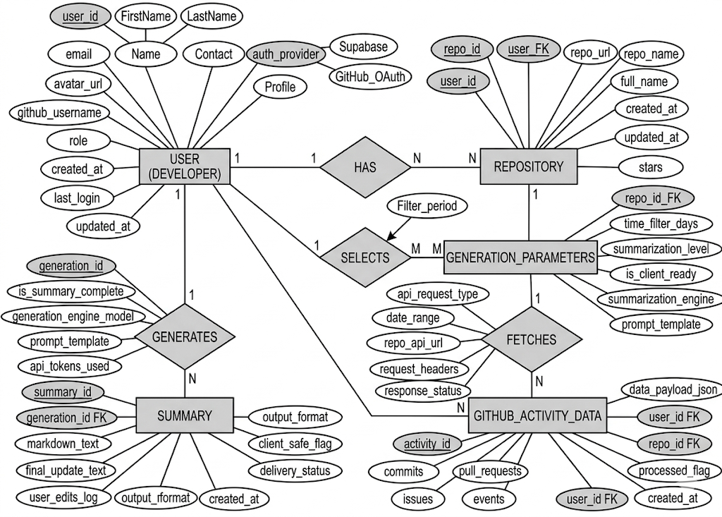

Fig-3.4: Entity Relationship

4. DATABASE DESIGN
4.1 RELATIONAL MODELING

The WorkPing database is designed using the relational model via Supabase (PostgreSQL), where data is organized into tables consisting of rows and columns. Each table represents a specific entity such as profiles, repositories, updates, and waitlist, and relationships between these entities are established using foreign keys.
The relational model ensures data consistency, integrity, and secure access through Supabase Row Level Security (RLS). In WorkPing, a single user can have one profile and multiple update records, each linked to a specific repository and time range. This structured approach keeps the data model clean, scalable, and efficient for the SaaS use case.

4.2 TABLE STRUCTURE

Table Name | Columns
Users | id, user_id, github_username, email, usage_count, created_at
Repositories | id, user_id, repo_full_name, repo_name, repo_description, is_private, last_fetched_at
Updates | id, user_id, repo_id, repo_name, time_range, ai_summary, created_at
Subscriptions / Payments | id, user_id, email, plan_name, payment_status, created_at

4.3 PRIMARY KEYS AND FOREIGN KEYS

Table | Primary Key | Foreign Key
Users | user_id | -
Repositories | repo_id | user_id → profiles
updates | update_id | user_id → profiles
Payments | payment_id | user_id → profiles

4.4 NORMALIZATION (1NF, 2NF, 3NF)

- First Normal Form (1NF):
All WorkPing tables contain atomic, non-repeating values. Each record in profiles, updates, repositories, and waitlist is uniquely identified by a primary key (UUID or serial).
- Second Normal Form (2NF):
All non-key attributes in WorkPing tables are fully dependent on the primary key. For example, ai_summary and repo_name in the updates table depend entirely on the update primary key, not on partial keys.
- Third Normal Form (3NF):
WorkPing’s schema eliminates transitive dependencies. User details such as github_username and usage_count are stored only in the profiles table and referenced by foreign key in the updates and repositories tables, never duplicated.

- ADVANCED SUPABASE FEATURES

5.1 GITHUB OAUTH AUTHENTICATION

Feature: GitHub OAuth via Supabase
provider: github
Used for secure login, session management, and protected dashboard access. Supabase handles token storage and refresh automatically.
Feature: Row Level Security (RLS)
policy: auth.uid() = user_id
Enforces that each user can only read and write their own profile, updates, and repository records. No sensitive data is exposed to other users.

5.2 OPENAI API INTEGRATION

Feature: AI Summary Generation
model: gpt-4o-mini
Receives structured commit and pull request data and generates a professional, client-safe progress update in paragraph form.
Feature: GitHub Oauth via Supabase
endpoint: /repos/{owner}/{repo}/commits
Used to fetch commits and merged pull requests within a user-specified date range (last 7 or 14 days).

5.3 USE CASES IN PROJECT

- GitHub Oauth (Supabase):
Stores theme, dashboard, and notification settings.
- OpenAI Summary Generation:
Stores additional details like brand, power rating, and notes.
- Usage Limiting (Paywall Simulation):
Stores multiple utility types such as electricity, water, and gas.
- Waitlist System:
Stores multiple communication methods like email and SMS.

6. IMPLEMENTATION AND TESTING
6.1 FRONTEND IMPLEMENTATION (NEXT.JS)

// app/api/generate/route.js
export async function POST(req) {
const { repo, timeRange, githubToken } = await req.json();
const commits = await fetchCommits(repo, timeRange, githubToken);
const pullRequests = await fetchMergedPRs(repo, githubToken);
const summary = await generateSummary(commits, pullRequests);
return Response.json({
success: true,
summary: summary
});
}

6.2 GITHUB API INTEGRATION

async function fetchCommits(repo, timeRange, githubToken) {
const res = await fetch(
`https://api.github.com/repos/${repo}/commits?since=${timeRange.start}&until=${timeRange.end}`,
{
headers: {
Authorization: `Bearer ${githubToken}`
}
}
);
return await res.json();

6.3 JOINS

SELECT
u.github_username,
r.repo_name
FROM users u
INNER JOIN repositories r
ON u.user_id = r.user_id;

6.4 AUTHENTICATION FLOW

SELECT github_username, email
FROM users
WHERE user_id IN (
SELECT user_id
FROM repositories
);

6.5 USAGE LIMITING

WITH user_updates AS (
SELECT
user_id,
COUNT(*) AS total_updates
FROM updates
GROUP BY user_id
)
SELECT * FROM user_updates;

6.6 EDGE CASE HANDLING

SELECT
repo_name,
time_range,
created_at,
RANK() OVER (ORDER BY created_at DESC) AS recent_rank

7. QUERY OPTIMIZATION & PERFORMANCE

7.1 SECURITY PRACTICES

-- Index on email for faster login/search
CREATE INDEX idx_users_email ON users(email);

-- Index on repositories (user relation)
CREATE INDEX idx_repositories_user_id ON repositories(user_id);

-- Index on GitHub activities (repo relation)
CREATE INDEX idx_github_activities_repo_id ON github_activities(repo_id);

7.2 DEPLOYMENT (VERCEL)

-- Avoid SELECT *
SELECT name, email FROM users;

-- Filter using indexed column
SELECT * FROM users WHERE email = murari@email.com’;

-- Limit results
SELECT * FROM bills ORDER BY amount DESC LIMIT 5;

7.3 ENVIRONMENT VARIABLES
EXPLAIN ANALYZE is used to check how queries are executed and measure performance.

EXPLAIN ANALYZE
SELECT * FROM users WHERE email = ‘murari@email.com’;
8. TRANSACTION MANAGEMENT

8.1 API ROUTE STRUCTURE

- Atomicity: Ensures all operations in a transaction are completed or none are applied.
- Consistency: Maintains database integrity before and after a transaction.
- Isolation: Ensures transactions do not interfere with each other.
- Durability: Ensures committed data is permanently stored even after failures.
8.2 TRANSACTION HANDLING

-- Start Transaction
BEGIN;

-- Insert new user (GitHub login)
INSERT INTO users (user_id, name, email, auth_provider)
VALUES (uuid_generate_v4(), ‘Murari’, ‘murari@email.com’, ‘github’);

-- Insert repository
INSERT INTO repositories (repo_id, user_id, repo_name, owner_name)
VALUES (uuid_generate_v4(), ‘USER_ID’, ‘WorkPing’, ‘Murari’);

-- Commit Transaction
COMMIT;

Example with Failure
BEGIN;
-- Insert GitHub activity
INSERT INTO github_activities (activity_id, repo_id, activity_type, title)
VALUES (uuid_generate_v4(), ‘REPO_ID’, ‘commit’, ‘Added dashboard feature’);

-- Insert progress report
INSERT INTO progress_reports (report_id, user_id, repo_id, summary)
VALUES (uuid_generate_v4(), ‘USER_ID’, ‘REPO_ID’, ‘Generated weekly update’);

-- If error occurs, undo all operations
ROLLBACK;

8.3 ERROR HANDLING

PostgreSQL uses Multi-Version Concurrency Control (MVCC) to handle multiple WorkPing users efficiently.

Key Points:
- Allows multiple users to generate reports simultaneously without conflicts
- Maintains different versions of GitHub activity data for each transaction
- Prevents data inconsistency during concurrent operations
- Improves performance without heavy locking
-- Example: Concurrent read
SELECT * FROM users;

9. RESULTS AND ANALYSIS

9.1 SAMPLE AI-GENERATED OUTPUT
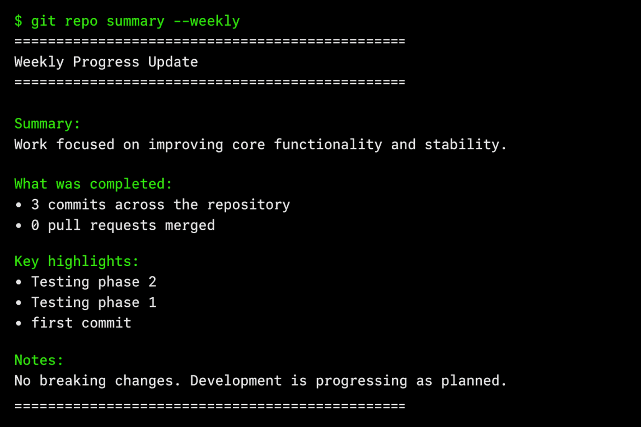
Fig-9.1: Sample Output
9.2 REPORTS GENERATED
Based on the application logic, system administrators can derive the following reports:
• Users per Workspace: Grouping the Participant table by RoomId.
• Files per Language Category: Aggregating the language column in the Files table (e.g., HTML vs CSS vs JS counts).
• Active Engagement Statistics: Counting the total number of workspaces managed by specific admins.
9.3 PERFORMANCE OBSERVATION

• Real-time sync: Yjs binary updates via WebSockets consistently occur with sub50ms latency over stable connections.
• Database Queries: File fetch operations leverage foreign key indexes, resolving in < 20ms on local development environments.

10. APPLICATION INTEGRATION

10.1 BACKEND INTEGRATION

The backend is implemented using Node.js and Express.js to handle API requests and interact with the PostgreSQL database.
const express = require('express');
import { createClient } from '@supabase/supabase-js';
const app = express();
const pool = new Pool({
process.env.NEXT_PUBLIC_SUPABASE_URL,
process.env.NEXT_PUBLIC_SUPABASE_ANON_KEY
);
// Fetch user profile
const { data, error } = await supabase
.from('profiles').select('*').eq('user_id', userId);
// API to fetch users
app.get('/users', async (req, res) => {
await supabase.rpc('increment_usage', { uid: userId });
// check limit
.from('profiles').select('*').eq('user_id', userId);
app.listen(5000);.

10.2 FRONTEND INTERACTION (REACT + TAILWIND)

The Next.js frontend communicates with backend API routes using fetch calls to retrieve GitHub data, trigger AI generation, and display the generated update to the user.
fetch('http://localhost:5000/users')
.then(res => res.json())
.then(data => console.log(data));
10.3 DATABASE CONNECTIVITY (SUPABASE)

import { createClient } from '@supabase/supabase-js';
// create connection
const pool = new Pool({
process.env.NEXT_PUBLIC_SUPABASE_URL,
process.env.NEXT_PUBLIC_SUPABASE_ANON_KEY
);
// Fetch user profile
const { data, error } = await supabase
.from('profiles').select('*').eq('user_id', userId);
// test connection
pool.connect()
.then(() => console.log('Database connected'))
.catch(err => console.error('Connection error', err));

// query example
app.get('/users', async (req, res) => {
await supabase.rpc('increment_usage', { uid: userId });
// check limit
.from('profiles').select('*').eq('user_id', userId);

11. CONCLUSION

11.1 SUMMARY OF WORK

WorkPing was successfully designed and implemented as a fully functional V1 SaaS application. The project involved building a complete full-stack solution using Next.js, React, Supabase, the GitHub REST API, and the OpenAI API. Key deliverables include GitHub OAuth authentication, repository selection, time-based activity filtering, AI-powered summary generation, editable output with clipboard copy and Markdown export, usage limiting, and a landing page waitlist system. The application is deployed on Vercel and represents a real-world product with early user validation in progress.
.
11.2 LEARNING OUTCOMES

- Building end-to-end full-stack SaaS applications with Next.js and Supabase
- Integrating third-party APIs including GitHub REST API and OpenAI API
- Implementing GitHub OAuth authentication and secure session management
- Applying SaaS architecture patterns including usage limiting and waitlist systems
- Handling edge cases, API errors, and rate limits gracefully in production
- Writing clean, maintainable code with React hooks and Tailwind CSS
- Applying product thinking alongside engineering to solve a real-world problem

11.3 FUTURE ENHANCEMENTS

- Stripe subscription integration for real SaaS paywall
- Smart filtering to separate client-facing updates from internal technical notes
- Scheduled automatic updates delivered via email at set intervals
- Multi-repository support to generate combined updates across projects

12. REFERENCES

A. BOOKS

- Fitzpatrick, R., The Mom Test: How to Talk to Customers, Robfitz Ltd.
- Ries, E., Database System Concepts, Crown Business.
B. WEBSITES

- Vercel Documentation – https://vercel.com/docs
- Supabase Documentation – https://supabase.com/docs
- OpenAI API Reference – https://platform.openai.com/docs
- GitHub REST API – https://docs.github.com/en/rest

C. DOCUMENTATION

- PostgreSQL Global Development Group – PostgreSQL Official https://nextjs.org/docshttps://nextjs.org/docs
- Tailwind CSS – Official Documentation – https://tailwindcss.com/docs
- OpenAI API – Official Documentation – https://platform.openai.com/docs

13. APPENDIX
A. SQL SCRIPTS

1. Table Creation Queries
CREATE EXTENSION IF NOT EXISTS "uuid-ossp";

CREATE TABLE users (
user_id UUID PRIMARY KEY DEFAULT uuid_generate_v4(),
name VARCHAR(100),
email VARCHAR(100) UNIQUE NOT NULL,
auth_provider VARCHAR(50),
created_at TIMESTAMP DEFAULT CURRENT_TIMESTAMP
);

CREATE TABLE repositories (
repo_id UUID PRIMARY KEY DEFAULT uuid_generate_v4(),
user_id UUID REFERENCES users(user_id),
repo_name VARCHAR(100),
owner_name VARCHAR(100),
repo_url TEXT,
is_private BOOLEAN DEFAULT false,
created_at TIMESTAMP DEFAULT CURRENT_TIMESTAMP
);

CREATE TABLE github_activities (
activity_id UUID PRIMARY KEY DEFAULT uuid_generate_v4(),
repo_id UUID REFERENCES repositories(repo_id),
activity_type VARCHAR(50),
title TEXT,
description TEXT,
activity_date DATE
);

CREATE TABLE progress_reports (
report_id UUID PRIMARY KEY DEFAULT uuid_generate_v4(),
user_id UUID REFERENCES users(user_id),
repo_id UUID REFERENCES repositories(repo_id),
summary TEXT,
report_status VARCHAR(50),
generated_at TIMESTAMP DEFAULT CURRENT_TIMESTAMP
);

2. Data Insertion Queries
INSERT INTO users (user_id, name, email, auth_provider)
VALUES
(111111111111', 'Murari', 'murari@email.com', 'github'),
(222222222222', 'Arun', 'arun@email.com', 'github');

INSERT INTO repositories (repo_id, user_id, repo_name, owner_name, repo_url, is_private)
VALUES
('aaaaaaaa-aaaa-aaaa-aaaa-aaaaaaaaaaaa', 111111111111', 'WorkPing', 'Murari', 'https://github.com/murari/workping', true),
('bbbbbbbb-bbbb-bbbb-bbbb-bbbbbbbbbbbb', 222222222222', 'ClientPortal', 'Arun', 'https://github.com/arun/clientportal', false);

INSERT INTO github_activities (activity_id, repo_id, activity_type, title, description, activity_date)
VALUES
(uuid_generate_v4(),aaaaaaaaaaaa', 'commit', 'Added GitHub OAuth login', 'Implemented GitHub authentication for users', '2026-05-01'),
(uuid_generate_v4(),-aaaaaaaaaaaa', 'commit', 'Fetched repository commits', 'Integrated GitHub API to fetch commit history', '2026-05-02'),
(uuid_generate_v4(),aaaaaaaaaaaa', 'pull_request', 'Merged dashboard UI', 'Completed dashboard page for viewing activities', '2026-05-03'),
(uuid_generate_v4(),bbbbbbbbbbbb', 'commit', 'Created client profile page', 'Added frontend page for client details', '2026-05-04');

INSERT INTO progress_reports (report_id, user_id, repo_id, summary, report_status)
VALUES
(uuid_generate_v4(),111111111111', aaaaaaaaaaaa', 'This week, GitHub login and repository activity fetching were completed.', 'generated'),
(uuid_generate_v4(),222222222222', bbbbbbbbbbbb', 'Client profile page was created and connected with the frontend.', 'generated');

3. Join Queries (INNER, LEFT)
SELECT
u.name,
r.repo_name,
r.repo_url
FROM users u
INNER JOIN repositories r
ON u.user_id = r.user_id;

SELECT
u.name,
r.repo_name
FROM users u
LEFT JOIN repositories r
ON u.user_id = r.user_id;

4. Subquery
SELECT name, email
FROM users
WHERE user_id IN (
SELECT user_id
FROM progress_reports
);
5. Common Table Expression (CTE)
WITH repo_count AS (
SELECT
user_id,
COUNT(*) AS total_repositories
FROM repositories
GROUP BY user_id
)
SELECT * FROM repo_count;

6. Window Function
SELECT
repo_id,
activity_type,
activity_date,
RANK() OVER (ORDER BY activity_date DESC) AS activity_rank
FROM github_activities;
7. Indexing Queries
CREATE INDEX idx_users_email ON users(email);

CREATE INDEX idx_repositories_user_id
ON repositories(user_id);

CREATE INDEX idx_github_activities_repo_id
ON github_activities(repo_id);

CREATE INDEX idx_progress_reports_user_id
ON progress_reports(user_id);

8. Performance Analysis
EXPLAIN ANALYZE
SELECT *
FROM github_activities
WHERE activity_type = 'commit';

B. CODE IMPLEMENTATION

Dashboard.tsx

"use client";

import { useEffect, useState } from "react";
import { useRouter } from "next/navigation";
import { supabase } from "@/lib/supabaseClient";
import EarlyAccessSurvey from "../../components/onboarding/EarlyAccessSurvey";

export default function DashboardPage() {
const [loading, setLoading] = useState(true);
const [authenticated, setAuthenticated] = useState(false);
const router = useRouter();

useEffect(() => {

})

useEffect(() => {
const checkAuth = async () => {
const { data: { session } } = await supabase.auth.getSession();

if (!session) {
router.push("/login");
return;
}

setAuthenticated(true);
setLoading(false);
};

checkAuth();
}, [router]);

if (loading) {
return (
<main className="min-h-screen bg-slate-50 px-4 py-12 flex items-center justify-center">
<div className="text-slate-600">Loading...</div>
</main>
);
}

if (!authenticated) {
return null;
}

return (
<main className="min-h-screen bg-slate-50 px-4 py-12">
<EarlyAccessSurvey />
</main>
);
}

Demo.tsx

import React from 'react';

export default function Demo() {
return (
<section className="py-24 bg-white" id="demo">
<div className="max-w-7xl mx-auto px-4 sm:px-6 lg:px-8">

{/* Header */}
<div className="text-center mb-16">
<h2 className="text-4xl font-bold text-slate-900 tracking-tight mb-4" style={{fontWeight: 700, fontSize: '3rem'}}>
See It In Action
</h2>
<p className="text-lg text-slate-600" style={{fontSize: '1.25rem'}}>
Watch how your GitHub activity transforms into professional client updates
</p>
</div>

{/* Demo Container */}
<div className="relative max-w-5xl mx-auto">

{/* Browser Frame */}
<div className="bg-white rounded-2xl shadow-2xl border border-slate-200 overflow-hidden">

{/* Browser Header */}
<div className="bg-slate-100 px-6 py-4 border-b border-slate-200 flex items-center gap-2">
<div className="flex gap-2">
<div className="w-3 h-3 rounded-full bg-red-400"></div>
<div className="w-3 h-3 rounded-full bg-yellow-400"></div>
<div className="w-3 h-3 rounded-full bg-green-400"></div>
</div>
<div className="ml-4 bg-white rounded-lg px-4 py-1 text-sm text-slate-600 flex-1">
workping.com/dashboard
</div>
</div>

{/* Demo Content */}
<div className="p-8">

{/* GitHub Activity Section */}
<div className="mb-8">
<h3 className="text-lg font-semibold text-slate-900 mb-4">Your GitHub Activity (Last 7 Days)</h3>
<div className="space-y-3">
<div className="flex items-center gap-3 p-3 bg-green-50 rounded-lg border border-green-200">
<div className="w-2 h-2 rounded-full bg-green-500"></div>
<span className="text-sm text-slate-700">Merged PR #47: Add user authentication system</span>
<span className="text-xs text-slate-500 ml-auto">2 days ago</span>
</div>
<div className="flex items-center gap-3 p-3 bg-blue-50 rounded-lg border border-blue-200">
<div className="w-2 h-2 rounded-full bg-blue-500"></div>
<span className="text-sm text-slate-700">8 commits to feature/payment-integration</span>
<span className="text-xs text-slate-500 ml-auto">1 day ago</span>
</div>
<div className="flex items-center gap-3 p-3 bg-purple-50 rounded-lg border border-purple-200">
<div className="w-2 h-2 rounded-full bg-purple-500"></div>
<span className="text-sm text-slate-700">Fixed critical bug in checkout flow</span>
<span className="text-xs text-slate-500 ml-auto">Today</span>
</div>
</div>
</div>

{/* Generated Update */}
<div className="border-t border-slate-200 pt-8">
<div className="flex items-center justify-between mb-4">
<h3 className="text-lg font-semibold text-slate-900">Generated Client Update</h3>
<button className="px-4 py-2 bg-indigo-600 text-white rounded-lg text-sm font-medium hover:bg-indigo-700 transition-colors">
Copy Update
</button>
</div>

<div className="bg-slate-50 rounded-lg p-6 border border-slate-200">
<div className="prose prose-sm max-w-none">
<p className="text-slate-700 mb-4">
<strong>Weekly Progress Update</strong>
</p>
<p className="text-slate-700 mb-3">
This week I completed the user authentication system and made significant progress on payment integration:
</p>
<ul className="text-slate-700 space-y-1 mb-4">
<li>✅ Implemented secure user login and registration</li>
<li>✅ Added password reset functionality</li>
<li>🔄 Working on Stripe payment integration (8 commits)</li>
<li>🐛 Fixed critical checkout flow bug affecting user experience</li>
</ul>
<p className="text-slate-700">
The authentication system is now live and ready for testing. Payment integration is on track for completion next week.
</p>
</div>
</div>
</div>
</div>
</div>

{/* Floating Elements */}
<div className="absolute -top-4 -right-4 bg-green-500 text-white px-3 py-1 rounded-full text-sm font-medium shadow-lg">
AI Generated
</div>
<div className="absolute -bottom-4 -left-4 bg-blue-500 text-white px-3 py-1 rounded-full text-sm font-medium shadow-lg">
Ready to Send
</div>
</div>

{/* CTA */}
<div className="text-center mt-16">
<p className="text-slate-600 mb-4 text-sm">
Generated only from merged PRs and commits — no guessing, no fluff.
</p>
<a
href="/signup"
className="inline-flex items-center gap-2 bg-indigo-600 text-white px-8 py-4 rounded-full font-semibold hover:bg-indigo-700 transition-colors shadow-lg"
>
Try It Yourself
<svg className="w-5 h-5" fill="none" stroke="currentColor" viewBox="0 0 24 24">
<path strokeLinecap="round" strokeLinejoin="round" strokeWidth={2} d="M17 8l4 4m0 0l-4 4m4-4H3" />
</svg>
</a>
</div>
</div>
</section>
);
}

Footer.tsx

'use client';

import Link from "next/link";

export default function Footer() {
const handleScroll = (e: React.MouseEvent<HTMLAnchorElement>, href: string) => {
if (href.startsWith('#')) {
e.preventDefault();
const element = document.querySelector(href);
if (element) {
element.scrollIntoView({ behavior: 'smooth' });
}
} else if (href === '/') {
e.preventDefault();
window.scrollTo({ top: 0, behavior: 'smooth' });
}
};
return (
<footer className="bg-primary px-4 sm:px-6">
<div className="mx-auto max-w-6xl py-16">
<div className="grid grid-cols-1 gap-12 sm:grid-cols-2 md:grid-cols-4">

{/* Brand */}
<div>
<h3 className="text-lg font-bold text-white">
WorkPing
</h3>
<p className="mt-4 max-w-xs text-sm text-white/80">
Clear, honest client updates from real GitHub work.
</p>
</div>

{/* Product */}
<div>
<h4 className="text-sm font-semibold text-white">
Product
</h4>
<ul className="mt-4 space-y-3 text-sm text-white/80">
<li><Link href="#features" onClick={(e) => handleScroll(e, '#features')} className="hover:text-white">Features</Link></li>
<li><Link href="#pricing" onClick={(e) => handleScroll(e, '#pricing')} className="hover:text-white">Pricing</Link></li>
<li><Link href="#howitworks" onClick={(e) => handleScroll(e, '#howitworks')} className="hover:text-white">How it works</Link></li>
</ul>
</div>

{/* Company */}
<div>
<h4 className="text-sm font-semibold text-white">
Company
</h4>
<ul className="mt-4 space-y-3 text-sm text-white/80">
<li><Link href="#" className="hover:text-white">About</Link></li>
<li><Link href="#" className="hover:text-white">Contact</Link></li>
<li><Link href="#" className="hover:text-white">Privacy</Link></li>
</ul>
</div>

{/* CTA */}
<div>
<h4 className="text-sm font-semibold text-white">
Get started
</h4>
<p className="mt-4 text-sm text-white/80">
Sign in with GitHub and generate your first update in minutes.
</p>
<Link
href="/login"
className="mt-6 inline-block rounded-full bg-white px-6 py-3 text-sm font-semibold text-primary transition hover:bg-gray-100"
>
Continue with GitHub →
</Link>
</div>

</div>

{/* Bottom bar */}
<div className="mt-16 flex flex-col items-center justify-between gap-4 border-t border-white/20 pt-8 text-sm text-white/60 sm:flex-row">
<span>
© {new Date().getFullYear()} WorkPing. All rights reserved.
</span>
<span>
Built for freelance developers • Trust first
</span>
</div>
</div>
</footer>
);
}

Hero.tsx

import Link from "next/link";

export default function Hero() {
return (
<section className="flex flex-col items-center text-center pt-32 pb-20 px-4 bg-slate-50">

{/* Small badge */}
<div className="mb-6">
<span className="px-4 py-1 rounded-full bg-indigo-50 text-indigo-600 text-sm font-medium">
Turn GitHub activity into clear, client-ready updates.
</span>
</div>

{/* Main heading */}
<h1 className="text-5xl md:text-6xl font-extrabold leading-tight max-w-4xl">
<span className="relative inline-block">
<span className="relative z-10">Clear client updates</span>
{/* The Golden Tear Shape */}
<svg className="absolute -bottom-2 left-0 w-full h-4 -z-0 opacity-70" viewBox="0 0 100 20" preserveAspectRatio="none">
<path
d="M0,10 Q25,0 50,10 T100,10 L100,20 L0,20 Z"
fill="#FFD700"
/>
</svg>
</span>
{" "}from your{" "}
<span className="relative inline-block">
<span className="relative z-10">real GitHub work</span>
<svg className="absolute -bottom-2 left-0 w-full h-4 -z-0 opacity-70" viewBox="0 0 100 20" preserveAspectRatio="none">
<path
d="M0,15 Q30,5 60,15 T100,5 L100,20 L0,20 Z"
fill="#FFD700"
/>
</svg>
</span>
</h1>

{/* Description */}
<p className="mt-6 max-w-2xl text-lg text-muted">
Stop wasting time writing weekly updates. <br />
WorkPing turns your commits and merged pull requests into clean, client-ready progress updates —
<span className="font-semibold text-black">
&nbsp;review, edit, and send.
</span>
</p>

{/* CTA */}
<Link
href="/login"
className="mt-10 inline-flex items-center gap-2 bg-primary text-white px-8 py-4 rounded-full text-lg font-semibold hover:bg-primary/90 transition-all duration-300 group active:scale-95 relative overflow-hidden"
>
<span className="relative z-10">Try for free</span>
<span className="group-hover:translate-x-1 transition-transform duration-300 relative z-10">→</span>
<div className="absolute inset-0 bg-gradient-to-r from-transparent via-white/20 to-transparent -translate-x-full group-hover:translate-x-full transition-transform duration-700 ease-in-out"></div>
</Link>

</section>
);
}

Howitworks.tsx

import React from 'react';
import { ChevronRight, ArrowDown } from 'lucide-react';

const steps = [
{
number: 1,
title: 'Connect GitHub',
description: 'Securely connect your GitHub account and choose the repositories you work on. Private repositories are fully supported.',
gradient: 'from-blue-500 to-blue-600',
shadow: 'shadow-blue-500/25',
},
{
number: 2,
title: 'AI generates your update',
description: 'We analyze your merged PRs, commits, and code changes to create a professional, client-ready update. Optional: add quick notes or customize your voice (Pro plans).',
gradient: 'from-violet-500 to-purple-600',
shadow: 'shadow-violet-500/25',
},
{
number: 3,
title: 'Review & copy',
description: 'Edit the update in a clean editor, then copy and send it anywhere — email, Slack, Notion, or client portals. You stay in full control.',
gradient: 'from-pink-500 to-rose-500',
shadow: 'shadow-pink-500/25',
},
];

export function HowItWorks() {
return (
<section className="py-20 bg-white" id="howitworks">
<div className="max-w-7xl mx-auto px-4 sm:px-6 lg:px-8">
{/* Section Header */}
<div className="text-center mb-16 max-w-2xl mx-auto">
<h2 className="text-4xl font-bold text-slate-900 tracking-tight mb-4" style={{fontWeight: 700, fontSize: '3rem'}}>
How it works
</h2>
<p className="text-lg text-slate-600" style={{fontSize: '1.25rem'}}>
Three simple steps to stress-free client updates
</p>
</div>

{/* Steps Grid */}
<div className="grid grid-cols-1 md:grid-cols-3 gap-8 relative">
{steps.map((step, index) => (
<div key={step.number} className="relative flex flex-col h-full">

{/* Card */}
<div className="bg-white rounded-2xl p-8 border border-slate-100 shadow-sm h-full flex flex-col z-10 relative hover:shadow-lg hover:-translate-y-2 transition-all duration-300 group">
{/* Number Icon */}
<div
className={`w-14 h-14 rounded-2xl bg-gradient-to-br ${step.gradient} flex items-center justify-center text-white text-xl font-bold mb-6 shadow-lg ${step.shadow} group-hover:scale-110 transition-transform duration-300`}
>
{step.number}
</div>

{/* Content */}
<h3 className="text-xl font-bold text-slate-900 mb-3" style={{fontSize: '1.5rem'}}>
{step.title}
</h3>
<p className="text-slate-600 leading-relaxed text-sm" style={{fontSize: '1rem'}}>
{step.description}
</p>
</div>

{/* Desktop Arrow (Right) - Only show between items */}
{index < steps.length - 1 && (
<div className="hidden md:flex absolute top-1/2 -right-4 transform -translate-y-1/2 translate-x-1/2 z-0 text-slate-300">
<ChevronRight size={48} strokeWidth={1.5} />
</div>
)}

{/* Mobile Arrow (Down) - Only show between items */}
{index < steps.length - 1 && (
<div className="md:hidden flex justify-center py-4 text-slate-300">
<ArrowDown size={32} strokeWidth={1.5} />
</div>
</div>
</section>
);
}

Page.tsx

import { Navbar } from "@/components/Navbar";
import Hero from "@/components/Hero";
import { HowItWorks } from "@/components/HowItWorks";
import { AutomationFeatures} from "@/components/AutomationFeatures";
import Demo from "@/components/Demo";
import EfficiencySection from "@/components/EfficiencySection";
import PricingSection from "@/components/PricingSection";
import FinalCTASection from "@/components/FinalCTASection";
import Footer from "@/components/Footer";
import Roadmap from "@/components/Roadmap";

export default function HomePage() {
return (
<>
<Navbar />
<Hero />
<Demo />
<HowItWorks />
<AutomationFeatures />
<Roadmap />
<PricingSection />
<FinalCTASection />
<Footer/>
</>
);
}
C. SAMPLE OUTPUTS

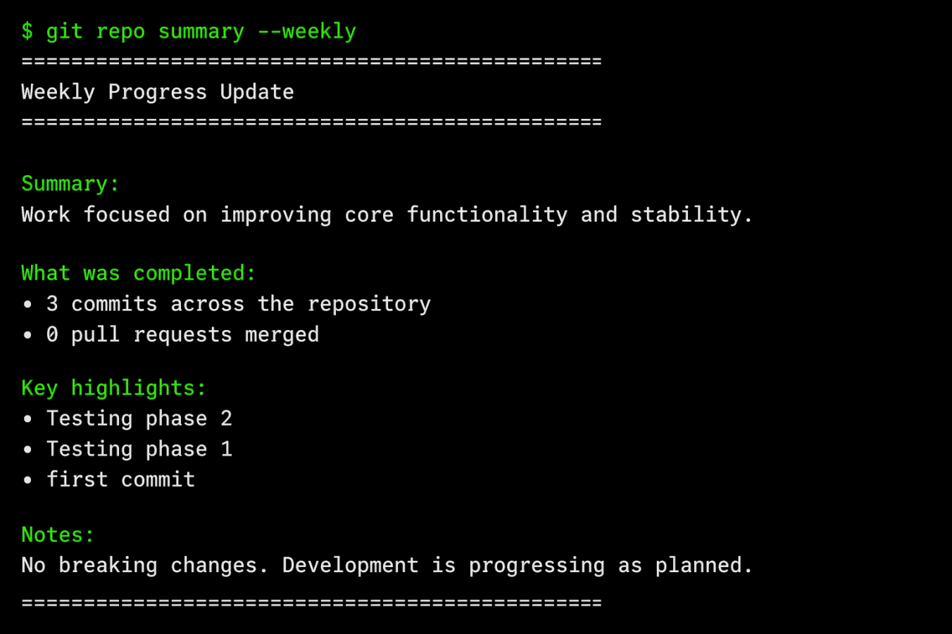
Fig-13.1: Output
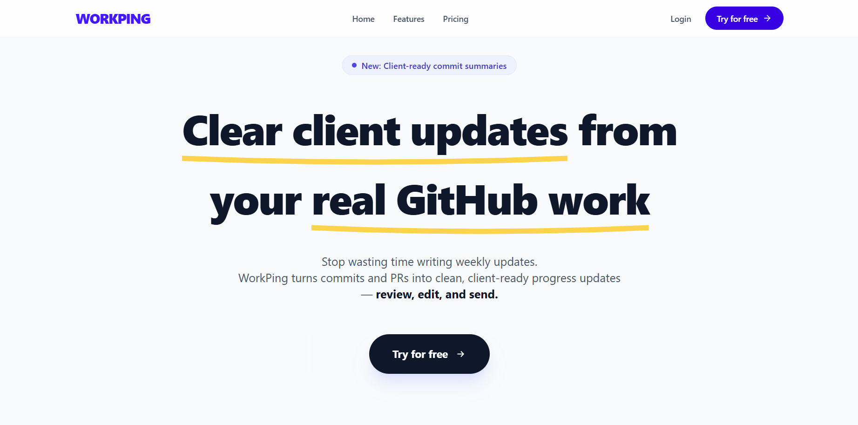
Fig-13.2: Landing Page

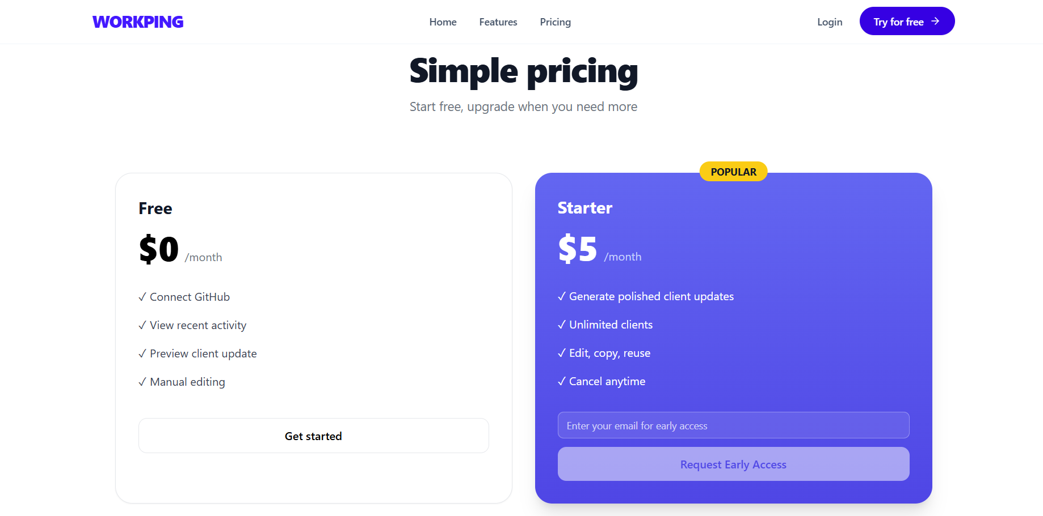
Fig-13.3: Pricing Page

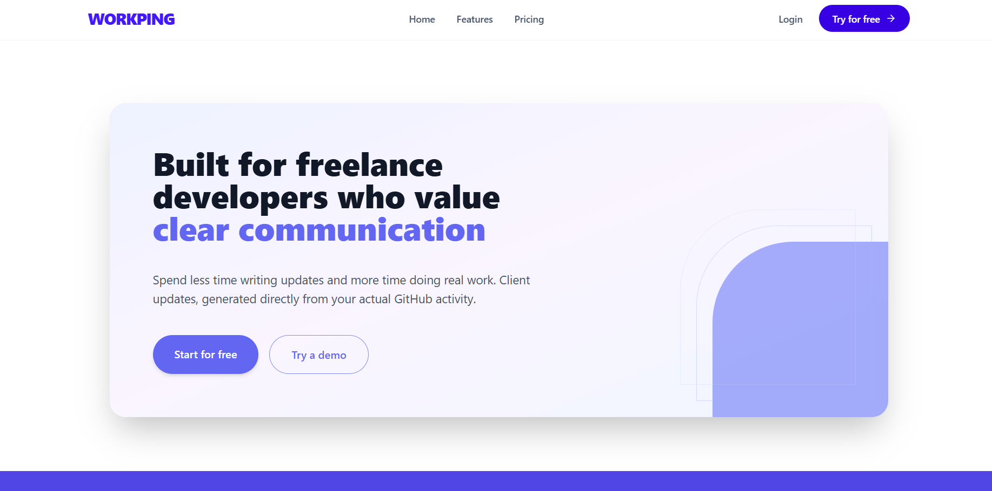
Fig-13.4: Communation Page

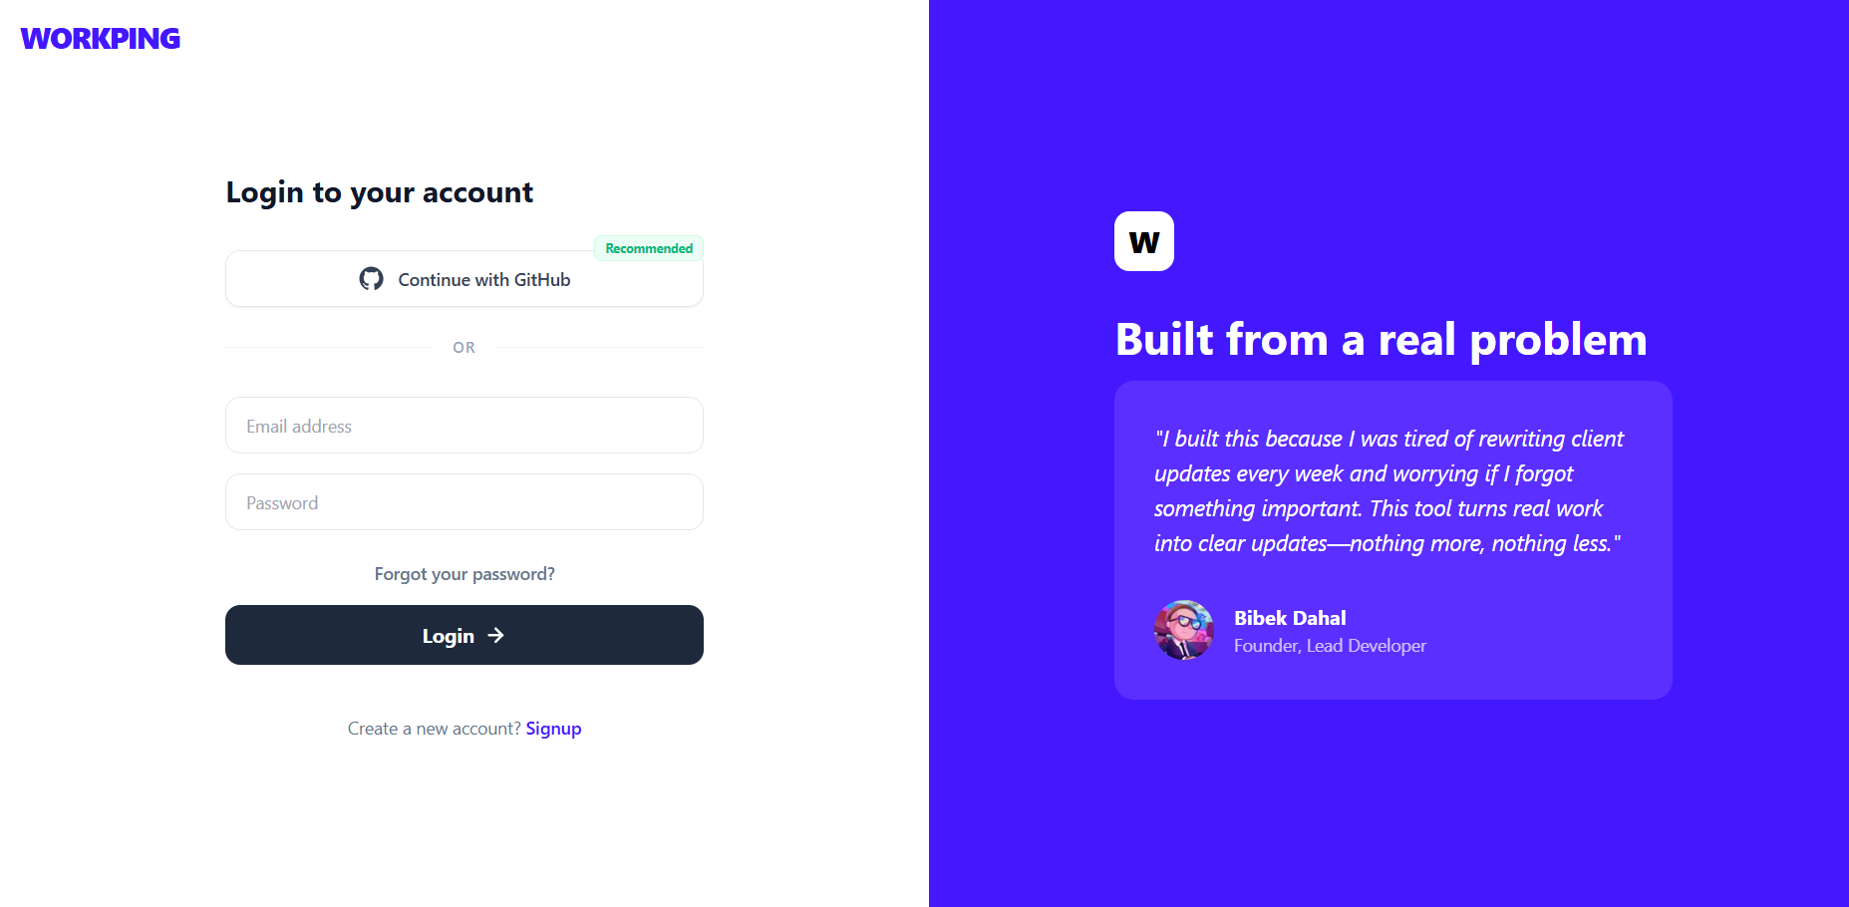
Fig-13.5: login Page

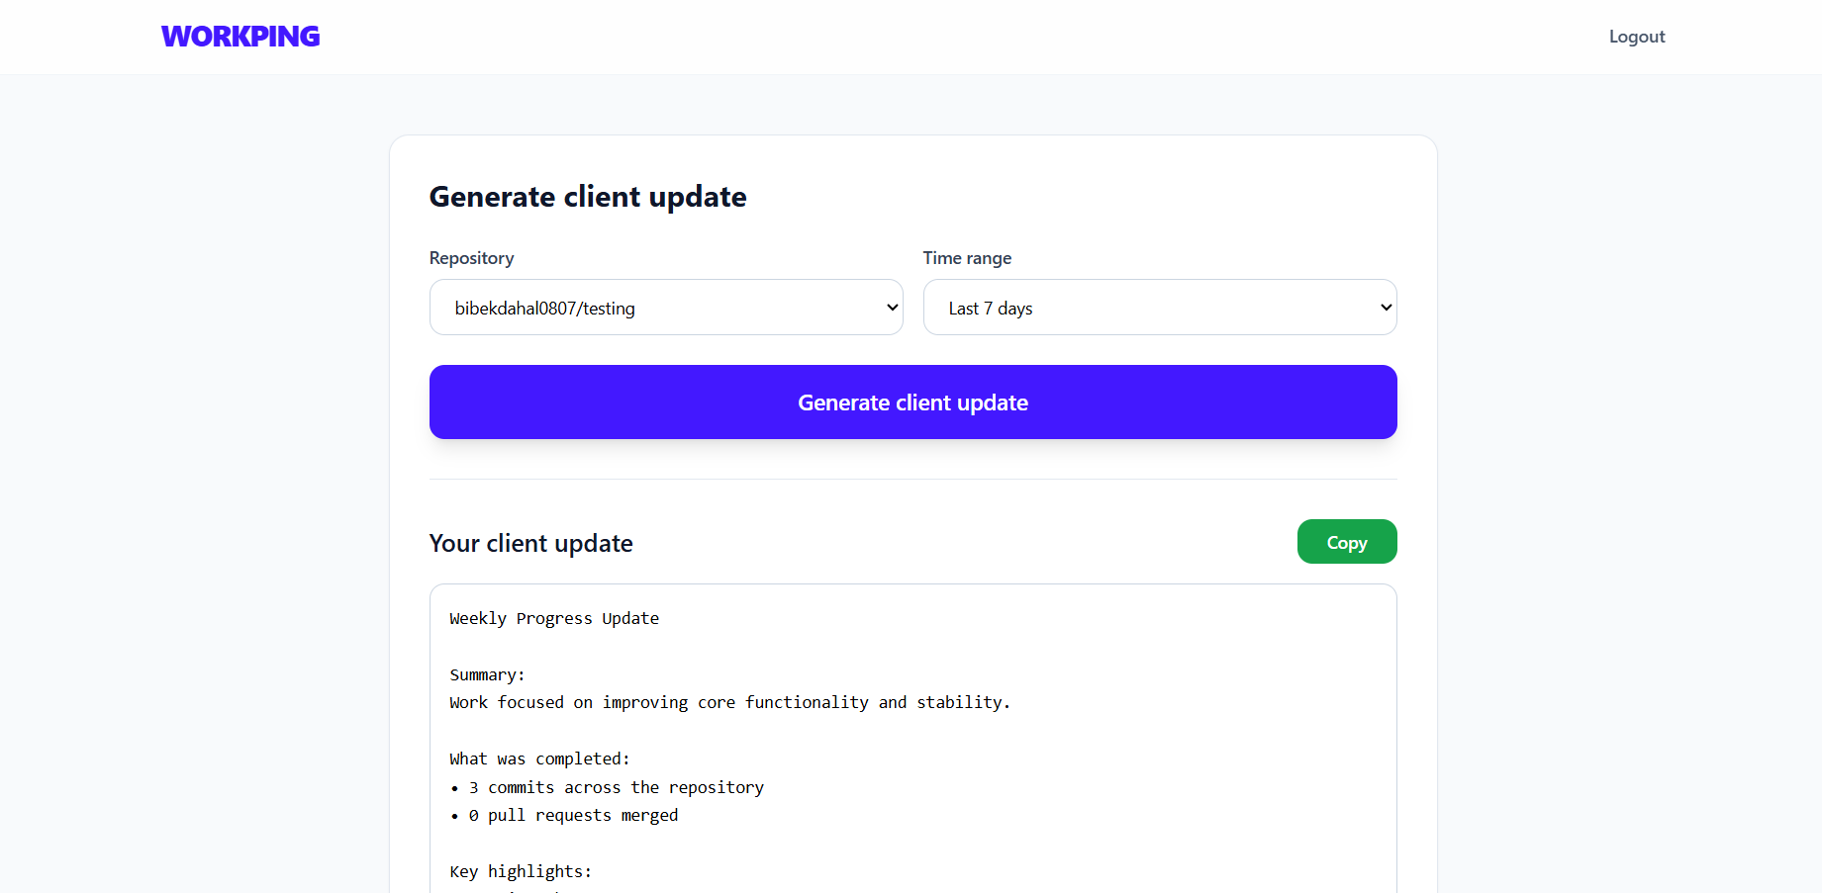

Fig-13.6: Dashboard Page


PROJECT TITLE | WorkPing
PROGRAM | B.E. COMPUTER SCIENCE & ENGINEERING
PROJECT BATCH NUMBER | 19
BATCH MEMBERS | 722824104146 | MURARI DAHAL
NAME OF THE SUPERVISOR | Mr. M. Karthick Raja M.E., (Ph.D.,)  Assistant Professor
NAME OF THE SDG GOALS MAPPED | - Responsible Consumption and Production  - Industry, Innovation and Infrastructure
MENTION THE SDG GOALS NUMBER | SDG – 9, 12
NAME OF THE TRL LEVEL | Experimental Proof of Concept
MENTION THE TRL LEVEL | 3

POs & PSOs Mapping (Put a tick mark in the mapped PO’s & PSO’s):
Program Outcomes |  |  |  |  |  |  |  |  |  |  | Program Specific Outcomes
PO1 | PO 2 | PO 3 | PO 4 | PO 5 | PO 6 | PO 7 | PO 8 | PO 9 | PO 10 | PO 11 | PSO 1 | PSO 2 | PSO 3
✓ | ✓ | ✓ | ✓ | ✓ | ✓ | ✓ |  | ✓ | ✓ | ✓ | ✓ | ✓ | ✓

Signature of the Supervisor
Mr. M. Karthick Raja M.E., (Ph.D.,)

VENUE AND EXPENDITURE STATEMENT FOR THE PROJECT WORK
Laboratory details where the project is carried out | AI Lab, CSE
Software / Hardware details | SOFTWARE:  - Visual Studio Code  - Spring Initializr (spring.io)  - Web Browser for running the server  - PostgreSQL (Database)  - Git & GitHub (Version control)  HARDWARE: -NIL
Details of the Component and Expenditure
S. No | Name of the Component | Qty | Price / Unit in (Rs.) | Amount (Rs.)
1 | Spring initializr (Spring.io) |  | - | OPEN SOURCE
2 | Visual Studio Code |  | - | FREE
3 | PostgreSQL |  | - | FREE
4 | Node.js & npm |  | - | FREE
5 | Git & GitHub |  | - | FREE

Signature of the student Signature of the Supervisor
MURARI DAHAL Mr. M. Karthick Raja M.E., (Ph.D.,)

