**TITLE: BUSINESS ANALYSIS OF SEED PRODUCTION OF BUSH BEANS.**

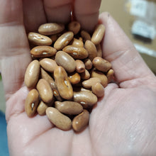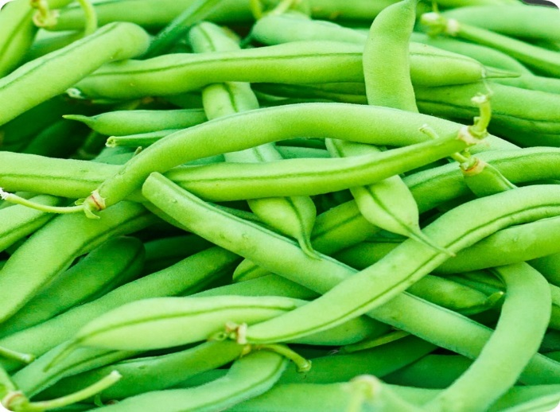

SUBMITTED BY: SUBMITTED TO

Pratikshya Subedi Suryamani Dhungana

Roll no: 1668 Assistant professor

Ramnagar Technical CNRM, Pakhribas, Dhankuta

And Management Collage AFU

**Executive summary**

Contender Bush Beans is a type of green bean that is popular among home gardeners and farmers. It is known for its high yield, disease resistance, and easy to grow nature. It is a type of snap beans, which means they are eaten whole when the pod is still young and tender. Bush beans are generally   ready to harvest within 50-60 days of planting and can continue to produce for several weeks. Additionally, bush beans can help improving soil fertility by fixing nitrogen in the soil, making them a valuable crop in a sustainable manner. In conclusion, bush beans are a valuable and versatile crop that offers many benefits to gardeners, farmer and consumers. They are easy to grow, disease resistance and produce a high yield, making them an excellent choice for anyone interested in growing their own food. However, there are some limiting factor for the cultivation of bush beans such as lack of knowledge about the appropriate technology, poor selection and understanding of suitable variety, lack of cultivation management and adverse effect of environment. So, it is necessary to make the farmer understood about the sowing adjustment according to appropriate weather and conditions, appropriate technology should be disseminated among the people and they should be made aware of proper management practices. So, this study solely focusses on the optimum production of the beans by the proper sowing adjustment.

**1** **INTRODUCTION**

**1.1Background information**.

Contender beans (*Phaseolus vulgaris L.cv, Contender*) are the popular variety of bush beans and is a native of South Carolina where it was developed by the Southeastern Vegetable Breeding Laboratory in Charleston and Introduced in 1961. McEwen, J., Yeoman, D. P., & Moffitt, R. (1988). It is the most cultivated leguminous tender warm weather annual vegetable in the world and is the most important food legume. Contender beans produce green, tender pods that are stringless and about 5-6 inches long and feature erect stems, green spade shaped leaves, 57 green snap bean pods, and tiny white flowers. The plant can be grown on the contender attract bees   and butterflies, creates biomass makes dye and fabric and is both edible and medicinal. They are known for their high yields, early maturity, and disease resistance. They are sometimes referred to as string beans or snap beans.

The plants themselves are compact and do not require staking or trellising, which makes them easy to grow in small spaces. The pods of the contender beans are typically harvested when they are young and tender, before the seeds inside have fully developed. Chatterjee, R., & Som, M. G. (1990). This results in a crisp, juicy texture and a sweet flavor. Contender beans are the good source of fiber, protein, and vitamins and minerals such as vitamin C, Vitamin B and folate. This vegetable not only plays a vital role in nourishment of human population but also improve soil fertility to a greater extend by the virtue of being highly nitrogen fixing crop.

Contender beans like other legumes, have the ability to fix the nitrogen in the soil through the symbiotic relationship with certain types of bacteria. These bacteria convert the atmospheric nitrogen into a form that can be used by the plant, which can then enhance soil productivity. This relationship with nitrogen-fixing bacteria allows Contender beans, it is important to provide the right condition for these bacteria to thrive.

This include maintaining proper soil pH, providing adequate moisture, and avoiding excessive use of nitrogen fertilizer, which can inhibit nitrogen fixation. In addition, it is important to inoculate the soil or growing medium with the appropriate strain of rhizobia bacteria to ensure successful nitrogen fixation. This can be done by purchasing the inoculant products or by using the soil from a previous crop of legumes. Overall, the relationship between the Contender beans and the nitrogen fixation is a unique and important aspect of their growth and productivity.In general, contender beans prefer warm, sunny weather with temperature between 60 and 85° Fahrenheit (15 to 29° Celsius). They require well drained soil with a pH level between 6.0 and 7.0.

However, there are some limiting factors to cultivate and produce the bush type French beans in the hills of Nepal. (Bhattarai et al, 1997) Reported that the main problems are lack of suitable varieties for the wider adaptation and large-scale production of the bush beans, lack of suitable practices, disease and pest control, adverse effect of climate during the entire season of crop production.

**OBJECTIVES**

General Objectives

To carry out economic assessment of bush bean seed production at West Rukum.

Specific Objectives

(i) To estimate the cost of production, marketing and returns of respondents associated to bean farming.

(ii) To assess investment criteria of bean entrepreneurs.

**SWOT ANALYSIS ON SEED PRODUCTION OF BEANS**

**STRENGTH**

(i) Availability of highly suitable climatic condition for bean seed production

(ii) Nearby market

(iii)Land availability

(iv) Knowledge among farmers.

(v) Good image of bean among the farmers in that locality due to its taste and profitability.

**WEAKNESS**

(i) Growers are scattered, low production mainly due to low use of external inputs

(ii) Use of low quality input.

(iii) Lack of storage and processing facility.

(iv) Lack of credit.

(v) Lack of suitable variety to prolonged harvesting time.

(vi) Post harvest loss.

**OPPURTUNITY**

(i) High demand of Seed in that region.

(ii) Better export potential to other regions

(iii) Optimum climate for seed production

(iv) Government is emphasizing commercial seed production of beans.

**THREAT**

(i) Bad weather.

(ii) Incidence of anthracnose disease.

(iii) Attack of different pest.

(iv) High cost of input.

(v) Increasing of Labor Cost.

(vi) Highly consumption markets are situated far, Farmers are not satisfied with the price they receive.

**Economic Analysis of Bush bean Seed Production**

Including,

1. Cost of Production

2. Benefit Cost Ratio

3. Net Present Value

**1. Analysis of Cost of Production**

Total cost of production was calculated by adding initial investment and variable cost incurred during the production. Land of area 4 kattha located at 25 km from headquater of rukum at Sankh for bush bean seed production.It has a fertile,well drained soil suitable for the seed production. The cost of land is NRs 70,000 per month and cost per unit kattha is Rs 17500.

**Calculation of Initial investment**

|  |  |  |  |  |  |
| --- | --- | --- | --- | --- | --- |
|  |  |  |  |  |  |

|  |  |  |  |  |  |
| --- | --- | --- | --- | --- | --- |
|  |  |  |  |  |  |
| SN | Fixed cost item | Unit | Quantity | Per Unit Cost(Rs.) | Total Cost(Rs) |
| 1 | land Cost | Hacter | 4 | 17500 | 70000 |
| 2 | Irrigation set | Number | 3 | 90000 | 270000 |
| 3 | Transportation Cost | Number | 1 | 40000 | 40000 |
| 4 | Storage Cost | kg | 2 | 12000 | 24000 |
| 5 | Seed dryer | kg | 1 | 20000 | 20000 |
| 6 | Sieve machine | kg | 2 | 1500 | 3000 |
| 7 | Bean pealing machine | kg | 1 | 15000 | 15000 |
| 8 | Weighing scale | kg | 2 | 1250 | 2500 |
| 9 | License |  |  |  | 2250 |
|  | Total |  |  |  | 446750 |

**Calculation of Operation cost**

|  |  |  |  |  |  |
| --- | --- | --- | --- | --- | --- |
|  |  |  |  |  |  |
| SN | Variable cost item | Unit | Quantity | Per unit cost(Rs) | Total Cost |
| 1 | Labor cost | Days | 190 | 500 | 95000 |
| 2 | Land Preparation Cost | Hacter | 4 | 5000 | 20000 |
| 3 | Layout cost | Hacter | 4 | 500 | 2000 |
| 4 | Raw material Cost | kg |  |  | 30000 |
| 5 | Compost | kg | 2 | 17500 | 35000 |
| 6 | Urea | kg | 20 | 325 | 6500 |
| 7 | DAP | kg | 48 | 250 | 12000 |
| 8 | Potash | kg | 50 | 250 | 12500 |
| 9 | Micronutrient | Sub-Total | 25 | 5000 | 125000 |
| 10 | Plant Protection Cost | Sub-Total | 25 | 5000 | 125000 |
| 11 | Farm management Cost | Year |  |  | 2500 |
|  | Total |  |  |  | 465500 |

**Total Cost = Total Fixed Cost (Initial investment) + Total Variable Cost (Operational cost)**

**= 406750+465500**

**=872250**

**2. Analysis of benefit cost ratio.**

|  |  |  |  |  |
| --- | --- | --- | --- | --- |
|  |  |  |  |  |
| **Particulars** | **Unit** | **Quantity** | **Rate** | **Amount** |
| From 400 kg of Seed | kg | 12,00 | 800 | 960000 |
| TOTAL RETURN PER SEASON |  |  |  | 960000 |

**B/C ratio =** Total benefits/Total costs

= 960000/872250

= 1.10

For Break-Even point

Per kg Sale = Rs 800

Variable cost per kg = Rs 726

Break-Even point = fixed cost / (per kg sale – variable cost per kg)

= 872250 / (800 – 726)

= 11787 kg

Payback period (PBP) = Initial Investment / Cash inflow

= 406750 / 872250

= 0.47 years