First Assignment Of CN5006
Name: Bibek Gurau
Student id: 2866164
Group-29

Output of Assignment
- Add
Operation: 4+6
Result: 10
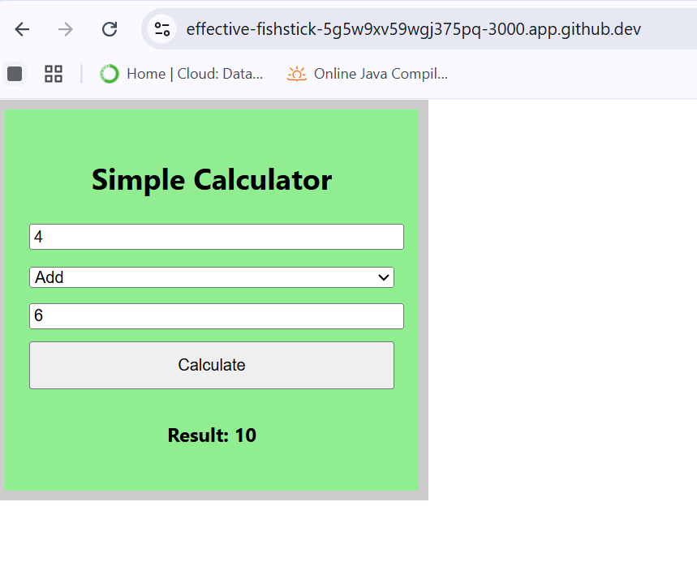
- Subtract
Operation: 4-6
Result: -2
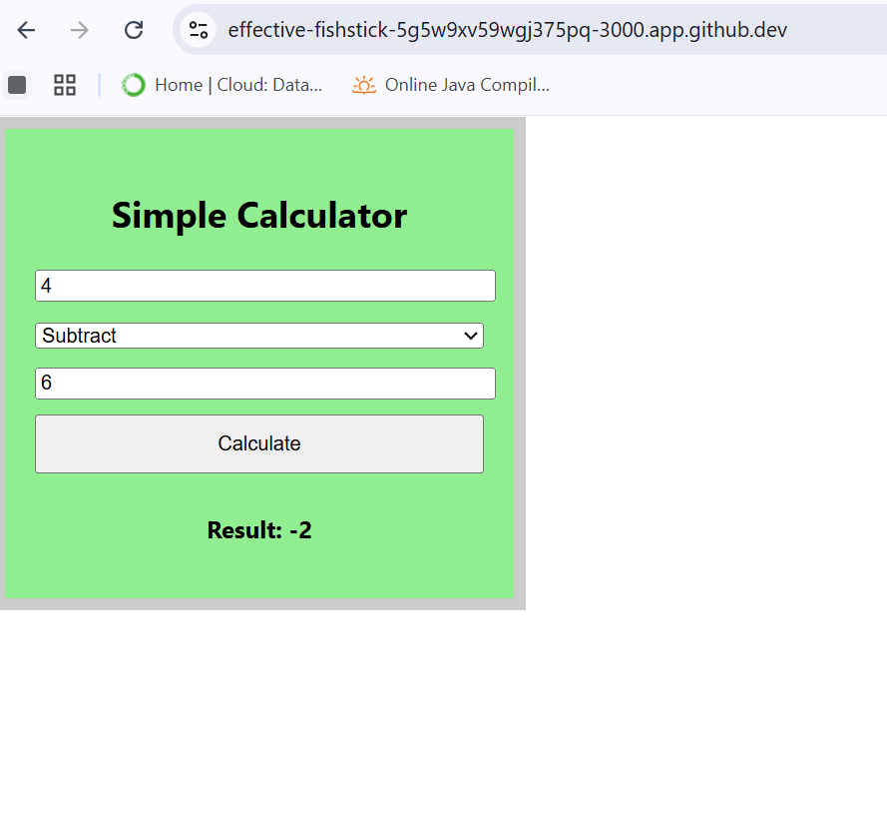
- Multiply
Operation: 4*6
Result: 24
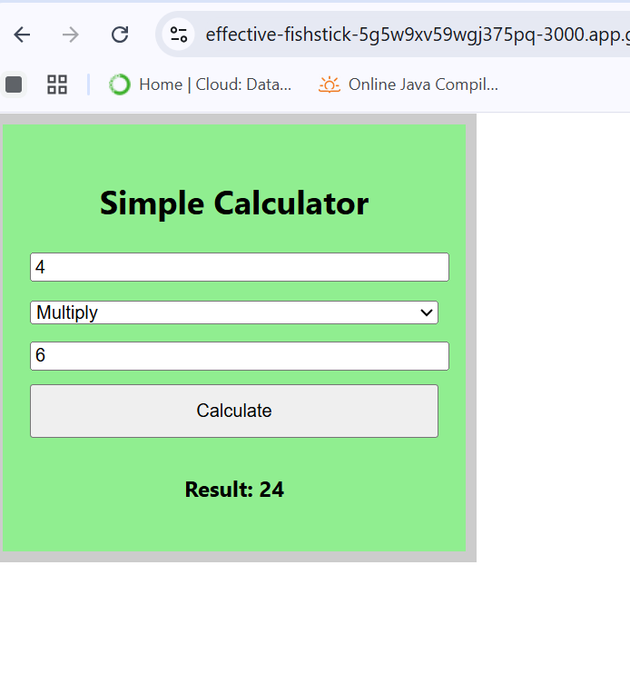
- Divide
Operation: 4/6
Result: 0.66
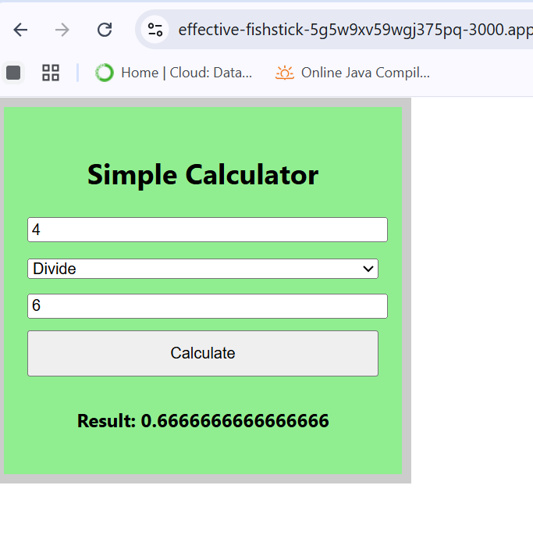
Reflection of Assignment
The calculator app has been created in React and has one functional component, namely Calculator.

The Calculate button initiates the calculate functionality that is the main component of the element. This is made possible by considering the two values (num1 and num2) and the mathematical operator the user chose through the drop down menu using normal JavaScript. Next, the logic is processed with the assistance of a JavaScript switch statement which creates the corresponding operation (addition, subtraction, multiplication or division) in accordance with the operator value. In the division case, a check may be in place to make sure that you do not divide by zero. Finally, the computation in real-time occurs on the screen.
I implemented the program on the GitHub Codespaces platform. To confirm that the project had the required packages, like react-scripts, I opened the project directory (/myapp) first and purchased the needed packages with the help of npm install. Then, I had to run the code npm start to start the application. This was a bundling of the React application and it was deployed with Codespaces port forwarding, which also enabled me to check out all the features.

