- Install Wamp Server.
- Set Max_Execution_time=1200 in PHP.ini file
- Unzip the File TCPDF.zip and Election.Zip and Copy Both Folder under WWW directory of Wamp server Path
- In PHPMyAdmin Create a Database say “election”
- Import the BlankDatabase.sql from Database folder under Election14 folder.
- If your Mysql database has Password then change the following line of config.class.php file under class folder.

$this->dbname="election"; Name of Database

$this->dbuser="root"; Name of User by default is “root”

$this->dbpwd=""; Set My SQL Password otherwise Keep blank

- Now Open IE or Mozila and browse http://localhost/election/index.php or You may Use IP like http://10.177.156.32/election/index.php
- First Time You will be redirected to following form for Setting First time Password of System User(root).

Set First Time Password for root User
User ID | 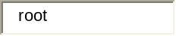*
Password(Minimum 4 Character) | 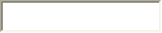*
Re Enter Password | *
Name of First User | 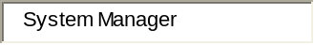

- Using this Password You may Create Other User with different Role

Thanking You

Jayanta Kumar Deka
Scientist-C
NIC, Nalbari
M-94350-27958
Email- deka.jk@nic.in

