1) What is boilerplate? ans. runtime + predefined services
2) In CloudantNoSQL DB of IBM Bluemix PAAS , what is generated when you click on "New Doc" ?

ans) A new json document with a system generated _id
3) What is the advantage of CloudantNoSQL DB?
ans.) It can scale horizontally
4) In IBM Bluemix PAAS , an application could not connect to a service and failed to start ? How should a developer fix the issue. manifest.yml file given below :
applications:
- path: .
memory: 256M
instances: 1
domain: mybluemix.net
name: HelloWorldNodeJSApp01
host: HelloWorldNodeJSApp01
disk_quota: 1024M
services : MongoDB-ijk
A) Change the name of the MongoDB service instance.
B) Check if the service is available in catalog using cf services command
C) Push the application without restarting cf push AppName --no--host
D) Check the service credential in VCAP_SERVICES environment variable
5) After executing below codes, what should be the result?
{
"_id": "_design/name",
"views": {
"view1": {
"map":"function(doc){emit(doc.field, 1)}",
"reduce": "function(key, value, rereduce){return sum(values)}"
}
}
}
A)Primary index
B)Secondary index
C)View
D) Don't remember this option
6) Question on Forking a project
7) Which of the following is the advantage of Cloudant sync
ans. you simply replicate and sync the copy of this database in Cloudant with a local copy on their phone or tablet (or vehicle, sensor, appliance, etc.). This can reduce round-trip database requests with the server.
8) Question of Live Edit
Ans -
Using Live Edit to quickly make changes without redeploying an application

9)
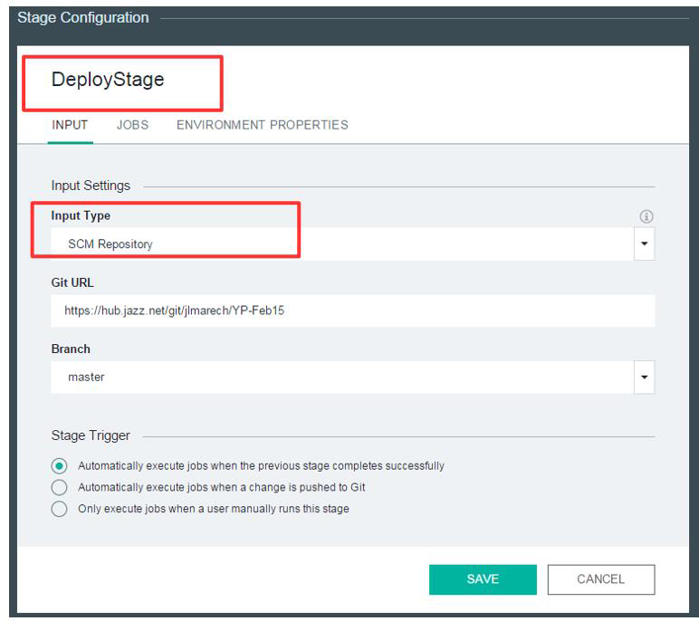

In the DeployStage, If the input type is build artifacts and Input stage id Build, then which of these following statement is correct?
Ans. Teams want to deploy successful builds
10 ) IBM DataWorks Forge-
Ans. Assess quality of sample data
11) Load Impact graph

12 )
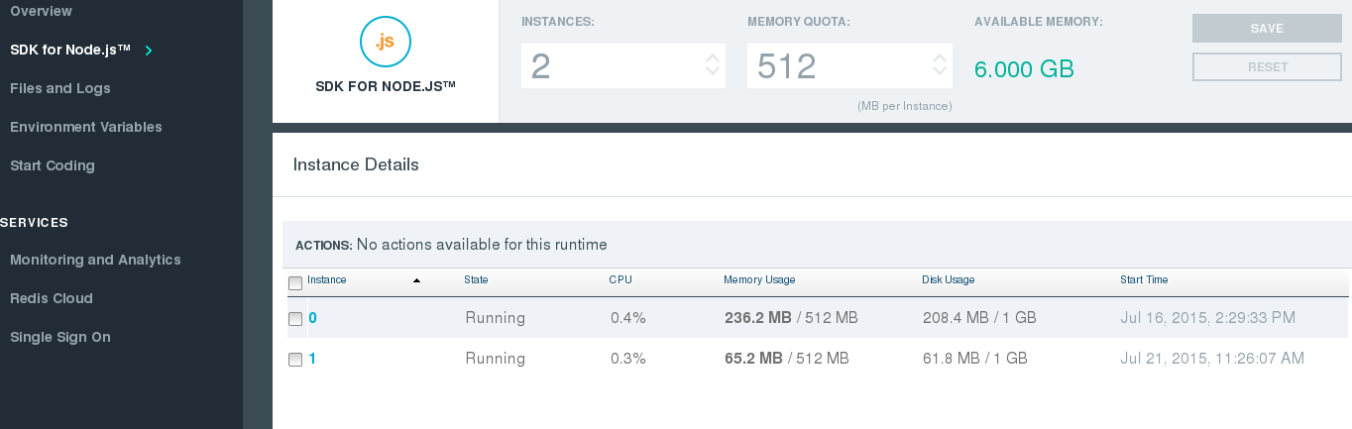
Ans. each instance will get 512 MB
13)
Question on pattern
"/Vechicles/Cars","Sedan" Client 2 gets Sedan, and Client 3 gets Sedan,Jet
"/Vehicles/Planes","Jet" So what should be the pattern?
A) client 2 -> "/Vechicles/Cars" and Client 3 -> "/Vechicles/$
B) client 2 -> "/cars" and client 3 -> "/Vehicles"
C) client 2 -> "/Vechicles/Cars" and Client 3 -> "/Vechicles$
D) client 2 -> "/Vechicles/Cars" and Client 3 -> "/Vechicles/+

