- When number of instances is increased to 2 using auto-scaling, and the memory displayed is 256 MB, will the memory be shared between the 2 instances or each instance gets 256 MB?
Yes each instance will get 256 MB
- Question on MQ light shared topic. There are 2 clients, client1, and client2. An application send messages hi1, hi2, hi3, hi4. Which client gets what message
If its equal distribution client1 – hi1,hi3, client2-hi2,h4

- In track and plan, which is the top most work item
  - Epic (ans)
  - Story
  - Task
  - Defect
- What is boilerplate
- What is the role of routing component
Connect external clents to Application instance
- Which of the following does not pertain to organization
  - Space (ans)
  - User
  - Domain
  - Quota
- Cf scale APP –m 512MB. Will this command increase Memory allocation by 512MB, decrease by 512MB, assing 512MB irrespective of current allocation
Assigning 512MB to all instances
- Which parameter is used to carry forward variables between jobs in delivery pipeline

- Which of the following is correct
  - An application can be bound to multiple services(ans)
  - Multiple applications can be bound to a service
  - Application can access a service without binding
  - <>
- A user sees that the app instances are changes very frequently. To stabilize what he should do. Increase/decrease breach/cooldown period?
Increase cooldown period
- Why load impact service is used?
To check performace of the application with more virtual users
- In instance details panel of Monitoring and Analytics service what all can be monitored? Cpu? Memory used? Throughput?
Yes all
- A question related to backlog in track and planning. I don’t remember what it was
- What will happen when restart is clicked in the below image
  - 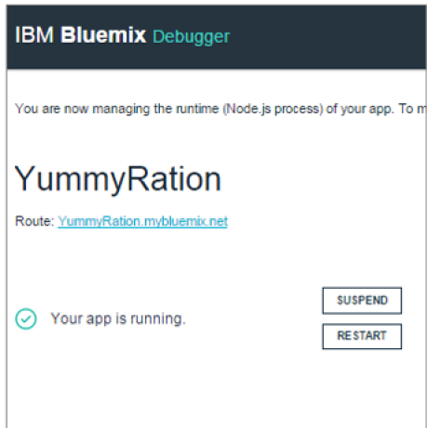
The changes will not be affected.

- There are 2 applications which use a common code. What is the right approach
  - Have 1 repository for each application and 1 repository for common code
  - Have 1 repository for each application and deploy common code as a dependency
  - Have 1 repository for all applications together
  - Blah blah
Ans-
- How a lead developer can share a minor modification in code
  - Send email
  - Commit and push changes to git repository
  - Deploy the changes
  - Blah blah
Ans-b
- How is the integrity of the code checkin verified
  - Commit and push
  - Deploy
  - Build
  - Run
Ans-c
- Which db should be used for faster processing of data
Ans-CloudantDB
- NoSQL db provides
  - Consistency over availability
  - Availability over consistency(ans)
  - Blah
  - Blah
- Using restful service to delete a record from NoSQL DB, what parameters are required
  - _rev
  - Id
  - Id and _rev(ans)
  - Blah
- Question on features of cloudant sync
- dashDB runSQL script / validate functionality question
- question on features of dataworks forge
- Question on purpose of session caching
- For image processing which service is required
- Question on cloudant primary index and secondary index

