VIRTUALIZATION
Move from Physical to Virtual

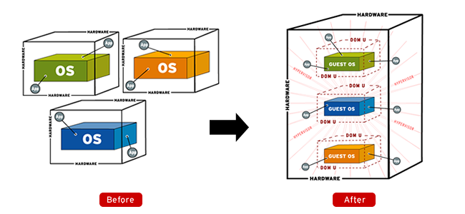

- Consolidation to reduce hardware cost.
- Optimization of workloads.
- IT flexibility and responsiveness.

Make one physical resource look like multiple virtual resources. Combine multiple physical resources into shared pools from which users receive virtual resources.

HYPERVISOR
- Provides platform virtualization
- Divides a physical machine in to multiple virtual Machines
- Controls and presents a machine’s physical resources as virtual resources to the VMs

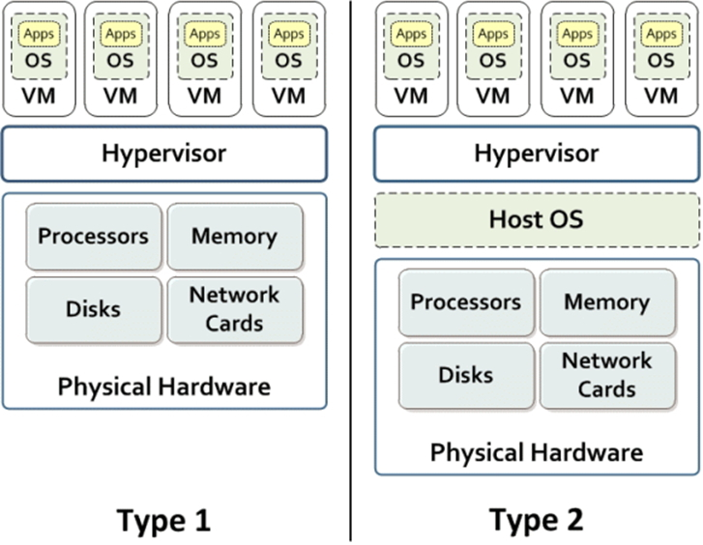
NATIVE/BARE-METAL HOSTED
IBM z/VM®, IBM PowerVM®, Citrix Xen, Kernel-Based Virtual Machine Microsoft® Hyper-V® (KVM), Oracle VirtualBox VMWare VSphere/ESX/ESXi Server VMWare Workstation

CONTAINERS
- Abstraction on top of hypervisor
- Build, ship, and run applications unchanged on any infrastructure
- Portable – irrespective of choice of cloud provider containers make it easy to move workloads between clouds

Containers Vs VM
VM – Guest OS, Binaries, Libraries and dependencies
Containers – application, dependencies, a lightweight runtime and Packaging Tool

Example of Containers – Docker. It is an open source container technology

Quality of Services of CLOUD
- Pay per Use
- Resource Pooling
- Self Service Provisioning
- Elasticity
- Wide range of Accessibility
- 24 x 7 – no downtime

CLOUD DEPLOYMENT MODELS

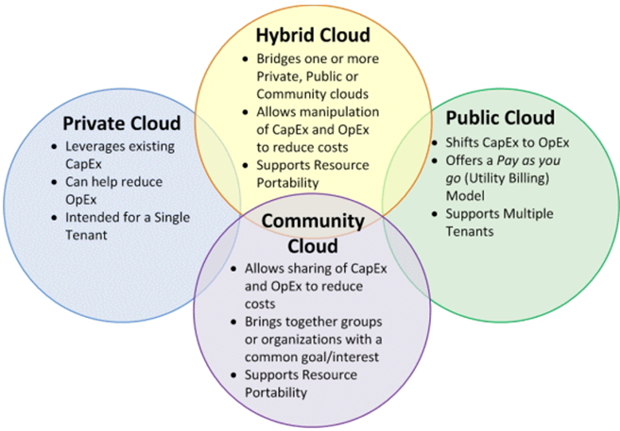

- Owned
- Managed
- Hosted

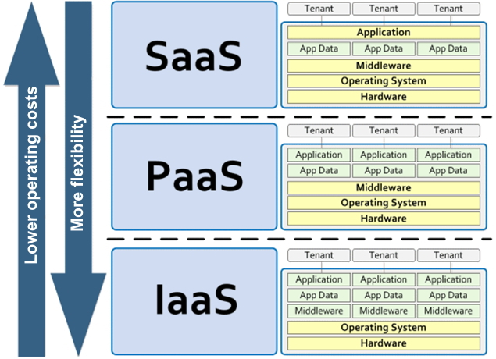
CLOUD DELIVERY MODELS

