**Lab Program Number: Date: 2079/03/2**

**Title: Write a program to find the number of movement made by read/write head for First Come First Serve (FCFS) disk scheduling algorithm.**

**First Come First Serve (FCFS)**

**First come first serve** (FCFS) scheduling algorithm simply schedules the jobs according to their arrival time. The job which comes first in the ready queue will get the CPU first. The lesser the arrival time of the job, the sooner will the job get the CPU.

FCFS scheduling may cause the problem of starvation if the burst time of the first process is the longest among all the jobs.

**Source Code:**

|  |
| --- |
| #include<stdio.h>  int main()  {  int p[10],at[10],bt[10],ct[10],tat[10],wt[10],i,j,temp=0,n;  /*p for process, at for arrival time, bt for brust time  ct for completion time, tat for tatal turnaround time  wt for waiting time*/  float awt=0,atat=0;  printf("enter no of proccess :");  scanf("%d",&n);  printf("enter %d process:",n);  for(i=0;i<n;i++)  {  scanf("%d",&p[i]);  }  printf("enter %d arrival time:",n);  for(i=0;i<n;i++)  {  scanf("%d",&at[i]);  }  printf("enter %d burst time:",n);  for(i=0;i<n;i++)  {  scanf("%d",&bt[i]);  }  // sorting arrival and brust time, and process according to arrival time  for(i=0;i<n;i++)  {  for(j=0;j<(n-i);j++)  {  if(at[j]>at[j+1])  {  temp=p[j+1];  p[j+1]=p[j];  p[j]=temp;  temp=at[j+1];  at[j+1]=at[j];  at[j]=temp;  temp=bt[j+1];  bt[j+1]=bt[j];  bt[j]=temp;  }  }  }  //calculating first completion time  ct[0]=at[0]+bt[0];  /* calculating 2 to n ct */  for(i=1;i<n;i++)  {  temp=0;  if(ct[i-1]<at[i])  {  temp=at[i]-ct[i-1];  }  ct[i]=ct[i-1]+bt[i]+temp;  }  // calculating total turnaround time and waitingtime  printf("\np\t A.T\t B.T\t C.T\t TAT\t WT");  for(i=0;i<n;i++)  {  tat[i]=ct[i]-at[i];  wt[i]=tat[i]-bt[i];  atat+=tat[i];  awt+=wt[i];  }  atat=atat/n;  awt=awt/n;  for(i=0;i<n;i++)  {  printf("\nP%d\t %d\t %d\t %d \t %d \t %d",p[i],at[i],bt[i],ct[i],tat[i],wt[i]);  }  printf("\naverage turnaround time is %f",atat);  printf("\naverage wating timme is %f",awt);  return 0;  } |

IDE: Dev-C++

Programming Language: C-programming

**Output:**

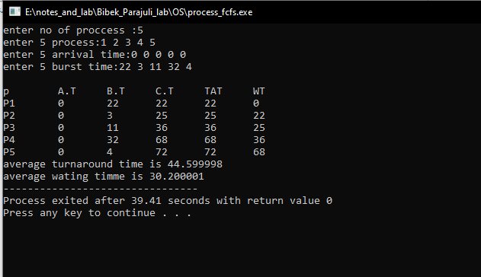

Fig: FCFS Output