**Lab Program Number:12 Date: 2079/03/2**

**Title: Write a program to implement First Come First Serve (FCFS) to find the no. of movements made by R/W head.**

**First Come First Serve (FCFS) disk scheduling**

FCFS is the simplest of all the Disk Scheduling Algorithms. In FCFS, the requests are addressed in the order they arrive in the disk queue.

**Source Code:**

|  |
| --- |
| // FCFS disk scheduling algorithm  #include<stdio.h>  #include<stdlib.h>  int main()  {  int request[15],i,p,TotalHeadMoment=0,initial;  printf("Enter the number of Requests\n");  scanf("%d",&p);  printf(" \nenter the requests sequence");  for(i=0;i<p;i++)  {  scanf("%d",&request[i]);  }  printf("Enter initial head position\n");  scanf("%d",&initial); //read write head at initial    for(i=0;i<p;i++)  {  TotalHeadMoment=TotalHeadMoment+abs(request[i]-initial);  initial=request[i]; //for next request it is inittial  }    printf("Total head moment is %d",TotalHeadMoment);  return 0;  } |

IDE: Dev-C++

Programming Language: C-programming

**Output:**

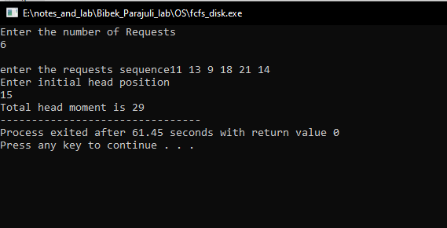

Fig: FCFS disk