**Lab Program Number: 12 Date: 2079/03/2**

**Title: Write a program to implement Shortest Seek Time First (SSTF) to find the no. of movements made by R/W head.**

**Shortest Seek Time First (SSTF):**

Shortest seek time first (SSTF) algorithm selects the disk I/O request which requires the least disk arm movement from its current position regardless of the direction. It reduces the total seek time as compared to FCFS.

**Source Code:**

|  |
| --- |
| #include<stdio.h>  int main()  {  int request[100],i,p,TotalHeadMoment=0,initial,count=0;  printf("Enter the number of Requests\n");  scanf("%d",&p);  printf("\nEnter the Requests sequence");  for(i=0;i<p;i++)  {  scanf("%d",&request[i]);  }  printf("\nEnter initial head position");  scanf("%d",&initial);    while(count!=p)  {  int val=1000,d,index;  for(i=0;i<p;i++)  {  d=abs(request[i]-initial); // calculating the minimum distance  if(val>d)  {  val=d;  index=i;  }    }  TotalHeadMoment=TotalHeadMoment+val;  initial=request[index];    // you can use any number in val  request[index]=1000;  count++;  }    printf("Total head movement is %d",TotalHeadMoment);  return 0;  } |

IDE: Dev-C++

Programming Language: C-programming

**Output:**

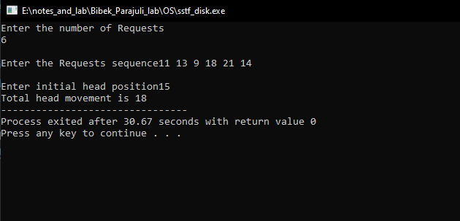

Fig: SSTF disk