

**Lab Program Number:**

**Date:**

**To configure and understand about Router on a stick using cisco packet tracer.**

**Theory:**

ROUTER-ON-A-STICK, also known as a “one-armed router” is a method for running multiple VLANs over a single connection in order to provide inter-VLAN routing. Essentially the router connects to a core switch with a single interface and acts as the relay point between networks.

**Procedure:**

First, we configure a topology for our ROUTER-ON-A-STICK:

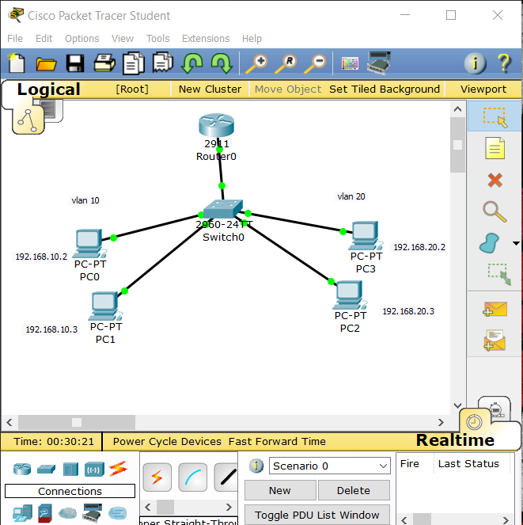

Now, we setup a Vlan network as vlan10 and vlan20.

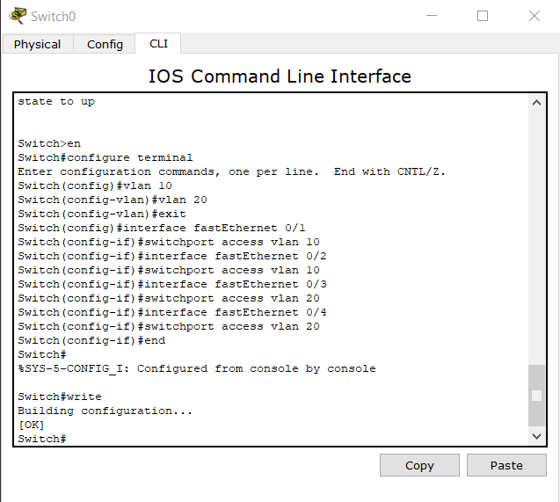

After setting up vlan, we setup a trunk for our vlan as:

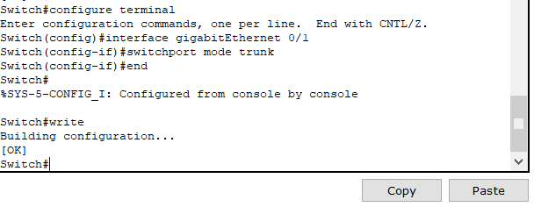

After the trunk, we set up the router

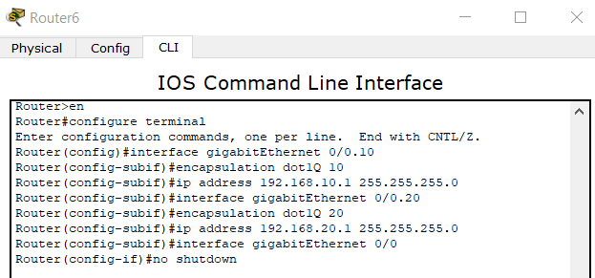

Configuring DHCP as:

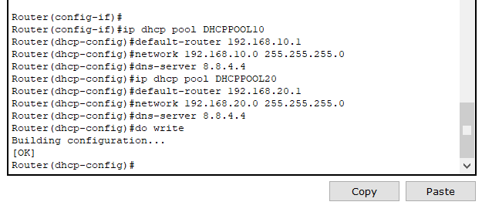

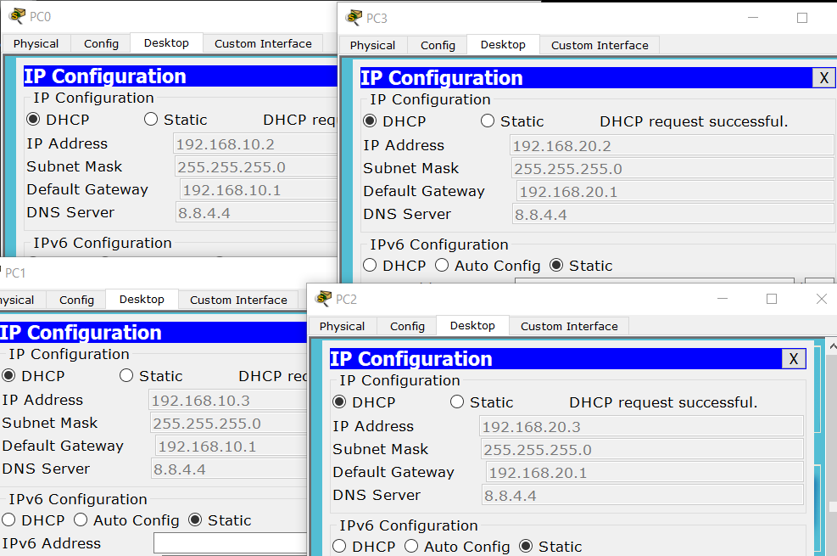

* Finally, we ping from each computer, to see if our setup is complete.

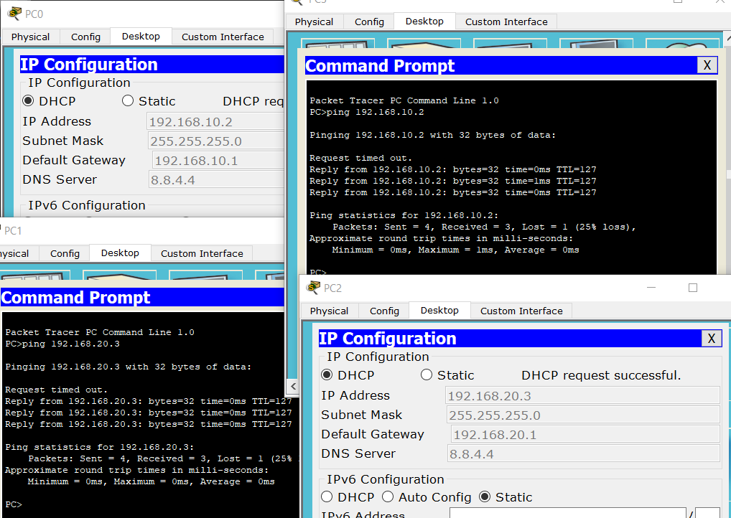

**Conclusion:**

* Hence, we configured Router on a stick and confirmed the connection.