**Lab Program Number:**

**Date:**

**2078/**



**Objective:**

**To setup Ubuntu in virtual machine(Oracle VM Virtual Box).**

**Theory**:

* In computing, a virtual machine (VM) is the virtualization/emulation of a computer system. Virtual machines are based on computer architectures and provide functionality of a physical computer. Their implementations may involve specialized hardware, software, or a combination.

**Procedure:**

* Install the Oracle VM Virtual box with iso file from official linux providers like kali.org.
* Open oracle VM and click on new option to setup the preferred OS.

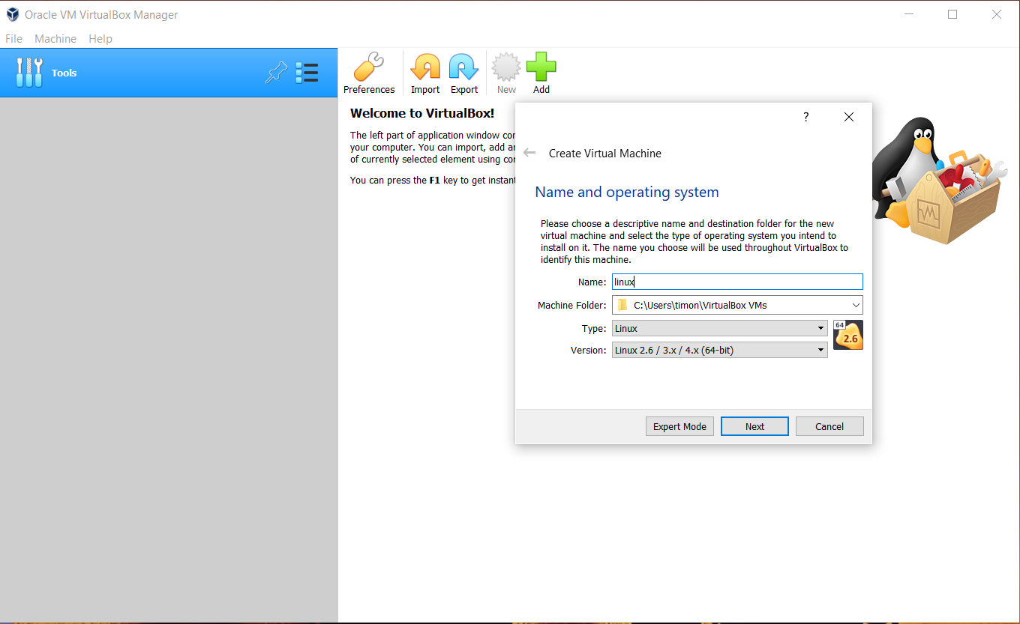

Keep continuing with the default option

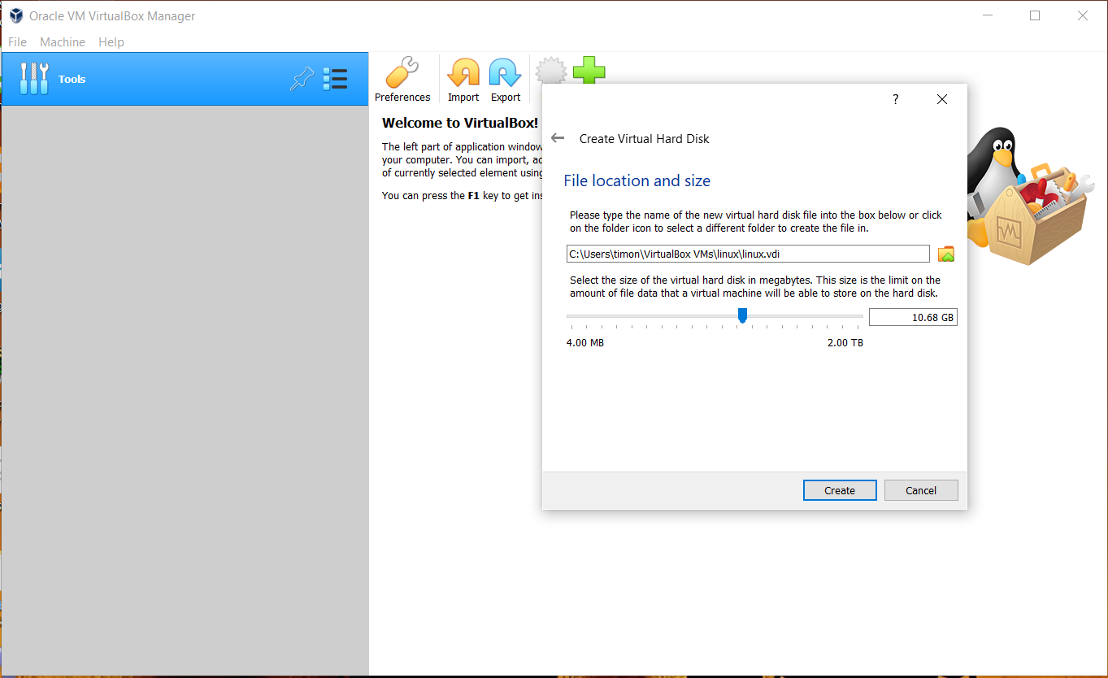

* This creates image in the set disk which can be reused in the future
* Now the option for linux appears in the screes select it and press start

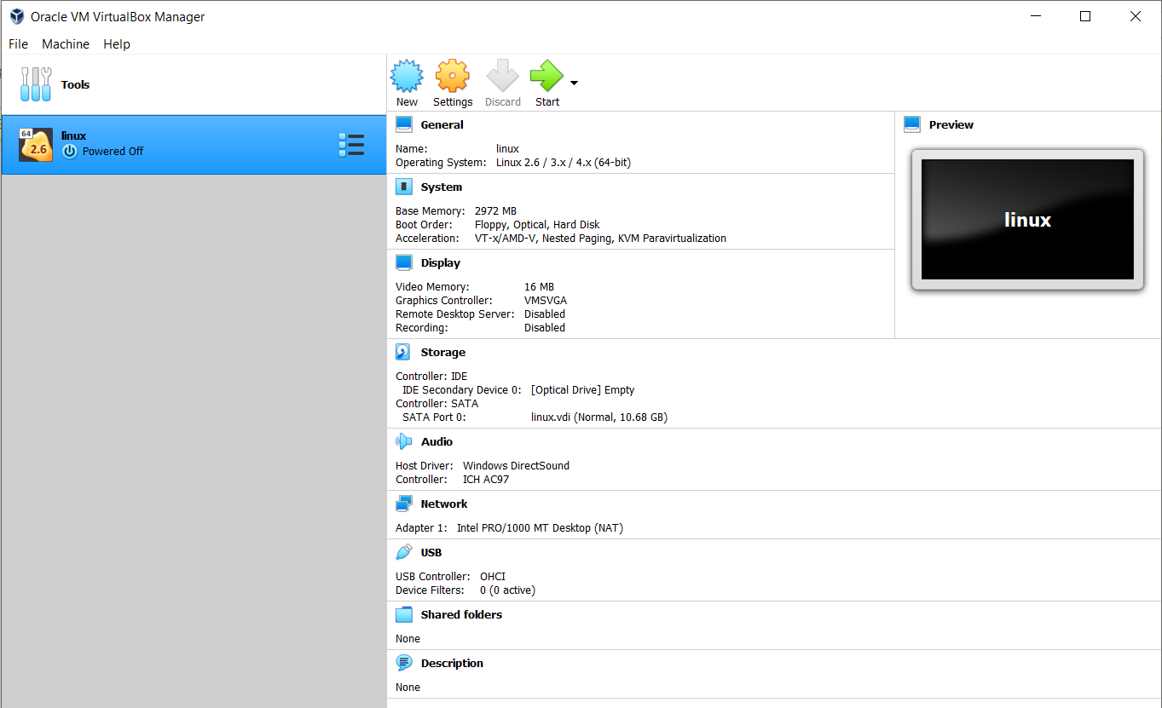

* Now select the iso file. Here I have already set the location in case it is not set click the folder icon

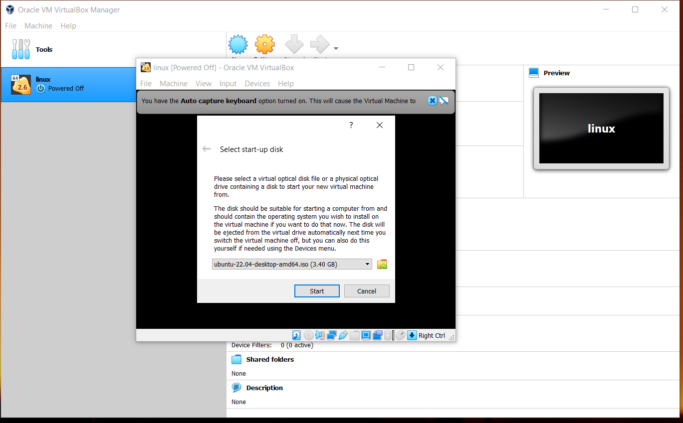

* click add and locate the iso file to install, and click choose and start.
* Now wait for ubuntu to load

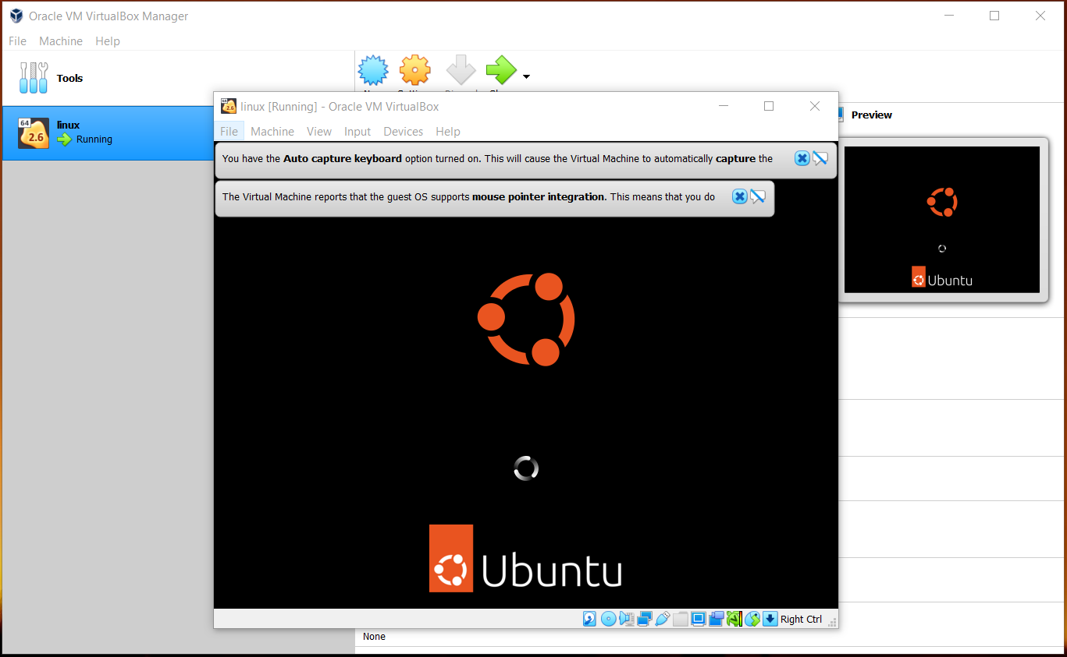

* After a while the install ubuntu option appears select install ubuntu

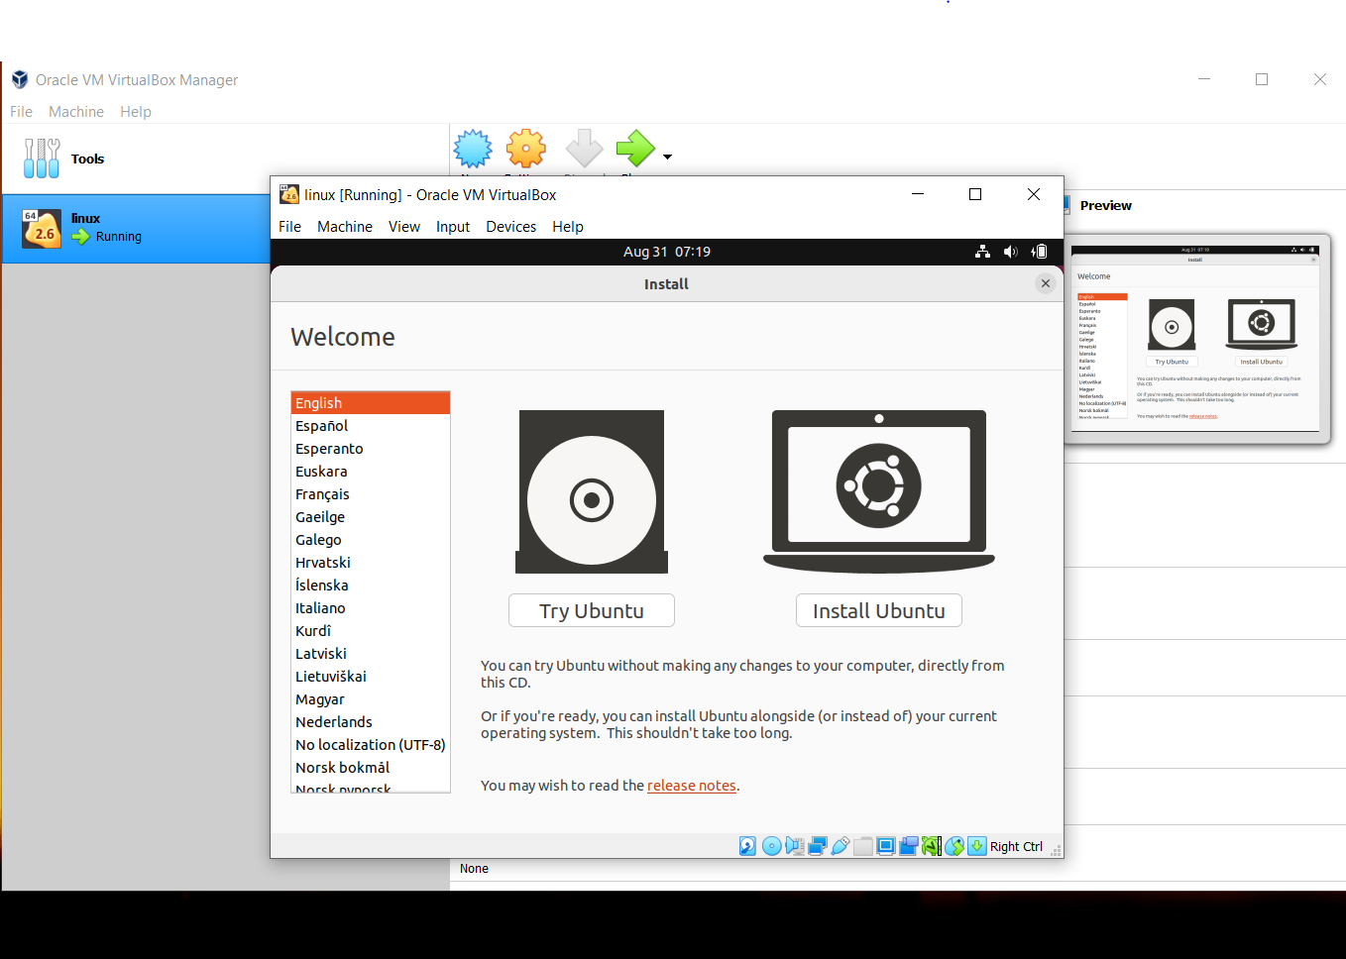

* Now select language of your preference
* Select timezone

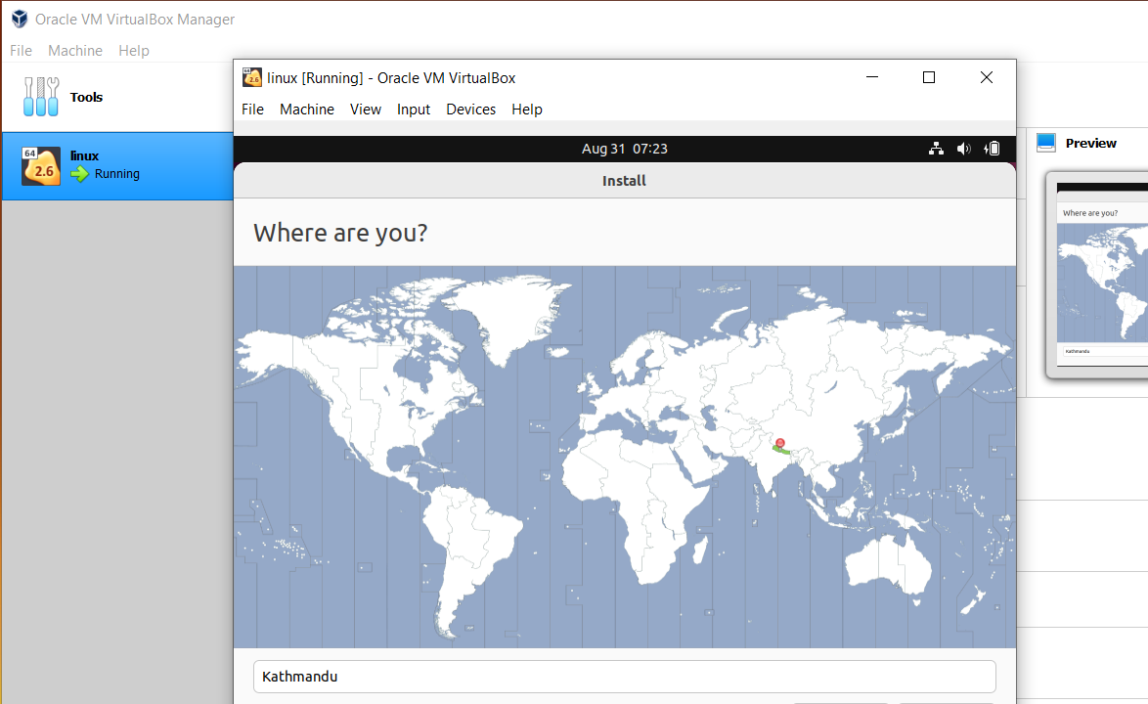

* Now continue with the default setup settings
* In case you don’t want to delete the data in your pc create partitions,

Here we use VM so the delete all and install is selected.

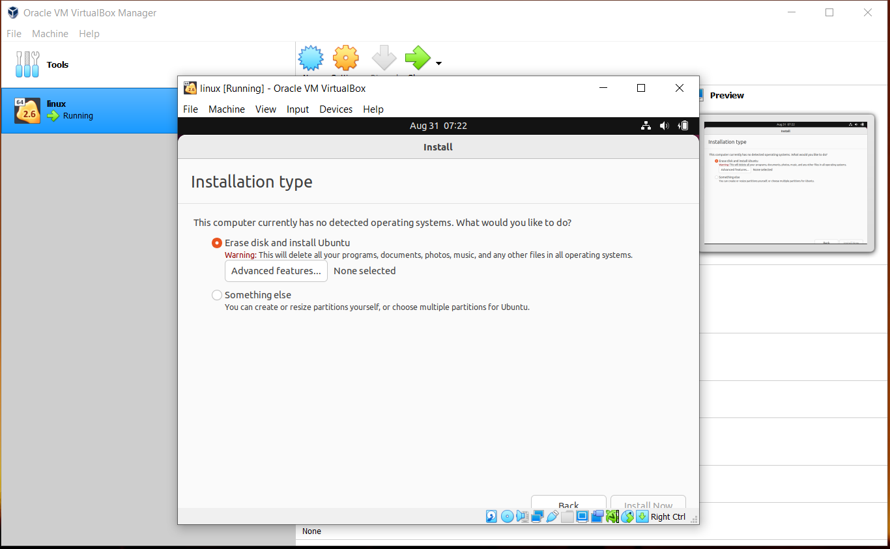

* Here set the name of your pc and password with your preference of login
* After this ubuntu downloads and installs the necessary drivers and settings and installs it so wait for it to load as it might take some time.After this press restart.
* After restart the linux ubuntu edition is installed in your pc and you can start using it.

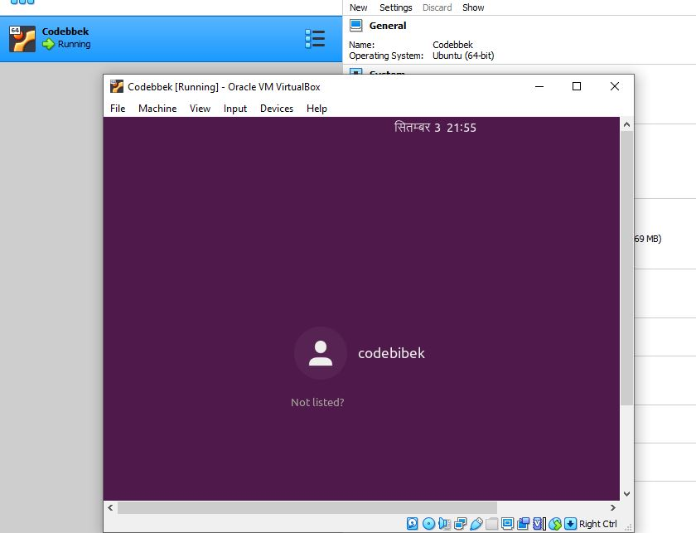

**Conclusion:**

Hence, we installed Ubuntu in virtual machine.