**Lab Program Number:**

4

**Date:**

**2078/**



**Objective:**

• **To configure and understand about VLAN using CISCO packet tracer.**

**Theory:**

VLANs allow network administrators to automatically limit access to a specified group of users by dividing workstations into different isolated LAN segments. When users move their workstations, administrators don't need to reconfigure the network or change VLAN groups.

**Procedure:**

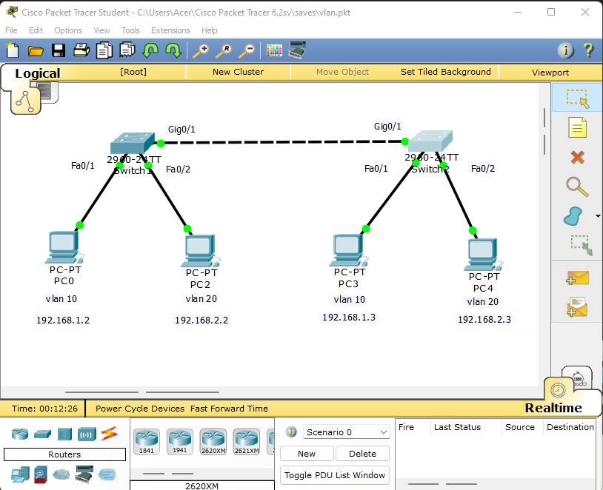

**Bibek Parajuli**