**Lab assignment 4:** **View related**

Consider the following relational schema for a banking database application.

Customer (Cid, Cname)

Branch (Bcode, Bname)

Account (Ano, Atype, Balance, Cid, Bcode)

Transaction (Tid, Ano, Tttype, Tdate, Tamount)

1. Create table and set required constraint on the above four tables.
2. Insert any 10 records in each of the above tables.
3. Create view named ‘customer_balance’ with customer name and total their balance.

CREATE VIEW customer_balance

AS

SELECT c.Cname, a.Balance

FROM Customer AS c INNER JOIN Account AS a

ON c.Cid=a.Cid;

1. Display all records of customer_balance view.
2. Insert new record to customer table and show their impact to customer_balance view by displaying view records.
3. Update any customer to customer table and show their impact to customer_balance view by displaying view records.
4. Update name of customer of id 5 to ‘Bibek’ in customer_balance view and show their impact to customer table by displaying customer tables’ record.
5. Create table and set required constraint on the above four tables.

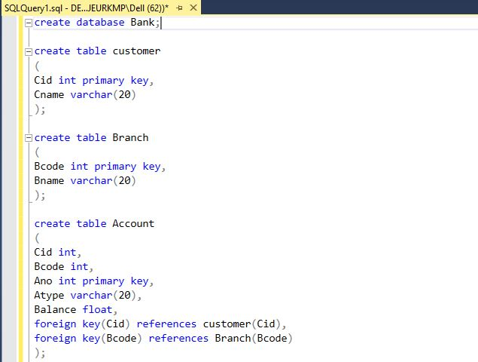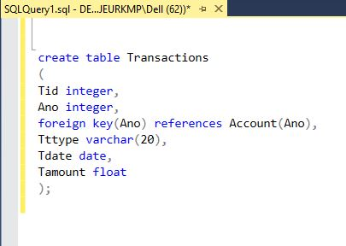

1. Insert any 10 records in each of the above tables.

Customer table:

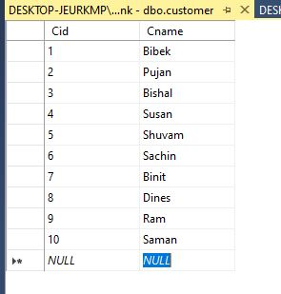

Branch table:

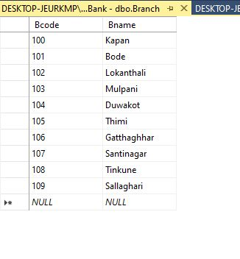

Account table:

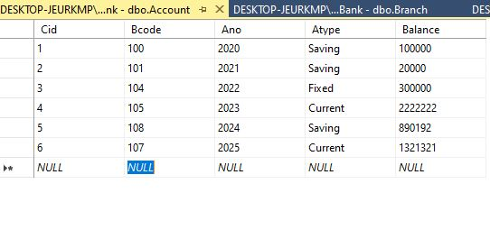

Transactions table:

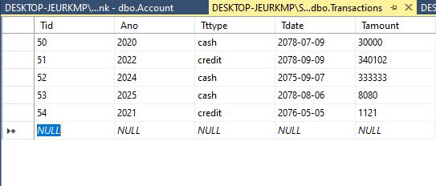

1. Create view named ‘customer_balance’ with customer name and total their balance.

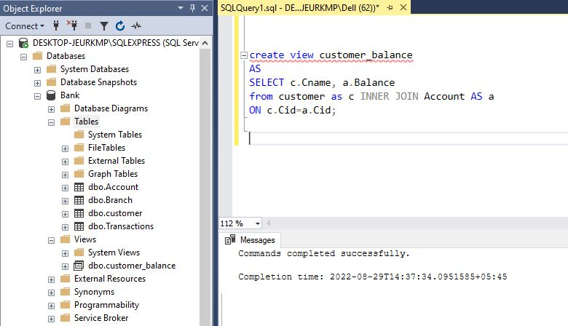

1. Display all records of customer_balance view.

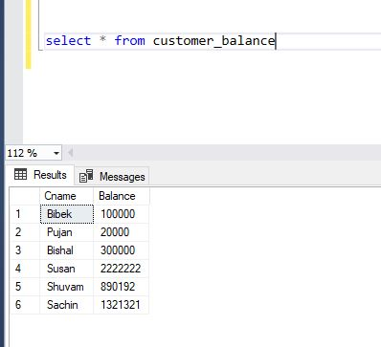

1. Insert new record to customer table and show their impact to customer_balance view by displaying view records.

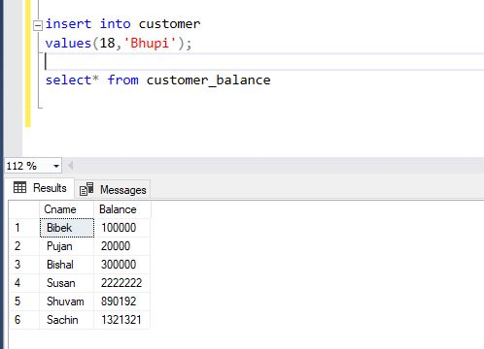

1. Update any customer to customer table and show their impact to customer_balance view by displaying view records.

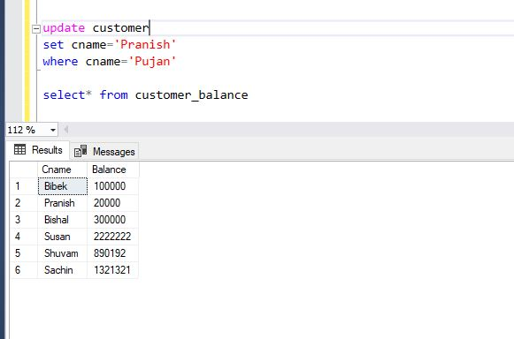

1. Update name of customer of id 5 to ‘Bibek’ in customer_balance view and show their impact to customer table by displaying customer tables’ record.

