**Lab Assignment No 1: Using Single table**

* Open database

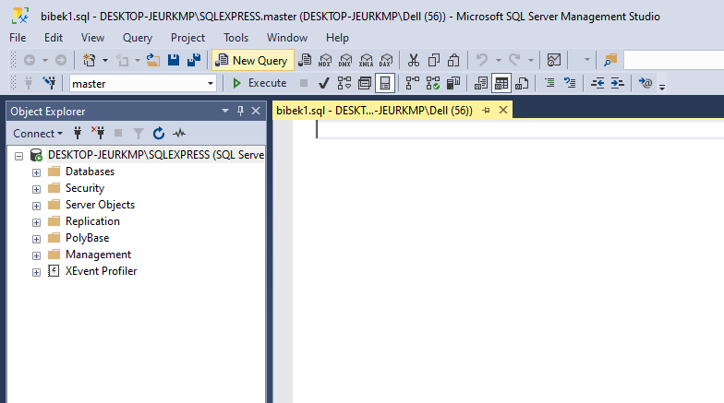

* List all available databases

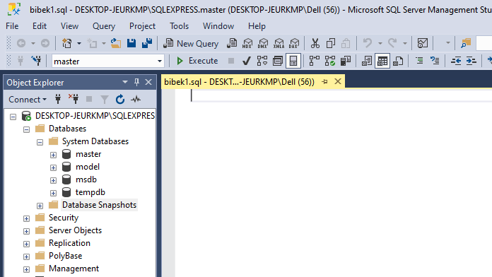

* Create your own database

Create database Test;

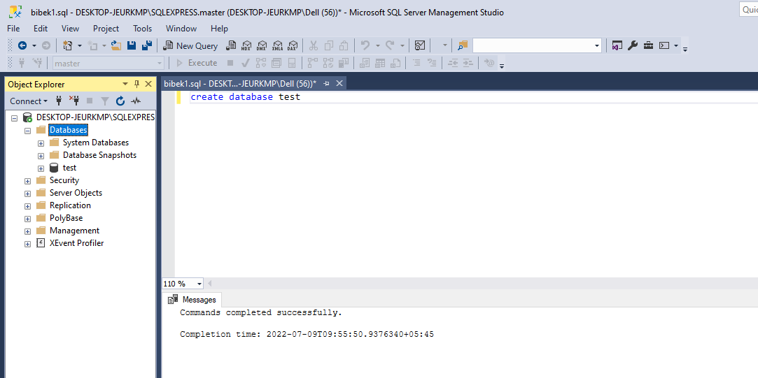

* Connect to your database

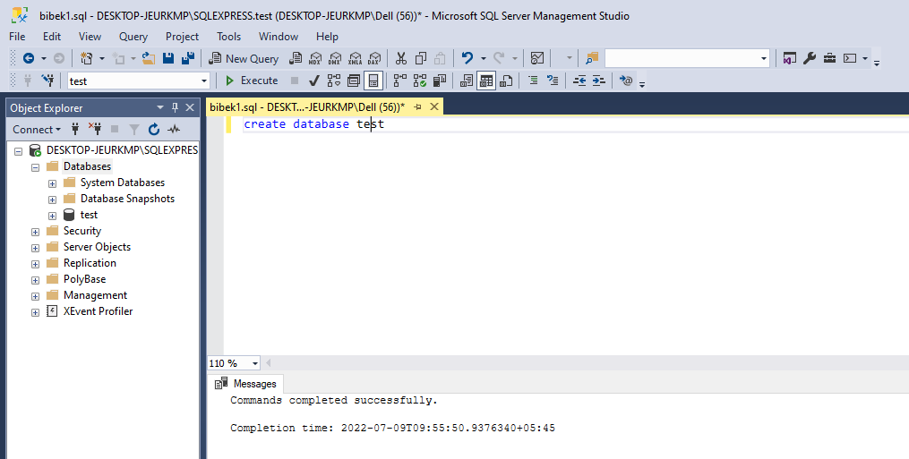

* Creating a table **STUDENT** with following information:
* Name of table: **STUDENT**
* Columns and data types:
* rollno integer
* name varchar(20)
* address varchar(20)

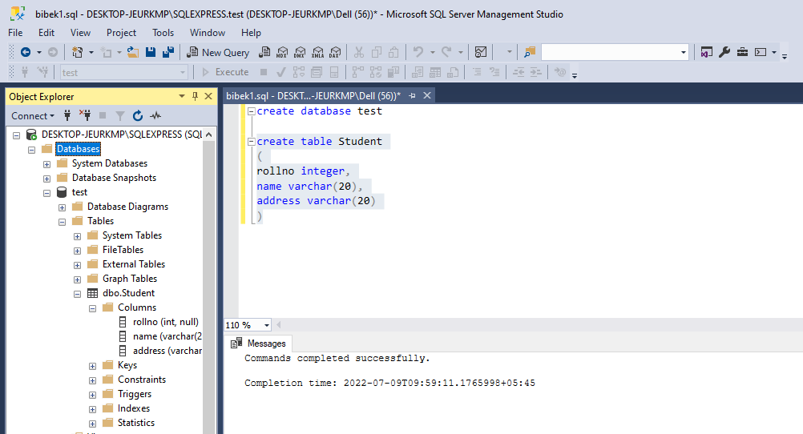

1. **Inserting any 5 records to the student table**

**{(1,”Anil”,”KTM”), (2,”Madhu”,”lalitpur”), (3,”Thamir”,”Palpa”), (3,”Ram”,”KTM”), (5,”Prakash”,”Banepa”),**

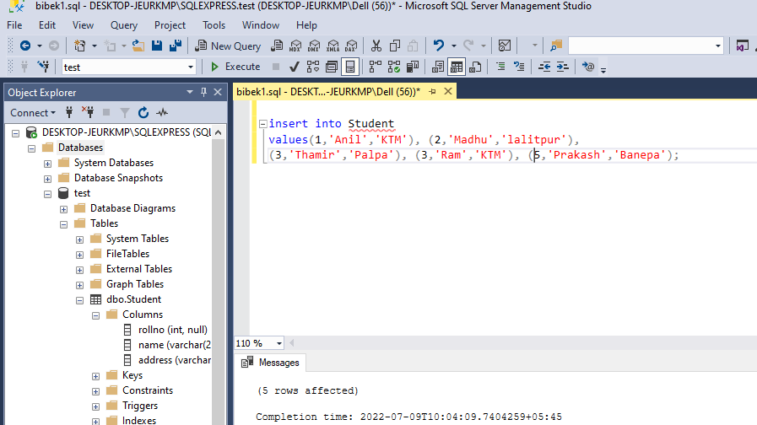

1. **Display all records of student relation.**

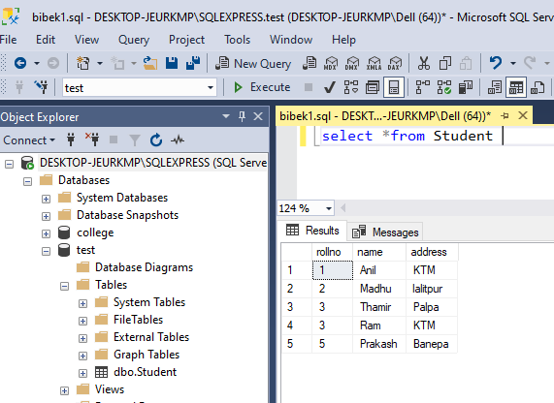

1. **Display only rollno and name of students.**

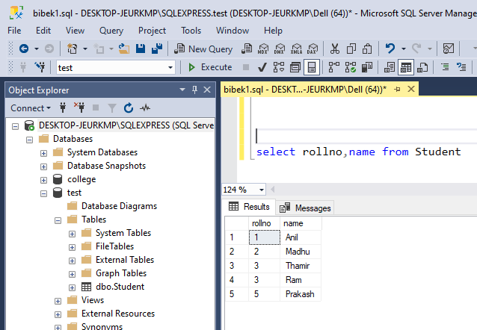

1. **Display only those students whose address is “KTM”.**

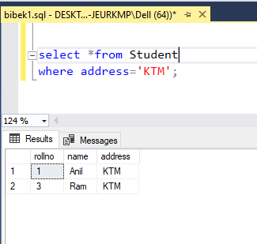

1. **Modify address of those students whose rollno 3 to “Kanchanpur”.**

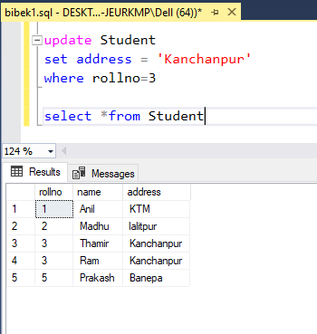

1. **Altering table by adding new column class varchar (20).**

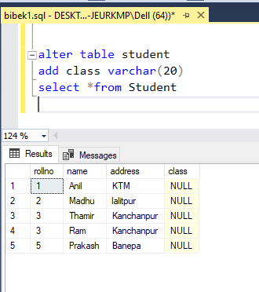

1. **Deleting a row from the table.**

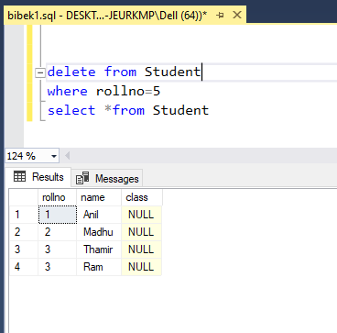

1. **Drop column address.**

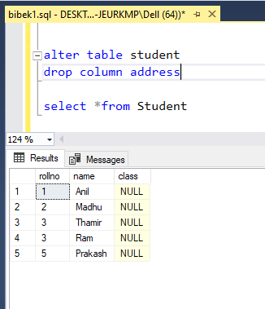

1. **Delete those students whose rollno greater than 2.**

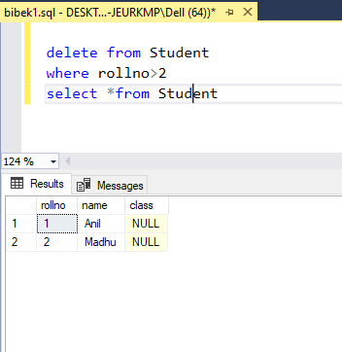

1. **Alter table by changing the data type of name to varchar(15).**

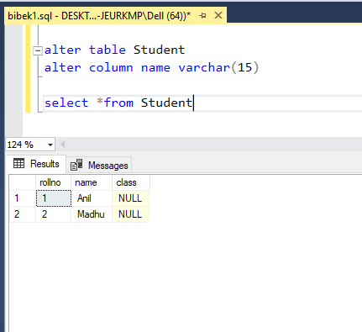

1. **Delete all the data from student table.**

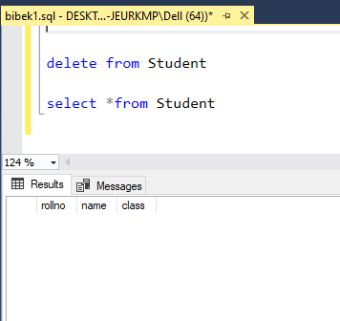

1. **Delete (DROP) the table.**

