

**Lab:-3**  **Date:**

**To configure and understand about RIP protocol using cisco packet tracer.**

**Theory:**

* Routing Information Protocol (RIP) is a protocol that routers can use to exchange network topology information. It is characterized as an interior gateway protocol, and is typically used in small to medium-sized networks.

**Procedure:**

* First we setup a topology to setup RIP protocol as:

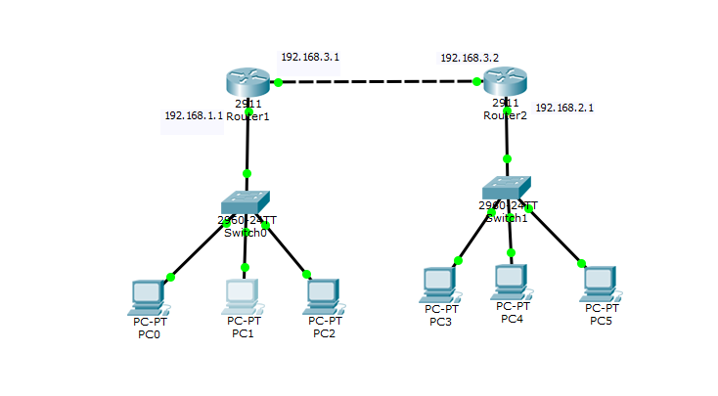

Configuring the routers as below:

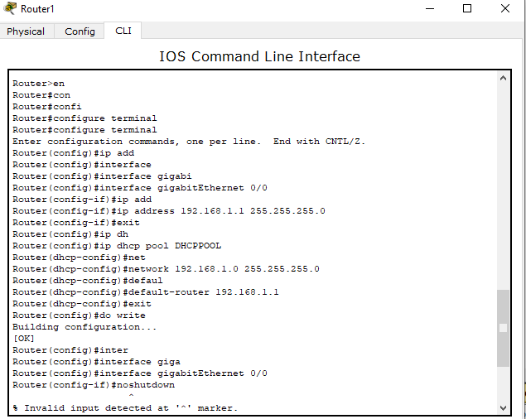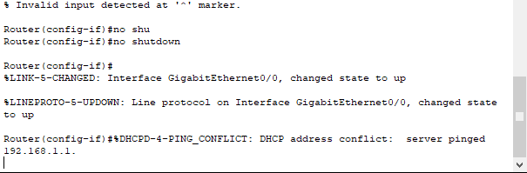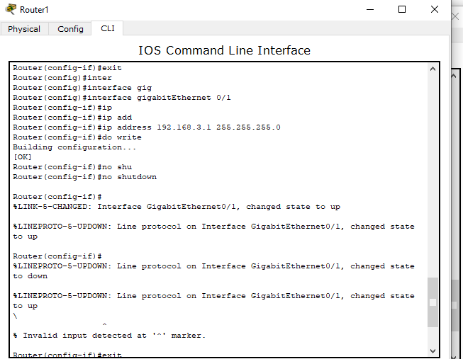

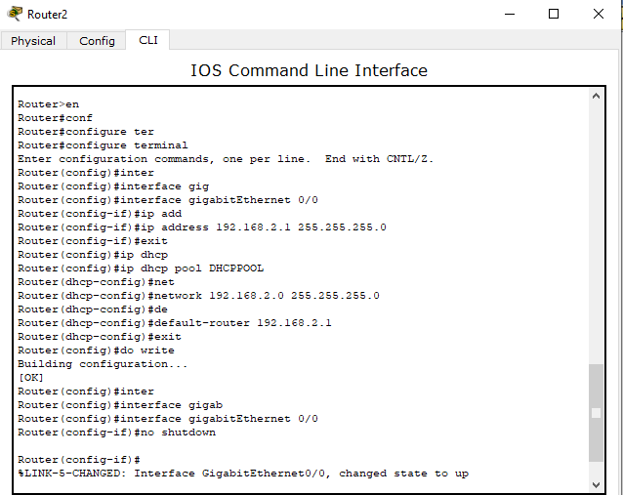

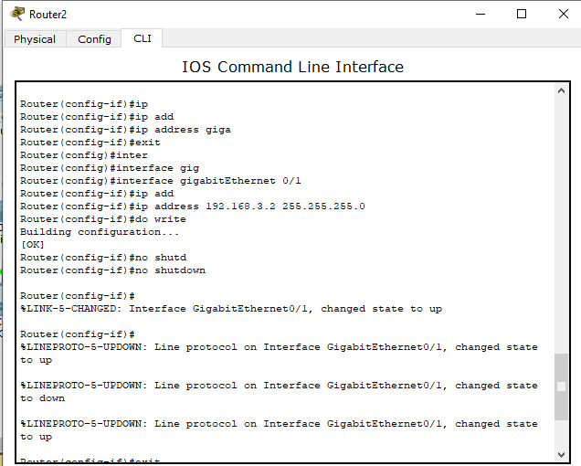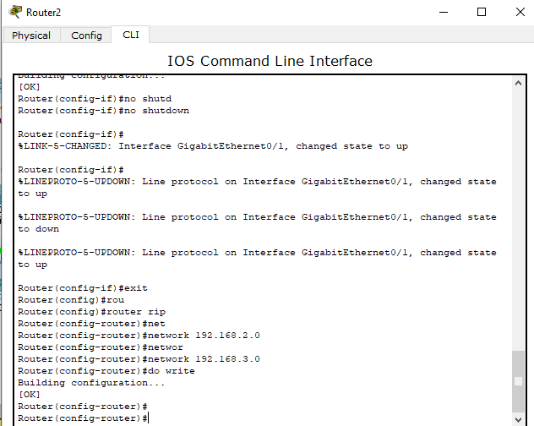

**Output:**

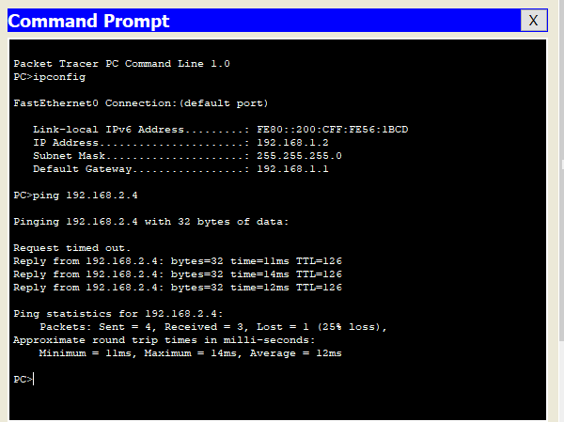

Conclusion:

Hence, we configured RIP protocol in router and confirmed the connection.