**Lab**:-9 Date: 2078/03/3

Objective:

* To setup OSPF in CISCO packet tracer.

Theory:

* The OSPF (Open Shortest Path First) protocol is one of a family of IP Routing protocols, and is an Interior Gateway Protocol (IGP) for the Internet, used to distribute IP routing information throughout a single Autonomous System (AS) in an IP network.
* The OSPF protocol is a link-state routing protocol, which means that the routers exchange topology information with their nearest neighbors. The topology information is flooded throughout the AS, so that every router within the AS has a complete picture of the topology of the AS. This picture is then used to calculate end-to-end paths through the AS, normally using a variant of the Dijkstra algorithm

. 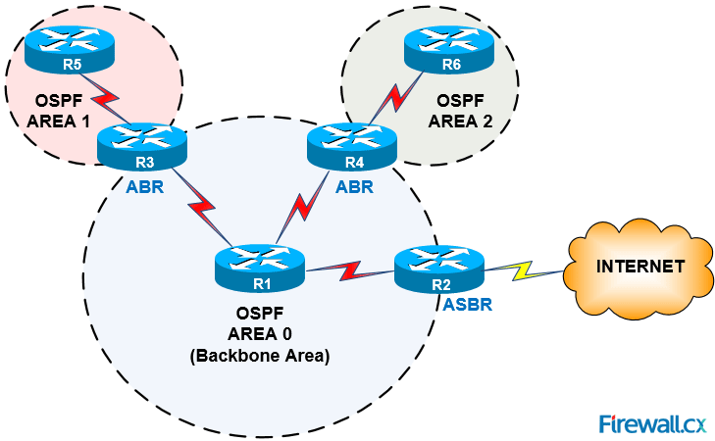

Procedure:

* First we setup a network. 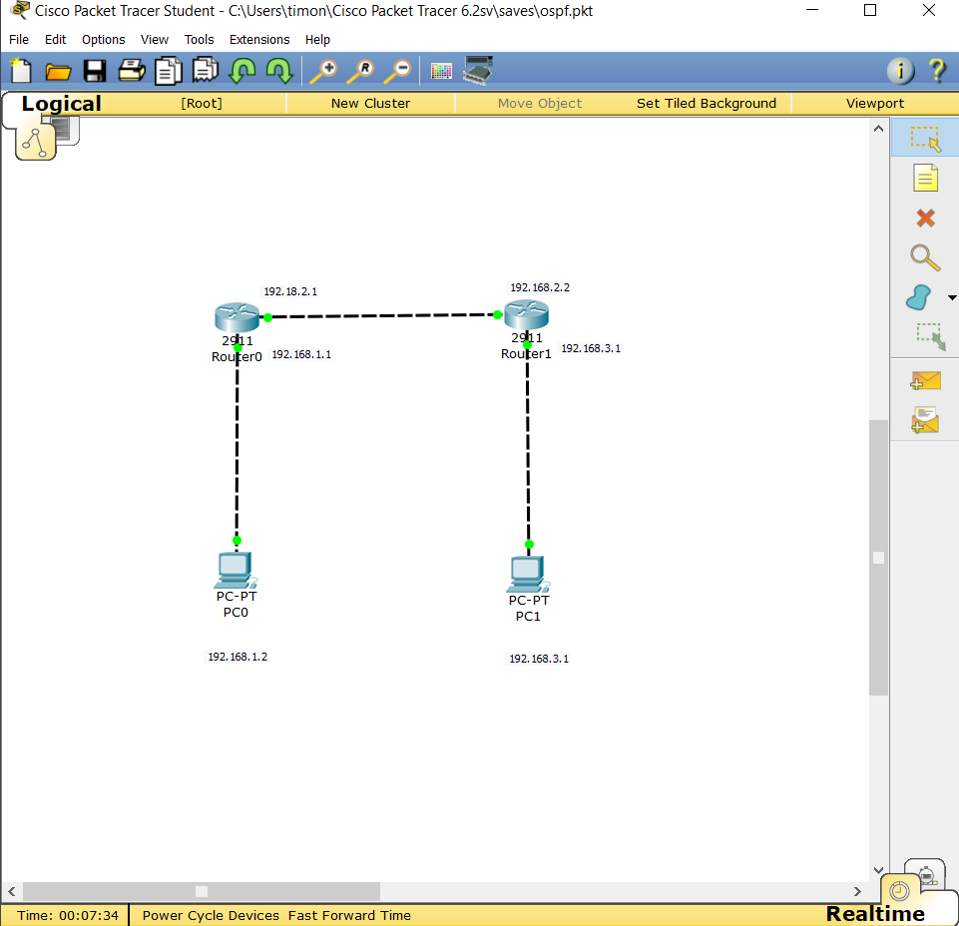
* After this we configure the routers with gateways.

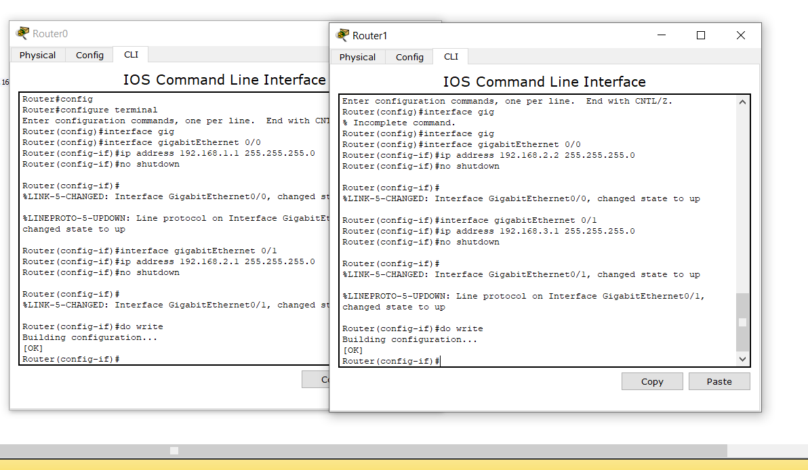

* After setting up the router gateways we set up the OSPF in the routers as.

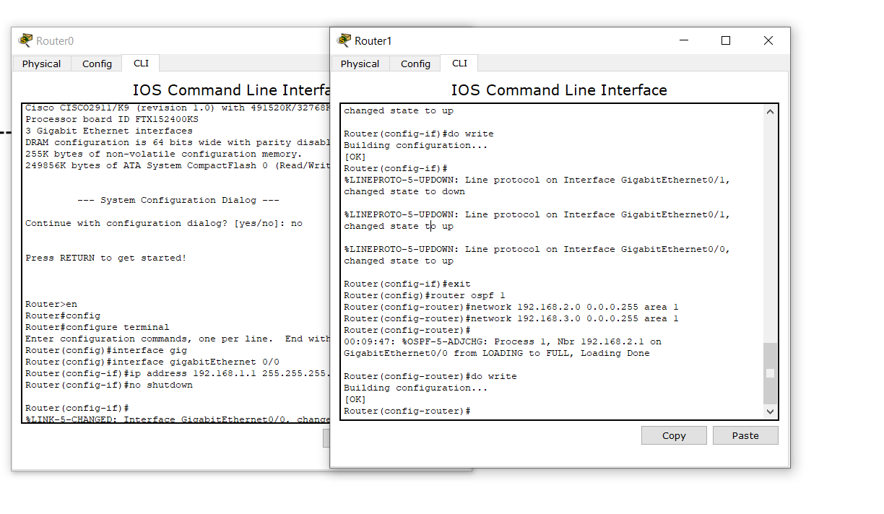

* After the OSPF being setup we provide the pc’s with IP address in this case I used static IP addressing as there are only 2 pc’s in network.

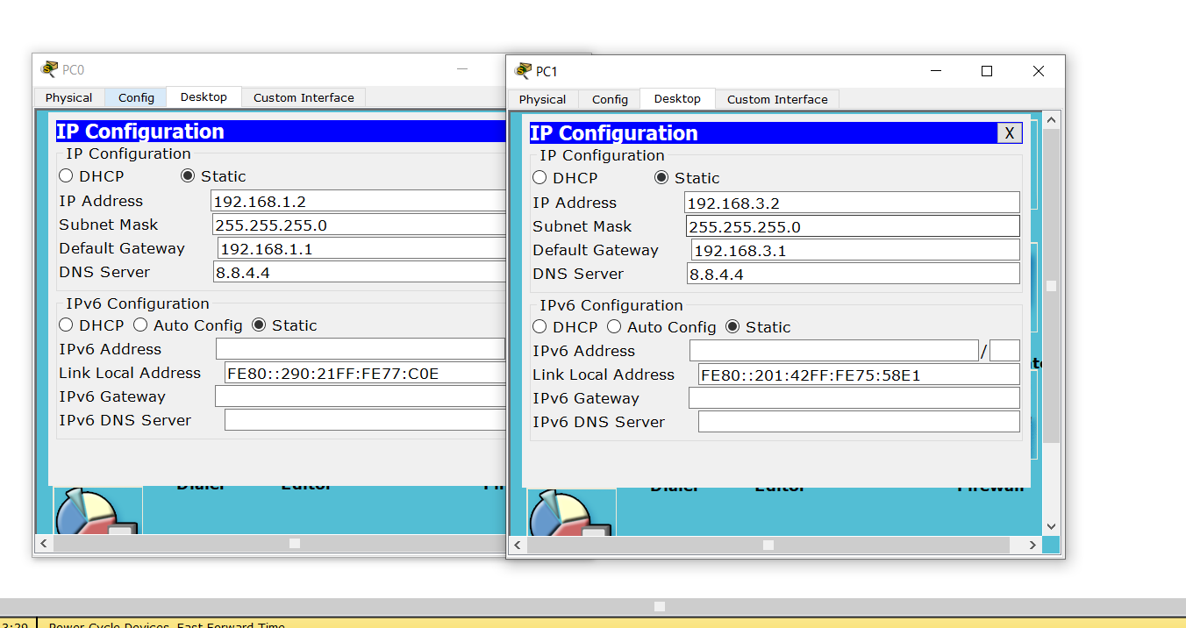

* After the setup is complete we ping the pc’s to each other to verify the network.

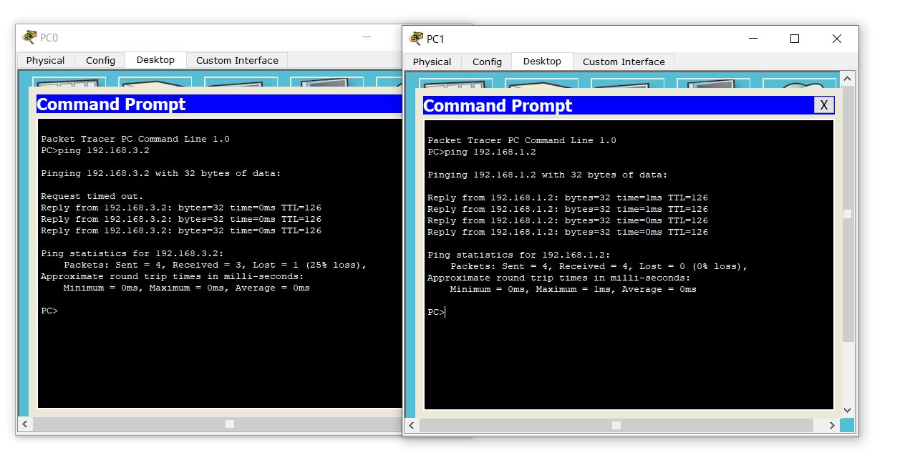

Conclusion:

* Hence, we were able to configure OSPF using CISCO packet tracer.