**Lab**:-2 Date: 2078/12/14

Objective:

* To configure DHCP and provide dynamic IP to the nodes in network using cisco packet tracer.

Theory:

* Dynamic Host Configuration Protocol (DHCP) is a client/server protocol, that automatically provides IP address and other related configuration information, such as the subnet mask and default gateway to the nodes in the network.

Procedure:

* First we set up a topology using a router, switch and PC’s as shown

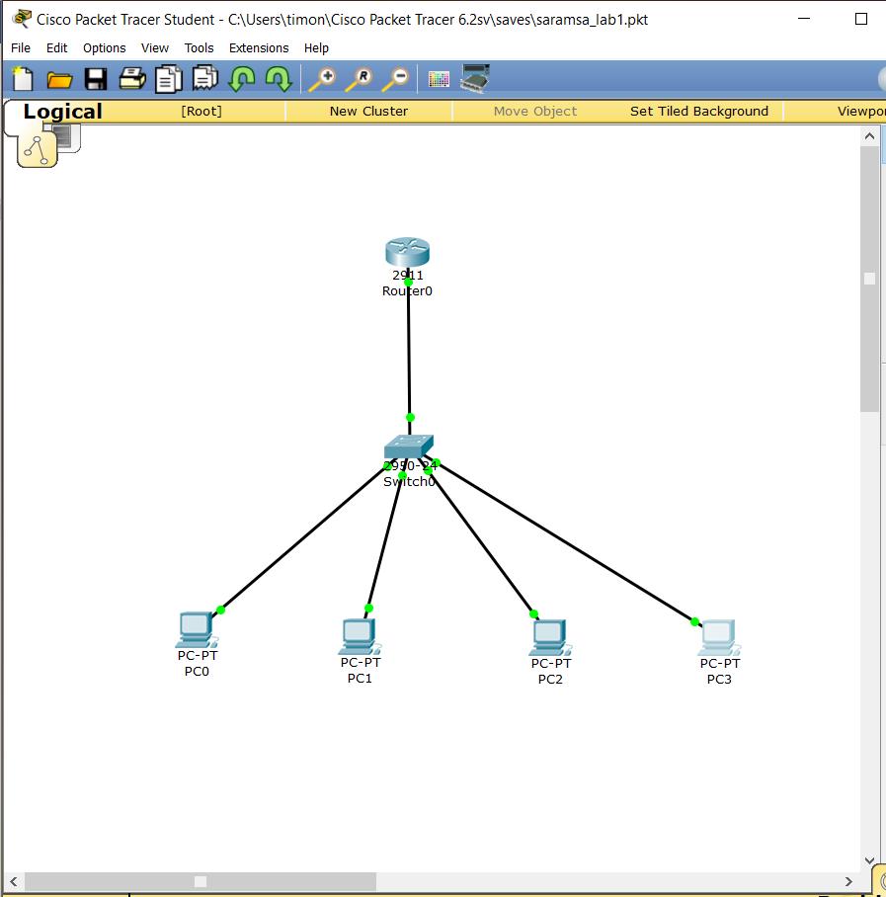

* Then we write the necessary configuration settings in the router:
* Where, the Default-router shows the gateway through which the router communicates to the switch to distribute IP addresses
* Network shows the range of ip being distributed in the network
* Ip dhcp excluded-address shows the address that will not be distributed by dhcp dynamically
* And, DNS-Server gives id of the Domain Name Server in use.

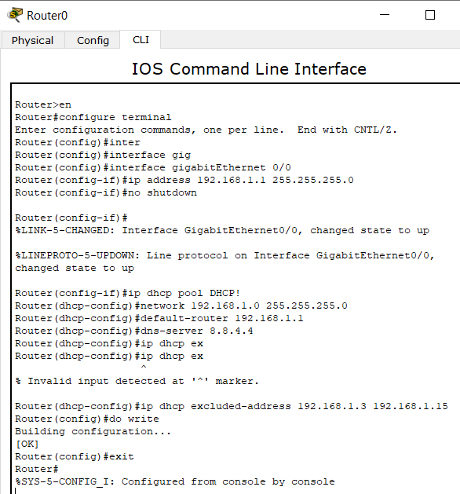

* After setting up the configuration we setup ip in the computer settings as:

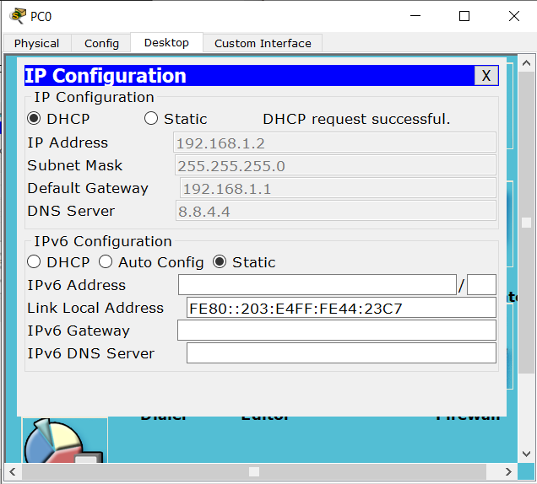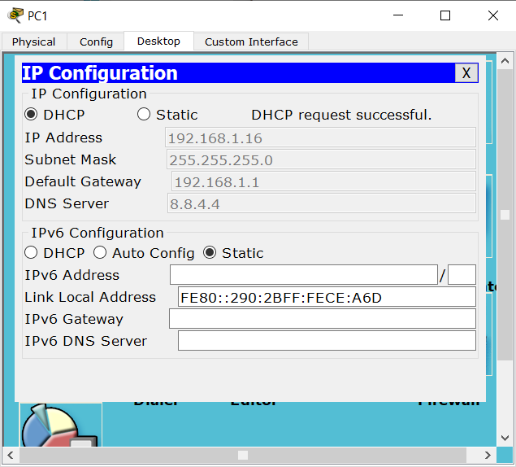

* Finally, we ping the nodes in the network to confirm that DHCP is setup properly.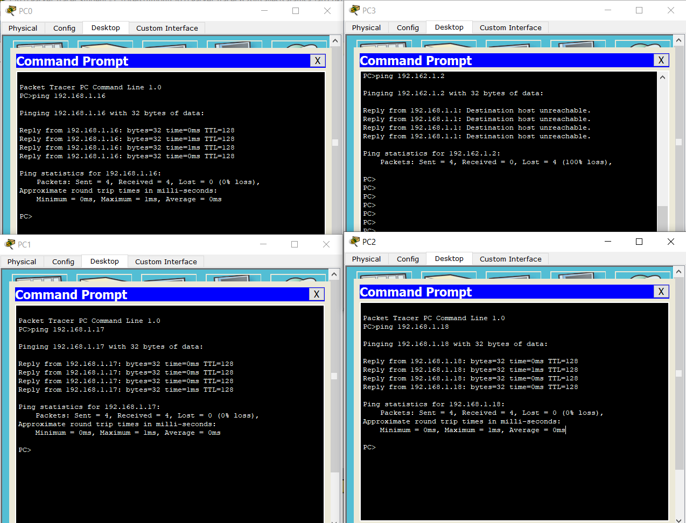

Conclusion:

* Hence, we configured DHCP in router and distributed dynamic IP address.