**Lab**:-3 Date: 2078/12/23

Objective:

* To configure and understand about RIP protocol using cisco packet tracer

Theory:

* Routing Information Protocol (RIP) is a protocol that routers can use to exchange network topology information. It is characterized as an interior gateway protocol, and is typically used in small to medium-sized networks.

Procedure:

* First we setup a topology to setup RIP protocol as:

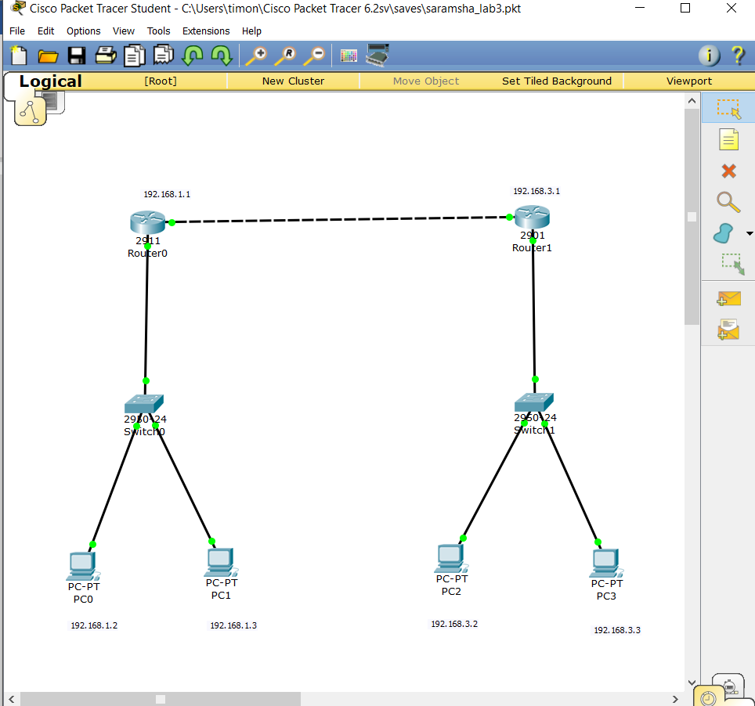

* Then, we set up the DHCP of both the routers in the network as:

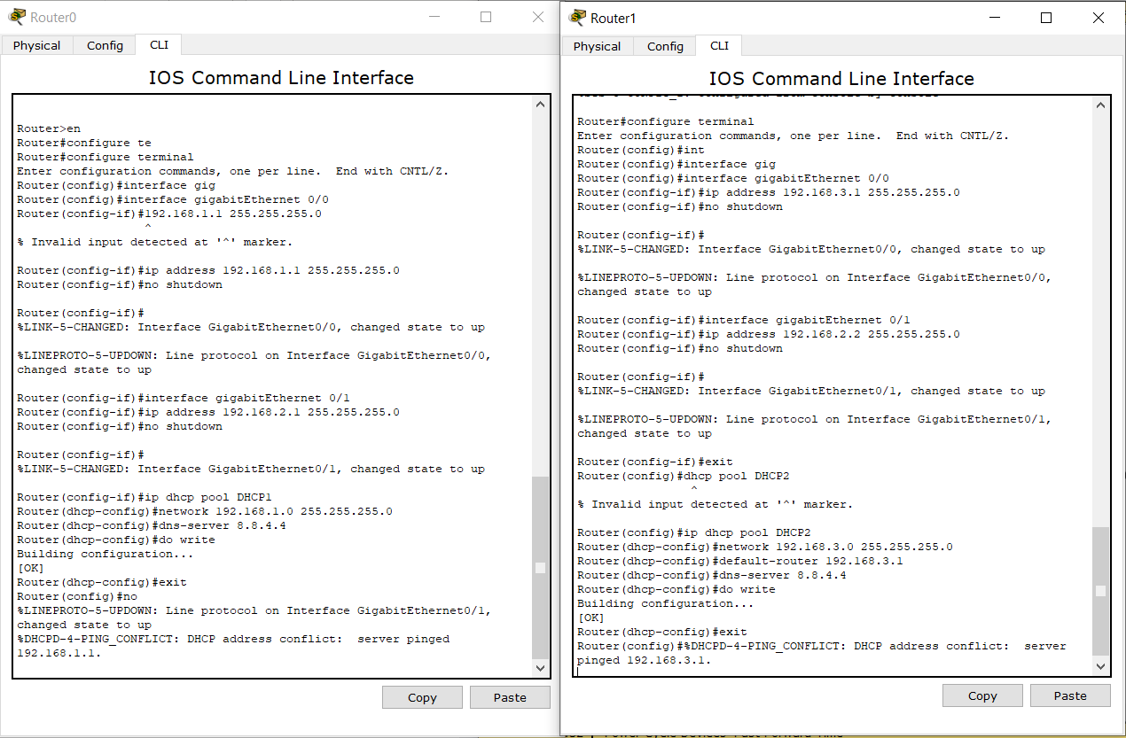

* After setting up DHCP we configure the router rip protocol as:

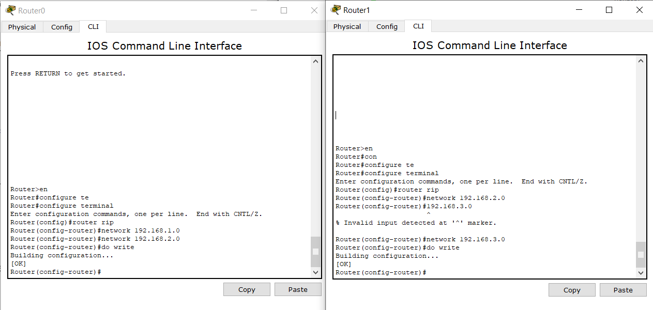

* Then to confirm the setup we ping the computers in the network as:

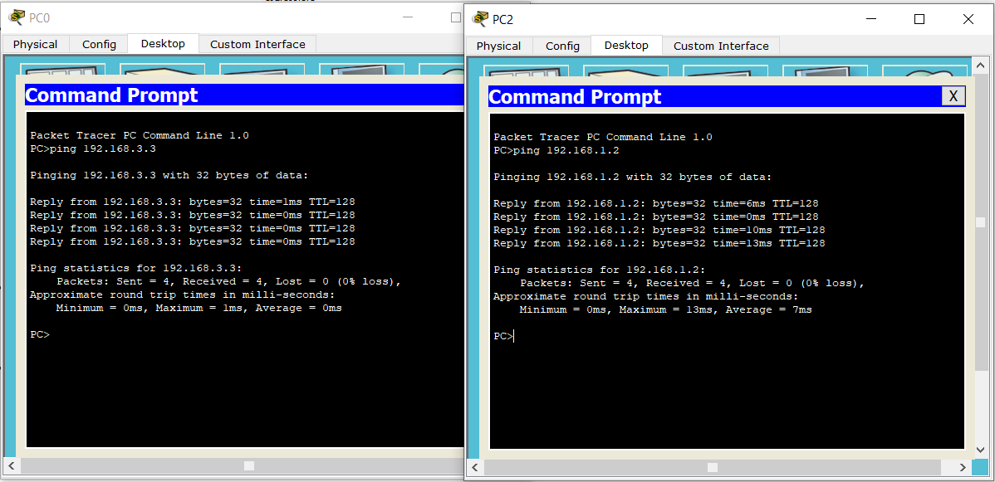

Conclusion:

* Hence, we configured RIP protocol in router and confirmed the connection.