**Lab**:-4 Date: 2078/12/24

Objective:

To configure and understand about VLAN using cisco packet tracer

Theory:

VLANs allow network administrators to automatically limit access to a specified group of users by dividing workstations into different isolated LAN segments. When users move their workstations, administrators don't need to reconfigure the network or change VLAN groups.

Procedure:

First, we create a topology, as:

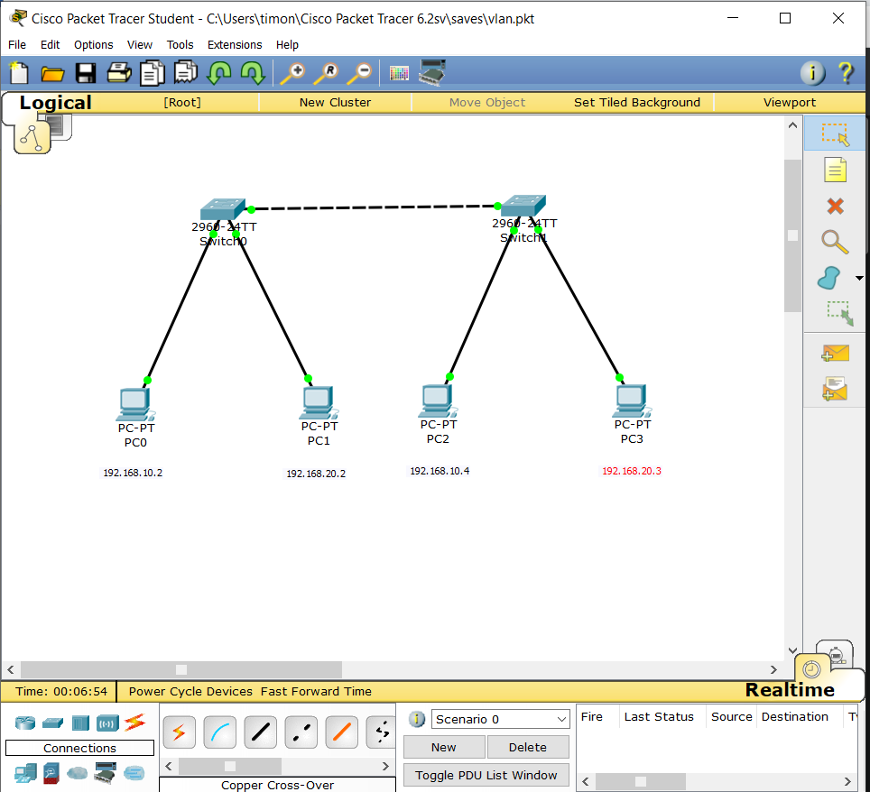

Then, we set up the configuration settings as:

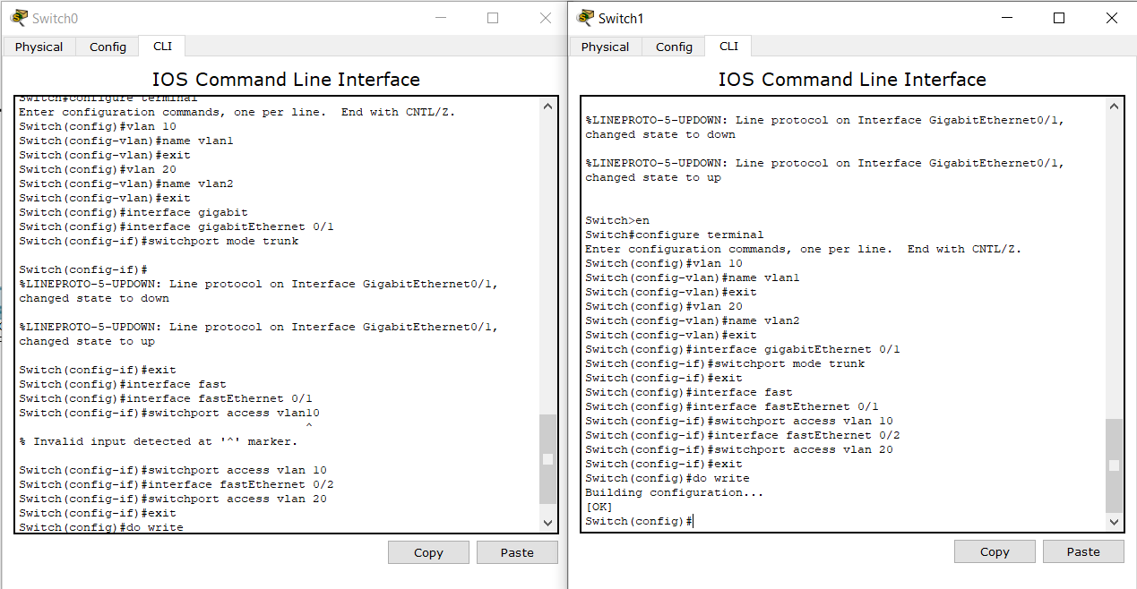

Finally, we confirm the network by pinging computers in same and different vlan network.

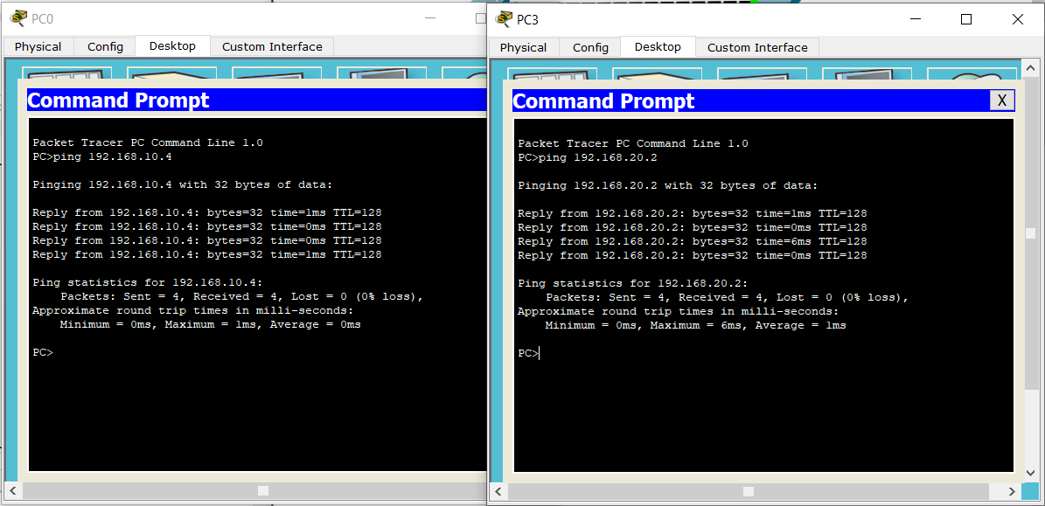

Conclusion:

Hence, we configured VLAN and confirmed the connection.