**Lab**:-5 Date: 2078/01/16

Objective:

* To configure and understand about Router on a stick using cisco packet tracer

Theory:

* ROUTER-ON-A-STICK, also known as a “one-armed router” is a method for running multiple VLANs over a single connection in order to provide inter-VLAN routing. Essentially the router connects to a core switch with a single interface and acts as the relay point between networks.

Procedure:

* First, we configure a topology for our ROUTER-ON-A-STICK,  as shown below:

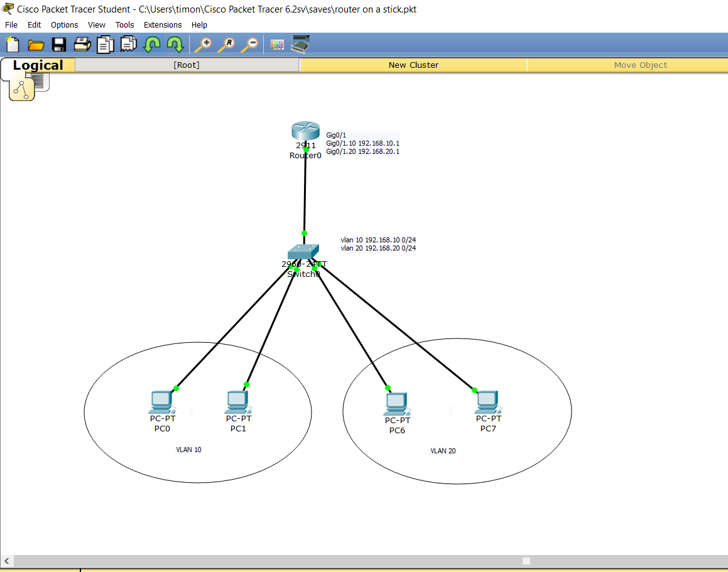

* Then , we setup a VLAN network, consisting of two networks 10 and 20

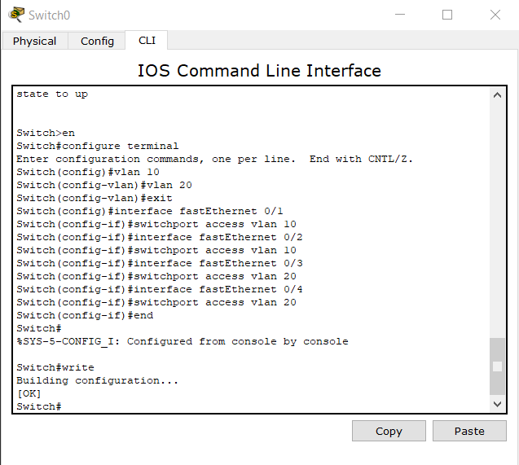

* After setting up vlan, we setup a trunk for our vlan traffic as:

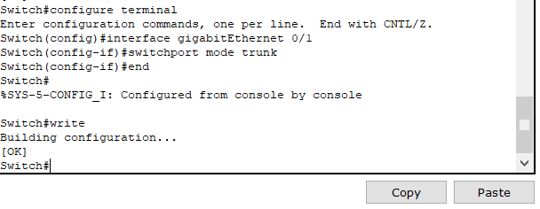

* After the trunk, we set up the router

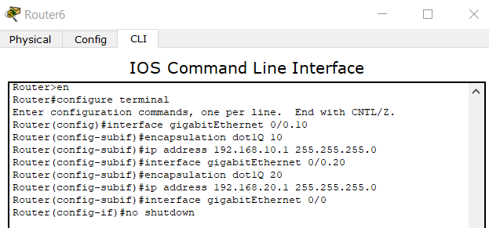

* We can then, give static IP to all the computers in network or, give IP from dhcp pool as used in this lab.

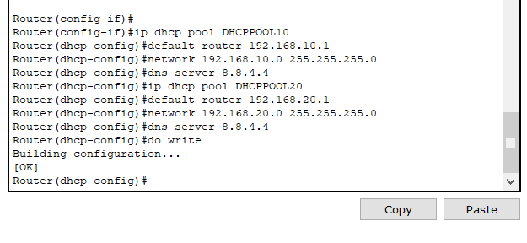

* Then we configure each computer for dhcp, as follows:

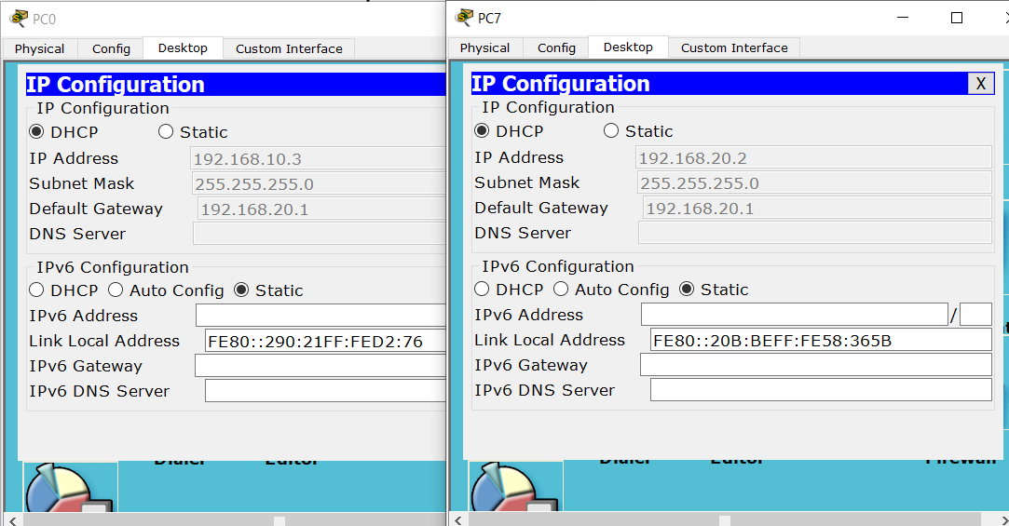

* Finally, we ping from each computer, to see if our setup is complete.

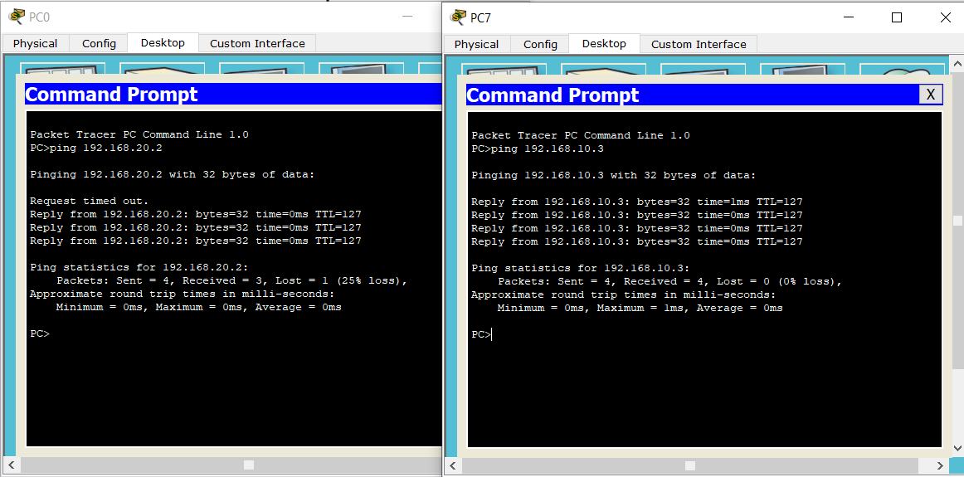

Conclusion:

* Hence, we configured Router on a stick and confirmed the connection.