**Lab**:-10 Date: 2078/03/17

Objective:

* To configure and understand about static routing using cisco packet tracer.

Theory:

* Static routing is a form of routing that occurs when a router uses a manually-configured routing entry, rather than information from dynamic routing traffic. In many cases, static routes are manually configured by a network administrator by adding in entries into a routing table, though this may not always be the case. Unlike dynamic routing, static routes are fixed and do not change if the network is changed or reconfigured.

Procedure:

* First, we configure a topology for our static routing,  as shown below:

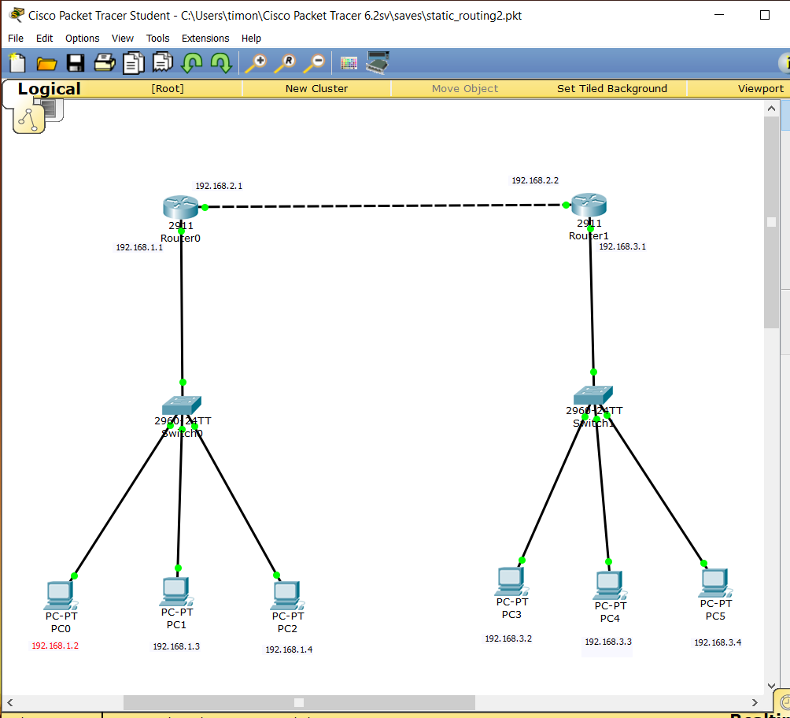

* Then, we setup the gigabit Ethernet ports in router as:

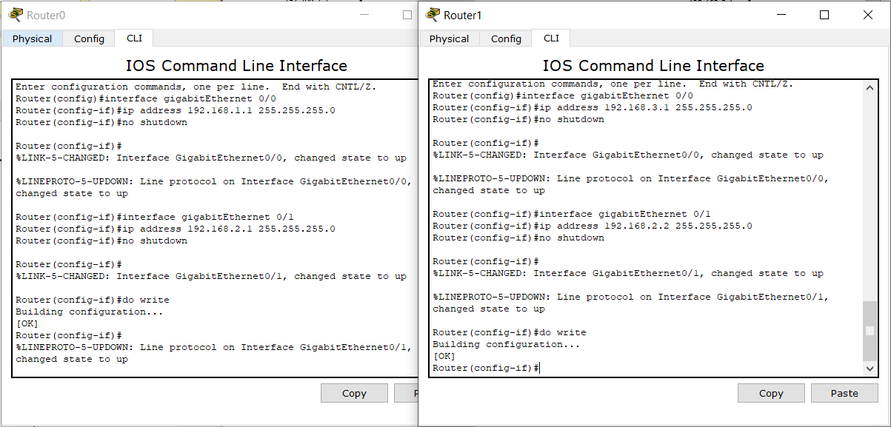

* After this, we setup the routing path as shown below:



* Now, we can either provide ip using dhcp or manually

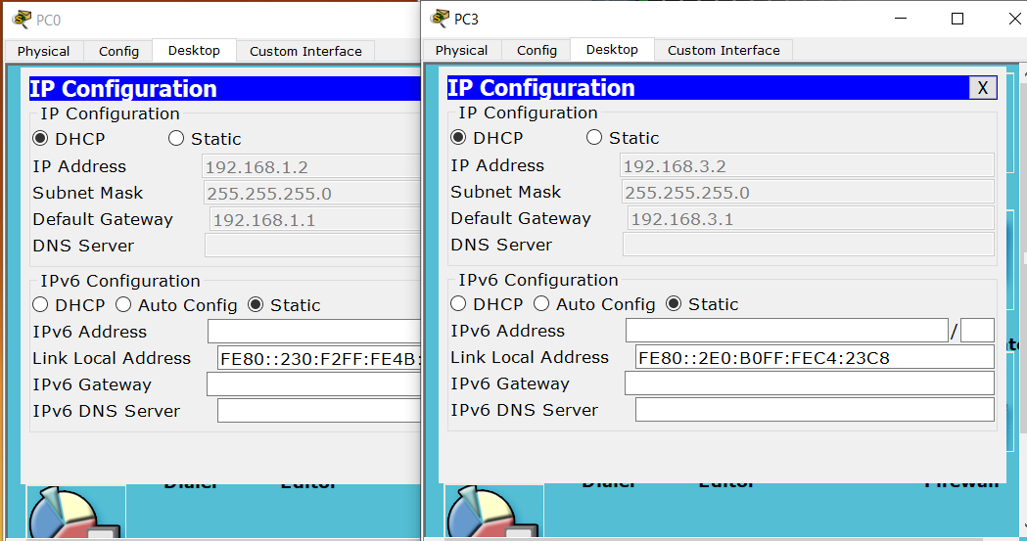

* Finally, we ping each pc in the network to confirm the network as below:

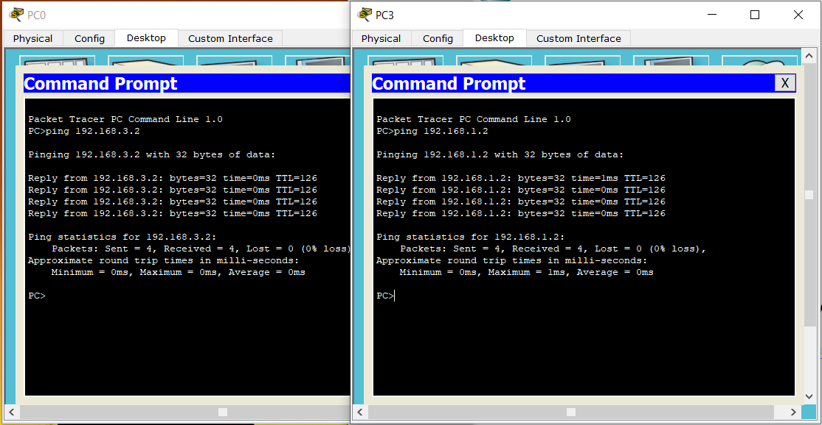

Conclusion:

* Hence, we configured static routing and confirmed the connection.