**Lab**:-6 Date: 2078/01/16

Objective:

* To setup ubuntu linux in virtual machine(Oracle VM Virtual Box)

Theory:

* In computing, a virtual machine (VM) is the virtualization/emulation of a computer system. Virtual machines are based on computer architectures and provide functionality of a physical computer. Their implementations may involve specialized hardware, software, or a combination.

Procedure:

* Install the Oracle VM Virtual box with iso file from official linux providers like kali.org
* Open oracle VM and click on new option to setup the preferred OS in this case linux

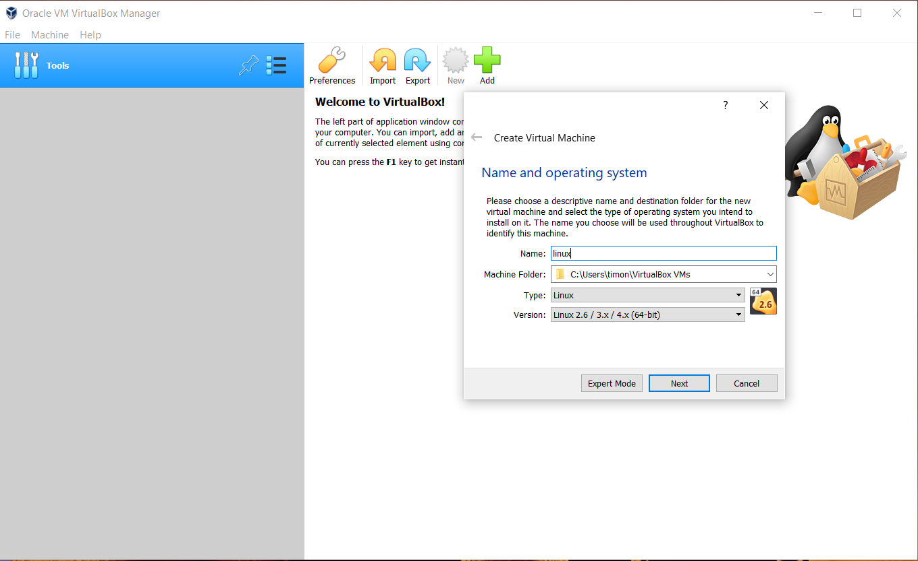

* Now select next with default settings then set the partition above 10 gb

And again continue with default settings

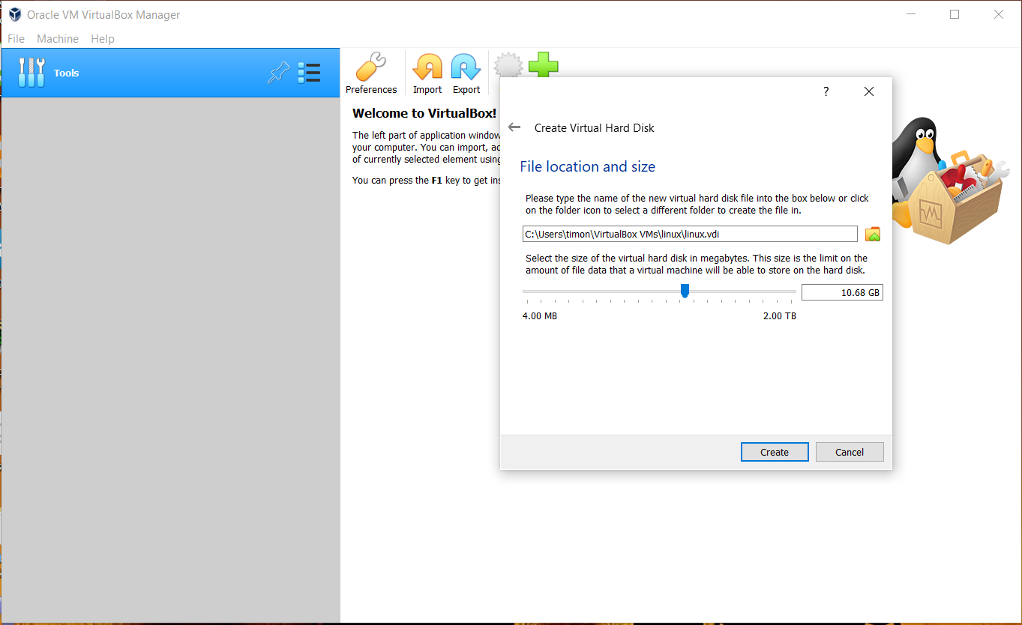

* This creates a image in the set disk which can be reused in the future
* Now the option for linux appears in the screes select it and press start

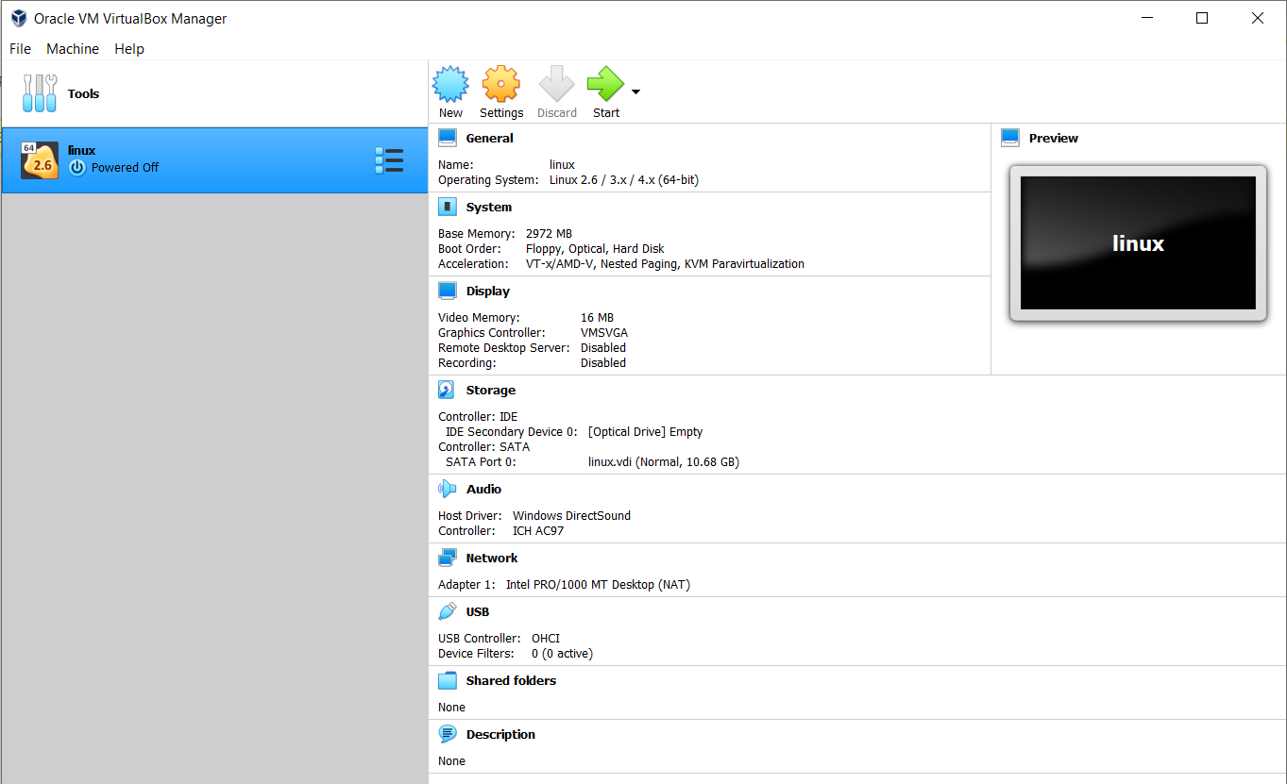

* Now select the iso file. Here I have already set the location in case it is not set click the folder icon

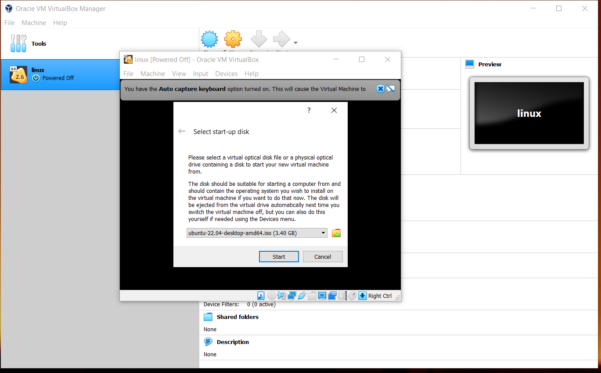

* Inside here click add and locate the iso file to install,and click choose and start
* Now wait for ubuntu to load

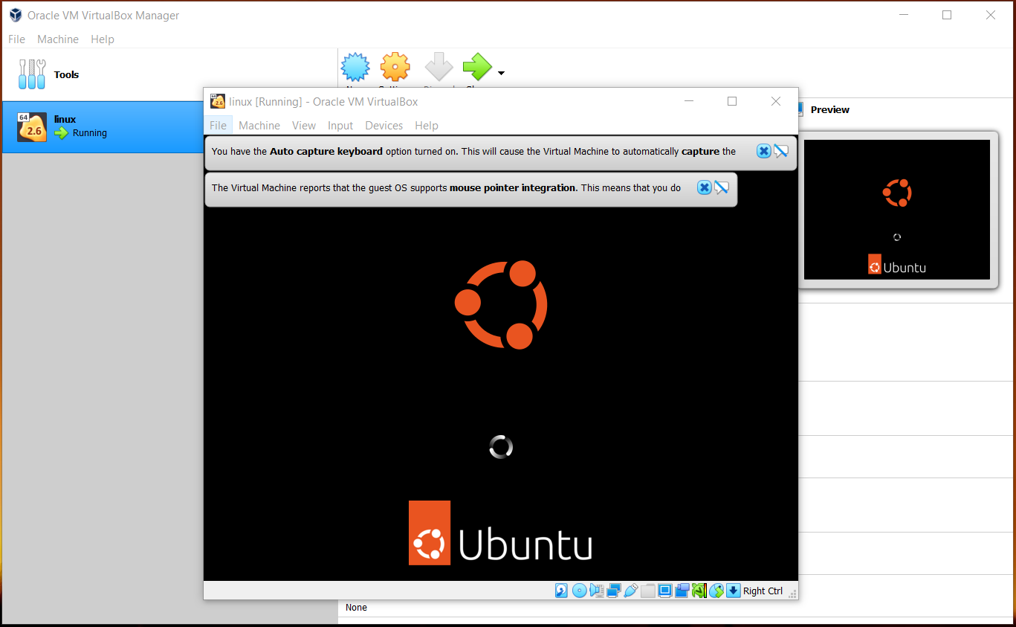

* Now the front screen appears
* After a while the install ubuntu option appears select install ubuntu

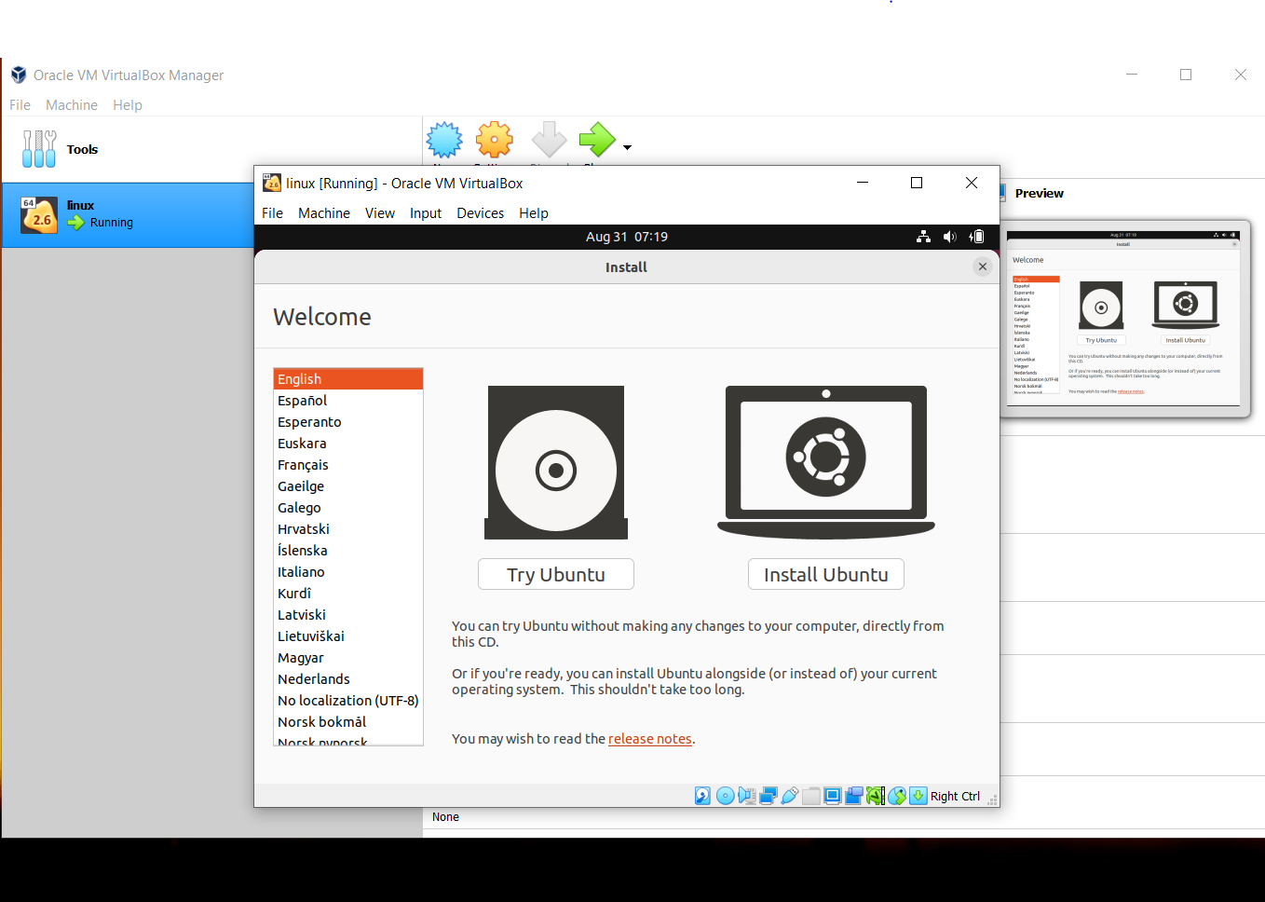

* Now select language of your preference
* Select timezone

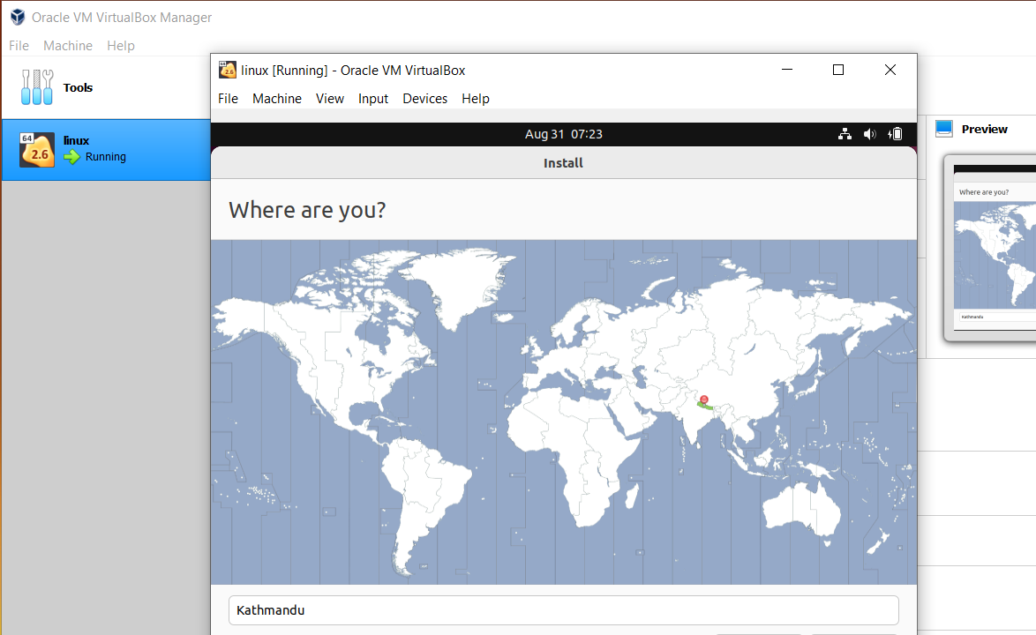

* Now continue with the default setup settings
* In case you don’t want to delete the data in your pc create partitions,

Here we use VM so the delete all and install is selected.

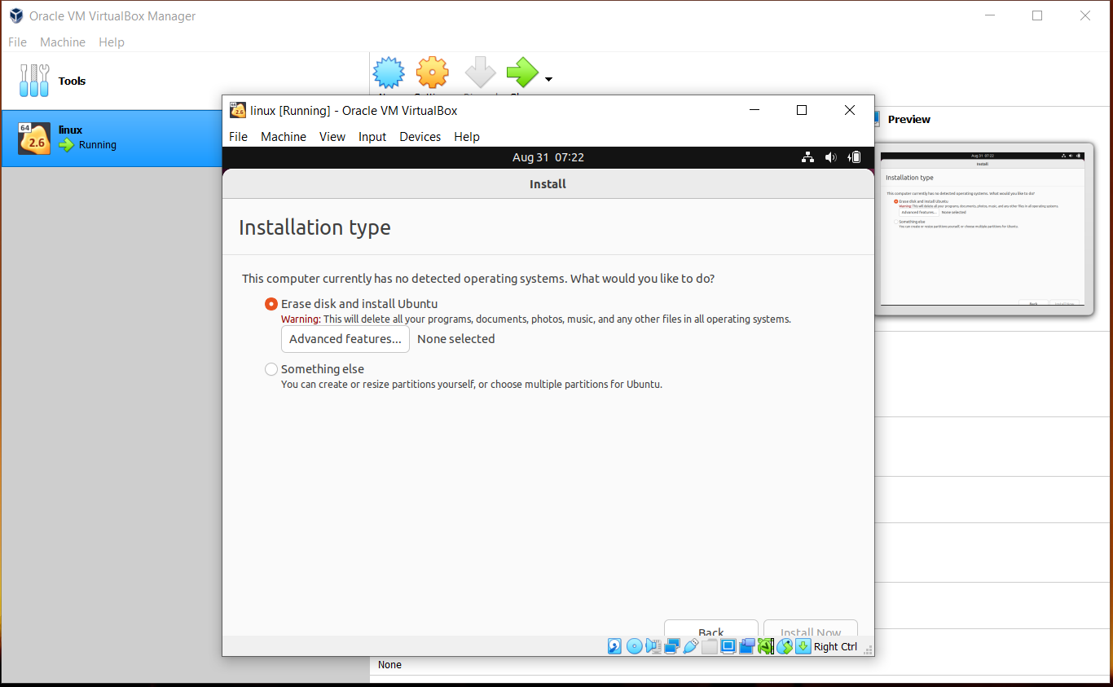

* Here set the name of your pc and password with your preference of login

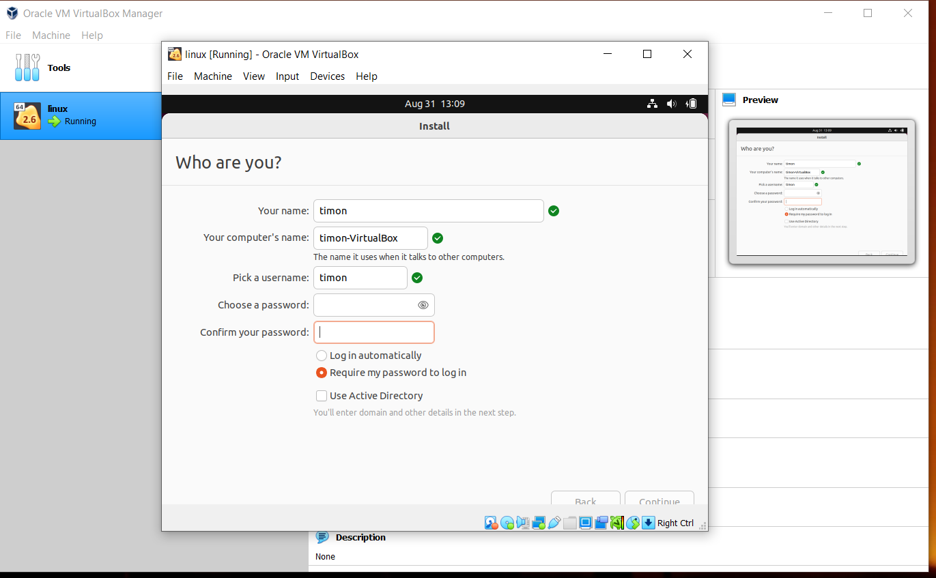

* Press continue and enter as instructed
* After this ubuntu downloads and installs the necessary drivers and settings and installs it so wait for it to load as it might take some time.After this press restart.

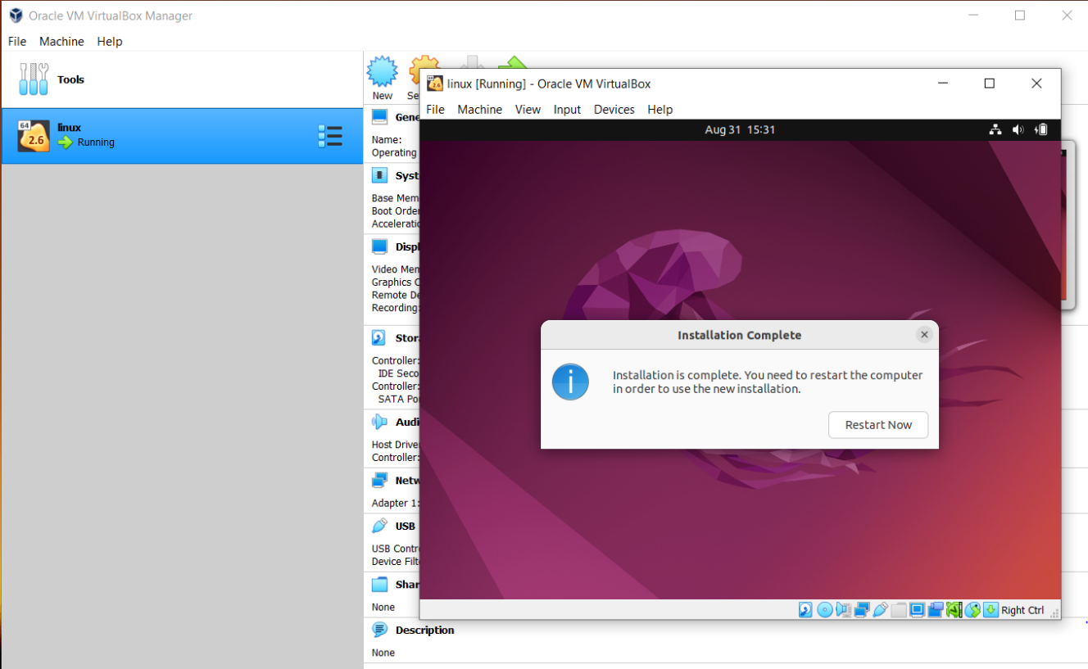

* After restart the linux ubuntu edition is installed in your pc and you can start using it.

Conclusion:

Hence, we installed linux in virtual machine