**Lab**:-7 Date: 2078/02/04

Objective:

* To clamp RJ-45 wire using clamper.

Theory:

* Unshielded twisted pair (UTP) cables are widely used in the computer and telecommunications industry as Ethernet cables and telephone wires. In an UTP cable, conductors which form a single circuit are twisted around each other in order to cancel out electromagnetic interference (EMI) from external sources.
* Cable clamps are a type of mechanical device designed to secure cables when installed at intervals along the length of cables. It defines a route for one or more cables along the building wall or within electrical enclosures, in order to restrict the cable movement, support and retain the cables, and offer resistance to electromechanical forces, so the cable clamps are commonly used in cable and electrical installation to ensure the installation is correct, then reduce the risk of damage and safety.

Procedure:

* First cut the wire at each end using a clamper.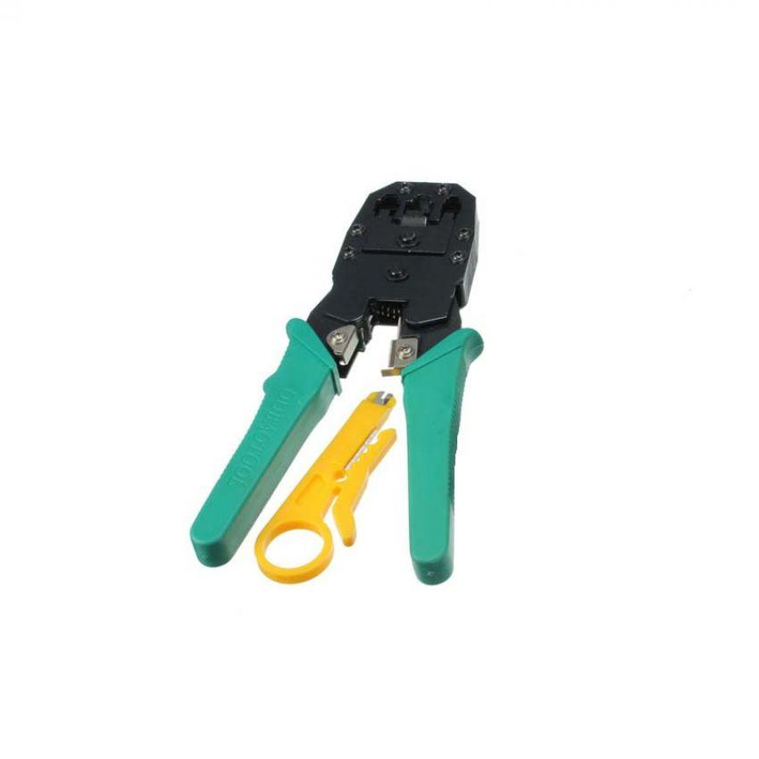
* After cutting the wire with clamper untwist the wires and set the wires according to need (Copper cross over or Straight through).
* Here is the picture representing the standard of wires of all types.

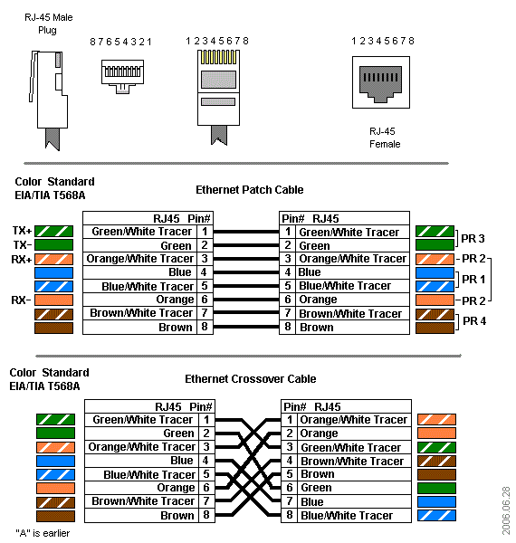

* After setting up the wire insert it into RJ-45 Jack
* Finally use the clamper to cut the excess cables and clamp the jack. This is what the finish product looks like.

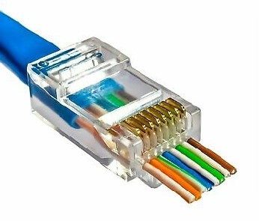

Conclusion:

* Hence, we were able to clamp the RJ-45 in unshielded twisted pair cable