**Lab**:-8 Date: 2078/02/13

Objective:

* To setup web DNS server in CISCO packet tracer.

Theory:

* The Domain Name System (DNS) is the phonebook of the Internet. Humans access information online through [domain names](https://www.cloudflare.com/learning/dns/glossary/what-is-a-domain-name/), like nytimes.com or espn.com. Web browsers interact through [Internet Protocol (IP)](https://www.cloudflare.com/learning/network-layer/internet-protocol/) addresses. A DNS server is a computer with a database containing the public IP addresses associated with the names of the websites an IP address brings a user to.

Procedure:

* First we setup a network using a switch and servers and a pc for demonstration.

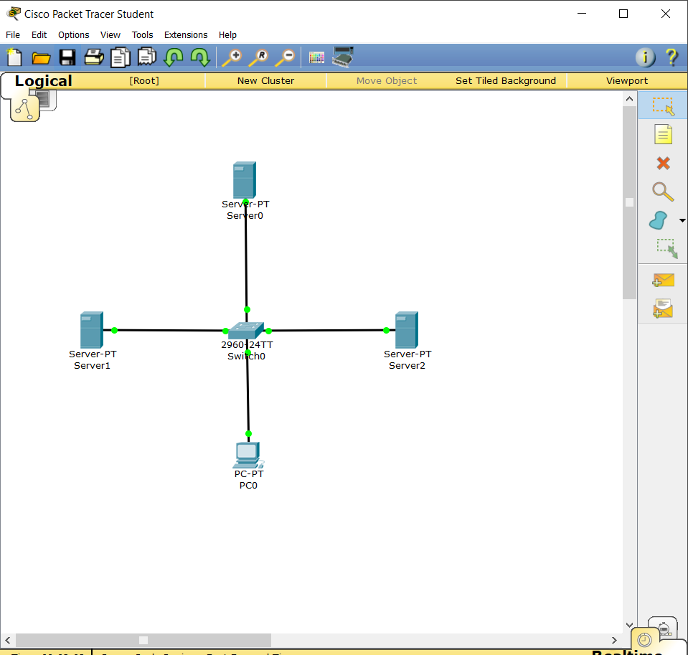

* Then the next step is to give IP to the servers and pc we will use a server as a DHCP provider by giving it the IP of gateway.

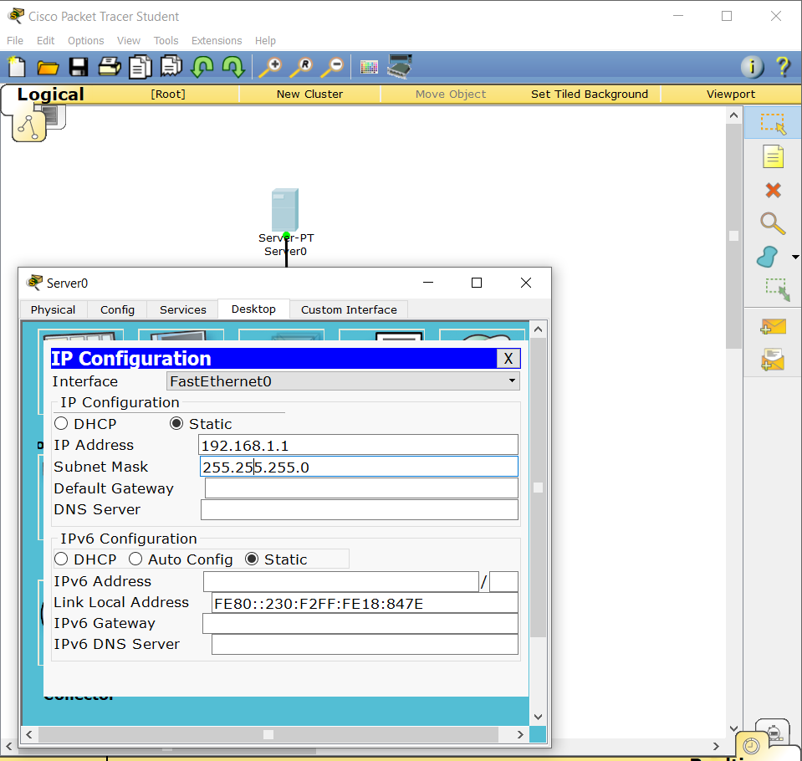

* The next step is to activate the service.

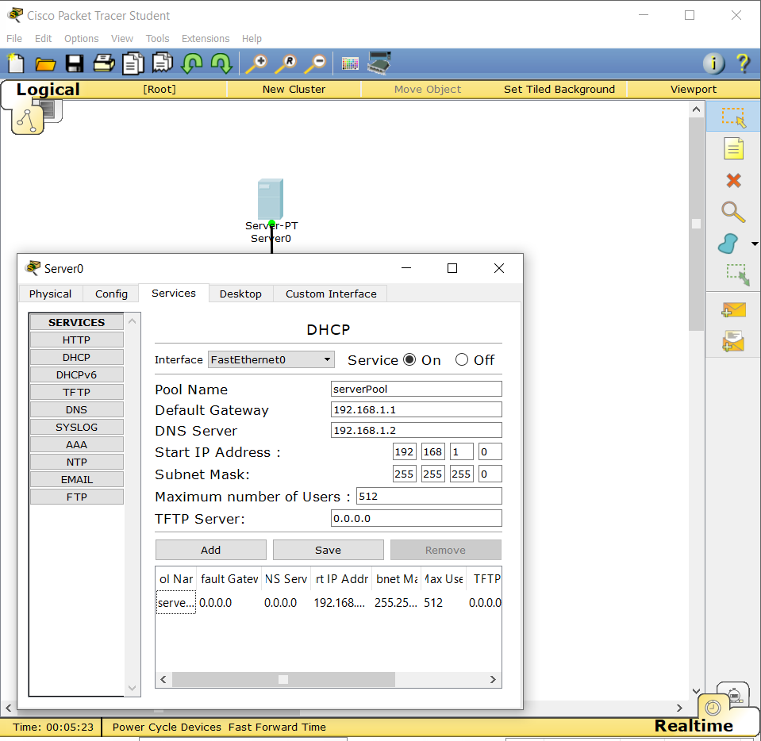

* After setting up the DHCP pool you can initiate the DHCP pool request in the pc.

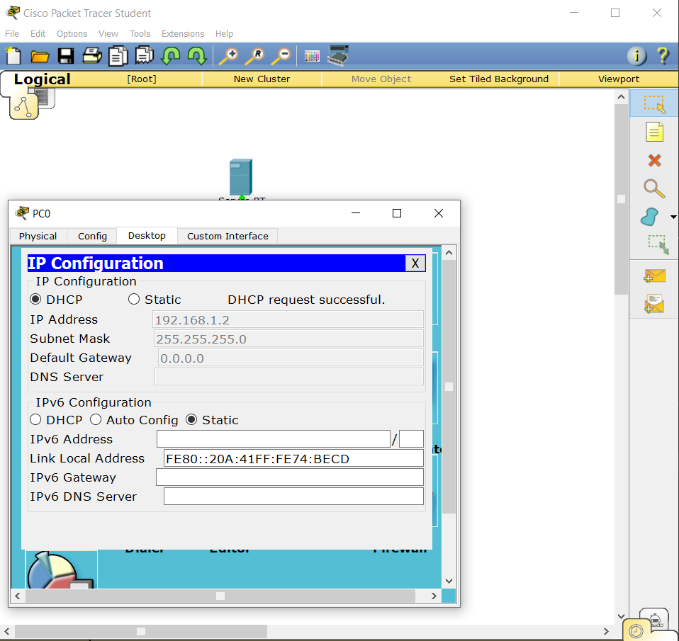

* Now provide the DNS server with a IP address of the network.

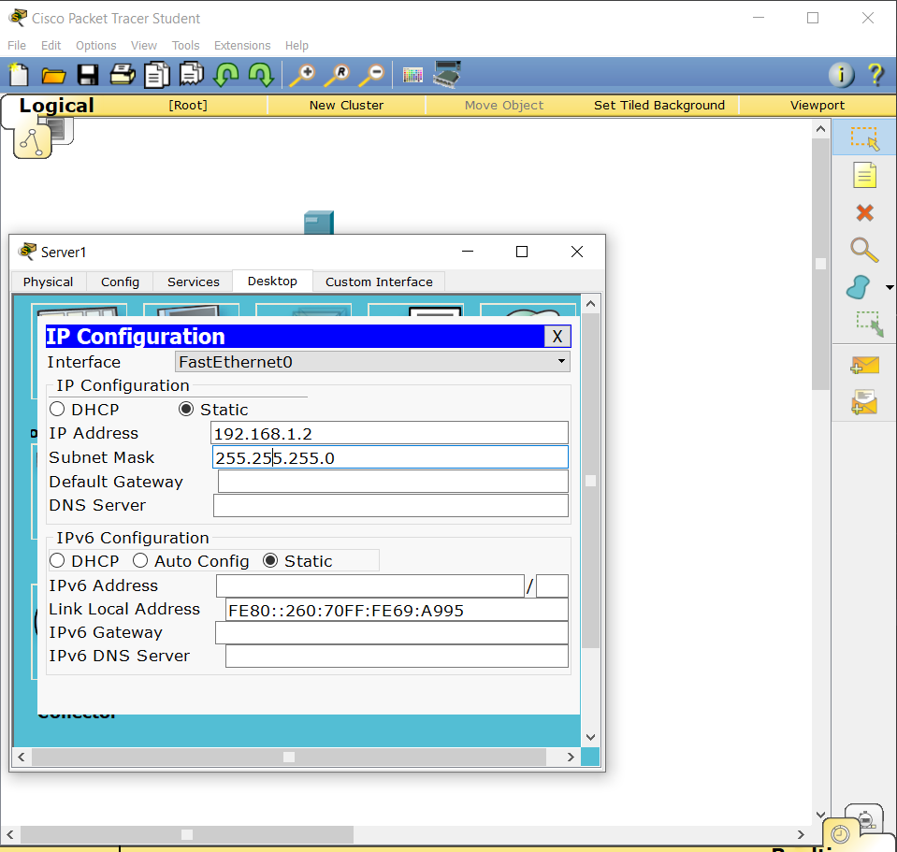

* Now Turn the service of DNS on in the server.

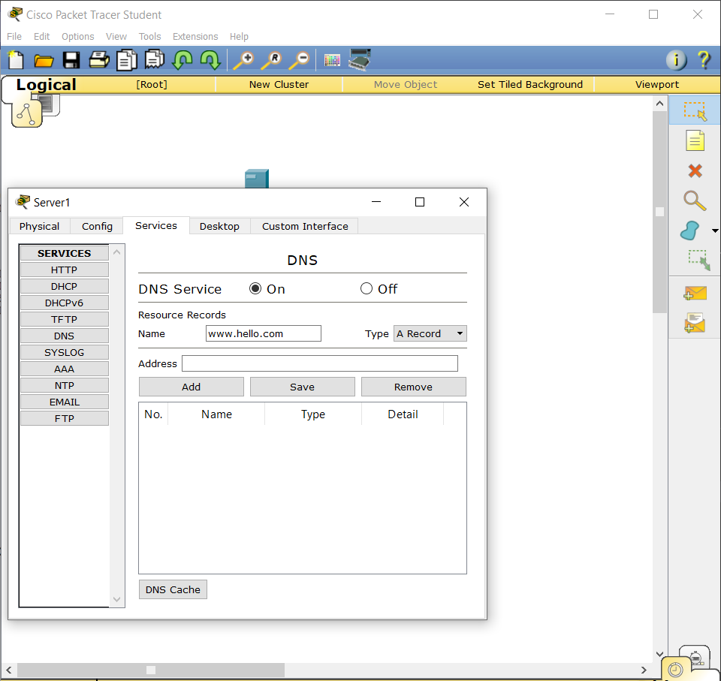

* Add the address and the name to be used in the browser.

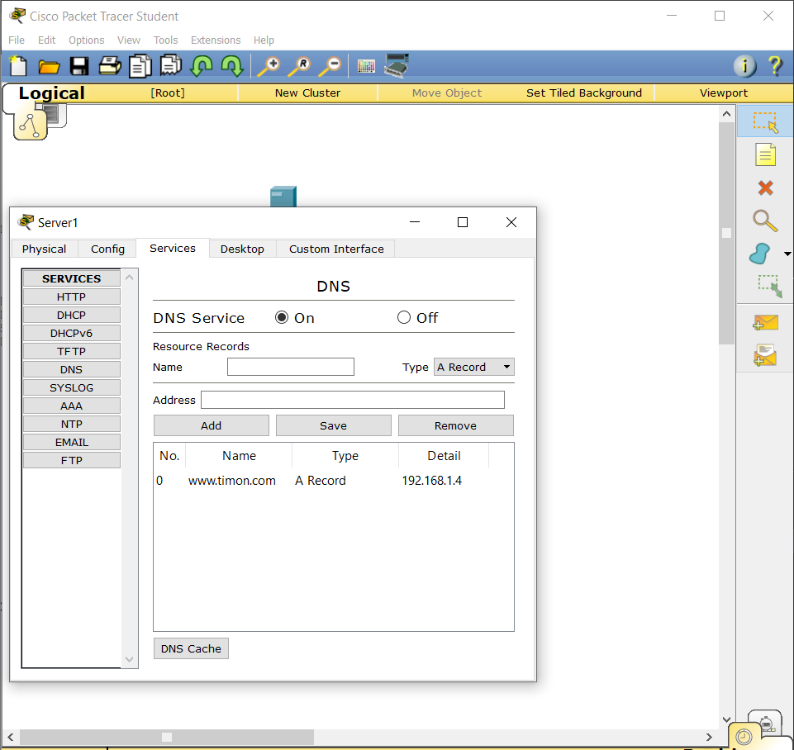

* Now setup the Web server from where the web pages are loaded from.

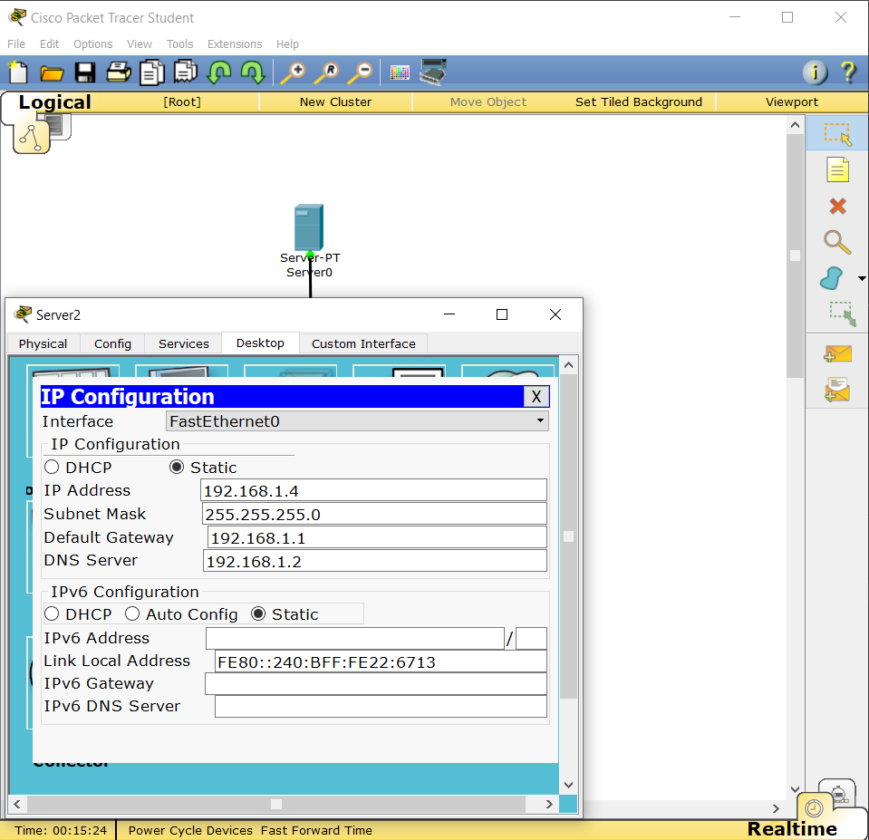

* Finally verify the setup by requesting the website from browser.

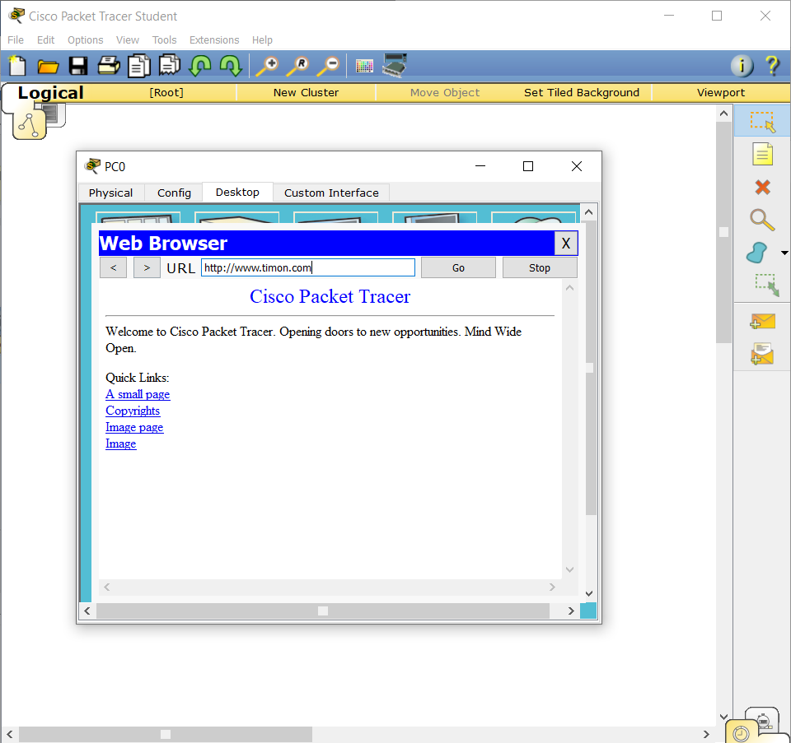

Conclusion:

* Hence, we were able to configure web and DNS server, and verify the service.