

**Lab no:** **Date: 2079/**

**Title: Write a program to implement LRU page replacement algorithm.**

**LRU:**

In this algorithm, the page that has not been used for the longest period of time has to be replaced. If we use the recent past as an approximation of the near future, then we will replace the page that has not been used for the longest period of time. This approach is the least-recently-used (LRU) algorithm.

**Algorithm:**

Step 1. Start the process

Step 2. Declare the page size

Step 3. Determine the number of pages to be inserted.

Step 4. Get the value.

Step 5. Declare the counter and stack value.

Step 6. Choose the least recently used page by the counter value.

Step 7. Stack them as per the selection.

Step 8. Display the values.

Step 9. Terminate the process.

Programming Language = C++

IDE = Dev-C++

**Source Code:**

|  |
| --- |
| //program for least recently uses page replacement algorithm..    #include<iostream>  using namespace std;  int main()  {  int nopages, nofaults, page[20],i ,count=0;  cout<<"\n Enter no of pages :";  cin>> nopages; //it will store the number of Pages  cout<<"\n Enter the Reference String:";  for(i=0;i< nopages;i++)  {  cout<<"\t";  cin>>page[i];  }  cout<<"\n\t Enter the Number of frames:";  cin>> nofaults;  int frame[nofaults],fcount[nofaults];  for(i=0;i< nofaults;i++)  {  frame[i]=-1;  fcount[i]=0; //keeps tracks og pages last used  }  i=0;  while(i< nopages)  {  int j=0,flag=0;  while(j< nofaults)  {  if(page[i]==frame[j])  { //it will check whether the page already exist  //in frames or not  flag=1;  fcount[j]=i+1;  }  j++;  }  j=0;  cout<<"\n";  cout<<"\t"<<page[i]<<":";  if(flag==0)  {  int min=0,k=0;  while(k<nofaults-1)  {  if(fcount[min]>fcount[k+1]) //It will calculate the page which is  //least recently used  min=k+1;  k++;  }  frame[min]=page[i];  fcount[min]=i+1; //Increasing the time it will count the total Page Fault  count++;  while(j< nofaults)  {  cout<<"\t"<<frame[j];  j++;  }  }  i++;  }  cout<<"\n";  cout<<"\n\t Page Fault:"<<count;  cout<<"\n\t Page Hit:"<<nopages-count;  return 0;  } |

**Output:**

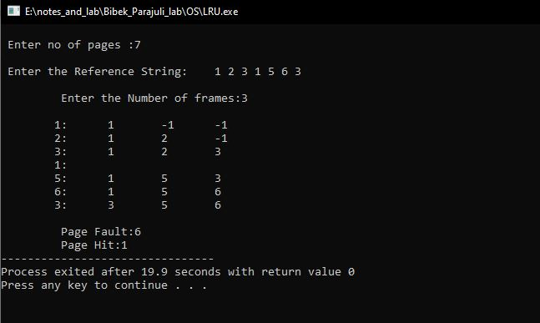

Fig: LRU page replacement algorithm