**Lab no:8  Date:2079/**

**Title: Write a program to simulate First Fit memory allocation algorithm**

In this algorithm we check the blocks in a sequential manner which means we pick the first process then compare size with first block size if it is less than size of block it is allocated otherwise we move to second block and so on.

**Algorithm:**

Step 1: Start

Step 2: From index 0 find the hole that fits the process

Step 3: Insert the process by making partition if necessary

Step 4: Repeat step 2 until processes are allocated

Step 5: Stop.

**Source code:**

|  |
| --- |
| #include<iostream>  using namespace std;  int main()  {  int partition,pocessNumber,i,j;  cout<<"Enter number of partition: ";  cin>>partition;  cout<<"enter the no of process to be allocated: ";  cin>>pocessNumber;  int processes[pocessNumber];  int holes[partition];  cout<<"Enter The size of partitions: \n";  for(i = 0 ; i < partition ; i++)  {  cout<<i+1<<": ";  cin>>holes[i];  }  cout<<"enter size of process: \n";  for(i = 0 ; i < pocessNumber ; i++)  {  cout<<i+1<<": ";  cin>>processes[i];  }  for(i = 0 ; i < pocessNumber ; i++)  {  for(j = 0 ; j < partition ; j++)  {  if(processes[i] <= holes[j])  {  cout<<"the process "<<i+1<<" fits in partition "<<j+1<<endl;  holes[j] = holes[j] - processes[i];  break;  }  }  }  } |

**Output:**

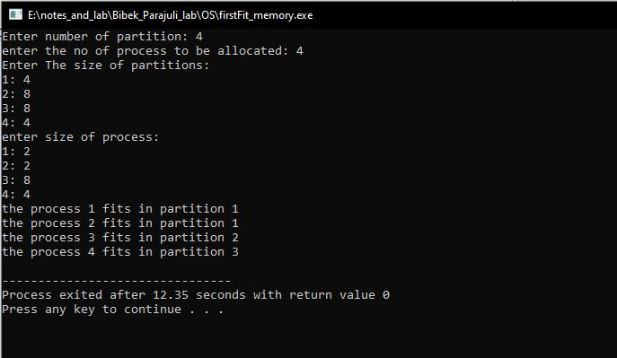

Fig: First Fit memory allocation