**Java Persistence API ( J P A )**

It is collection of classes and methods by which vast amount of data can be stored in the database persistently. Persistence is the process of copying the database object in the temporary memory.

Generally , for connecting to the database there has to be written lot of codes but using JPA it becomes easier.JPA works as the bridge between the object model (JAVA program) and the relational model(database program).

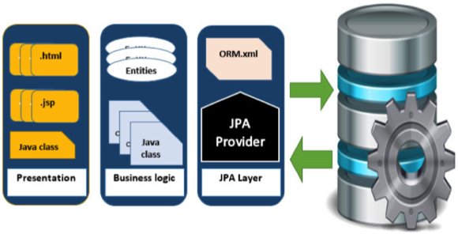

Java persistence entities is a source to store business entities as relational entities.It shows how to define a PLAIN ORIENTED JAVA OBJECT (POJO) as an entity and how to manage entitites with the relation.

What is ENTITY?

Entities are persistence objects and stores as record in the database.

What is ENTITY MANAGER?

It is an instance which manages the persistence objects on instance. It works like factory for query instance.

What is Entity Manager Factory ?

This is a factory of entity manager. It creates and manages multiple EntityManager instances.