**Servlets:**

A servlet is a Java programming class that is used to extend the capability of servers that host applications accessed by means of **request and response programming model**. Servlets can handle any requests but it commonly used to extend the applications hosted by WEB Servers.

Java Servlets are programs that run on web or application server and acts as middleware between request coming from HTTP client and the database or applications.

Using servlets we can make dynamic web page , take inputs from the users throught the web forms,present record from database from or other source.

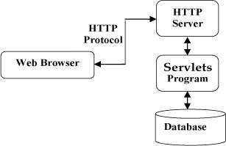

Servlets can be accessed using javax.servlet or javax.servlet.http. First one is a standard one whereas later one is used for the large scale development projects.