There are two types of mapping : XML mapping and annotation basis mapping

Steps to create the servlet:

1. First make Java file of servlet

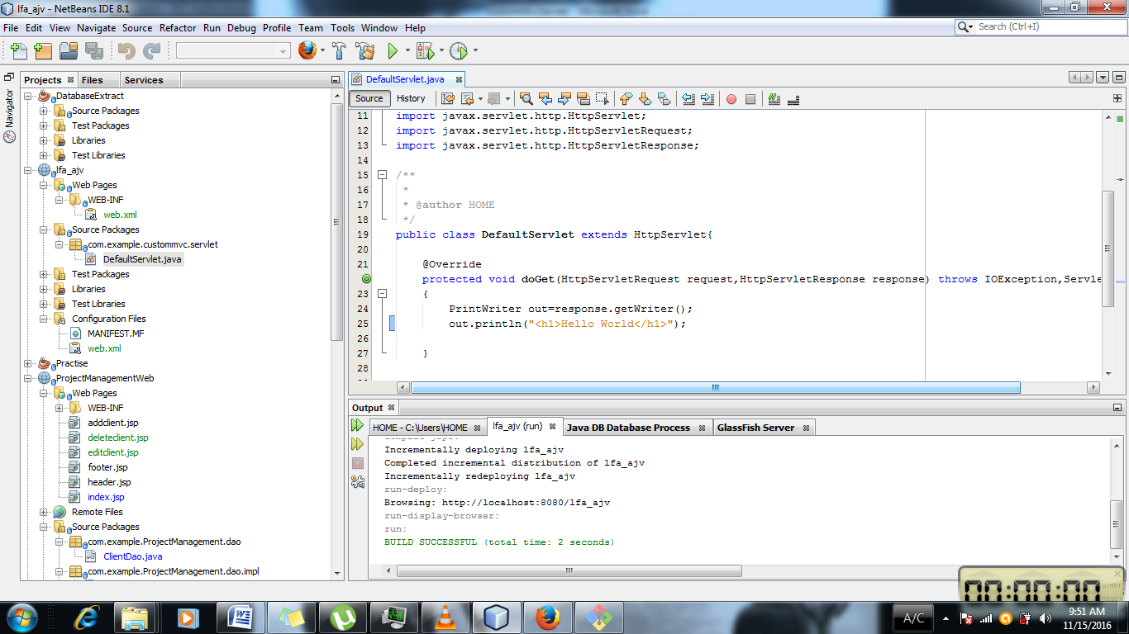

1. Then make the xml file for the mapping purpose from java to web pages.

In the xml file we have to make the servlet object.

<servlet>

<servlet-name>Default</servlet-name>

<servlet-class>com.example.custommvc.servlet.DefaultServlet</servlet-class </servlet>

So writing above code is like saying

Default = com.example.custommvc.servlet.DefaultServlet . It is like instantiating the new object of servlet which is named as Default

<servlet-mapping>

<servlet-name>Default</servlet-name>

<url-pattern>/</url-pattern>

</servlet-mapping>

So in this servlet is mapped to the url pattern.

Writing java code in the Jsp will cause to compile the java code again . So precompiled tag is used.

