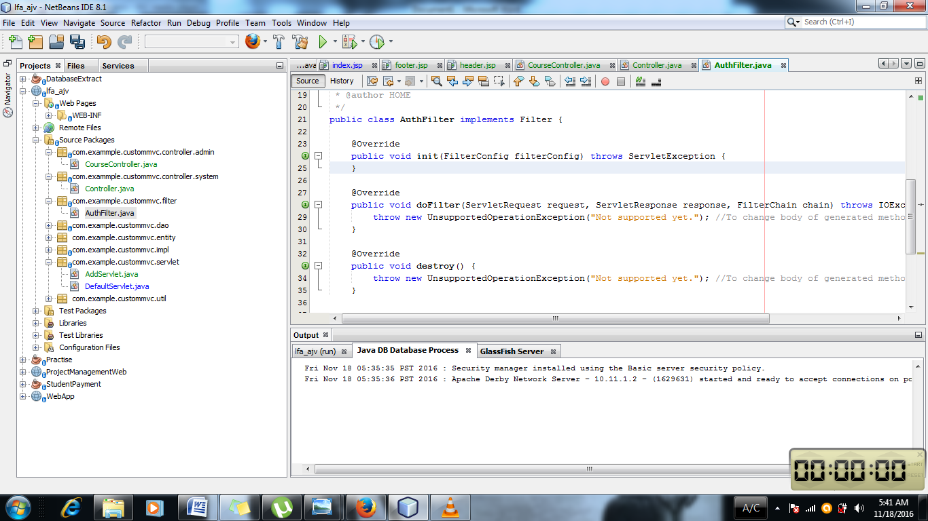

Filter is implemented i.e package of javax.servlet.filter . There are three methods i.e init , doFilter and destroy.

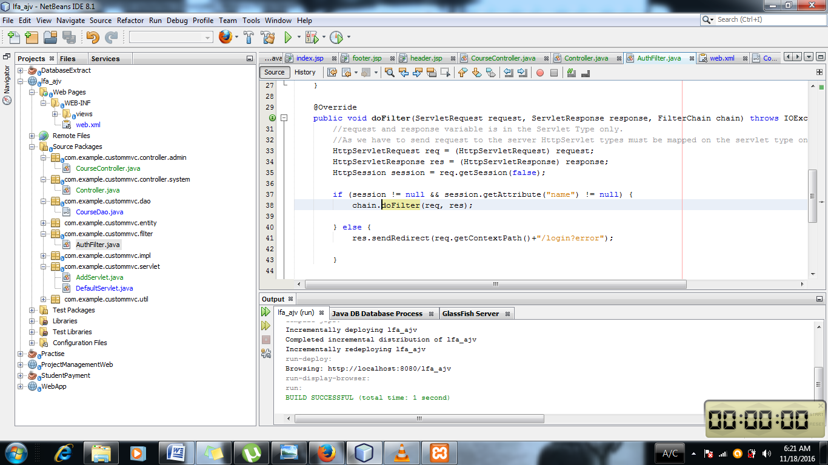

ServletRequest , Servlet Response is seen in doFilter method. And it is not HttpServlet it is only servlet.So thing must also be taken care of.

Session is checked during the request to the server.

request and response variable is in the Servlet Type only.As we have to send request to the server HttpServlet types must be mapped on the servlet type only.

if (session != null && session.getAttribute("name") != null) {

chain.doFilter(req, res); }

* It sees if session is null or not. If the name is not null in the login then the HttpServlet request and response is passed to the needed parts. So after this filter part the other parts can be accessed.

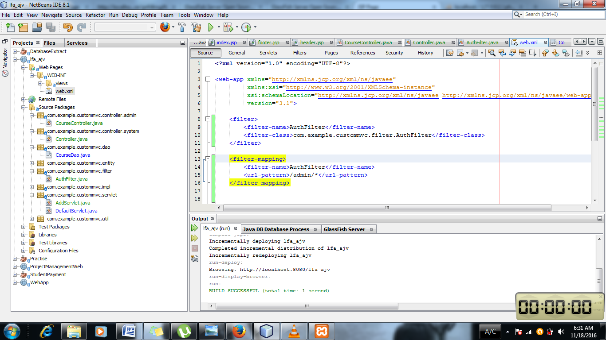

1. <filter>

<filter-name>AuthFilter</filter-name>

<filter-class>com.example.custommvc.filter.AuthFilter</filter-class>

</filter>

<filter-mapping>

Name AuthFilter is given and the class location is given in the filter class.

2) <filter-name>AuthFilter</filter-name>

<url-pattern>/admin/\*</url-pattern>

</filter-mapping>

Name AuthFilter is given and the url pattern of /admin/\* is mapped.So the filter works on the url with the address of /admin/\* . \* means after the admin / (Over here anything can come ).