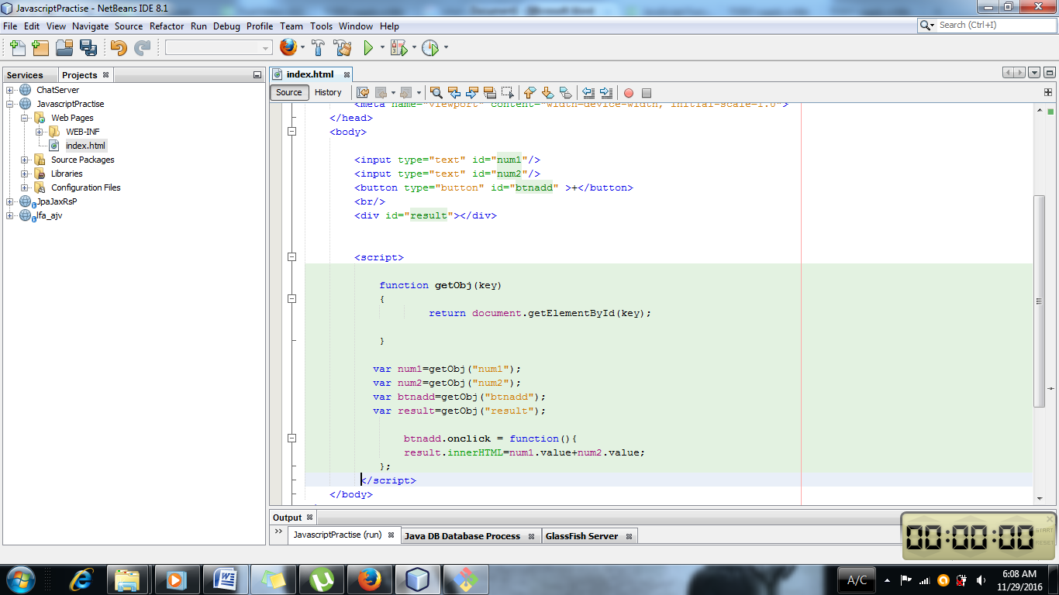

In index.html Javascript codes are written. Between the <script> and </script> the javascript code is written. Id is named such as num1, num2,btnadd,result . Now these id are taken for the reference in the javascript code.

* element= document.getElementById(id) :

Returns a reference to the element by its id. The id is a string which can be used to identify the element. It can established using id attribute in html or script.

Element is reference to the element object, or null if specified id is not in the document.

Id is a case sensitive id representing the unique id of the element being sought.

* Var num1=getObj(“num1”);
* This makes the object num1 .

Btnadd.onclick=function()

{

Result.innerHTML=num1.value+num2.value;

}

Above is anonymous function. So when the button is clicked which is referenced as btnadd object. When the button is clicked the anonymous function is called.

Result.innerHTML=num1.value+num2.value:

This will push the HTML code in result object . As this is javascript it must be pushed in HTML for the overriding of the HTML code.

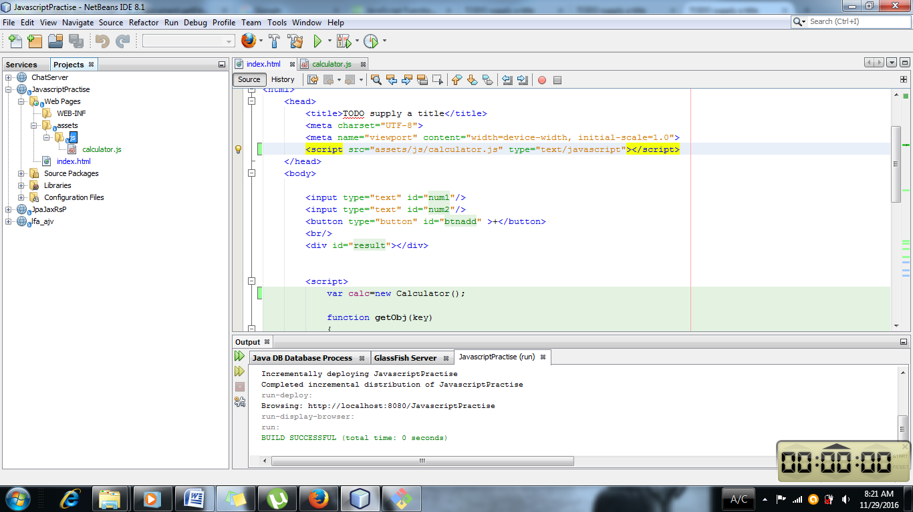

Folder structure must be placed in the above way. If it is placed inside the web-inf then the program will not work. So it is mandatory that the folder structure should be like above.

<script src=”assets/js/calculator.js” type=”text/javascript”></script>

So the src must be defined in order to use the objects from other functions which is defined outside such as calculator.js which is defined outside and the function is also made. So in order to define the object the src must be also defined.