**INTRODUCTION**

Now day’s many industries are using robots due to their high level of performance and reliability and which is a great help for human beings. The [obstacle avoidance robotics](https://www.edgefxkits.com/obstacle-avoidance-robotic-vehicle) is used for detecting obstacles and avoiding the collision. This is an autonomous robot. The design of obstacle avoidance robot requires the integration of many sensors according to their task.

The obstacle detection is primary requirement of this autonomous robot. The robot gets the information from surrounding area through mounted sensors on the robot. Some sensing devices used for obstacle detection like ultrasonic sensor. Ultrasonic sensor is most suitable for obstacle detection and it is of low cost and has high ranging capability. An [Obstacle Avoidance Robot](https://www.pantechsolutions.net/robotics/obstacle-avoidance-robot) is an intelligent robot, which can automatically sense and overcome obstacles on its path. It contains of a Microcontroller to process the data, and [Ultrasonic sensors](https://www.pantechsolutions.net/sensors/ultrasonic-sensor) to detect the obstacles on its path. Obstacle avoidance is one of the most important aspects of mobile robotics. Without it robot movement would be very restrictive and fragile. This tutorial explains obstacle avoidance using ultrasonic sensors. This project also presents a dynamic steering algorithm which ensures that the robot doesn't have to stop in front of an obstacle which allows robot to navigate smoothly in an unknown environment, avoiding collisions.

Convolution Neural Networks

A CNN is a neural network with some convolutional layers (and some other layers). A convolutional layer has a number of filters that does convolutional operation.

OBJECTIVES

Avoiding the one

ADVANTAGES AND DISADVANTAGES

ADVANTAGES

* Whenever robot senses any obstacle automatically diverts its position to left or right and follows the path without human guidance .
* The programming of the microcontroller is easy .
* It is a low cost circuit .
* Simple in construction.
* Easy to maintain and repair.
* Portable and easy to use.
* Can be used in space .
* Relieving vehicle occupants from driving and navigating chores, so allowing them to concentrate on other tasks .

DISADVANTAGES

* It is time consuming project.
* It is not in human control.
* It is not recommended to keep the range very long because this would cause the robot to keep moving forward and backwards as it sense any obstacle , even far away from it.
* Rapidly power reduced.
* It is use for short distance only.

LITERATURE SURVEY

Autonomous driving is not a easy task. It involves various subjects and technologies such as IOT, automation control and artificial intelligence. A working system would be very complicated and comprehensive. Although obstacle avoiding robot is quite challenging, with the development of related technologies, it is not completely unfeasible.

BASE PAGES

MOTIVATION

Travelling by car is currently one of the most deadly forms of transportation, with over a million deaths annually worldwide. As nearly all car crashes are caused by human driver error, driverless car would effectively eliminate nearly all hazards associated with driving as well as driver fatalities and injuries.

EXISTING SYSTEM

The existing system uses a Raspberry pi with an ultrasonic sensor as inputs to detect object and avoid such objects. A ultrasonic sensor is used to measure the distance between the obstacle and the robot. It uses servo motor to rotate ultrasonic sensor to check another direction for avoiding objects. Another existing system consists of Raspberry pi with line flowing sensor which use line flowing sensor following parallel white lines to reach the destination.

PROPOSED SYSTEM

The proposed system consists of raspberry pi with an ultrasonic sensor and pi camera. The ultrasonic sensor is used to measure the distance between the obstacle and the robot. The pi camera is used for object identification, detection and localization. Input from the pi camera is used by convolution neural network to steer the robot. The convolution neural networks provides four outputs: (1) left, (2) right, (3) forward and (4) reverse. L298N DC motor driver is used to change direction and vary speed of dc motors.

**TOOLS AND TECHNOLOGY USED**

1. **Raspberry pi 3 B**

The **Raspberry Pi** is a series of small [single-board computers](https://en.wikipedia.org/wiki/Single-board_computer) developed in the [United Kingdom](https://en.wikipedia.org/wiki/United_Kingdom) by the [Raspberry Pi Foundation](https://en.wikipedia.org/wiki/Raspberry_Pi_Foundation) to promote teaching of basic [computer science](https://en.wikipedia.org/wiki/Computer_science) in schools and in [developing countries](https://en.wikipedia.org/wiki/Developing_countries) . The Raspberry Pi 3 Model B is the third generation Raspberry Pi. This powerful credit-card sized single board computer can be used for many applications and supersedes the original Raspberry Pi Model B+ and Raspberry Pi 2 Model B.

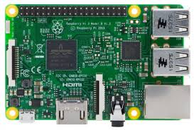

**Fig: Raspberry pi 3 b**

Whilst maintaining the popular board format the Raspberry Pi 3 Model B brings you a more powerful processor, 10x faster than the first generation Raspberry Pi.

Additionally ,it adds wireless LAN & Bluetooth connectivity making it the ideal solution for powerful connected designs.

1. **SERVO MOTOR**

This is nothing but a simple electric motor.it is controlled with the help of servo mechanism. The servo motor is usually a simple [DC motor](https://www.electrical4u.com/dc-motor-or-direct-current-motor/) controlled for specific angular rotation with the help of additional servomechanism. Now day’s servo system has large industrial applications. [Servo motor applications](https://www.electrical4u.com/servo-motor-applications-in-robotics-solar-tracking-system-etc/) are also commonly seen in remote-controlled toy cars for controlling the direction of motion. It is also very widely used as the motor which moves the tray of a CD or DVD player. Besides these, there are other hundreds of servo motor applications we see in our daily life. The main reason behind using a servo is that it provides angular precision, i.e. it will only rotate as much we want and then stop and wait for next signal to take further action.

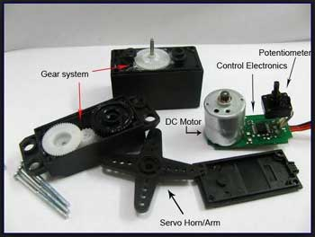

**Fig 2.3.5: SERVO MOTOR**

**Servo motor** is a special type of motor which is automatically operated up to a certain limit for a given command with the help of error-sensing feedback to correct the performance.

1. **ULTRASONIC SENSOR**

As the name indicates, ultrasonic sensors measure distance by using ultrasonic waves.  
The sensor head emits an ultrasonic wave and receives the wave reflected back from the target. Ultrasonic Sensors measure the distance to the target by measuring the time between the emission and reception.

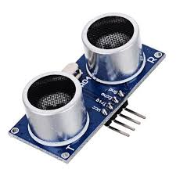

**Fig: Ultrasonic sensor**

**Ultrasonic transducers** or **ultrasonic sensors** are a type of acoustic sensor divided into three broad categories: transmitters, receivers and transceivers. Transmitters convert [electrical signals](https://en.wikipedia.org/wiki/Signal_(electrical_engineering)) into [ultrasound](https://en.wikipedia.org/wiki/Ultrasound), receivers convert ultrasound into electrical signals, and transceivers can both transmit and receive ultrasound.

1. **Pi camera**

The Raspberry Pi camera module can be used to take high-definition video, as well as stills photographs. It’s easy to use for beginners, but has plenty to offer advanced users if you’re looking to expand your knowledge. There are lots of examples online of people using it for time-lapse, slow-motion and other video cleverness. You can also use the libraries we bundle with the camera to create effects.

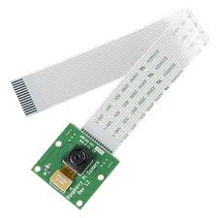

**fig: pi camera**

If you’re interested in the nitty-gritty, you’ll want to know that the module has a five megapixel fixed-focus camera that supports 1080p30, 720p60 and VGA90 video modes, as well as stills capture. It attaches via a 15cm ribbon cable to the CSI port on the Raspberry Pi. It can be accessed through the MMAL and V4L APIs, and there are numerous third-party libraries built for it, including the Picamera Python library.

1. **L298n motor driver**

**L298N Dual H Bridge Motor Driver** is a motor controller breakout board which is typically used for controlling speed and direction of motors. It can also be used to control the brightness of certain lighting projects such as high powered LED arrays.

An H-bridge is a circuit that can drive a current in either polarity and be controlled by pulse width modulation.

L298N  Motor Driver Module is a high voltage Dual H-Bridge manufactured by ST company. It is designed to accept standard TTL voltage levels.

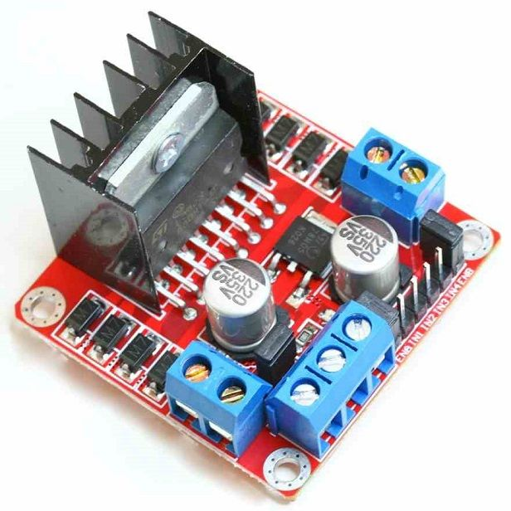

**Fig: L298n motor driver**

H-bridge drivers are used to drive inductive loads that requires forward and reverse function with speed control such as DC Motors, and Stepper Motors. This Dual H-Bridge driver is capable of driving voltages up to 46V and continuous current up to 2A in each channels.

1. **4 Wheel Drive Curious Robotic Robotic Chassis**

4WD (Wheel Drive) Curious Chassis from Kit4Curious is a high quality robotic kit. The kit can be used to make a 4 Wheel drive robotic chassis for your robotic projects. The chassis has enough space and holes to put your Arduino, Motor driver, battery, switch, servo motor, ultrasonic sensor etc.

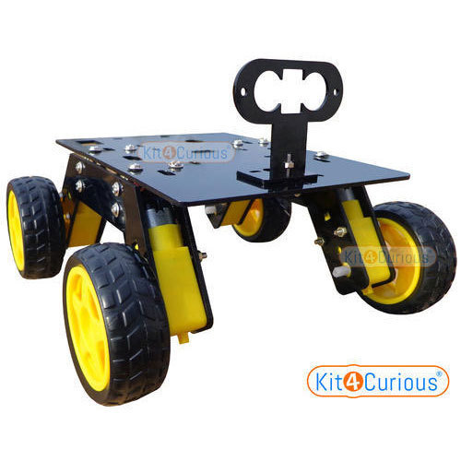

**Fig: 4 Wheel Drive Curious Robotic Robotic Chassis**

**HARDWARE AND SOFTWARE REQUIREMENTS**

**Software Requirement**

* Raspbian Operating System
* Python
* Jupiter notebook

**Hardware Requirement**

* Raspberry pi 3 b
* Dc Motor
* L298n motor driver
* Power supply
* Jumper wire
* 4 Wheel robot chassis
* 4 double shaft dc motor
* Ultrasonic sensor
* Pi camera

**ARCHITECTURE**  
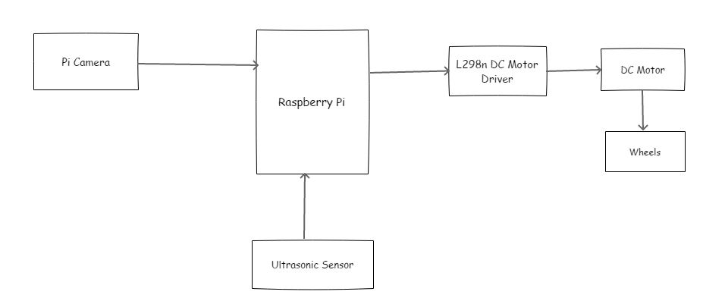

Fig Architecture of obstacle avoiding robot

APPLICATION

Obstacle sensing robot can be applied at toys where small children will play.

It can be used for army applications.

It can be used in mines.

Obstacle detecting system for a motor vehicle.

Search and rescue.

Move towards goal by avoiding hurdles.

Future Works

Adding infared sensor for object detection

Adding reverse navigation option and varying speed of car

Conclusions

Neural networks are used for object avoidance and goal reaching.Raspberry pi is used to control the dc motor.

Image taken from pi camera is feeded as input to the neural networks.

REFERENCES