Questions

Name: Bibhas Paramguru

Registration No: 1941012324

JAVA

1. Find unique strings in an array of strings?

Input

strArray = {“abc”, “def, “ABZ”, “ASD”, “AbC”};

Similar strings - include case insensitive output - “abc”, “def”,”ABZ”,”ASD”

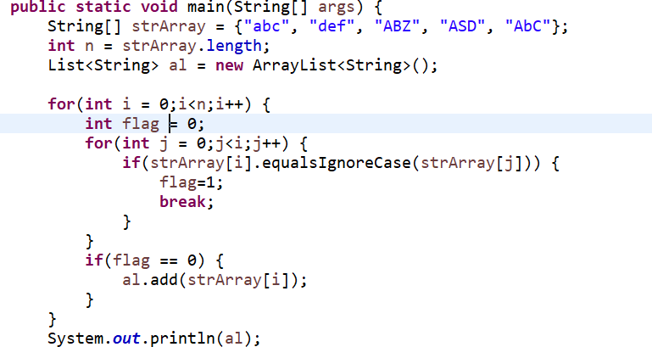

1. Write a program in Java to create an abstract class market. There are two methods getPrice() and getProductName() as abstract method.

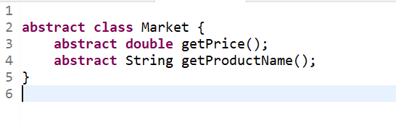

1. Write a program in Java to find 2nd largetst number in an array of Strings ?

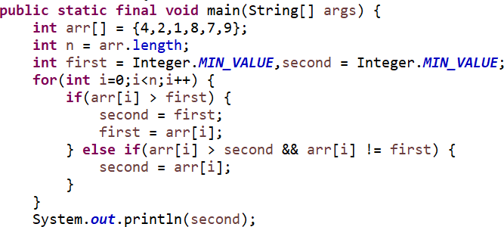

1. Write a program in Java to find pair of numbers whose sum is a number present in an array of integers?

Example - { 2, 5 ,8 ,9, 0,1, 7 , 10}

Output - (2,5), (9,1) ,(0,1)

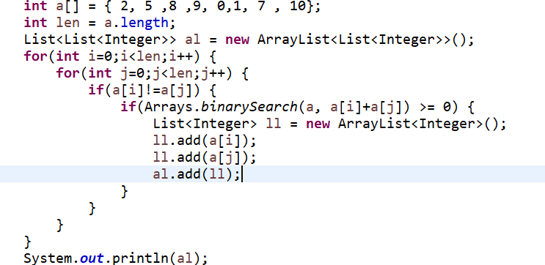

SQL

2. create and execute the sql in the tables(mentioned below)

Tables

Subject ( id , rollno, subjectname , marks) Student (id, rollno, sname, address )

Write a SQL query to find the count of all students studying a paticular subject?

Select subjectname,count(id) as Count from Student group by subjectname;

Write a SQL query to find total marks of a particular student for all subjects?

SELECT SUM(marks) AS TotMarks FROM Subject, Student WHERE Subject.id = Student.id group by sname;

2)

product(id, name , price ,location)

manufacturer( id, company_name, product_id, address)

Write a SQL query to find company_name of a particular product and location given input as product _id?

(Use Join statements)

SELECT company_name FROM Product, manufacturer WHERE Product.id = manufacturer.id

AND product_id = '9E22R57Y';

HTML

Design an html page with following layout as mentioned below (Include CSS as mentioned in diagram color) include table inside content section

Table-1

|  |  |  |  |
| --- | --- | --- | --- |
| product_id | product_name | price | location |

Signup Home Product Help

FOOTER

CONTENT

SITE NAME

LOGO

<!DOCTYPE html>

<html lang="en">

<head>

<meta charset="UTF-8">

<meta http-equiv="X-UA-Compatible" content="IE=edge">

<meta name="viewport" content="width=device-width, initial-scale=1.0">

<title>Assignment</title>

<style>

div.container{ display:grid;

grid-template-columns:18% 78%; grid-gap:10px;

}

div.nested-item{ display:grid;

grid-template-columns:repeat(1,1fr); grid-template-rows: 75px 420px 75px;

}

div.main-section{ display:grid;

grid-template-columns:30% 20%; grid-gap:10px;

}

div.item2{

background-color:green; padding:10px;

}

div.item3{

background-color:skyblue; padding:10px;

}

div.item4{

background-color:rgb(169, 205, 50); padding:10px;

}

</style>

</head>

<body>

<div class="container">

<div class="item1" id="nav" >

Sign up<br> Home<br> Product<br> Help

</div>

<div class="nested-item">

<div class="item2" id="header">

<tr>Site Name</tr>

<tr >Product_id</tr>

<tr >Product_name</tr>

<tr >Location</tr>

</div>

<div class="main-section">

<div class="item3" id="artical"> CONTENT

</div>

<div class="item4" id="ads">

</div>

</div>

<div class="item2" id="footer"> Footer

</div>

</div>

</div>

</body>

</html>