# Project Report

# On

# MEASURING ENERGY HETEROGENEITY IN WIRELESS SENSOR NETWORK

(A Project Report submitted in partial fulfillment of the requirements of Bachelor of Technology in Information Technology of the West Bengal University of Technology, West Bengal)

**Submitted by:**

* Bibhas Mondal (Roll No - 10200215012)
* Tamoghna Rakshit (Roll No - 10200216002)
* Indranil Chowhury (Roll No - 10200215023)
* Samapti Adhikari (Roll No - 10200216008)

# Under the guidance of

# Mr. Partha Sarathi Banerjee

# Assistant Professor

Dept. of Information Technology

# Image result for kgec logo

# Kalyani Government Engineering College

(Affiliated to [Maulana Abul Kalam Azad University of Technology](https://r.search.yahoo.com/_ylt=AwrPhOsIK.FchjsArgK7HAx.;_ylu=X3oDMTByaW0wdmlxBGNvbG8Dc2czBHBvcwMyBHZ0aWQDBHNlYwNzcg--/RV=2/RE=1558289288/RO=10/RU=https%3a%2f%2fen.wikipedia.org%2fwiki%2fMaulana_Abul_Kalam_Azad_University_of_Technology/RK=2/RS=AFHac.lo.MWzYCHmhCUv8h7l290-))

## Kalyani - 741235, Nadia, WB

2018-2019

**Phone: 25826680 (PBX) e-mail:**

**Fax : 25821309**



**Certificate of Approval**

This is to certify that …………………………………has done final year project work entitled …………………………………………under my direct supervision and he/she has fulfilled all the requirements of relating to the Final Year Project. It is also certified that this project work being submitted, fulfills the norms of academic standard for B. Tech Degree in Information Technology of The West Bengal University of Technology and it has not been submitted for any degree whatsoever by him/her or anyone else previously.

………………………………………… ……………………………………………..

Head Supervisor

Department of Information Technology Department of Information Technology

Kalyani Government Engineering College Kalyani Government Engineering College

……………………………………………… ………………………………………………

Project Coordinator Examiner

Department of Information Technology

Kalyani Government Engineering College

### ACKNOWLEDGEMENTS

# We take this opportunity to express our profound gratitude and deep regards to our guide Mr. Partha Sarathi Banerjee for his exemplary guidance, monitoring and constant encouragement throughout the course of this project .The blessing, guidance and help provided by him time to time shall carry us long way in the journey of our career on which we are about to embark.

We also take this opportunity to express a deep sense of gratitude to our respected HOD of Information Technology, Prof. Malabika Sengupta for her cordial support, valuable information and guidance and constant support.

We are also obliged to other respected faculty members of our department for the valuable information provided by them in their respective fields. We are grateful for their cooperation during the period of our academic project. This helped us in completing our task through various stages.

We do express our deepest gratitude to all our classmates for their constant support and help in this project. Without them this work would have been lesser than what it is now.

With sincere thanks,

1. Bibhas Mondal - 10200215012

Signature-

2. Tamoghna Rakshit - 10200216002

Signature-

3. Indranil Chowdhury - 10200215023

Signature-

4. Samapti Adhikari - 10200216008

Signature-

**ABSTRACT**

Wireless sensor networks (WSNs) have received tremendous attention in recent years because of the development of sensor devices, as well as wireless communication technologies. It is usually randomly deployed where battery replacement or recharge is difficult or even impossible to be performed. For this reason, network lifetime is of crucial importance to a WSN.

The project focuses on the performance as well as energy consumption issues of a wireless sensor network. The sensors are assumed to be randomly deployed. We formulate the energy consumption and study their estimated lifetime based on network size, distance between the nodes and remaining power of the nodes. We have implemented RPL and AODV routing protocol for the calculation of Best Parent and Best Path respectively.

Our main goal was to improve the Energy Heterogeneity of the network so that energy is equally consumed among all nodes. This way the network can work for a longer time period. This increased longevity will ensure nodes can communicate with each other more using the same battery source.

Our final result shows that by increasing the priority from hop count to remaining energy of the nodes, energy diversity among the nodes have decreased. As a result, the total numbers of sessions performed have seen improvement and energy heterogeneity among the nodes have significantly decreased.

|  |  |  |
| --- | --- | --- |
|  | **Contents** |  |

|  |  |
| --- | --- |
| **Chapter Name** | **Page No.** |
| 1. **INTRODUCTION**    1. WHAT IS ENERGY HETEROGENEITY    2. SENSOR NETWORKS APPLICATION    3. MOTIVATION    4. BACKGROUND    5. HARDWARE/SOFTWARE USED 2. **RELATED WORK** 3. **METHODOLOGY**    1. RPL    2. AODV    3. GINI COEFFICIENT 4. **IMPLEMENTATION**    1. PROBLEM STATEMENT    2. PROPOSED ALGORITHMS AND FLOWCHARTS 5. **RESULTS AND DISCUSSIONS**    1. RPL    2. AODV 6. **FUTURE SCOPE** 7. **CONCLUTION**   **REFERENCES** | **6**  6  7  8  9  10  **11**  **13**  13  16  **19**  19  20  **24**  24  31  **37**  **38**  **39** |

|  |  |
| --- | --- |
| **Chapter 1** | **INTRODUCTION** |

* 1. **WHAT IS ENERGY HETEROGENEITY?**

In WSN (Wireless sensor network), sensor node’s power control is needed to efficiently make use of the limited energy resources in order to minimize the energy consumed by the sensor nodes and thus prolong network lifetime. For this purpose, energy efficiency must be considered in every aspect of network design and operation, not only for individual sensor nodes, but also for the communication of the entire network.

Most of the protocols designed for WSNs assume that the sensors have the same capabilities in terms of storage, processing, sensing, and communication. The resulting network is said to be homogeneous*.* In these types of networks, a pair of sensors would have the same lifetime if they have the same energy consumption rate. Some sensing applications, however, use sensors with different capabilities and accordingly the resulting network is said to be heterogeneous*.* In the real world, the assumption of homogeneous sensors may not be practical because sensing applications may require heterogeneous sensors in terms of their sensing and communication capabilities in order to enhance network reliability and extend network lifetime.

There are three common types of resource heterogeneity in sensor node Computation heterogeneity, Link heterogeneity, and Energy Heterogeneity. In our project we mainly focus on Energy Heterogeneity.

Energy heterogeneitymeans that in the heterogeneous node, battery is replaceable or rechargeable. Among above three types of resource heterogeneity, the most important heterogeneity is the energy heterogeneity because both computational heterogeneity and link heterogeneity will consume more energy resource.

* 1. **SENSOR NETWORKS APPLICATION**

Sensor networks may consist of many different types of sensors such as seismic, low sampling rate magnetic, thermal, visual, infrared, acoustic and radar, which are able to monitor a wide variety of ambient conditions that include the following:

* temperature
* humidity
* vehicular movement
* lightning condition
* pressure
* soil makeup
* noise levels
* the presence or absence of certain kinds of objects,
* mechanical stress levels on attached objects, and
* the current characteristics such as speed, direction, and size of an object.
  1. **MOTIVATION**

WSN (Wireless sensor network) is the one of the most emerging technology in current time. Sometimes it is not physically possible to connect the sensor nodes to a power source, so a rechargeable or removable battery source is the only option. Before the advancement of the wireless technology, the process of communication was very slow and time consuming which resulted in lesser convenience and increasing man power. To overcome this type of problems related to time wastage and man power, wireless sensor network can be used.

Our system mainly focuses on minimal power consumption of the WSNs. From there it can be determined what kind of a system will be best for a particular type of network and task.

As the future is moving towards wireless networks, the necessity for reducing the heterogeneity in energy consumption is of utmost importance. Better optimization of the network will ensure better use of power source. This will finally help in more opportunities for communication.

* 1. **BACKGROUND**

Though rapid interest and research in WSN fields have taken place only recently but, use of sensors for specialized services is not new. During the Cold War, quiet Soviet submarines were detected by deploying the Sound Surveillance System (SOSUS), which employed acoustic sensors. These systems are now adopted by National Oceanographic and Atmospheric Administration (NOAA) for sensing the events in the oceans. Simultaneously, Air defense radar networks were developed employing aerostats as sensors. The predecessor to the internet, Advanced Research Project Agency (ARPANET ) formed by US DARPA in 1969, served as a test bed for new networking technologies connecting various universities and research centers. A sensor network can be assumed to have many spatially distributed autonomous sensing devices which route the information to a node which can make the best use of the acquired information. The actual WSN may be traced back to the Distributed Sensor Networks (DSN) program which started in 1980 at Defense Advanced Research Projects Agency (DARPA).

Recent advances in micro fabrication technologies have made it possible to produce tiny nodes which can house multiple sensors and have reasonable processing and communication capabilities. In addition to this, development of wireless networking standards having security, stability and minimum end to end delays have led to proliferation of WSN in to the field of control and monitoring the area which was unheard of earlier. The usage of WSN is increasing exponentially due to the features such as: Scalability, Adaptability, Convenience, Mobility, Accessibility, low cost etc.



* 1. **HARDWARE/SOFTWARE USED**

**HARDWARE:**

* Processor : i7 3rd gen
* RAM: 8gb

**SOFTWARE:**

* **Python**: The programming language of choice for the project.
* **Matplotlib**: It is a plotting library for the Python programming language and its numerical mathematics extension is NumPy.

|  |  |
| --- | --- |
| **Chapter 2** | **RELATED WORK** |

The [clustering Algorithm](https://www.sciencedirect.com/topics/engineering/clustering-algorithm) is a kind of key technique used to [reduce energy consumption](https://www.sciencedirect.com/topics/engineering/reduce-energy-consumption). It can increase the [scalability](https://www.sciencedirect.com/topics/computer-science/scalability) and lifetime of the network. [Energy-efficient](https://www.sciencedirect.com/topics/computer-science/energy-efficient) [clustering](https://www.sciencedirect.com/topics/engineering/clustering) protocols should be designed for the characteristic of heterogeneous [wireless sensor networks](https://www.sciencedirect.com/topics/engineering/wireless-sensor-network). Evaluation of a new distributed energy-efficient [clustering scheme](https://www.sciencedirect.com/topics/computer-science/clustering-scheme) for heterogeneous [wireless sensor networks](https://www.sciencedirect.com/topics/computer-science/wireless-sensor-networks) is developed, which is called DEEC. In DEEC, the [cluster-heads](https://www.sciencedirect.com/topics/engineering/cluster-head) are elected by a probability based on the ratio between [residual energy](https://www.sciencedirect.com/topics/engineering/residual-energy) of each node and the average energy of the network. The epochs of being cluster-heads for nodes are different according to their [initial and residual energy](https://www.sciencedirect.com/topics/engineering/initial-energy). The nodes with high initial and [residual energy](https://www.sciencedirect.com/topics/computer-science/residual-energy) will have more chances to be the cluster-heads than the nodes with low energy. Finally, the [simulation results](https://www.sciencedirect.com/topics/engineering/simulation-result) show that DEEC achieves longer lifetime and more effective messages than current important [clustering](https://www.sciencedirect.com/topics/computer-science/clustering) protocols in heterogeneous environments [1].

In this study the impact of heterogeneity of nodes, in terms of their energy, in wireless sensor networks that are hierarchically clustered. In these networks some of the nodes become cluster heads, aggregate the data of their cluster members and transmit it to the sink. Assuming that a percentage of the population of sensor nodes is equipped with additional energy resources-this is a source of heterogeneity which may result from the initial setting or as the operation of the network evolves. This show that the behavior of such sensor networks becomes very unstable once the first node dies, especially in the presence of node heterogeneity. Classical clustering protocols assume that all the nodes are equipped with the same amount of energy and as a result, they cannot take full advantage of the presence of node heterogeneity. SEP, a heterogeneous-aware protocol to prolong the time interval before the death of the first node (we refer to as stability period), which is crucial for many applications where the feedback from the sensor network must be reliable. SEP is based on weighted election probabilities of each node to become cluster head according to the remaining energy in each node. Simulation with that SEP always prolongs the stability period compared to (and that the average throughput is greater than) the one obtained using current clustering protocols. SEP yields longer stability region for higher values of extra energy brought by more powerful nodes [2].

A general formula for the lifetime-of wireless sensor networks which holds independently of the underlying network model including network architecture and protocol, data collection initiation, lifetime definition, channel fading characteristics, and energy consumption model. This formula identifies two key parameters at the physical layer that affect the network lifetime: the channel state and the residual energy of sensors. As a result, it provides not only a gauge for performance evaluation of sensor networks but also a guideline for the design of network protocols. Based on this formula, we propose a medium access control protocol that exploits both the channel state information and the residual energy information of individual sensors. Referred to as the max-min approach, this protocol maximizes the minimum residual energy across the network in each data collection [3].

|  |  |
| --- | --- |
| **Chapter 3** | **METHODOLOGY** |

* 1. **RPL**
     1. **INTRODUCTION**

Low-power and Lossy Networks (LLNs) consist largely of constrained nodes (with limited processing power, memory, and sometimes energy when they are battery operated or energy scavenging). These routers are interconnected by lossy links, typically supporting only low data rates that are usually unstable with relatively low packet delivery rates. Another characteristic of such networks is that the traffic patterns are not simply point-to-point, but in many cases point-to-multipoint or multipoint-to-point. Furthermore, such networks may potentially comprise up to thousands of nodes. These characteristics offer unique challenges to a routing solution: the IETF ROLL working group has defined application-specific routing requirements for a Low-power and Lossy Network (LLN) routing protocol.

* + 1. **WORKING PRINCIPLE**

RPL creates a topology similar to a tree (DAG or directed acyclic graph). Each node within the network has an assigned rank (Rank), which increases as the teams move away from the root node (DODAG). The nodes resend packets using the lowest range as the route selection criteria.

Three types of packages are defined [ICMPv6](https://en.wikipedia.org/wiki/ICMPv6):

* DIS (information request DODAG): Used to request information from nearby DODAG, analogous to router request messages used to discover existing networks.
* DIO (object of information of the DAG): Message that shares information from the DAG, sent in response to DIS messages, as well as used periodically to refresh the information of the nodes on the topology of the network
* DAO (object of update to the destination): Sent in the direction of the DODAG, it is a message sent by the teams to update the information of their "parent" nodes throughout the DAG [6].
  1. **AODV**
     1. **INTRODUCTION**

An Ad Hoc On-Demand Distance Vector (AODV) is a routing protocol designed for wireless and mobile ad hoc networks. This protocol establishes routes to destinations on demand and supports both unicast and multicast routing. The AODV protocol was jointly developed by Nokia Research Center, the University of California, Santa Barbara and the University of Cincinnati in 1991.

* + 1. **WORKING PRINCIPLE**

The AODV protocol builds routes between nodes only if they are requested by source nodes. AODV is therefore considered an on-demand algorithm and does not create any extra traffic for communication along links. The routes are maintained as long as they are required by the sources. They also form trees to connect multicast group members. AODV makes use of sequence numbers to ensure route freshness. They are self-starting and loop-free besides scaling to numerous mobile nodes.   
  
In AODV, networks are silent until connections are established. Network nodes that need connections broadcast a request for connection. The remaining AODV nodes forward the message and record the node that requested a connection. Thus, they create a series of temporary routes back to the requesting node.  
  
A node that receives such messages and holds a route to a desired node sends a backward message through temporary routes to the requesting node. The node that initiated the request uses the route containing the least number of hops through other nodes. The entries that are not used in routing tables are recycled after some time. If a link fails, the routing error is passed back to the transmitting node and the process is repeated [4].

* + 1. **FEATURES**

❒ Reactive or on Demand

❒ Descendant of DSDV

❒ Uses bi-directional links

❒ Route discovery cycle used for route finding

❒ Maintenance of active routes

❒ Sequence numbers used for loop prevention and as route freshness criteria

❒ Provides unicast and multicast communication 4-6

❒ Whenever routes are not used -> get expired -> Discarded

❍ Reduces stale routes

❍ Reduces need for route maintenance

❒ Minimizes number of active routes between an active source and destination

❒ Can determine multiple routes between a source and a destination, but implements only a single route, because

❍ Difficult to manage multiple routes between same source/destination pair

❍ If one route breaks, it’s difficult to know whether other route is available [5]

* 1. **GINI COEFFICIENT**
     1. **INTRODUCTION**

Complex networks describe a variety of large systems found in nature and society, examples of which include the Internet, cellular networks, etc. In recent years, it has been increasingly recognized that the degree distribution of most real world complex networks has a “power law” tail: P(k) ∝ k−γ…… (1) Networks with a power-law degree distribution are called “scale-free.” Equation (1) implies that most real-world networks are short of any characteristic degree — large degree fluctuations — and display a high heterogeneity of the network structure. We can characterize the heterogeneity of scale-free networks in quantity by using the degree exponent γ which can play that role to some extent. However, γ is only an estimated coefficient obtained by linear regression. In fact, the degree distribution of most real-world networks is not a strict “power law.” For some more general complex networks, even the functional forms of their degree distributions cannot be conclusively established. Thus, it is hard to detect the heterogeneity of this kind of network by degree distribution .We apply the concept of the Gini coefficient.

• The use of the Gini coefficient to characterize the heterogeneity of general complex networks quantitatively and accurately. For scale-free networks, this eliminates the error arising from the estimation in linear regression, and for non-scale-free networks, the Gini coefficient is the first concept used to characterize the heterogeneity;

• The use of the Gini Coefficient to classify infinite scale-free networks as only two categories strictly.

* + 1. **WORKING PRINCIPLE**

The Gini coefficient is defined by virtue of the concept of the Lorenz curve. The Lorenz curve is a graphical representation of income inequality, which shows, for the cumulative percentage x% of population (plotted on the x-axis) arranged from poorest to richest, their cumulative percentage y% of the total income (plotted on the y-axis). A perfectly equal income distribution in a society would be one in which every person has the same income. In this case, the bottom N% of population would always have N% of the income. Thus, a perfectly equal distribution can be depicted by the straight line y = x; we call this line the line of perfect equality. A perfectly unequal distribution, by contrast, would be one in which one person has all the income and everyone else has none. In that case, the curve would be at y = 0 for all x < 100, and y = 100 when x = 100. We call this curve the line of perfect inequality. A typical Lorenz curve always lies between the line of perfect equality and the line of perfect inequality (see Fig. 1). The Lorenz curve can be used to calculate the Gini coefficient, which is a ratio of the area between the line of perfect equality and the Lorenz curve (A), to the area between the line of perfect equality and the line of perfect inequality (A + B). Apparently, with larger Gini coefficient comes greater income inequality and vice versa. It is clear from the definition that the Gini coefficient can also be used to characterize the heterogeneity of general complex networks. Its calculation approach is described as follows. Arrange the nodes of a given network in increasing order of node degrees, and the Lorenz curve

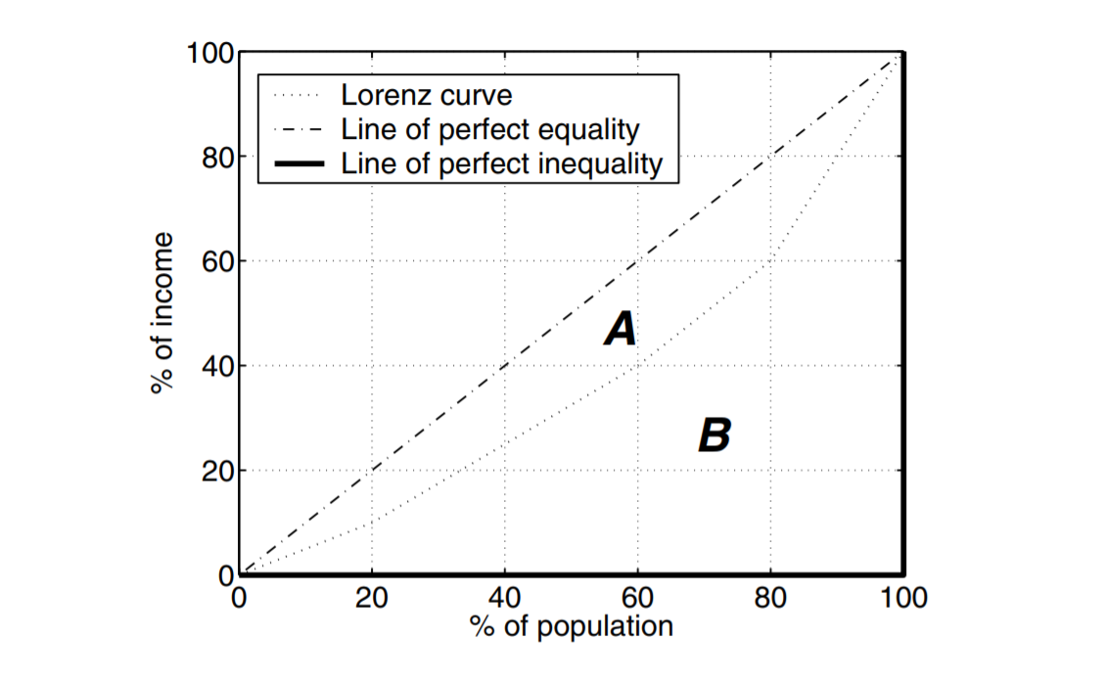

***Figure 1:* *Lorenz curve, line of perfect equality, and line of perfect inequality***

is defined as the ratio of the total degree of the beginning i nodes to the total degree of all nodes for each i between 1 and N, where N is the number of nodes.

We obtain the formula for Gini coefficient**:**

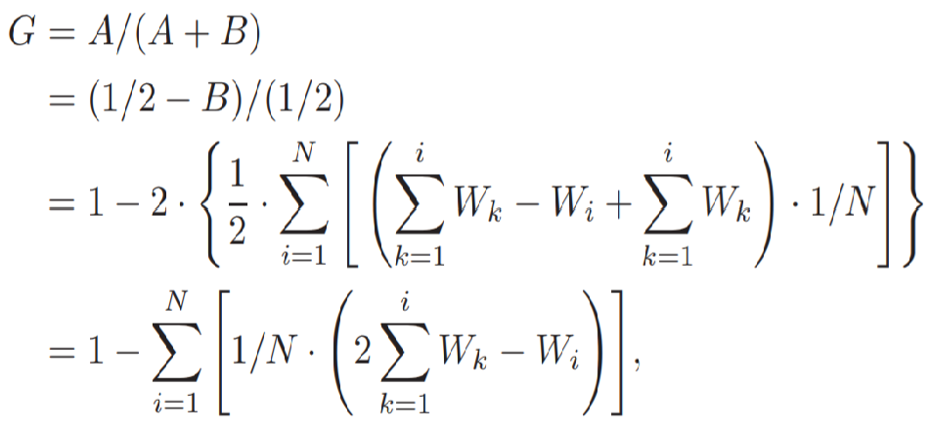

Where Wi (1 ≤ i ≤ N) is the ratio of the ith node’s degree to the total degree of all nodes and 0 ≤ G ≤ 1 [7].

|  |  |
| --- | --- |
| **Chapter 4** | **IMPLEMENTATION** |

* 1. **PROBLEM STATEMENT**

Considering a randomly deployed ad-hoc network, data is transmitted among different sensor nodes. Due to the different topological position of the nodes, energy consumption of each node is different from the others. In long term this leads to a situation where energy level of some nodes diversely differs from one another. Now if the energy level of the neighbors for some node is not sufficient enough to send data through them, but when that node tries to send data packets by only considering the nearest neighbor it is possible that data packet is not delivered due to the low energy level of the neighbours. But the node that is trying to send the packet has sufficient amount of energy.

As we begin to send the packet by considering not only energy state of the node but by considering the energy state of the neighbours as well.

Then the delivery of the packet may be slow but the guaranteed delivery of the dat packet can be ensured. As we are always choosing the neighbours who has sufficient energy to send the data packets.

Previously the energy of some nodes are being depleted rapidly. This causes the network to breakdown. Now after choosing the neighbours who has the sufficient energy to transfer the data packets, energy is evenly distributed among the whole network. Energy states of all the nodes are now more balanced. As a result the network can stay alive for a longer period of time and more data transfer can be possible within the network.

* 1. **PROPOSED ALGORITHMS AND FLOW CHARTS**
     1. **RPL ALGORITHM**
  2. *Sink broadcast DIO to Childs*
  3. *Childs node receive DIO and retrieve attributes and calculate score*
  4. *If it has best parent go to step 4 else go to step 7*
  5. *If dis_idcurrent > dis_idprevious then go to step 5 else step 8*
  6. *If scorecurrent > scoreprevious thyen got to step 6 else step 8*
  7. *Update best parent temporary and go to step 9*
  8. *Add best parent temporary and go to step 9*
  9. *Discard DIO and go to step 9*
  10. *Restart best parent timer*
  11. *Broadcast DIO to Childs*
  12. *Wait for best parent*
  13. *Add to best parent*
  14. *End*
      1. **RPL FLOWCHART**

**Start**

Sink broadcast DIO to Childs

Retrieve attributes and calculate score

Is it has best parent?

If score**current** > score**previous**

Update temp best parent

Broadcast DIO to Childs

Add temp best parent

Wait for best path

Add to best parent

Yes

No

Discard DIO

Yes

No

**End**

If dis_id**current** > dis_id**previous**

Yes

No

Restart best parent timer

* + 1. **AODV ALGORITHM**
  1. *Source broadcast RREQ to its neighbours*
  2. *Neighbours node receive RREQ and retrieve attributes and calculate score*
  3. *If source in routing table then go to step 4 else step 12*
  4. *If seq_nocurrent > seq_noprevious then go to step 5 else step 16*
  5. *If scorecurrent > scoreprevious thyen got to step 6 else step 16*
  6. *Update routing table for source*
  7. *If it is destination go to step 7 else go to step 17*
  8. *Restart RREP timer*
  9. *Wait for best path*
  10. *Unicast RREP to source*
  11. *If it is source go to step 12 else 10*
  12. *Add to routing table to destination and go to step 18*
  13. *Add routing table for source*
  14. *If it is destination go to step 14 else go to step 17*
  15. *Start RREP timer and go to step 9*
  16. *Discard RREQ and go to step 9*
  17. *Broadcast RREQ to its neighbours and go to 2*
  18. *End*
      1. **AODV FLOWCHART**

**Start**

Source broadcast RREQ to neighbours

Retrieve attributes and calculate score

Is source in routing table?

If score**current** > score**previous**

Update routing table

Broadcast RREQ to neighbours

Add to routing table

Is it destination?

Is it destination?

Restart RREP timer

Start RREP timer

Wait for best path

Unicast RREP to source

Broadcast RREQ to neighbours

Yes

Yes

No

No

No

Discard RREQ

Yes

No

Is it destination?

Add to routing table

**End**

Yes

No

If seq_no**current** > seq_no**previous**

Yes

No

|  |  |
| --- | --- |
| **Chapter 5** | **RESULTS AND DISCUSSIONS** |

* 1. **RPL**

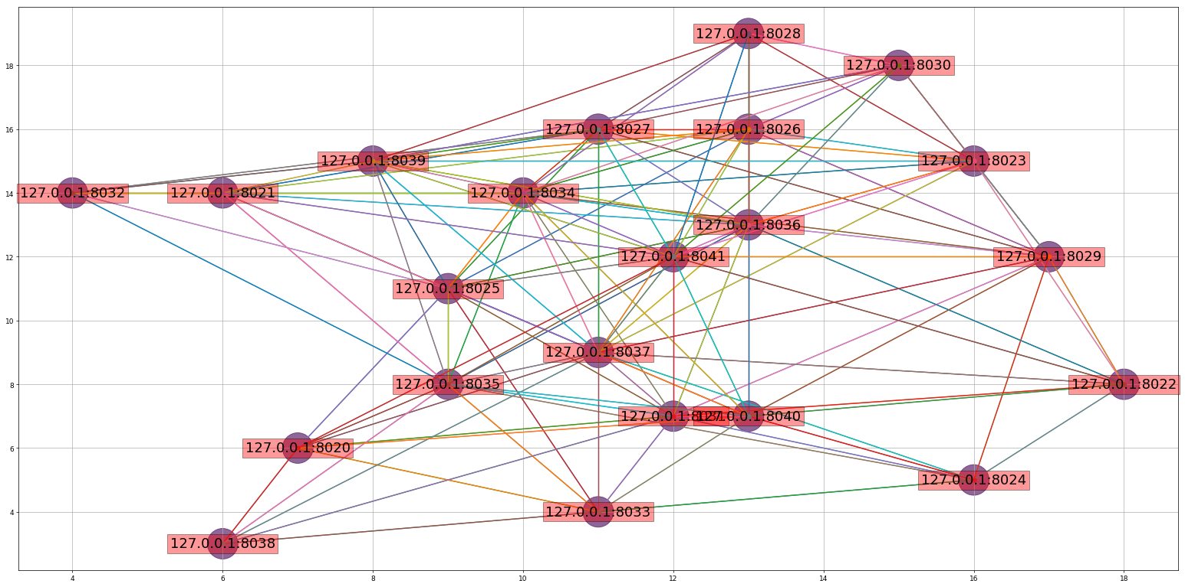

***Figure 2: Network Structure***

**Table:**

|  |  |  |  |  |  |  |  |  |  |  |  |  |  |  |  |  |  |  |  |  |  |  |
| --- | --- | --- | --- | --- | --- | --- | --- | --- | --- | --- | --- | --- | --- | --- | --- | --- | --- | --- | --- | --- | --- | --- |
| Node no | 20 | 21 | 22 | 23 | 24 | 25 | 26 | 27 | 28 | 29 | 30 | 31 | 32 | 33 | 34 | 35 | 36 | 37 | 38 | 39 | 40 | 41 |
| Position (x,y) | 7,6 | 6,14 | 18,8 | 16,15 | 16,5 | 9,11 | 13,16 | 11,16 | 13,19 | 17,12 | 15,18 | 12,7 | 4,14 | 11,4 | 10,14 | 9,8 | 13,13 | 11,9 | 6,3 | 8,15 | 17,7 | 12,12 |

This is a randomly plotted network within an area of 20 unit * 20 unit with 22 nodes. Each node no with its corresponding position is given in the table.

Node no 20->127.0.0.1:8020

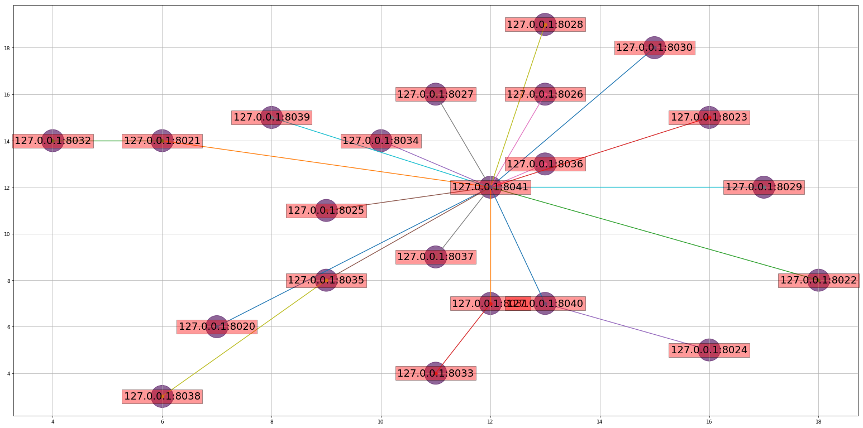

***Figure 3: Network Structure with best parent***

**Table:**

|  |  |  |  |  |  |  |  |  |  |  |  |  |  |  |  |  |  |  |  |  |  |  |
| --- | --- | --- | --- | --- | --- | --- | --- | --- | --- | --- | --- | --- | --- | --- | --- | --- | --- | --- | --- | --- | --- | --- |
| Node no | 20 | 21 | 22 | 23 | 24 | 25 | 26 | 27 | 28 | 29 | 30 | 31 | 32 | 33 | 34 | 35 | 36 | 37 | 38 | 39 | 40 | 41 |
| Position (x,y) | 7,6 | 6,14 | 18,8 | 16,15 | 16,5 | 9,11 | 13,16 | 11,16 | 13,19 | 17,12 | 15,18 | 12,7 | 4,14 | 11,4 | 10,14 | 9,8 | 13,13 | 11,9 | 6,3 | 8,15 | 17,7 | 12,12 |

Node no 41 being the root and other nodes are the senders. Using RPL routing protocol each node has selected its best parent to the destination.

Node no 20->127.0.0.1:8020

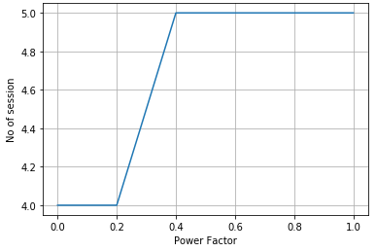

***Figure 4: Max Session vs Power Factor***

**Table:**

|  |  |  |  |  |  |  |
| --- | --- | --- | --- | --- | --- | --- |
| Power Factor | 0.0 | 0.2 | 0.4 | 0.6 | 0.8 | 1.0 |
| No of Session | 4 | 4 | 5 | 5 | 5 | 5 |

Power Factor 0.0 is giving maximum priority to hop count for deciding the best parent.

Power Factor 1.0 is giving maximum priority to remaining energy for deciding the best parent.

Intermediate Power Factors are showing the transition for giving priority from hop count to remaining energy.

From Figure 4, it is evident that when choosing the best parent using hop count only the network is able to complete 4 sessions. But as we increase the priority to remaining energy the network was able to complete 5 sessions.

1 session = each node sending data to the root.

So, if we consider remaining power to choose the parent our network will perform better.

It is showing 25% improvement rate.

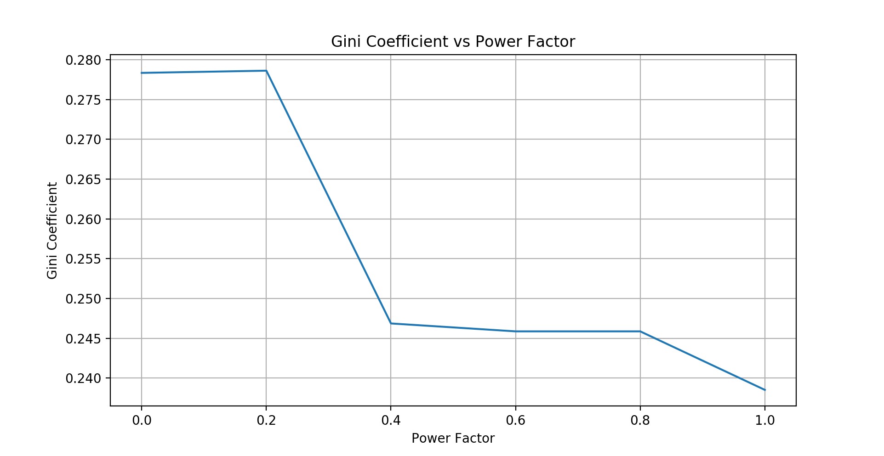

***Figure 5: Gini Coefficient after 4 sessions***

**Table:**

|  |  |  |  |  |  |  |
| --- | --- | --- | --- | --- | --- | --- |
| Power Factor | 0.0 | 0.2 | 0.4 | 0.6 | 0.8 | 1.0 |
| Gini Coefficient | 0.278 | 0.278 | 0.247 | 0.246 | 0.246 | 0.238 |

Figure 5 is showing the gini-coefficient for different Power Factors after completing 4 sessions.

Greater value for gini-coefficient indicates that the neighbour’s energy heterogeneity is more and lesser value for gini-coefficient indicates that the neighbour’s energy heterogeneity is less.

For Power Factor 0.0 as energy is diversely distributed the gini-coefficient is showing a greater value.

For Power Factor 1.0 as energy is equally distributed the gini-coefficient is showing a lesser value.

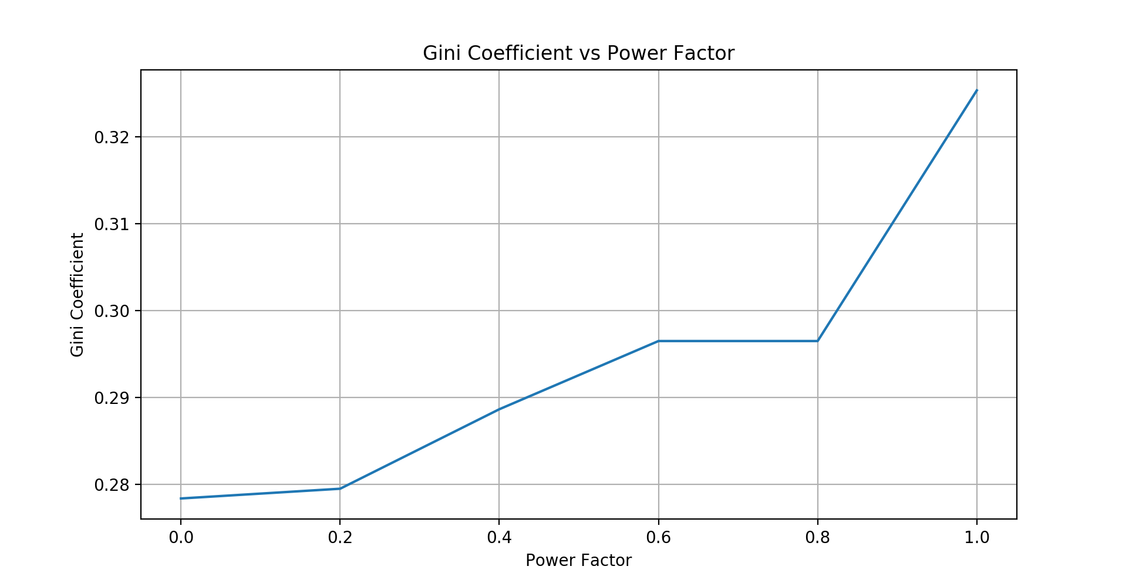

***Figure 6: Gini Coefficient after first death***

**Table:**

|  |  |  |  |  |  |  |
| --- | --- | --- | --- | --- | --- | --- |
| Power Factor | 0.0 | 0.2 | 0.4 | 0.6 | 0.8 | 1.0 |
| Gini Coefficient | 0.278 | 0.279 | 0.288 | 0.297 | 0.297 | 0.326 |

Figure 6 is showing the gini-coefficient for different Power Factors after encountering the first death.

For Power Factor 0.0 as the first death has happened at 4th session there is change in the gini-coefficent value between Figure 6 and Figure 5.

But for Power Factor 1.0 as the first death was encountered at 5th session. More energy is consumed and difference can be seen between Figure 6 and figure 5.

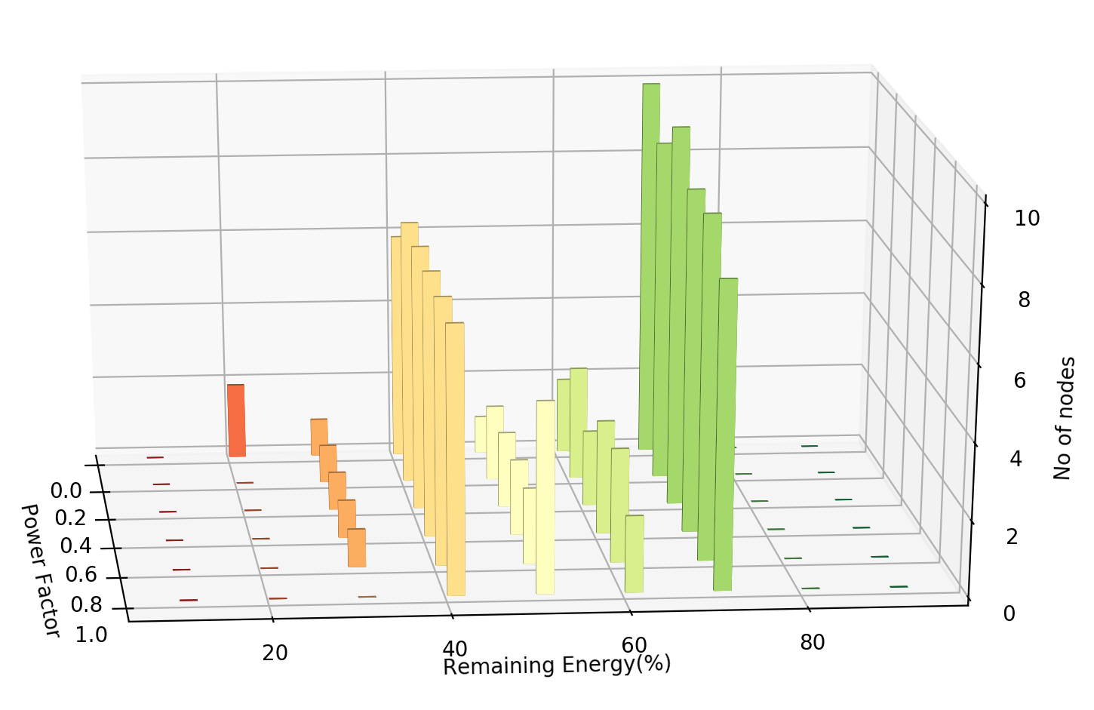

***Figure 7: Energy status after 4 sessions***

**Table:**

|  |  |  |  |  |  |  |
| --- | --- | --- | --- | --- | --- | --- |
| Power Factor  Remaining Energy | ***0.0*** | ***0.2*** | ***0.4*** | ***0.6*** | ***0.8*** | ***1.0*** |
| 10-20% | ***2*** | ***0*** | ***0*** | ***0*** | ***0*** | ***0*** |
| 20-30% | ***1*** | ***1*** | ***1*** | ***1*** | ***1*** | ***0*** |
| 30-40% | ***6*** | ***7*** | ***7*** | ***7*** | ***7*** | ***7*** |
| 40-50% | ***1*** | ***2*** | ***2*** | ***2*** | ***2*** | ***4*** |
| 50-60% | ***2*** | ***3*** | ***2*** | ***3*** | ***3*** | ***2*** |
| 60-70% | ***10*** | ***9*** | ***10*** | ***9*** | ***9*** | ***8*** |
| 70-80% | ***0*** | ***0*** | ***0*** | ***0*** | ***0*** | ***0*** |

Figure 7 is showing total no of nodes (out of 22 nodes in the network) for their remaining percentage of energy left for different power factors after completing 4 sessions.

When giving only priority to hop count (Power Factor 0.0) after completing 4 sessions, 2 nodes (out of 22 nodes) are below 20% of their initial energy and 10 nodes are below 70% of their initial energy. This shows that the energy heterogeneity is maximum when best parent is chosen only using hop count.

But when the total priority is given to remaining energy of the nodes (Power Factor 1.0) completing 4 sessions no node is below 30%. This shows that energy is evenly consumed among different nodes.

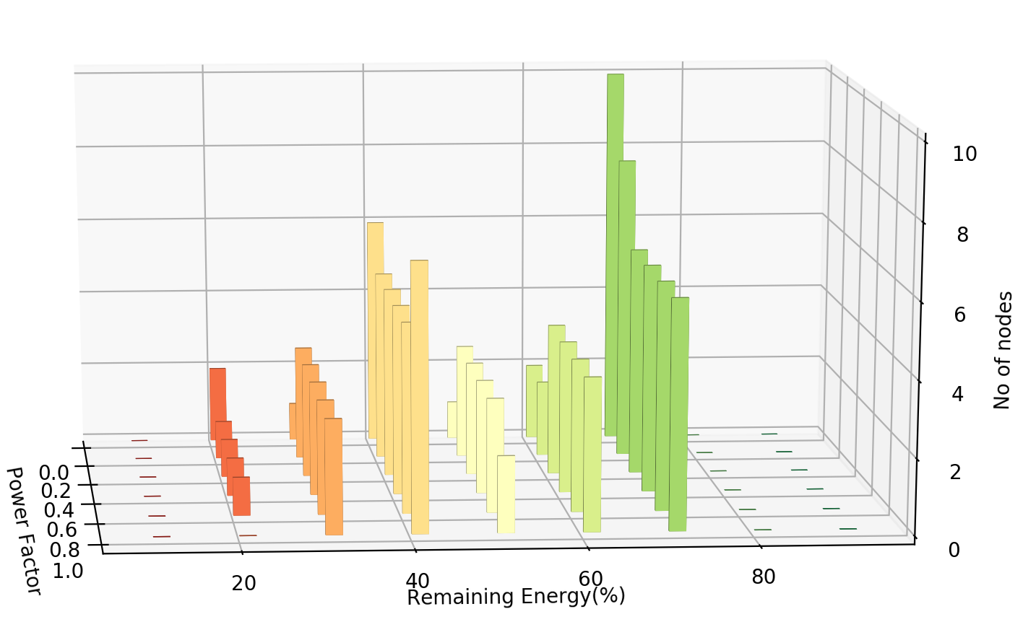

***Figure 8: Energy Status after first death***

**Table:**

|  |  |  |  |  |  |  |
| --- | --- | --- | --- | --- | --- | --- |
| Power Factor  Remaining Energy | ***0.0*** | ***0.2*** | ***0.4*** | ***0.6*** | ***0.8*** | ***1.0*** |
| 10-20% | ***2*** | ***1*** | ***1*** | ***1*** | ***1*** | ***0*** |
| 20-30% | ***1*** | ***3*** | ***3*** | ***3*** | ***3*** | ***3*** |
| 30-40% | ***6*** | ***5*** | ***5*** | ***5*** | ***5*** | ***6*** |
| 40-50% | ***1*** | ***3*** | ***3*** | ***3*** | ***3*** | ***2*** |
| 50-60% | ***2*** | ***2*** | ***4*** | ***4*** | ***4*** | ***4*** |
| 60-70% | ***10*** | ***8*** | ***6*** | ***6*** | ***6*** | ***6*** |
| 70-80% | ***0*** | ***0*** | ***0*** | ***0*** | ***0*** | ***0*** |

Figure 8 is showing total no of nodes (out of 22 nodes in the network) for their remaining percentage of energy left for different power factors after encountering first death.

From Figure 7 it is evident that energy heterogeneity is much less when giving priority to remaining energy of the nodes (Power Factor 1.0). So first death has not happened at that time. Session 5 can be completed for the same network. That is why remaining energy percentage for Power Factor 1.0 has come down in Figure 8 compared to Figure 7.

* 1. **AODV**



***Figure 9: Network Structure***

**Table:**

|  |  |  |  |  |  |  |  |  |  |  |  |  |  |  |  |  |  |  |  |  |  |  |
| --- | --- | --- | --- | --- | --- | --- | --- | --- | --- | --- | --- | --- | --- | --- | --- | --- | --- | --- | --- | --- | --- | --- |
| Node no | 20 | 21 | 22 | 23 | 24 | 25 | 26 | 27 | 28 | 29 | 30 | 31 | 32 | 33 | 34 | 35 | 36 | 37 | 38 | 39 | 40 | 41 |
| Position (x,y) | 7,6 | 6,14 | 18,8 | 16,15 | 16,5 | 9,11 | 13,16 | 11,16 | 13,19 | 17,12 | 15,18 | 12,7 | 4,14 | 11,4 | 10,14 | 9,8 | 13,13 | 11,9 | 6,3 | 8,15 | 17,7 | 12,12 |

This is a randomly plotted network within an area of 20 unit * 20 unit with 22 nodes. Each node no with its corresponding position is given in the table.

Node no 20->127.0.0.1:8020



***Figure 10: Network Structure with best path***

Table:

|  |  |  |  |  |  |  |  |  |  |  |  |  |  |  |  |  |  |  |  |  |  |  |
| --- | --- | --- | --- | --- | --- | --- | --- | --- | --- | --- | --- | --- | --- | --- | --- | --- | --- | --- | --- | --- | --- | --- |
| Node no | 20 | 21 | 22 | 23 | 24 | 25 | 26 | 27 | 28 | 29 | 30 | 31 | 32 | 33 | 34 | 35 | 36 | 37 | 38 | 39 | 40 | 41 |
| Position (x,y) | 7,6 | 6,14 | 18,8 | 16,15 | 16,5 | 9,11 | 13,16 | 11,16 | 13,19 | 17,12 | 15,18 | 12,7 | 4,14 | 11,4 | 10,14 | 9,8 | 13,13 | 11,9 | 6,3 | 8,15 | 17,7 | 12,12 |

Node no 41 being the root and other nodes are the senders. Using AODV routing protocol each node has selected its best path to the destination.

Node no 20->127.0.0.1:8020

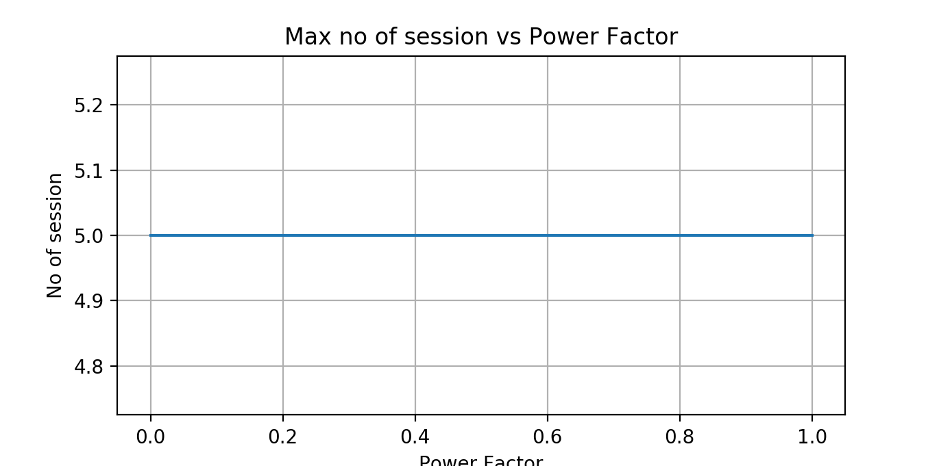

***Figure 11: Max Session vs Power Factor***

Table:

|  |  |  |  |  |  |  |
| --- | --- | --- | --- | --- | --- | --- |
| Power Factor | 0.0 | 0.2 | 0.4 | 0.6 | 0.8 | 1.0 |
| No of Session | 5 | 5 | 5 | 5 | 5 | 5 |

Power Factor 0.0 is giving maximum priority to hop count for deciding the best parent.

Power Factor 1.0 is giving maximum priority to remaining energy for deciding the best parent.

Intermediate Power Factors are showing the transition for giving priority from hop count to remaining energy.

From Figure 11, it is evident that when choosing the best parent using hop count only the network is able to complete 5 sessions. This is same as we increase the priority to remaining energy the network was able to complete 5 sessions.

There is no immenent difference for chsnging the priority from hop count to power factor.

1 session = each node sending data to the root.

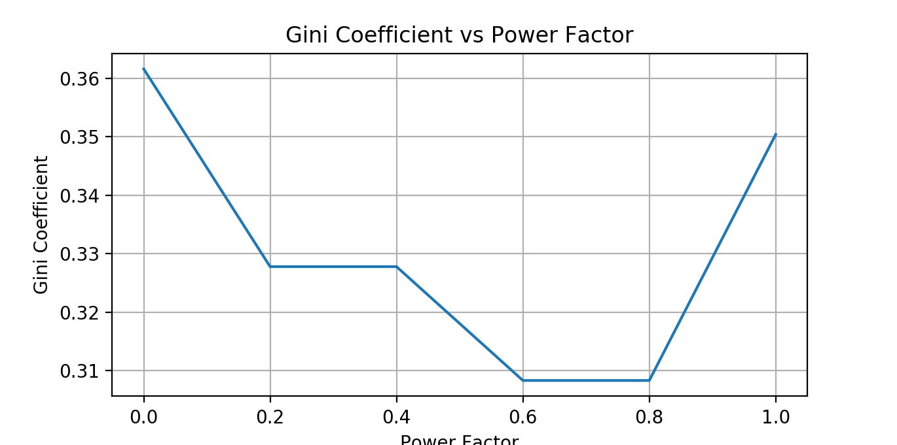

***Figure 12: Gini Coefficient after 5 sessions***

Table:

|  |  |  |  |  |  |  |
| --- | --- | --- | --- | --- | --- | --- |
| Power Factor | 0.0 | 0.2 | 0.4 | 0.6 | 0.8 | 1.0 |
| Gini Coefficient | 0.362 | 0.328 | 0.328 | 0.309 | 0.309 | 0.35 |

Figure 12 is showing the gini-coefficient for different Power Factors after completing 5 sessions.

Greater value for gini-coefficient indicates that the neighbour’s energy heterogeneity is more and lesser value for gini-coefficient indicates that the neighbour’s energy heterogeneity is less.

For Power Factor 0.0 as energy is diversely distributed the gini-coefficient is showing a greater value.

For Power Factor 1.0 as energy is equally distributed the gini-coefficient is showing a lesser value.



***Figure 13: Gini Coefficient after first death***

Table:

|  |  |  |  |  |  |  |
| --- | --- | --- | --- | --- | --- | --- |
| Power Factor | 0.0 | 0.2 | 0.4 | 0.6 | 0.8 | 1.0 |
| Gini Coefficient | 0.362 | 0.328 | 0.328 | 0.309 | 0.309 | 0.35 |

Figure 13 is same as Figure 12 as they have both completed same no of sessions.

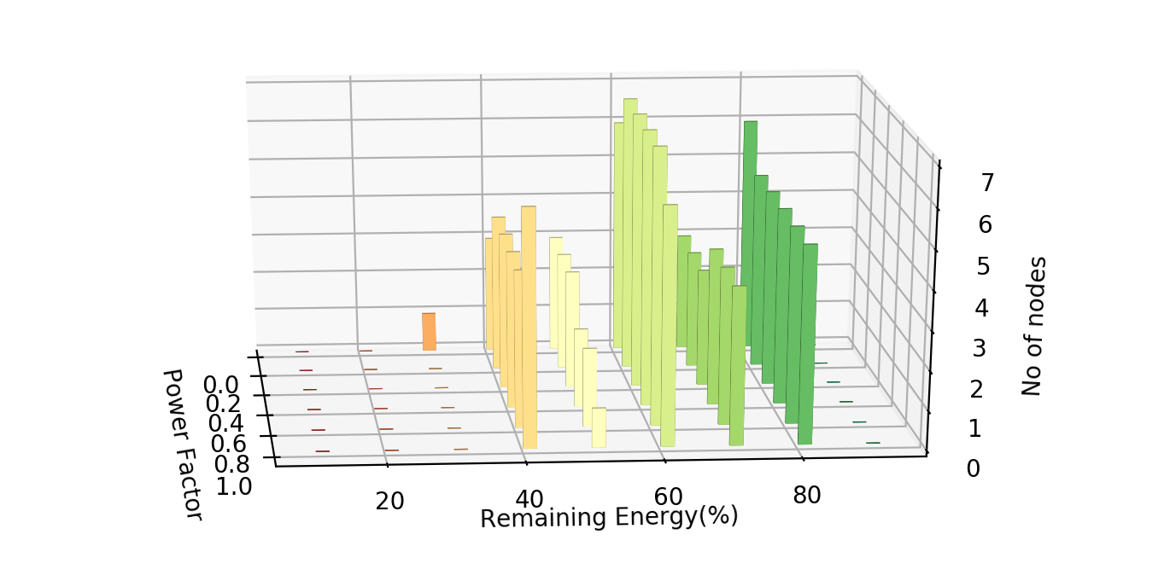

***Figure 14: Energy status after 5 sessions***

**Table:**

|  |  |  |  |  |  |  |
| --- | --- | --- | --- | --- | --- | --- |
| Power Factor  Remaining Energy | ***0.0*** | ***0.2*** | ***0.4*** | ***0.6*** | ***0.8*** | ***1.0*** |
| 10-20% | ***2*** | ***0*** | ***0*** | ***0*** | ***0*** | ***0*** |
| 20-30% | ***1*** | ***1*** | ***1*** | ***1*** | ***1*** | ***0*** |
| 30-40% | ***6*** | ***7*** | ***7*** | ***7*** | ***7*** | ***7*** |
| 40-50% | ***1*** | ***2*** | ***2*** | ***2*** | ***2*** | ***4*** |
| 50-60% | ***2*** | ***3*** | ***2*** | ***3*** | ***3*** | ***2*** |
| 60-70% | ***10*** | ***9*** | ***10*** | ***9*** | ***9*** | ***8*** |
| 70-80% | ***0*** | ***0*** | ***0*** | ***0*** | ***0*** | ***0*** |

Figure 14 is showing total no of nodes (out of 22 nodes in the network) for their remaining percentage of energy left for different power factors after encountering first death.

From Figure 14 it is evident that energy heterogeneity is much less when giving priority to remaining energy of the nodes (Power Factor 1.0).

|  |  |
| --- | --- |
| **Chapter 6** | **FUTURE SCOPE** |

Only a limited number of aspects of a sensor network have been considered here. Future work would explore similar issues in a query-driven and event-driven type of sensor networks. The possibility of several collectors located in different places should also be considered. Another important issue to be explored is a heterogeneous network model where the difference between the sensors is not only the difference in available energy, but also in their processing capabilities, and thus the consideration of energy consumption in data processing (compression, fusion, etc.). Throughout the paper efficient use of the energy was given top priority. In cases where delay and the resolution of the data are just as important, these performance measures should be considered jointly with energy efficiency.

|  |  |
| --- | --- |
| **Chapter 7** | **CONCLUSION** |

By selecting the best path using hop count only some particular nodes will be used repeatedly result of which is that there will be more energy drainage of that particular nodes because after establishment of a path for sending and receiving packet from source to destination the same path is used repeatedly without altering .Hence a time will immerse when the nodes will be unable to send or receive  further packets while the remaining nodes in the network will still have higher energy levels resulting in the decrease in the longitivity of the network . On the other hand by selecting the best path considering the power therefore using remaining power of the other nodes resulting in the increasing number of session because now in every node there is equal power consumption which shows the network can stay alive for a longer period of time as well as the energy consumption for each nodes will not change drastically, which was happening when we were considering only the hop count.

**REFERENCES**

1. Chen, Yunxia, and Qing Zhao. "On the lifetime of wireless sensor networks." *IEEE Communications letters* 9.11 (2005): 976-978
2. Smaragdakis, Georgios, Ibrahim Matta, and Azer Bestavros. *SEP: A stable election protocol for clustered heterogeneous wireless sensor networks*. Boston University Computer Science Department, 2004
3. Qing, Li, Qingxin Zhu, and Mingwen Wang. "Design of a distributed energy-efficient clustering algorithm for heterogeneous wireless sensor networks." *Computer communications* 29.12 (2006): 2230-2237
4. <https://www.techopedia.com/definition/2922/ad-hoc-on-demand-distance-vector-aodv>
5. <https://www.cs.jhu.edu/~cs647/aodv.pdf>
6. <https://en.wikipedia.org/wiki/RPL_(IPv6_Routing_Protocol_for_LLNs)>
7. Joseph L. Gastwrith * “The estimation of lorentz curve and gini index”

|  |
| --- |
|  |