**SQL | ALL and ANY**

**ALL & ANY** are logical operators in SQL. They return boolean value as a result.

**ALL**

ALL operator is used to select all tuples of SELECT STATEMENT. It is also used to compare a value to every value in another value set or result from a subquery.

* The ALL operator returns TRUE iff all of the subqueries values meet the condition. The ALL must be preceded by comparison operators and evaluates true if all of the subqueries values meet the condition.
* ALL is used with SELECT, WHERE, HAVING statement.

**ALL with SELECT Statement:**

Syntax:

SELECT ALL field_name

FROM table_name

WHERE condition(s);

**ALL with WHERE or HAVING Statement:**

Syntax:

SELECT column_name(s)

FROM table_name

WHERE column_name comparison_operator ALL

(SELECT column_name

FROM table_name

WHERE condition(s));

Example:  
Consider the following Products Table and OrderDetails Table,

## Products Table

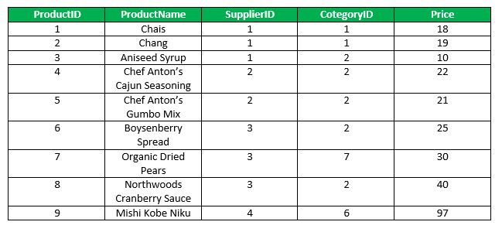

# OrderDetails Table

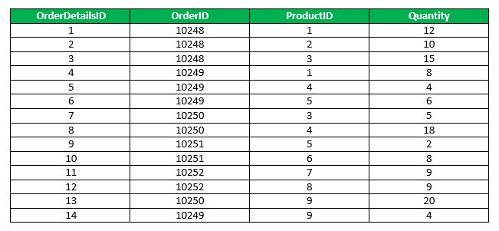

**Queries**

* **Find the name of the all the product.**
* SELECT ALL ProductName
* FROM Products
* WHERE TRUE;

Output:

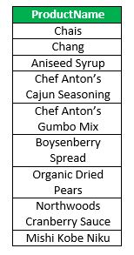

* **Find the name of the product if all the records in the OrderDetails has Quantity either equal to 6 or 2.**
* SELECT ProductName
* FROM Products
* WHERE ProductID = ALL (SELECT ProductId
* FROM OrderDetails
* WHERE Quantity = 6 OR Quantity = 2);

Output:

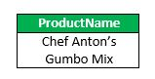

* **Find the OrderID whose maximum Quantity among all product of that OrderID is greater than average quantity of all OrderID.**
* SELECT OrderID
* FROM OrderDetails
* GROUP BY OrderID
* HAVING max(Quantity) > ALL (SELECT avg(Quantity)
* FROM OrderDetails
* GROUP BY OrderID);

Output:

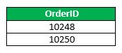

ANY

ANY compares a value to each value in a list or results from a query and evaluates to true if the result of an inner query contains at least one row.

* ANY return true if any of the subqueries values meet the condition.
* ANY must be preceded by comparison operators.  
  **Syntax:**

SELECT column_name(s)

FROM table_name

WHERE column_name comparison_operator ANY

(SELECT column_name

FROM table_name

WHERE condition(s));

**Queries**

* Find the Distinct CategoryID of the products which have any record in OrderDetails Table.
* SELECT DISTINCT CategoryID
* FROM Products
* WHERE ProductID = ANY (SELECT ProductID
* FROM OrderDetails);

Output:

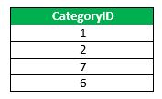

* Finds any records in the OrderDetails table that Quantity = 9.
* SELECT ProductName
* FROM Products
* WHERE ProductID = ANY (SELECT ProductID
* FROM OrderDetails
* WHERE Quantity = 9);

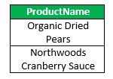

SQL SOME

SOME operator evaluates the condition between the outer and inner tables and evaluates to true if the final result returns **any one** row. If not, then it evaluates to false.

## The SOME and ANY comparison conditions are similar to each other and are completely interchangeable.

## SOME must match at least one row in the subquery and must be preceded by comparison operators.

## Syntax:

## SELECT column_name(s)

## FROM table_name

## WHERE expression comparison_operator SOME (subquery)

### Instructor Table:

|  |  |  |
| --- | --- | --- |
| Name | Department | Salary |
| Chandra | Computational Biology | 1 |
| Visweswaran | Electronics | 1.5 |
| Abraham | Computer Science | 1.3 |
| John | Electronics | 1.2 |
| Samantha | Computer Science | 2 |
| Jyoti | Electronics | 1.2 |
| Debarka | Computer Science | 2 |
| Ganesh | Computational Biology | 0.9 |

select name

from instructor

where Salary > some(select Salary

from instructor

where dept='Computer Science');

**Output:**

|  |
| --- |
| Visweswaran |
| Samantha |
| Debarka |

How to Convert From BLOB to Text in MySQL?

**BLOB:** It stands for Binary Large Object. It is a kind of data type in MySQL that can store files or images in the database in binary format.  It has four types i.e TINYBLOB, BLOB, MEDIUMBLOB, and LONGBLOB. All four types are similar, the only difference among them is the amount of data they can hold.

AS the name suggests, LONGBLOB can hold the maximum amount of data and TINYBLOB can hold the least amount of data among the four types.

TEXT datatype in MySQL is used for storing long text strings in the database. It is just like VARCHAR. In order to convert BLOB to TEXT, we will use the CONVERT statement.

**Syntax:**

CONVERT( column_name using utf8);

utf8 is the way of encoding Unicode characters. It is recommended to use ut8 while creating web pages and databases. For demonstration, follow the below steps:

**Step 1:** Create a database

we can use the following command to create a database called geeks.

**Query:**

CREATE DATABASE geeks;

https://media.geeksforgeeks.org/wp-content/uploads/20211118222211/sql1.PNG

**Step 2:** Use database

Use the below SQL statement to switch the database context to geeks:

**Query:**

USE geeks;

https://media.geeksforgeeks.org/wp-content/uploads/20211118222306/sql1.PNG

**Step 3:** Table definition

We have demo_table in our geek’s database.

**Query:**

CREATE TABLE demo_table(

NAME VARCHAR(20),

AGE INT,

CITY VARCHAR(20),

FILE BLOB);

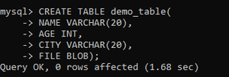

**Step 4:**Insert data into a table

**Query:**

INSERT INTO demo_table VALUES ('Romy', 21,

'Delhi', 'My name is romy kumari,

I am 21 yrs old'),

('Pushkar', 22, 'Delhi',

'My name is Pushkar jha,

I am 22 yrs old'),

('Rinkle', 22, 'Punjab',

'My name is Rinkle Arora,

I am 22 yrs old'),

('Ayushi', 22, 'Patna', 'My name is

Ayushi choudhary, I am 22 yrs old');

**Step 5:** View the content

Execute the below query to see the content of the table

**Query:**

SELECT * FROM demo_table;

**Output:**

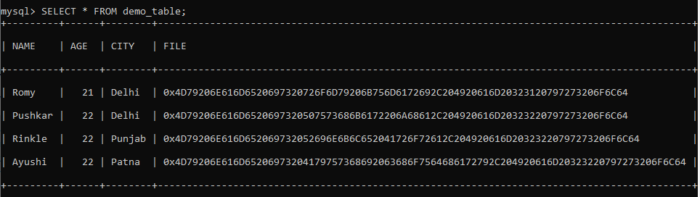

We can see that content of the FILE column is in encoded format.

**Step 6:** Conversion from BLOB to TEXT.

**Query:**

SELECT convert(File using utf8)

from demo_table;

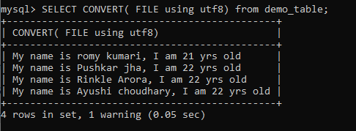

If you want to update the BLOB datatype column to the TEXT datatype column. Follow these steps:

* Alter the table and add a column having data type TEXT.
* Add content to that column after converting BLOB data to TEXT date.
* Drop BLOB column.

**Step 1**: Add column

**Syntax**:

ALTER Table demo_table ADD

COLUMN AFTER_CONERSION TEXT;

https://media.geeksforgeeks.org/wp-content/uploads/20211120195334/sql1.PNG

**Step 2:**Add content to column

UPDATE demo_table SET AFTER_CONERSION

= CONVERT (FILE using utf8);

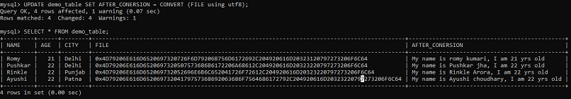

**Step 3:** Drop BLOB column

ALTER TABLE demo_table

DROP COLUMN FILE;

