**********************************************************
**CALLABLE NODE**
IN
IBM
INTEGRATION
BUS
************************************************************
Contains

- Introduction of Callable Node
- Callable Node used in flow
- Error Related Concept
- Server Related Scenarios
- Preparing the environment for Integration server

Reviewed By:-

Introduction
In IIB V10.0.0.4 Callable node was introduced. This enables a message flow (or integration service, or REST API) to invoke a separate message flow in a call/return the appropriate output.
The Node Basically uses for calling the message flows. Here the caller and called message flow can be in the same or in a different integration node in the local system or in different remote system.
There are 5 Callable nodes are available to design the message flow according to our requirement. The nodes are following ;
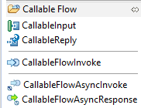
fig:1(Callable Node)
- CallableInput Node
- The CallableInput node is contained in the Callable Flow Drawer of the palette.
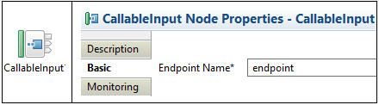
fig:2(CallableInput Node with properties)
- This is used to invoke/called from another message flow of another location.
- We have to mention the Endpoint Name value, which should match with the CallableFlowInvoke node property called "Endpoint Name" value.
- CallableReplay Node
- The CallableReplay node is contained in the Callable Flow Drawer of the palette.
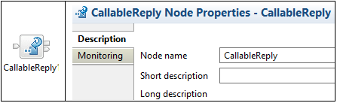
fig:3(CallableReplay Node with properties)

- This is used to return information to a called message flow of another location.

- CallableFlowInvoke Node
- The CallableFlowInvoke node is contained in the Callable Flow Drawer of the palette.
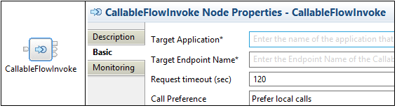
fig:4(CallableFlowInvoke Node with properties)
- This is used to invoke/call a message flow of another location.
- We have to mention the Target Application name, which one we want to call in Target Application Property in the main property named "Basic".
- Request Timeout properties indicate that, The time within which the callable flow must be called,in seconds. If the callable flow not called within the specified time, we will get an error.
- Call Preference Property indicates that, what is the flow location which is going to call by our CallableFlowInvoke Node. This property has two options, first one is "Prefer local calls" and "Remote calls only" used for local call and remote call.

- CallableFlowAsyncInvoke Node
- The CallableFlowAsyncInvoke node is contained in the Callable Flow Drawer of the palette.
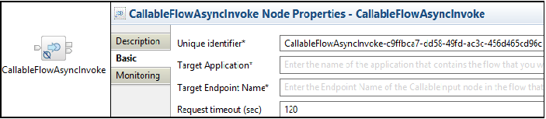
fig:5(CallableFlowAsyncInvoke Node with properties)
- This is used to invoke/called a message flow of another location as an Asynchronous manner.
- Except one extra property all the properties are same as CallableFlowInvoke Node.
- The extra property is Unique Identifier.
- By using this property value we connect CallableFlowAsyncInvoke Node to CallableFlowAsyncResponse Node . And the Unique Identifier properties values automatically generated at the time of flow creation, we only have to copy that unique identifier values and paste that into our CallableFlowAsyncResponse Node unique Identifier values.

- CallableFlowAsyncResponse Node
The CallableFlowAsyncResponse node is contained in the Callable Flow Drawer of the palette.
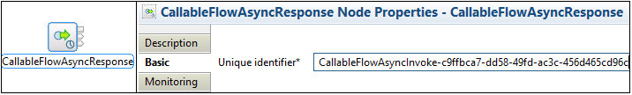
fig:6(CallableFlowAsyncResponse Node with properties)

- This is used to receive messages from the CallableReplay node of another location as an Asynchronous manner.
- Here the Unique Identifier property values must be same as the Unique Identifier value of the related CallableFlowAsyncInvoke Node.
Callable Node Uses in Our Flow
- Example 1
Here you have to create a sample flow to call another message flow, which is working like a provider flow.
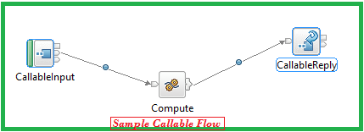
fig:7(Basic Caller flow)
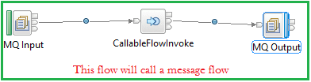
fig:8(Basic Callable flow)
step:1 Create a flow like fig: 7 and fig: 8, take CallableInput node, Compute node, CallableReplay node and MQ input, CallableFlowInvoke node, MQ output respectively as per flow.
step:2 Keep a value (e.g.: - endpoint, AAA, xyz, etc.) in Endpoint Name property of CallableInput Node.
step:3 In fig:8 keep a Queue name in MQ Input Node and choose the type of message domain which type of message you want to send to callable flow and keep a Queue name in MQ output Node also.
step:4 In fig: 8, In CallableFlowInvoke Node keep the Target Application Name, Unique Identifier name same as CallableInput node(fig:7) and choose the Call Preference as prefer local calls(Can take remote call also).
step:5 After finishing all the configuration, deploy your provider flow and then deploy your consumer flow in same integration server.
step:6 Then put a message in your Queue the observe the flow execution.

- Example 2
Here you have to take a message Asynchronous flow, and observe the execution flow.
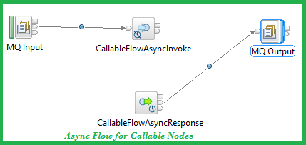
fig:9(Basic Callable flow of Asynchronous nodes)
Note:- Follow all the steps of Example one for the same properties.
Extra Steps: Here your flow creation time the Unique Identifier property value will automatically generate in CallableFlowAsynInvoke Node so we have to copy this value and paste in CallableFlowAsyncResponse Node's Unique identifier property value.

Some Error Related Concept
You may get one error like below picture;
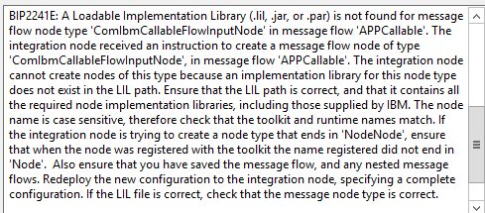
fig:10(error got at deployment time)
This error you may get, while deployed your flow in your integration server.
And If your integration node created in older version than v10 .0.0.4.
I was trying to deploy my application in one integrated server named as "default" which was associated with the Integration node called "IIB" which was created with the version of 10.0.0.2 .

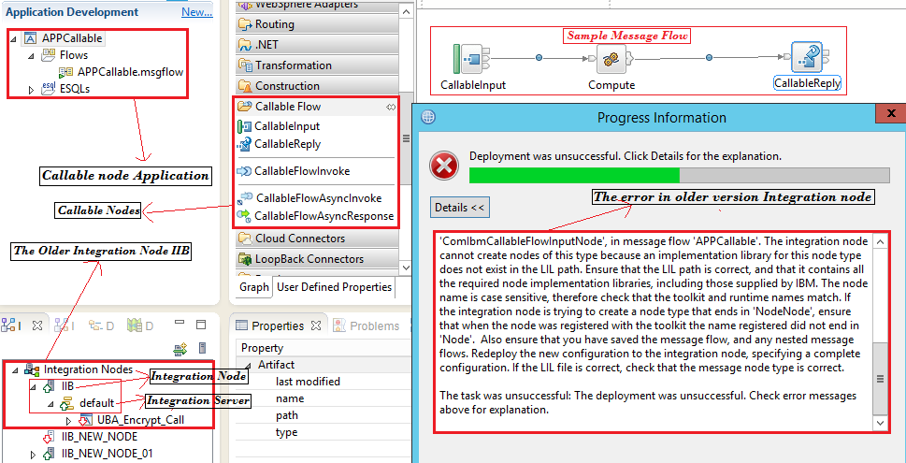
fig:11(error while deploying the application in older version 10.0.0.2)

- Why I got this error?
As I was trying to deploy this application in the 'default' server of Integration node called 'IIB' and I created this Integration Node through the V10.0.0.2 and at the time of creation of this Integration Node the version related node's implement library are created in LIL path. And when I was trying to deploy my callableNode flow the Integration node did not find the node related implementation library in lil path, so that it was give a error and my flow was not deployed in that Integration node called 'IIB'.
For resolving this issue I created a new Integration node and created a new server on my newer version FIX Pack of IIB toolkit. And finally I resolved the issue.

(Note: Even you use the newer version than 10.0.0.4 and your Integration node is associated with the older version than 10.0.0.4 ,then you will get same issue. So always remember that your Integration node must and should create with 10.0.0.4 and later version while working with Callable node.)

Scenarios

Before going to next level discussion, we have to know some small concept, like
- Connection Agent :- An agent which takes an active role or produced Connection on something (like: Server and etc.).
- Switches :- Switches are used to connect multiple devices on the same network.
- Switch Server :- Switch Server is nothing but the server which is connected multiple server in a network and help those servers to exchange the their information and connect each other to finish dependable work.

01.Splitting flows synchronously between applications on the same integration server
For This no need of any Switch server and Connection agent. And this scenario is supported on all OS.
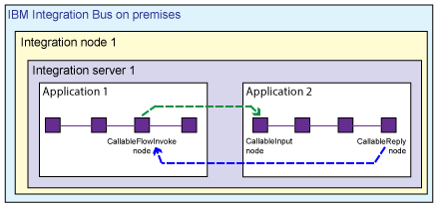
fig:12

02.Splitting flows synchronously between applications on the Different integration server
A message flow is an IIB integration server calls a message flow in a different integration server. These integration servers can be on the same integration node or different integration nodes, as shown in the following fig:13.
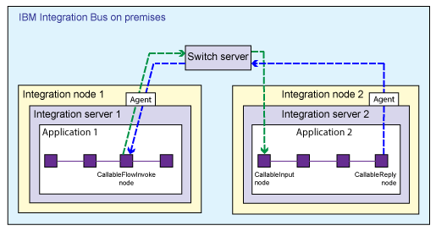
fig:13

For above effect we have run some command and create Connection agent and switch server.

03.Splitting flows synchronously between IIB and IIB on Cloud
A message flow in IBM Integration Bus calls a message flow in IBM Integration Bus on Cloud, or a message flow in IBM Integration Bus on Cloud calls a message flow in IBM Integration Bus.
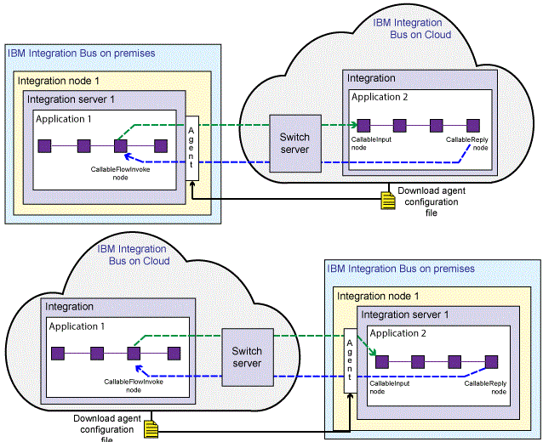
fig:14
If your flows are split between IBM Integration Bus and IBM Integration Bus on Cloud, the Switch server is managed by IBM Integration Bus on Cloud. You download a file from the cloud that configures an on-premises connectivity agent. This scenario is supported on Windows and Linux only.

04.Splitting flows synchronously between IIB and IAC on IBM Cloud -Enterprise Plan(Beta)
A message flow in IBM Integration Bus calls a message flow in IBM App Connect on IBM Cloud - Enterprise plan (beta), or a message flow in IBM App Connect on IBM Cloud - Enterprise plan (beta) calls a message flow in IBM Integration Bus.
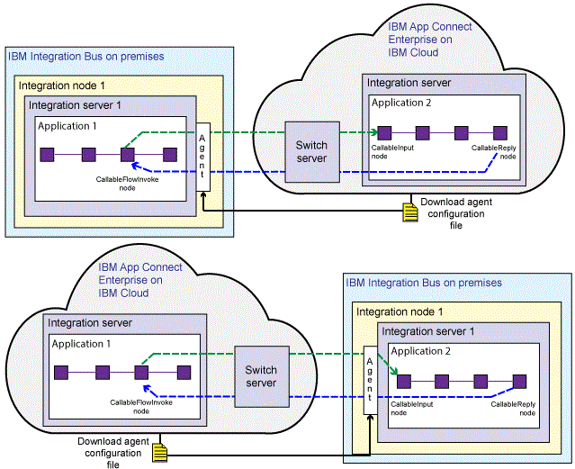
fig:17
If your flows are split between IBM Integration Bus and IBM App Connect on IBM Cloud - Enterprise plan (beta), the Switch server is managed by IBM App Connect on IBM Cloud - Enterprise plan (beta). You download a file from the cloud that configures an on-premises connectivity agent. This scenario is supported on Windows and Linux only.

05.Splitting flows synchronously between different Locations in IBM Integration Bus on Cloud
A message flow in one application calls a message flow in another application in the same integration in IBM Integration Bus on Cloud. If you have an on-demand subscription, where you can run multiple integrations in the same space, you can also call an application in a different integration.
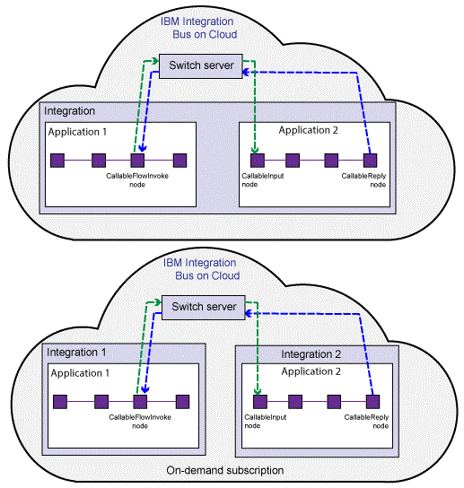
fig:18
The Switch server is created automatically in the cloud. When you upload a BAR file, any callable flow nodes are registered automatically with the Switch server. Therefore, no other setup is required.

06.Splitting flows synchronously between IBM Integration Bus and IBM Integration Bus on Cloud
A message flow in IBM Integration Bus calls a message flow in IBM Integration Bus on Cloud, or a message flow in IBM Integration Bus on Cloud calls a message flow in IBM Integration Bus.
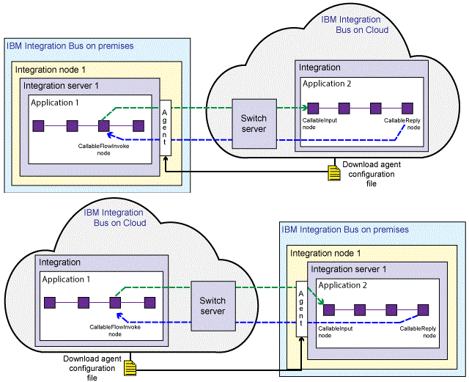
fig:19
If your flows are split between IBM Integration Bus and IBM Integration Bus on Cloud, the Switch server is managed by IBM Integration Bus on Cloud. You download a file from the cloud that configures an on-premises connectivity agent. This scenario is supported on Windows and Linux only.
Preparing the Environment For Integration Server
When you split message flow processing between different integration servers, you must configure a data router and a connectivity agent. The integration servers can be running on different integration nodes.
When you split processing between different integration servers, your flows communicate by using a Switch server and connectivity agents.

To prepare the environment to split processing between integration servers, complete the following steps.
- Open the console and run
iibcreateswitchcfg /output c:\temp

(create a temp folder in c drive )(Windows)

iibcreateswitchcfg -output /temp (linux)
*If this command is successful, you will see the following responses:
Generated self signed certificate file 'c:\temp\adminClient.p12'
Generated switch configuration file 'c:\temp\switch.json'
Generated agentx configuration file 'c:\temp\agentx.json'

(This command creates two JSON configuration files, and a certificate, which is reserved for future use. One file (switch.json) is used to create the Switch server. The other file (agentx.json) is used by the mqsichangeproperties command to configure secure connectivity for the integration servers where your flows are deployed.)

- Run the Command

iibswitch create switch /config c:\temp\switch.json

iibswitch create switch -c /temp/switch.json (linux)

* If the command is successful, you will see the following response:

iibswitch created and started

* The Switch server is created in a special integration node called IIBSWITCH_NODE.
- To test that the Switch server is created and running

Run The below command.
mqsilist IIBSWITCH_NODE

* If the Switch server is running, you see the following response:
BIP1286I: Integration server 'IIBSWITCH_SERVER' on integration node 'IIBSWITCH_NODE' is running.

- Run the mqsichangeproperties command for each integration server where you have deployed message flows

For example, the following command uses the integration server configuration file (agentx.json) that you created.

mqsichangeproperties integrationNodeName -e integrationServerName -o ComIbmIIBSwitchManager -n agentXConfigFile -p filepath\agentx.json

e.g. mqsichangeproperties IIB_NEW_NODE -e test -o ComIbmIIBSwitchManager -n agentXConfigFile -p c:\temp\agentx.json

This command ensures that the integration servers have the correct certificates to communicate securely with the Switch server.

- Restart the integration nodes that contain the affected integration servers.
- Verify that your nodes have connected to the switch, by running the mqsireportproperties commands.

- To view status of the switch server

mqsireportproperties IIBSWITCH_NODE -e IIBSWITCH_SERVER -o ComIbmIIBSwitchManager/Switch -r

- To view the status of the connectivity agent

mqsireportproperties integrationNodeName -e integrationServerName -o ComIbmIIBSwitchManager/AgentX -r

Check that your callable flows are registered

The mqsireportproperties command lists the calling and callable flows that are registered for a specified integration server.
mqsireportproperties integrationNodeName -e integrationServerName -o CallableFlowManager -r

e.g. mqsireportproperties IIB_NEW_NODE -e test -o CallableFlowManager -r

To delete the Switch server

iibswitch delete switch

**All The Best**

***********************************
******************************************

