Readme Notes
Discount Exercise

.........

Table of Contents

1 Introduction 2
1.1 Get, Post 2
1.2 Rest Client 2
1.3 User Identification Logic 2
1.4 Test Coverage 2
1.5 API Documentation 3
1.6 Sample Rest Test – Request / Response 3
2 REST APIs 3
2.1 Get Discount 3
2.2 POST Discount 4
3 Class Diagram 5
4 Unit Test & Code Coverage 5
4.1 Unit Test 5
4.2 Test Coverage 6
5 API Documentation – Swagger 7
5.1 Swagger 7
6 Sample Request and Response 8
6.1 GET discount 8
6.2 POST Discount 9

Introduction

Refer the class diagram, and Rest API diagram below for request, and response objects.

Offshore network restriction

Due to restricted access, I don’t have much access to outside network. Hence I am sharing the source code in zip file, along with this document for reference

Import the Project
Once unzipped the project. You can import as an existing maven project.

User Identification Logic

For the shake of demo, and simplicity, I have formed below Rule for identifying various users:

- The user id is string type.
- First 3 characters must be alphabet describing type of user
- The different types of users can be identified by the initial characters of user id.
  - If user Id starts with “EMP” then the user is identified as employee. Example: EMP001, EMP002
  - If user id starts with “AFF”, then the user is identified as Affiliate User. Example: AFF010, AFF011
  - If user id starts with “CUST”, then the user is identified as Customer. Example: CUST001, CUST002

Get, Post
Used both Get and Post method for request, and response, so as to demo unit test cases, and request, response handling.

Rest Client
I used postman for testing the rest calls. You can choose postman or any other rest client as preferred for your testing.

Test Coverage
Most of complex test scenarios are covered for demonstration of implementation. However due to time constraints not all (negative, and success) test cases could be covered.

However overall Test Coverage is 73% for the demo app. Refer Section 4.2 for more details

I have used Mockito test framework for unit test cases.

API Documentation
Swagger API is used for API documentation. Refer Section 5 for more details

Sample Rest Test – Request / Response
Refer Section 6 for sample request and response

REST APIs

Get Discount

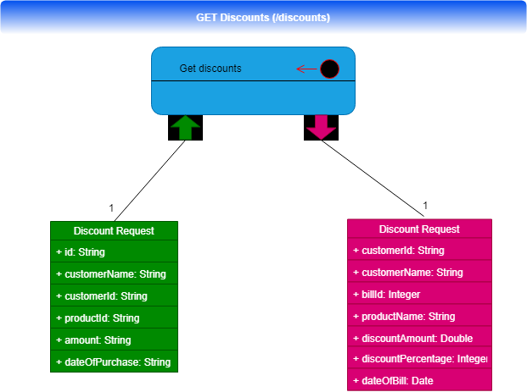

POST Discount

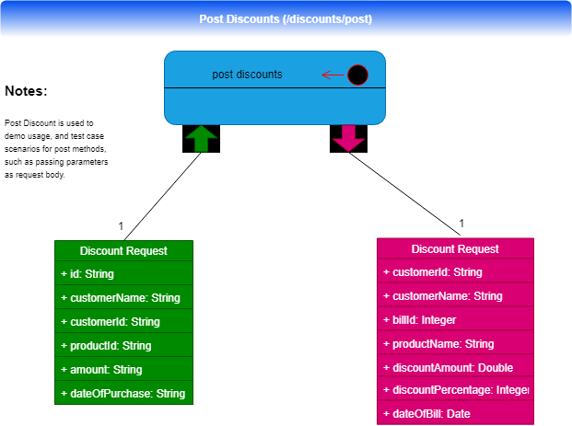

Class Diagram
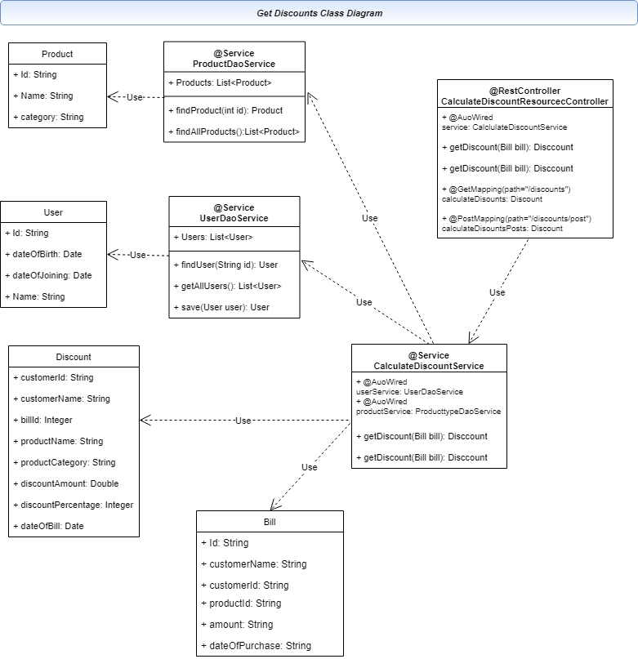

Unit Test & Code Coverage

Unit Test
Mockito is used for unit test cases. Most test cases are covered with various scenarios:
- Get unit test case
- Post Unit test case
- User Service test case
- Product service test case
Considering the time limit I have only demonstrated major complex scenarios. Many negative, and various other scenarios could be added on real time projects.

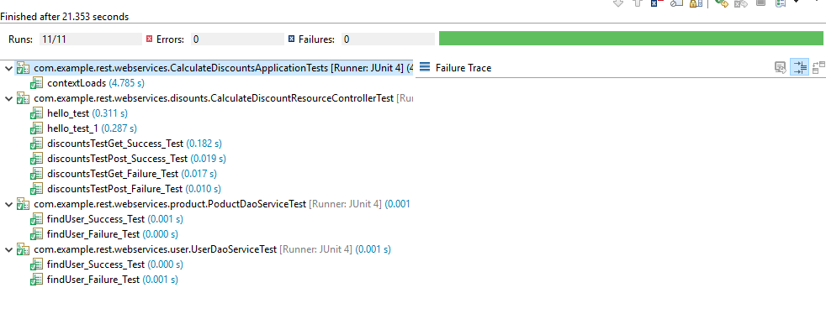

Test Coverage

Test coverage can be used reported via sonarqube. However due to shortage of time could not used it for this exercise.

You can use Eclipse test coverage to view the coverage report.

Steps:

Open Eclipse -> Import Project -> Right Click on Project -> Covergage As -> Junit test
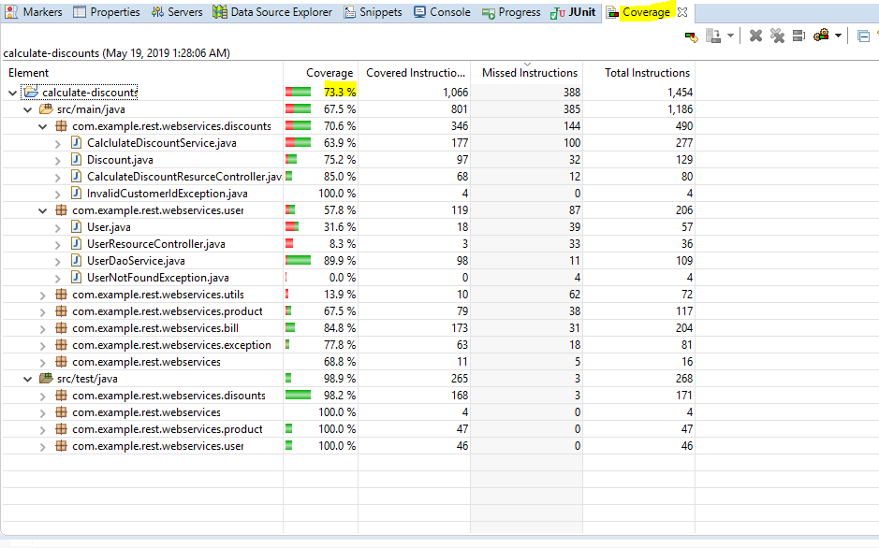

API Documentation – Swagger

Swagger
The Swagger API is configured for this project. It generates all the API contracts, and documentation.

url: http://localhost:8080//swagger-ui.html
Note: Replace localhost, port appropriately based on reviewers environment, and preferred port setting.

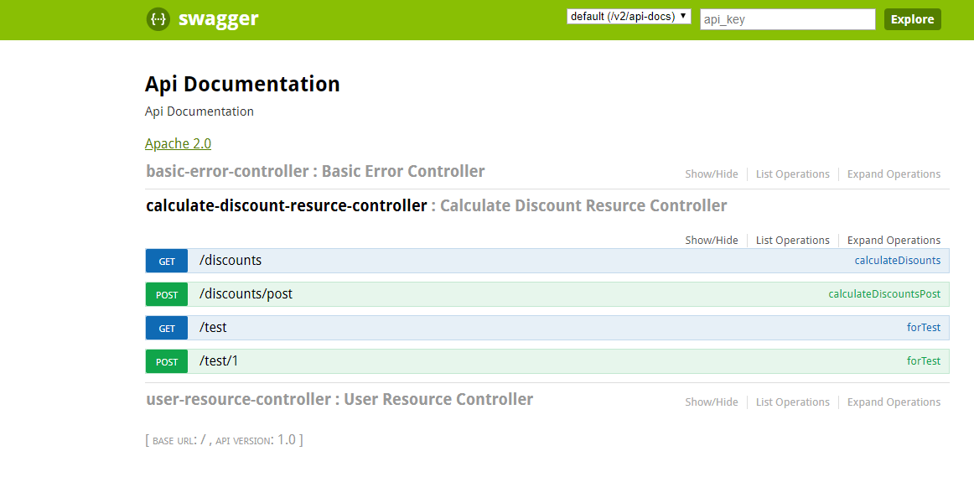

Sample Request and Response

GET discount

Request:
http://localhost:8080/discounts?id=1&customerName=Bibhu&customerid=affl001&productId=2&amount=300.00&&dateOfPurchase=2019-05-18T07:44:14.503+0000

Response:
{
"customerId": "affl001",
"customerName": "Bibhu",
"billId": 1,
"productName": "Product Two",
"productCategory": "retail",
"discountAmount": 30,
"dicountPercentage": 10,
"dateOfCheck": "2019-05-18T19:42:38.882+0000"
}
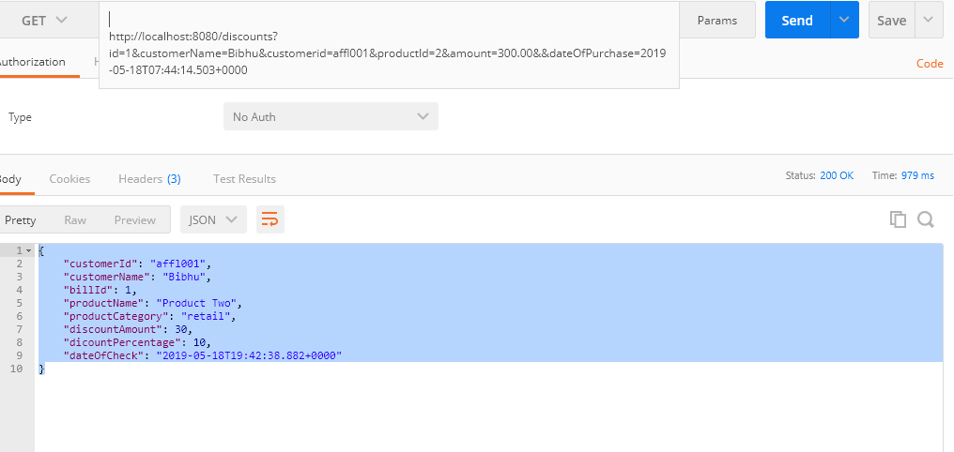

POST Discount
post http://localhost:8080/discounts/post

Request: (application/json)
{
"id": "1",
"customerName":"Bibhu",
"customerid" : "affl001",
"productId" : 2,
"amount" : 300.00,
"dateOfPurchase": "2011-05-14T12:38:56.593+0000"
}

Response
{
"customerId": "affl001",
"customerName": "Bibhu",
"billId": 1,
"productName": "Product Two",
"productCategory": "retail",
"discountAmount": 30,
"dicountPercentage": 10,
"dateOfCheck": "2019-05-18T06:28:31.415+0000"
}

