NATIONAL COLLEGE OF COMPUTER STUDIES (NCCS)
Tribhuvan University
A PROJECT REPORT
ON
"Test Automation of Reddit Web Application using Playwright"
Submitted in partial fulfillment of the requirements
for the 7th Semester of B.Sc. CSIT program
Submitted by:
Bibhushan Sapkota
Roll No: 79010725
Under the Supervision of:
Saurav Tuladhar
National College of Computer Studies (NCCS)
June 3, 2026

CERTIFICATE

This is to certify that the project report entitled "Test Automation of Reddit Web Application using Playwright" submitted by Bibhushan Sapkota (Roll No: 79010725) in partial fulfillment of the requirements for the 7th Semester of the B.Sc. CSIT program at National College of Computer Studies (NCCS), Tribhuvan University, is a bona fide record of the work carried out under my supervision during the academic year 2026.
To the best of my knowledge, this project work has not been submitted elsewhere for the award of any other degree or diploma.
____________________
Saurav Tuladhar
Project Supervisor

Date: June 3, 2026
Place: National College of Computer Studies (NCCS)

DECLARATION

I, Bibhushan Sapkota (Roll No: 79010725), hereby declare that the project report entitled "Test Automation of Reddit Web Application using Playwright" submitted to National College of Computer Studies (NCCS), Tribhuvan University, in partial fulfillment of the requirements for the 7th Semester of the B.Sc. CSIT program, is an original work carried out by me under the supervision of Saurav Tuladhar. The content has not been submitted elsewhere for any other degree, diploma, or certificate. All sources used and referenced have been duly acknowledged.
____________________
Bibhushan Sapkota
Roll No: 79010725
Date: June 3, 2026

ACKNOWLEDGMENT

I extend my heartfelt thanks to my project supervisor, Saurav Tuladhar, for his invaluable guidance, constructive feedback, and continuous support throughout this project. I am also deeply grateful to the faculty and administration of National College of Computer Studies (NCCS) for providing a strong academic foundation and an environment conducive to learning. I acknowledge the open-source community, particularly the developers of Playwright, whose excellent tools and documentation made this project possible. Finally, I thank my family and friends for their unwavering support throughout my academic journey.
Bibhushan Sapkota
Roll No: 79010725

ABSTRACT

Abstract—This project presents the design and implementation of an automated end-to-end test framework for the Reddit web application using Microsoft Playwright and JavaScript. The framework adopts the Page Object Model (POM) design pattern to ensure maintainability and code reuse. Sixteen test cases covering authentication, navigation, subreddit management, post interactions, search, theming, and feed sorting were implemented and executed against the live production site. Real-world challenges including Shadow DOM elements, dynamic dialogs, and rate-limited endpoints were addressed using industry-recommended techniques. Experimental results show a 100% pass rate with an average suite runtime of approximately 3.5 minutes, demonstrating Playwright's effectiveness for modern JavaScript-heavy single-page applications.
Index Terms—Software Testing, Test Automation, Playwright, Page Object Model, End-to-End Testing, JavaScript, Quality Assurance.

TABLE OF CONTENTS

CERTIFICATE ii
DECLARATION iii
ACKNOWLEDGMENT iv
ABSTRACT v
TABLE OF CONTENTS vi
LIST OF FIGURES viii
LIST OF TABLES ix
LIST OF ABBREVIATIONS x
Chapter 1: Introduction 1
1.1 Background and Problem Statement 1
1.2 Objectives and Scope 1
1.3 Limitations 1
Chapter 2: Literature Review and Tools 3
2.1 Test Automation and Playwright 3
2.2 Page Object Model 3
2.3 Framework Comparison 3
Chapter 3: System Analysis and Design 4
3.1 Application Under Test 4
3.2 Functional Requirements 4
3.3 Framework Architecture 4
3.4 Page Object Design 5
3.5 Authentication Strategy 6
Chapter 4: Implementation 7
4.1 Environment and Folder Structure 7
4.2 Sample Test and Page Object 7
Chapter 5: Testing and Results 9
5.1 Test Case Summary 9
5.2 Execution and Metrics 9
Chapter 6: Challenges and Solutions 12
6.1 Shadow DOM and Dynamic Overlays 12
6.2 Rate Limiting, Isolation, and Authentication 13
Chapter 7: Conclusion and Future Scope 14
7.1 Conclusion 14
7.2 Future Enhancements 14
References 15

LIST OF FIGURES

Figure 1. Framework Architecture Diagram 5
Figure 2. Page Object Model Class Diagram 6
Figure 3. Project Folder Structure 7
Figure 4. VS Code Project Setup 8
Figure 5. Test Execution in Headed Mode 10
Figure 6. Playwright HTML Report — All Tests Passed 10
Figure 7. Test Case Repository in Excel 11
Figure 8. Shadow DOM Element in Reddit UI 12
Figure 9. Community Guide Dialog Overlay 13

LIST OF TABLES

Table 1. Comparison of Major Automation Frameworks 3
Table 2. Functional Requirements 4
Table 3. Page Object Responsibilities 5
Table 4. Test Case Summary 9
Table 5. Execution Metrics 11
Table 6. Challenges and Solutions Summary 13

LIST OF ABBREVIATIONS
Abbreviation | Full Form
AUT | Application Under Test
CI/CD | Continuous Integration / Continuous Delivery
DOM | Document Object Model
E2E | End-to-End
IDE | Integrated Development Environment
JS | JavaScript
JSON | JavaScript Object Notation
POM | Page Object Model
QA | Quality Assurance
SDLC | Software Development Life Cycle
SPA | Single Page Application
UI | User Interface
URL | Uniform Resource Locator

Chapter 1: Introduction

1.1 Background and Problem Statement
Software testing is a fundamental phase of the Software Development Life Cycle (SDLC) that ensures applications meet requirements and function reliably. With rapid agile development cycles, the demand for automated testing has grown significantly because manual testing cannot scale to match continuous deployment [1]. Modern web applications such as Reddit employ complex client-side rendering, custom web components, and dynamic dialogs, making manual verification across browsers and user states impractical. This project addresses how to design a maintainable test framework that handles Shadow DOM, manages authentication efficiently, and remains reliable when testing against a live production site.

1.2 Objectives and Scope
The primary objectives of this project are:
- To design and implement an end-to-end test automation framework using Playwright and JavaScript.
- To apply the Page Object Model design pattern for separation of concerns and code reuse.
- To author at least fifteen functional test cases covering critical user journeys on Reddit.
- To integrate authentication using Playwright's storageState feature for efficient session management.
- To document the design decisions, challenges, and best practices applied throughout the project.
The scope covers user-facing features of the Reddit web application — including login, logout, navigation, subreddit interactions, post search, voting, commenting, theme switching, and feed sorting — implemented with Node.js and executed in Chromium.

1.3 Limitations
- Tests run against the live Reddit site; rate limits and personalization may cause intermittent variations.
- OAuth third-party login flows (Google, Apple) are not automated due to security restrictions.
- Mobile-specific Reddit UI variants and performance/load testing are outside the project scope.

Chapter 2: Literature Review and Tools

2.1 Test Automation and Playwright
Test automation uses software tools to execute pre-scripted tests, increasing speed and enabling continuous integration [4][9]. Playwright is an open-source framework developed by Microsoft that supports Chromium, Firefox, and WebKit with a single API. Its key features include automatic waiting for actionable elements, native support for Shadow DOM and modern web components, a trace viewer for post-mortem debugging, and parallel execution with isolated browser contexts [1][7].

2.2 Page Object Model
The Page Object Model, introduced by Martin Fowler [2], is a widely adopted design pattern in test automation. Each page of the application is represented by a class that exposes its elements and behaviors as methods. This separates test logic from UI selectors, improves reusability, and localizes maintenance to a single file when the UI changes [8].

2.3 Framework Comparison
Table 1 compares Playwright with two widely used alternatives.
Table 1. Comparison of Major Automation Frameworks
Feature | Playwright | Selenium | Cypress
Browser Support | Chromium, Firefox, WebKit | Chrome, Firefox, Edge, Safari | Chromium, Firefox, WebKit
Auto-Wait | Yes (built-in) | Manual | Yes
Shadow DOM | Native support | Limited | Limited
Trace Viewer | Yes | No | Time Travel
Parallel Run | Yes (built-in) | Yes (with Grid) | Paid feature

Chapter 3: System Analysis and Design

3.1 Application Under Test
Reddit (https://www.reddit.com) is a globally recognized social discussion platform hosting thousands of communities (subreddits) [5]. Its web application is a JavaScript-heavy SPA using custom web components, dynamic content loading, personalized feeds, and contextual overlays — making it an excellent candidate for demonstrating Playwright's capabilities.

3.2 Functional Requirements
Table 2. Functional Requirements
Req ID | Feature | Description
FR-01 | Authentication | Login (valid/invalid), logout, forgot password, field validation.
FR-02 | Navigation | Open user menu and access account features.
FR-03 | Subreddit | View subreddits, join and leave communities.
FR-04 | Search | Search for subreddits and posts.
FR-05 | Post Interactions | Upvote, downvote, and comment on posts.
FR-06 | UI Preferences | Theme switching, feed sorting (Best/New/Top).

3.3 Framework Architecture
The framework follows a layered architecture where each layer has a specific responsibility, ensuring that changes (such as selector updates) do not ripple across the codebase [8]. The layers are: (i) Test Layer — defines scenarios using describe/test blocks; (ii) Page Object Layer — encapsulates UI selectors and actions; (iii) Fixtures Layer — externalizes test data in JSON; (iv) Configuration Layer — manages timeouts, projects, and storage state; (v) Utilities Layer — shared helpers.
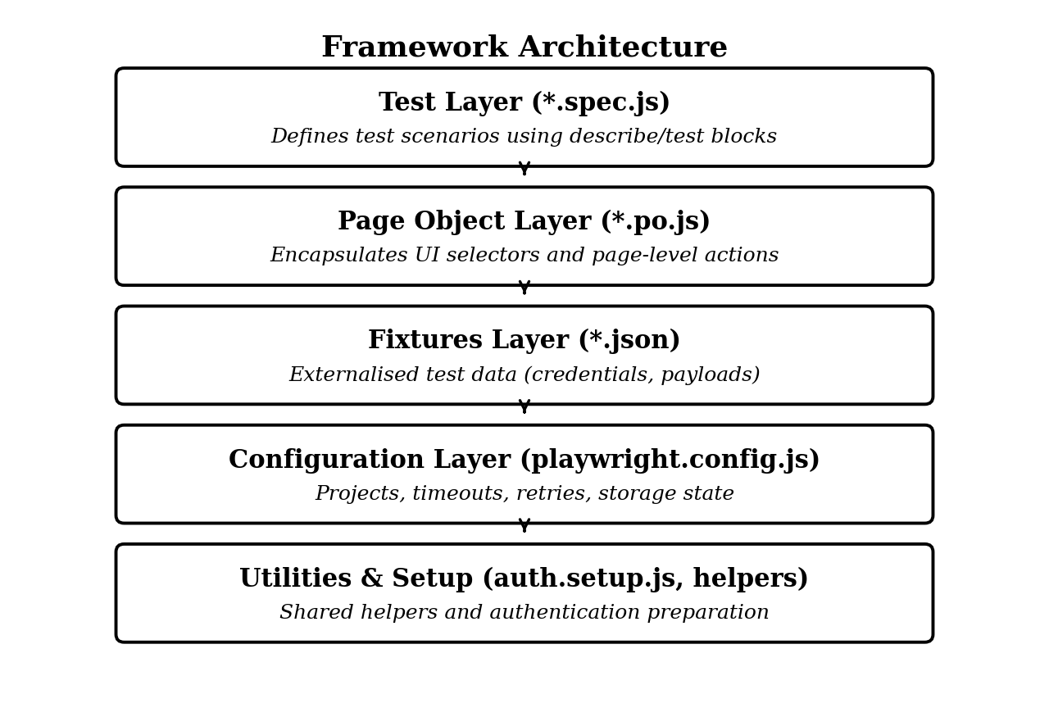
Figure 1. Framework Architecture Diagram

3.4 Page Object Design
Each significant area of the Reddit UI is represented by a dedicated Page Object class exposing locators as properties and actions as methods, as summarized in Table 3.
Table 3. Page Object Responsibilities
Page Object | Responsibility
LoginPage | Login form interactions and validations.
RedditNavigation | Header navigation, user menu, logout, and theme toggle.
RedditForgotPasswordPage | Forgot password form interactions.
RedditSubredditPage | Subreddit join, leave, and post navigation.
RedditSubredditSearchPage | Searching for subreddits and selecting results.
RedditPostPage | Post detail page — voting and commenting.
RedditFeedPage | Home and popular feeds with sort controls.
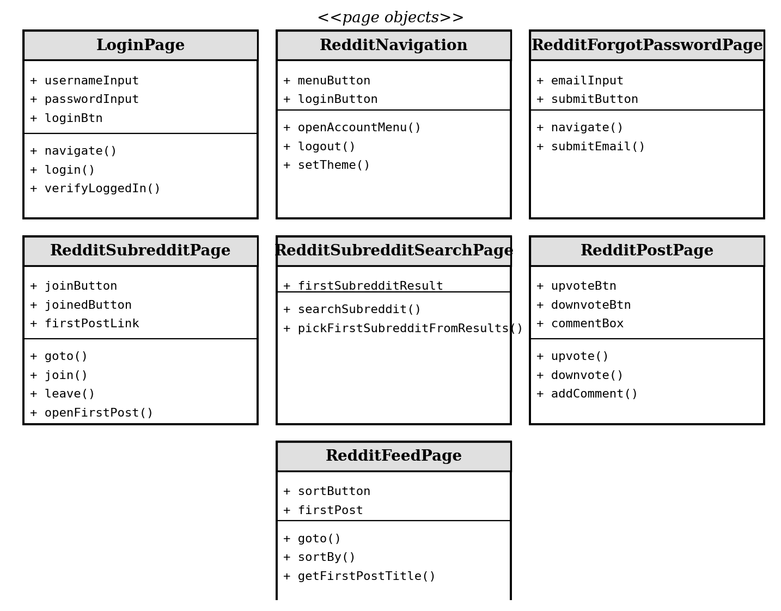
Figure 2. Page Object Model Class Diagram

3.5 Authentication Strategy
Playwright's storageState feature is used to persist authentication across tests [1]. A dedicated setup test logs in once and saves cookies/local storage to JSON. Subsequent tests in the authenticated project load this state at startup, while login and forgot-password tests run in a separate guest project that starts with a clean context.

Chapter 4: Implementation

4.1 Environment and Folder Structure
The project was developed on Windows 11 using Node.js v20 LTS [6], Playwright v1.40+, and Visual Studio Code. Installation requires npm init, npm install -D @playwright/test, and npx playwright install. The project follows a modular structure separating Page Objects, test specifications, fixtures (JSON data), and configuration.
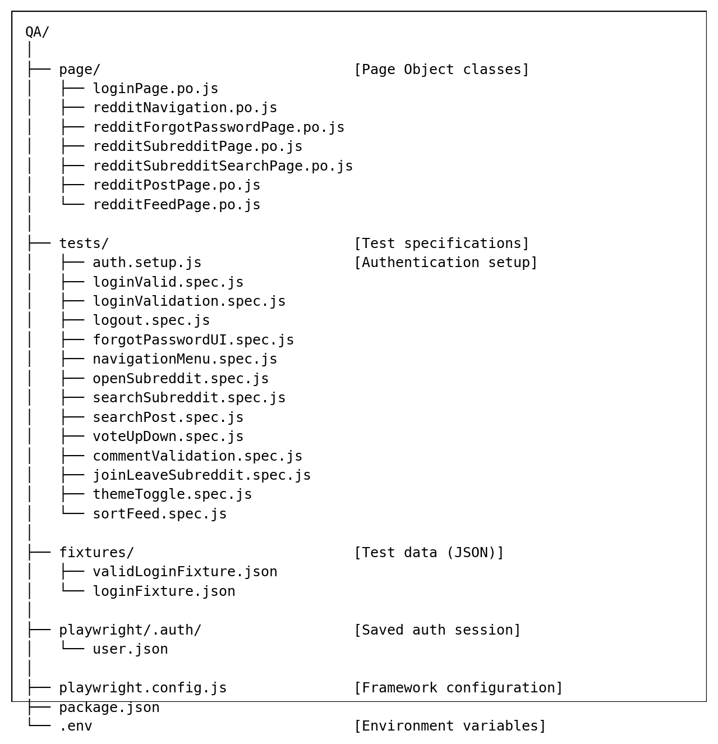
Figure 3. Project Folder Structure

4.2 Sample Test and Page Object
A representative test is shown in the VS Code environment in Figure 4. The corresponding Page Object exposes locators (e.g., usernameInput, loginBtn) as class properties and actions (navigate, login, verifyLoggedIn) as methods. Test data is read from JSON fixtures, decoupling data from logic.
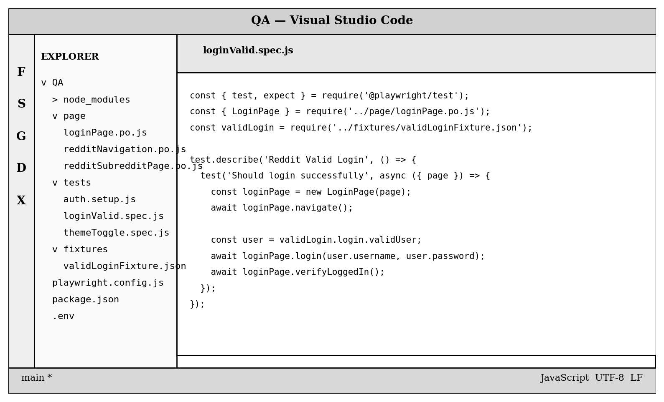
Figure 4. VS Code Project Setup

Chapter 5: Testing and Results

5.1 Test Case Summary
A total of sixteen test cases were implemented and executed sequentially against the live Reddit site. Each test is documented in the Excel test case repository with steps, expected results, and actual results.
Table 4. Test Case Summary
Test ID | Test Summary | Module | Status
Red_001 | Valid login | Auth | Pass
Red_002 | Invalid login | Auth | Pass
Red_003 | Empty fields validation | Auth | Pass
Red_004 | Bad format validation | Auth | Pass
Red_005 | Forgot password UI | Auth | Pass
Red_006 | Valid logout | Auth | Pass
Red_007 | Navigation menu | Navigation | Pass
Red_008 | Open subreddit | Subreddit | Pass
Red_009 | Search subreddit | Search | Pass
Red_010 | Join community | Subreddit | Pass
Red_011 | Leave community | Subreddit | Pass
Red_012 | Search post | Search | Pass
Red_013 | Upvote/Downvote | Posts | Pass
Red_014 | Comment on post | Posts | Pass
Red_015 | Theme toggle | UI | Pass
Red_016 | Sort feed | Feed | Pass

5.2 Execution and Metrics
The suite was run with npx playwright test using a single worker for stable interaction with the live site. The Playwright HTML reporter generated a detailed report including timing and trace recordings.
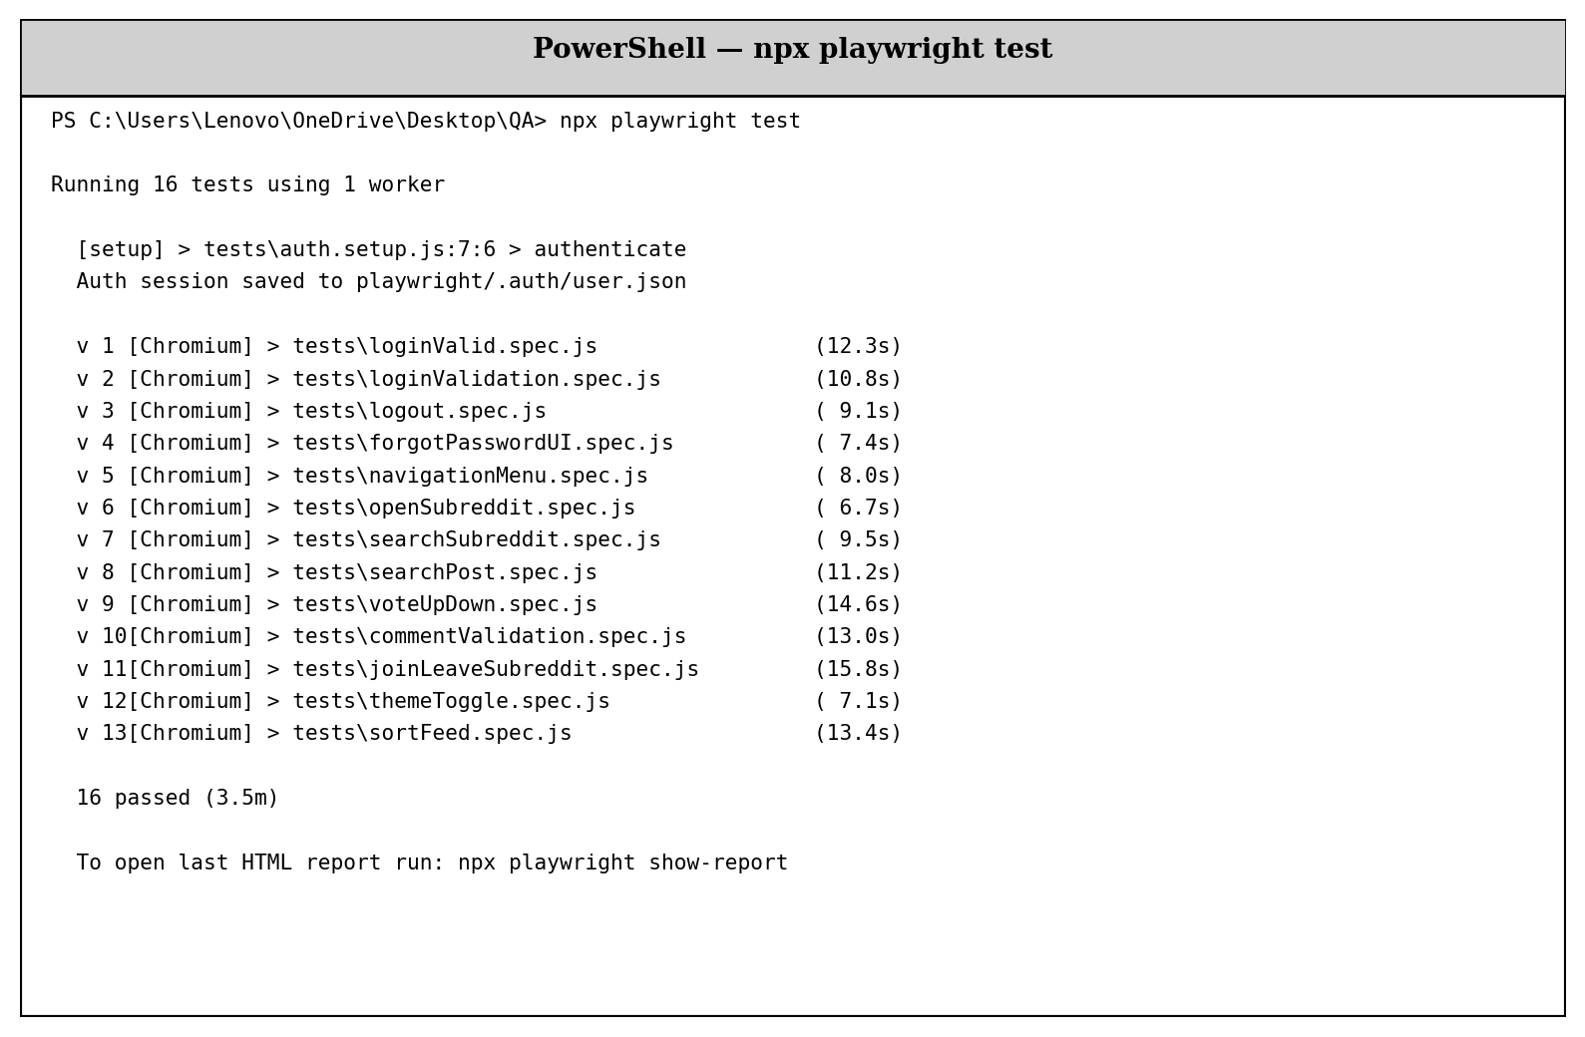
Figure 5. Test Execution in Headed Mode
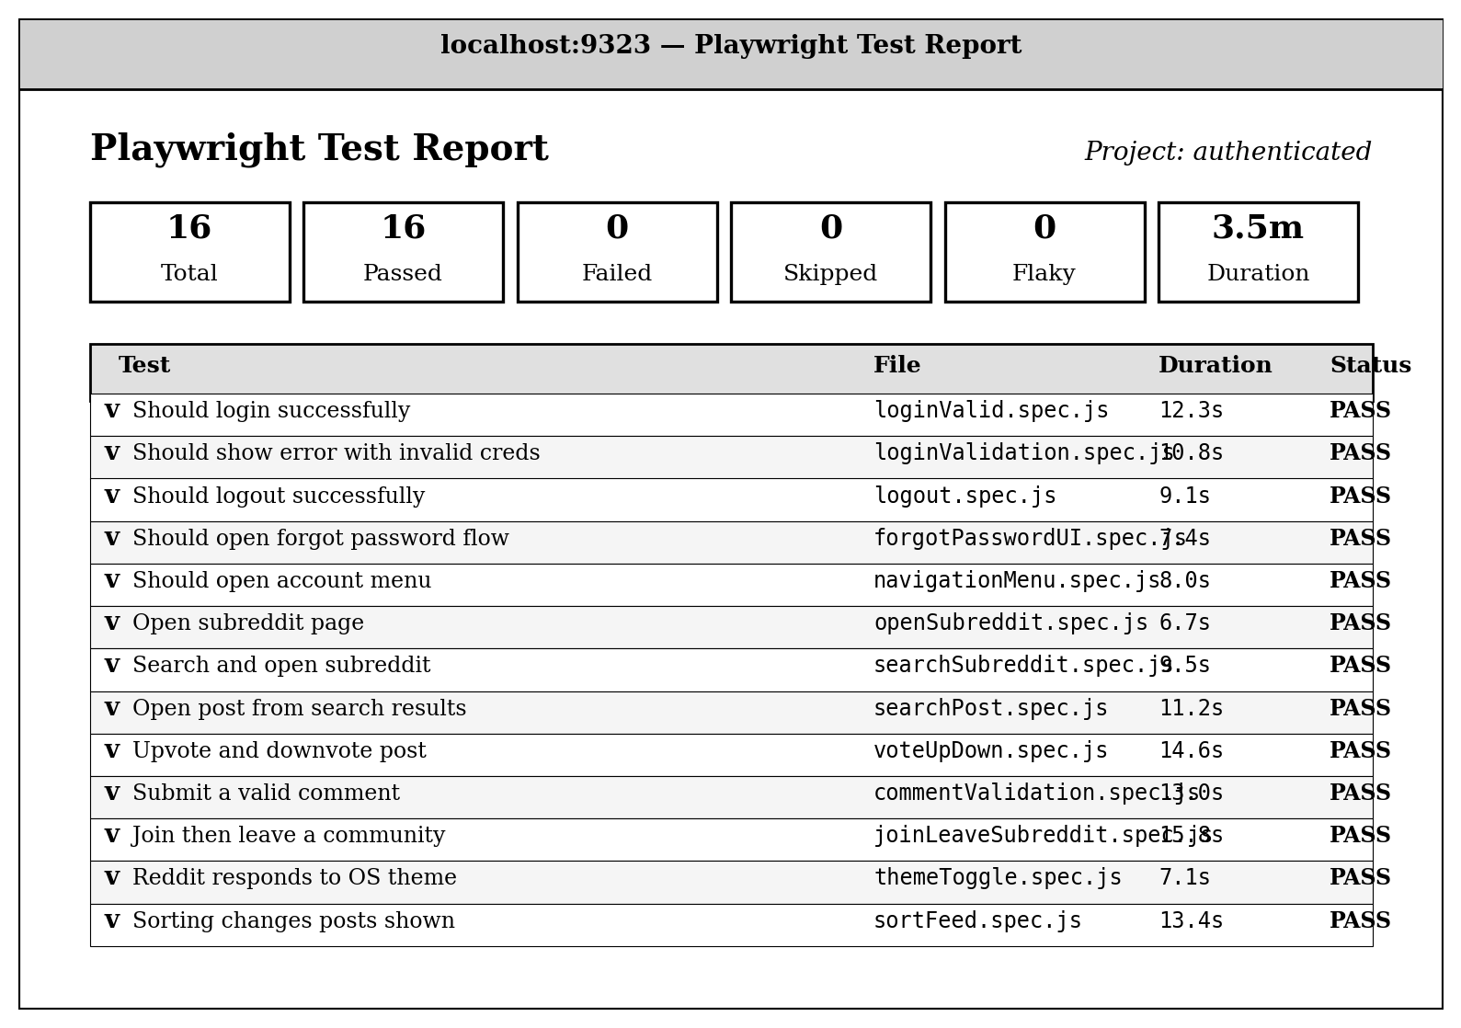
Figure 6. Playwright HTML Report — All Tests Passed
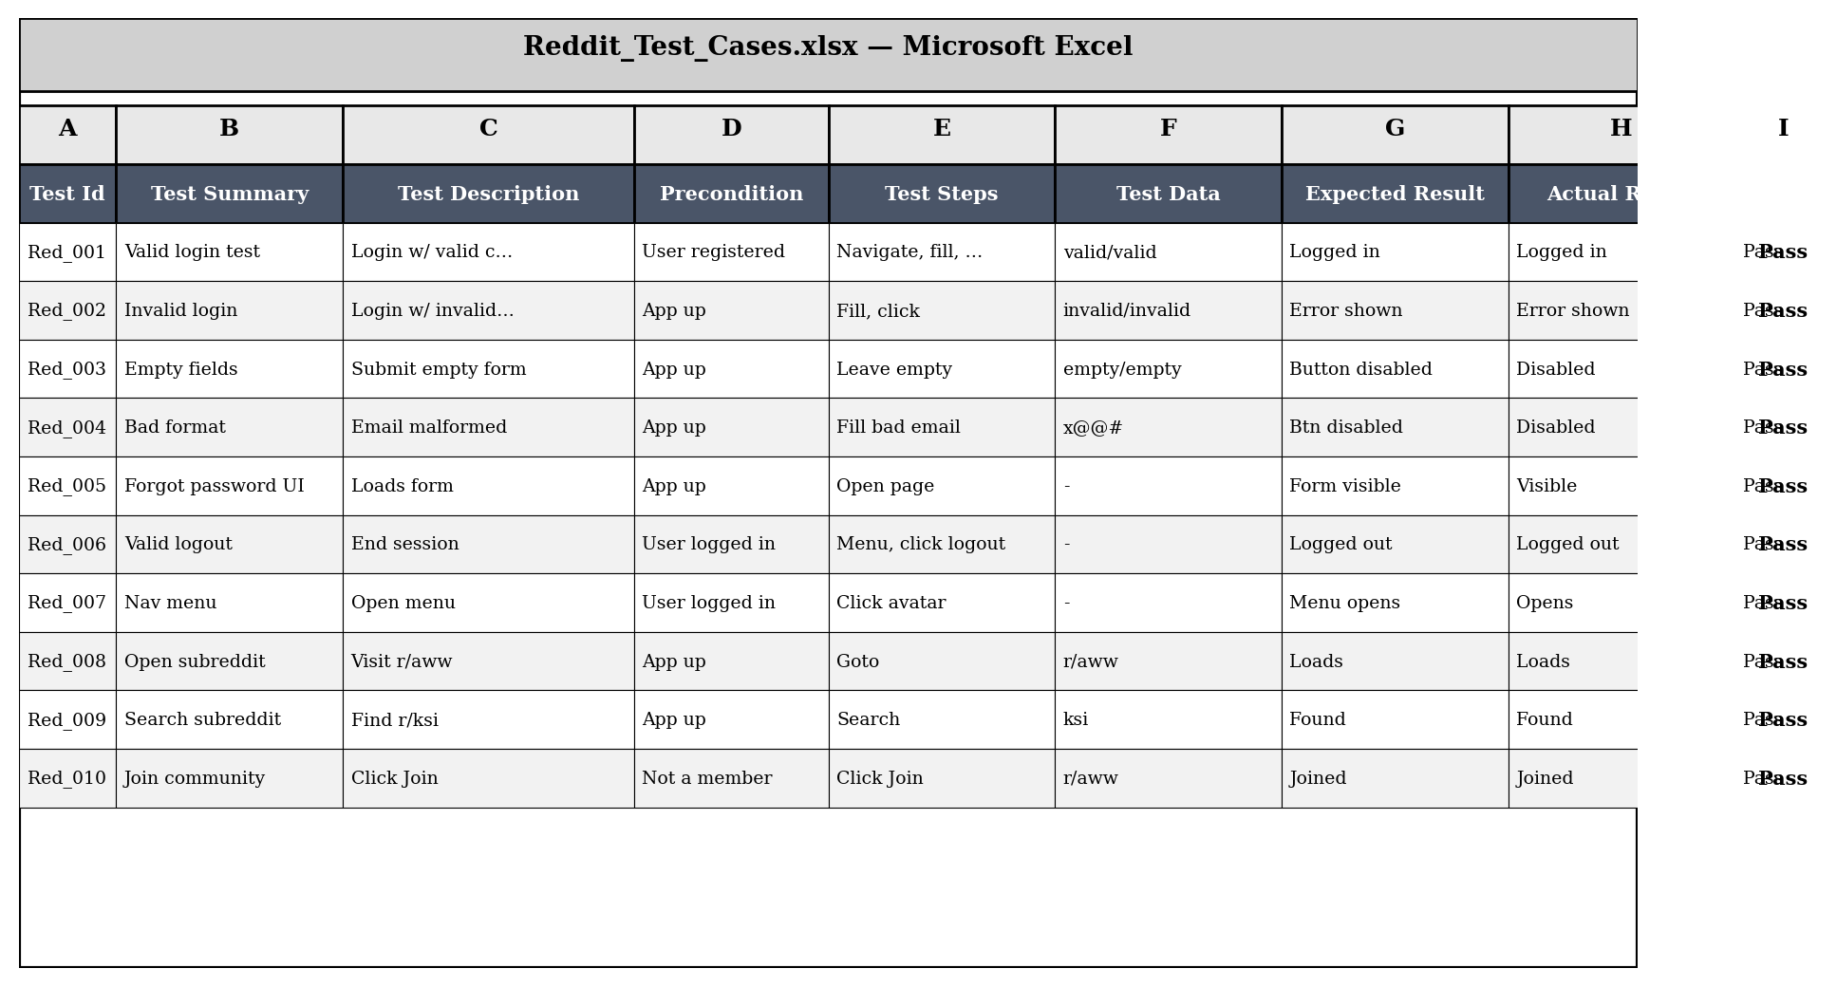
Figure 7. Test Case Repository in Excel
Table 5. Execution Metrics
Metric | Value
Total Test Cases | 16
Passed | 16
Failed | 0
Pass Percentage | 100%
Suite Runtime | ~3.5 minutes
Browser | Chromium

Chapter 6: Challenges and Solutions

6.1 Shadow DOM and Dynamic Overlays
Reddit's UI uses custom web components (e.g., <faceplate-text-input>) that hide their real input elements within Shadow DOM [7]. Playwright's CSS engine pierces open shadow roots, so selectors such as input[name="username"] still resolve. For closed shadow roots, role-based locators (getByRole, getByLabel) were preferred because they walk the accessibility tree, which is shadow-root-aware by design.
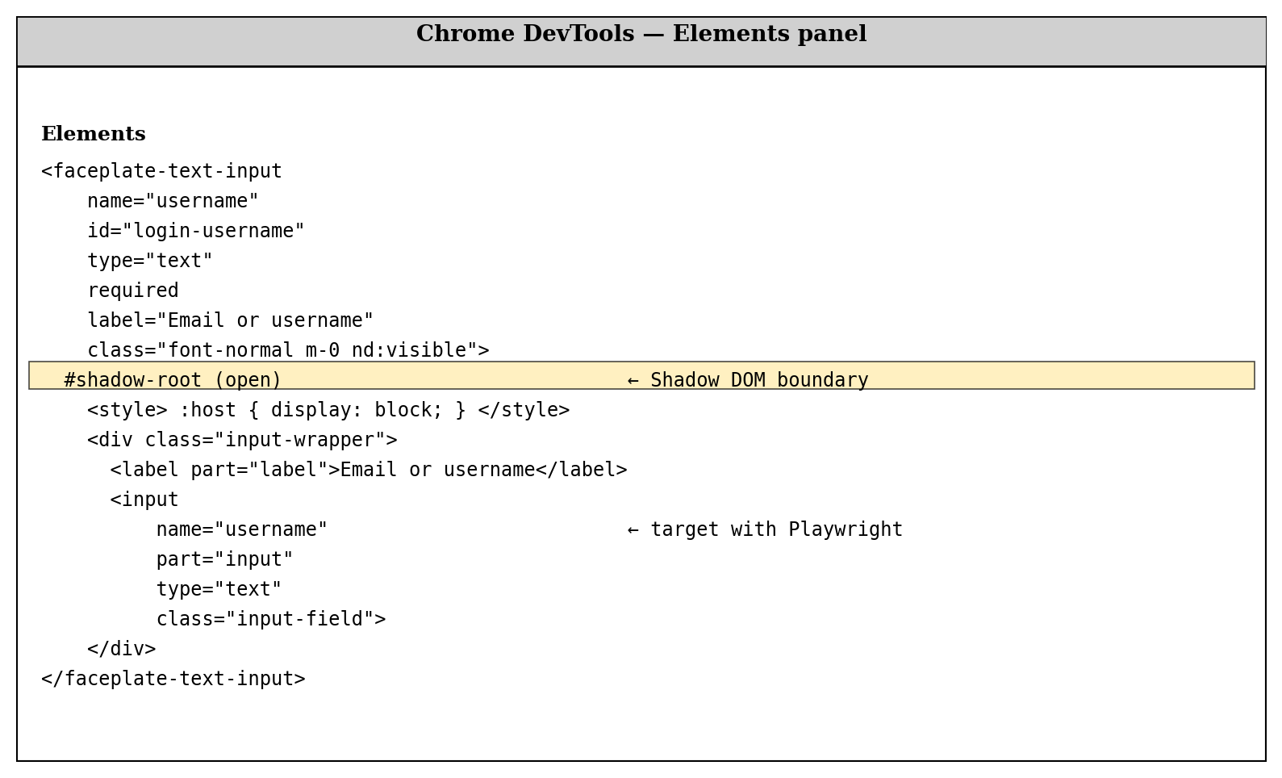
Figure 8. Shadow DOM Element in Reddit UI
After joining a subreddit, Reddit displays a "Community Guide" dialog that intercepts pointer events and blocks subsequent leave actions. The solution was a dedicated dismissCommunityGuide method that detects and closes the dialog, invoked both before and during retry blocks using expect(...).toPass().
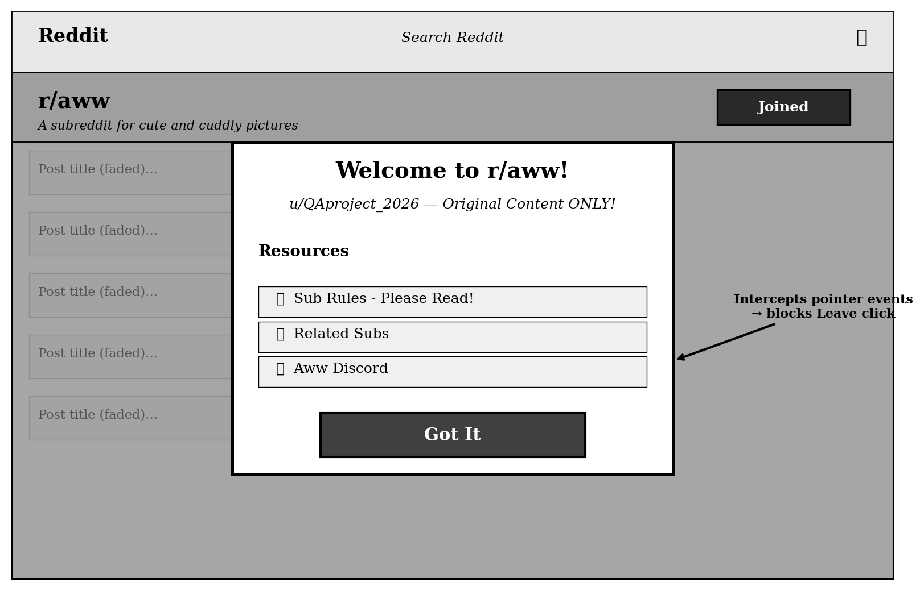
Figure 9. Community Guide Dialog Overlay

6.2 Rate Limiting, Isolation, and Authentication
When the full suite ran, some tests failed intermittently due to Reddit's rate limiting and leftover state from earlier tests. Solutions included resetting state at the start of each modifying test, enabling retries on CI, increasing navigation timeouts, and preferring domcontentloaded over load to skip non-essential resources. For authentication, Playwright's storageState was used to persist sessions once and load them in subsequent tests [1]. For logout, clearing cookies/storage proved more reliable than clicking the Shadow-DOM-buried Log Out button. Table 5 summarizes the challenges.
Table 6. Challenges and Solutions Summary
Challenge | Solution
Shadow DOM elements | Role-based locators that traverse the accessibility tree
Dynamic popups | Dedicated dismiss methods before sensitive actions
Rate limiting | Sequential execution, increased timeouts, retries on CI
State pollution | Reset state in beforeEach or test setup
Logout via Shadow DOM | Clear cookies/storage instead of clicking buried button
Theme toggle | Use Playwright's emulateMedia for OS color-scheme

Chapter 7: Conclusion and Future Scope

7.1 Conclusion
This project successfully demonstrates the design and implementation of a robust, maintainable test automation framework for a production-scale web application using Playwright and JavaScript. Sixteen test cases covering critical user journeys were authored and executed reliably against the live Reddit site with a 100% pass rate. The Page Object Model design pattern produced a clean separation between test logic and UI selectors, making the framework easy to extend. Real-world challenges — Shadow DOM, dynamic overlays, and rate limiting — were addressed using industry-recommended techniques. The project also produced an Excel-based test case repository and comprehensive documentation, forming a complete QA package suitable for handover or extension.

7.2 Future Enhancements
- Integration with a CI/CD platform such as GitHub Actions for automated test runs on every push.
- Cross-browser execution by enabling Firefox and WebKit projects in the configuration.
- Visual regression testing using Playwright's built-in screenshot comparison.
- Accessibility testing via axe-core integration.
- API-level smoke tests using Playwright's request fixture for faster validation.
- Mobile viewport testing and defect tracking integration with Jira or TestRail.

References
[1] Microsoft, "Playwright Documentation," 2024. [Online]. Available: https://playwright.dev/docs/intro. [Accessed: May 2026].
[2] M. Fowler, "PageObject," martinfowler.com, 2013. [Online]. Available: https://martinfowler.com/bliki/PageObject.html.
[3] IEEE Std 829-2008, "IEEE Standard for Software and System Test Documentation," IEEE, 2008.
[4] ISTQB, "Foundation Level Syllabus," International Software Testing Qualifications Board, 2018.
[5] Reddit Inc., "Reddit Help Center," 2024. [Online]. Available: https://support.reddithelp.com.
[6] Node.js Foundation, "Node.js Documentation," 2024. [Online]. Available: https://nodejs.org/en/docs.
[7] Mozilla Developer Network, "Shadow DOM," 2024. [Online]. Available: https://developer.mozilla.org/en-US/docs/Web/Web_Components/Using_shadow_DOM.
[8] G. Meszaros, xUnit Test Patterns: Refactoring Test Code. Addison-Wesley, 2007.
[9] L. Crispin and J. Gregory, Agile Testing: A Practical Guide for Testers and Agile Teams. Addison-Wesley, 2009.

