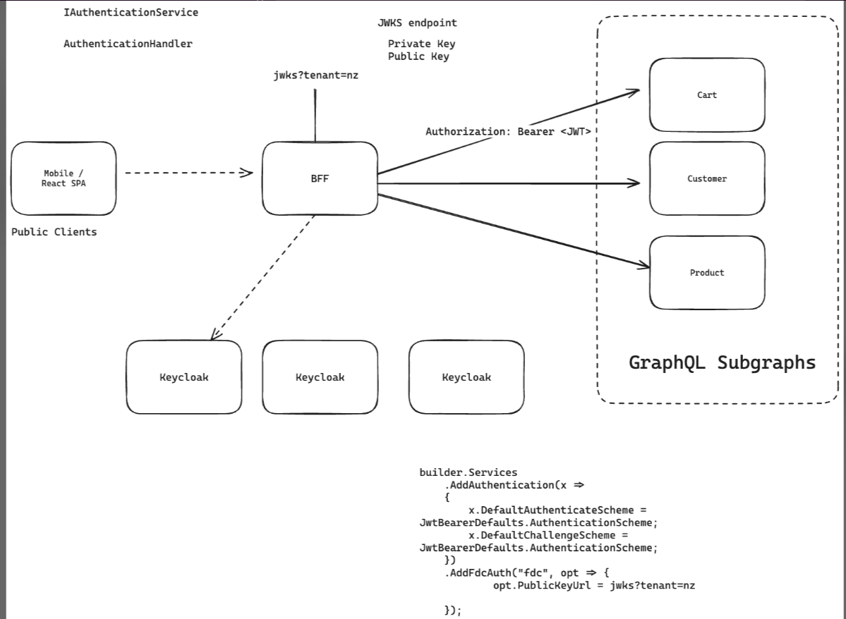

**Regular Process**

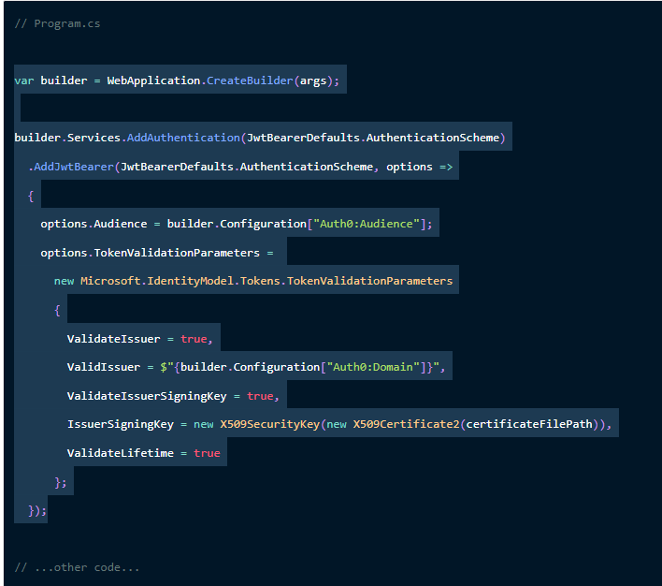

**Expected process**

Need to call Backend for frontend(BFF) endpoint to get public key and use it like below

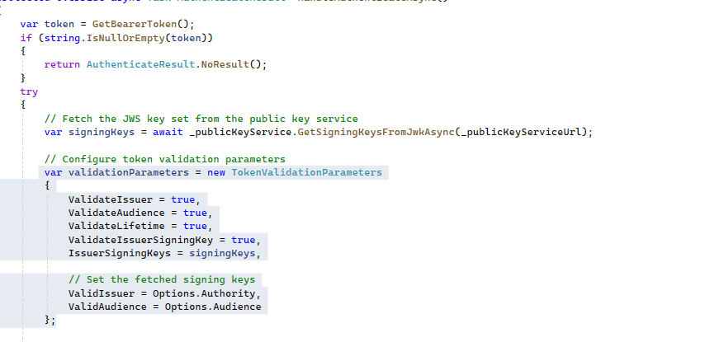

In the middleware the Developers from other teams should be able to do below with the help of Nuget package we create

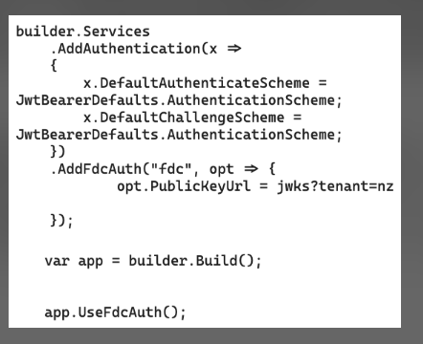

This is the class that JWT auth uses under the hood

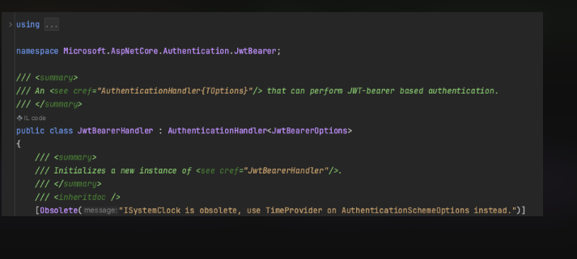

AddFdcAuth() will register a similar Authentication handler

Our custom handler  uses this jwtbearer handler under the hood.

Implementing a Authentication handler requires you to override this method called "**HandleAuthenticateAsync**"

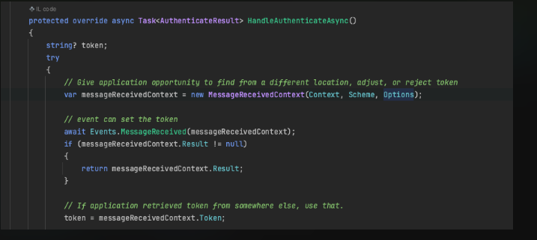

Should look something like below

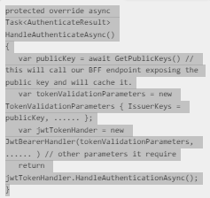

We essentially delegate the actual validation to the existing *JwtBearerHandler*class

All we are doing is to fetch the public keys and cache it.