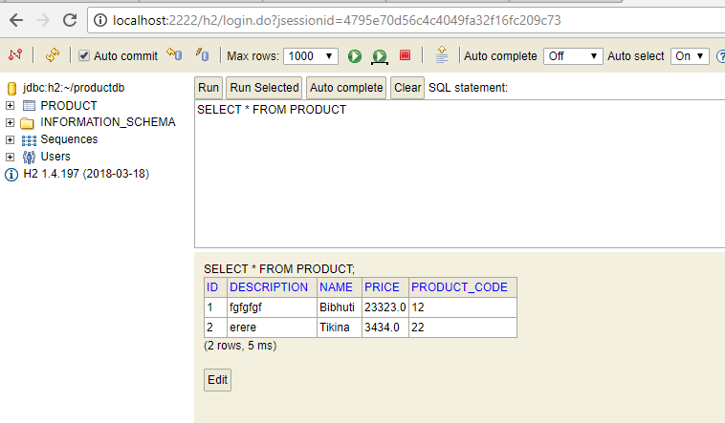

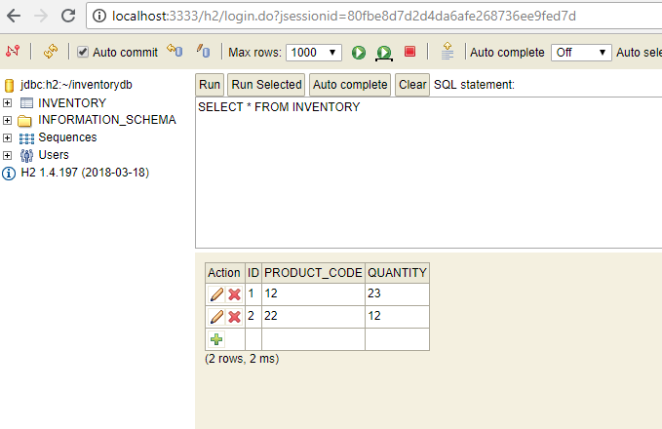

Eureka Server:-

<http://localhost:8888/>

Product-Inventory urls:-

http://localhost:2222/api/products/22

<http://localhost:3333/api/inventory/22>

Hystrix Dashboard:-

http://localhost:4444/hystrix

localhost:1244/actuator/hystrix.stream