We aim to evaluate how pattern of crossings are determined by landscape traits in a binary landscape. In which habitat amount do we observe crossings aggregation? Does landscape configuration have influence in crossings aggregation? Relative contribution of landscape traits (habitat amount/configuration scenarios and matrix permeability) and movement traits (perceptual range and vision) were measured to understand the outputs sensitivity to these parameters. We expected that habitat amount will have a quadratic response, with intermediate values having higher aggregation; and scenarios less fragmented will have higher proportion of crossings aggregated.

**Materials and methods**

*Model overview*

We developed an individual-based model (IBM) using the NetLogo version 6.0.4 (Wilensky, 1999). Model details are provided in detail, following the Overview, Design concepts, and Details (ODD) protocol (Grimm et al., 2010), in Supplementary Material XX. Condensed information of model parameters and its processes are described below.

Our IBM aimed to simulate animal movement in a binary landscape composed by patches of habitat and non-habitat (hereafter called matrix) and an illustrative road cutting it horizontally. The model has two submodels, one for understanding the role of habitat amount in crossings pattern and the other one for the configuration role. The habitat amount submodel was developed as we were focused to understand how crossings pattern is determined by the habitat amount in the landscape (Figure X). We tested the correlation between proportion of habitat and patches number and found these variables being correlated (-0.79, SM XX). Since we found this high correlation but wondering that landscape configuration might have influence on crossings, we developed the configuration submodel, keeping habitat amount constant and evaluating some landscape configurations (different number and arrangement of patches) as input (Figure X).

Both submodels have as input parameters: matrix permeability (how easily is to animal move in matrix patches), perceptual range (animal's perception radius) and vision angle (angle of animal’s vision range). Habitat amount submodel also has the input parameter proportion of habitat (habitat amount in the landscape); while configuration submodel also has scenarios (seven different landscapes) as input. The model outputs are crossings aggregation and total crossings. Crossings aggregation is the proportion of crossings in the 25% of road most crossed sections. We calculate the aggregation in sections of road as we usually have limited resource to apply mitigation and then we need to choose places to prioritize. The values of crossings aggregation vary between 0 and 1, being 0.25 a threshold of uniformity of crossings distribution, as this means that 25% of crossings are present in 25% of the road. Although our focus was crossings aggregation, we also quantify total crossings (the counting of crossings in the entire road) to understand how much the individuals move in the landscape.

First, before running the model, the user will have to define input values and the number of individuals and steps of the model. Then, the model can be setup, with the landscape being generated according to the submodel chosen. After this, the individuals move around and keep choosing patches and going in direction to them until the model stops (when it reaches the steps number chosen by user).

We used the “*nlrx*” package (Salecker et al., 2019), in the R environment (R Core Team, 2023), to run simulations with the different combinations of inputs parameters, and to save the outputs. Codes of NetLogo model and data analysis are available at https://github.com/bibianadasoler/ibm-code.

*Sensitivity analysis*

Sensitivity analysis is a comprehensive way to evaluate how outputs respond to inputs variation (Grimm & Railsback, 2005). We used the Sobol’ method, a global sensitivity analysis, which is a quantitative method that can inform parameter sensitivity by calculating the contribution of each input (variyng them in a full range) on the model outputs variance (Abreu & Ralha, 2018; Thiele et al., 2014) . We performed one sensitivity analysis for each submodel, using the function sobol2007 from “*sensitivity*” package (Pujol et al., 2015) on the R environment (R Core Team, 2023). In both submodels we set the number of individuals as 100, and the number of steps as 500 to perform the simulations. We used 6000 model evaluations (samples of parameters, with values variation described in Table 1), totalizing 36000 simulations, to obtain Sobol’s first-order sensitivity index (*Si*) and Sobol’s total-effects sensitivity index (*STi*).

Table 1. List of parameters and their minimum and maximum values used in the sensitivity analysis for each submodel.

|  |  |  |
| --- | --- | --- |
| Variables | Configuration submodel | Habitat amount submodel |
| Matrix permeability | 10 – 90 | |
| Perceptual range | 5 – 42 | |
| Vision angle | 90 – 180 | |
| Scenario | 1 – 7 | 8 |
| Proportion of habitat | - | 10 – 90 |

**Results**

From the 36000 simulations ran for sensitivity analysis we analyzed the relation of the parameter’s values with crossings aggregation. For all input parameters, in both submodels, we found crossings being aggregated in the 25% road most crossed sections, since all outputs were higher than 0.25 of crossings aggregation.

*Habitat amount submodel*

We observed higher crossings aggregation in intermediate values of proportion of habitat (Figure xA) and in low values of matrix permeability (upper left side of Figure xB). Proportion of habitat between 40% and 65% had aggregation rate mean around 0.5. In matrix permeability values until 30, we observed aggregation rates mean higher than 0.5, meaning that more than 50% of the crossings occurred in the 25% road most crossed sections. As observed in the configuration submodel, in higher values of perceptual range and vision angle, we observed more crossings aggregation (upper right side of figure XD). Total crossings…

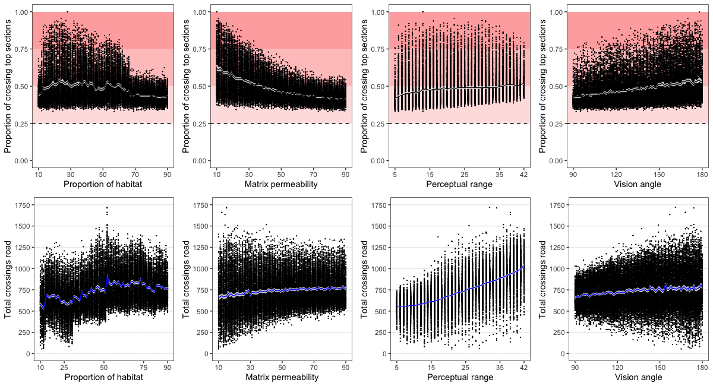

Matrix permeability input (*Si* = 0.46, CI95% = 0.40 – 0.52) showed the greater main effect (*Si*) in sensitivity analysis for crossings aggregation. The other parameters have smaller importance in the output (vision angle: *Si* = 0.17, CI95% = 0.14 – 0.20; perceptual range: *Si* = 0.09, CI95% = 0.06 – 0.11; proportion of habitat: *Si* = 0.08, CI95% = 0.06 – 0.10). The same was observed in relation to total sensitivity index, with matrix permeability having highest index (*STi* = 0.67, CI95% = 0.63 – 0.70) and the other parameters having smaller indexes (vision angle: *STi* = 0.28, CI95% = 0.25 – 0.31; proportion of habitat: *STi* = 0.27, CI95% = 0.24 – 0.31; perceptual range: *STi* = 0.22, CI95% = 0.20 – 0.25). These results suggest that crossings aggregation output is most sensible to variance in matrix permeability values. Total crossings…

Figure X. Sobol sensitivity analysis for habitat amount submodel. Black circles and error bars show bias-corrected original first-order sensitivity index (main effects, *Si*). Grey circles and error bars show bias-corrected original total sensitivity index (main and interaction effects, *STi*).

*Configuration submodel*

The higher crossings aggregation was identified in scenarios with fewer patches and matrix permeability values (upper left side of figure xA and xB). Scenarios 1, 2 and 3 (with one, two horizontally and two vertically patches, respectively) had aggregation rate higher the 0.5, which means that more than 50% of the crossings are aggregated in 25% of the road. In relation to matrix permeability, when the value is smaller than XXXX, we observed more aggregations. However, the wider the field of view of the agents, high perceptual range and high vision angle, the higher is crossings aggregation in the road (upper right side of figure xC and xD).

Figure parametros individualmente. Vermelho: graus de agregação; mais forte, mais agregado. Linha tracejada = threshold of uniformity of crossings distribution.

Sensitivity analysis showed higher main effect (*Si*) of matrix permeability (*Si* = 0.27, CI95% = 0.22 – 0.31) and scenarios (*Si* = 0.22, CI95% = 0.17 – 0.26) parameters, while the other two showed small effects (perceptual range: *Si* = 0.07, CI95% = 0.04 – 0.10; vision angle: *Si* = 0.07, CI95% = 0.05 – 0.09). The highest total effect was observed for scenario input (*STi* = 0.53, CI95% = 0.42 – 0.57), but matrix permeability (*STi* = 0.49, CI95% = 0.45 – 0.54) also has high importance. Perceptual range (*STi* = 0.33, CI95% = 0.29 – 0.37) has a smaller significance than the other two, but still more relevant than vision angle (*STi* = 0.16, CI95% = 0.13 – 0.19). The high values of scenario and matrix permeability inputs suggest that these parameters have important influence in crossings aggregation output variation.

Figure X. Sobol sensitivity analysis for configuration submodel. Black circles and error bars show bias-corrected original first-order sensitivity index (main effects, *Si*). Grey circles and error bars show bias-corrected original total sensitivity index (main and interaction effects, *STi*).

Discussion

References

Supplementary material

ODD

Correlação