**Objectives, Design concepts, and Details (ODD protocol)**

## Purpose

The main goal of this model is to understand how landscape traits (configuration and habitat amount) determine the crossing pattern on a road. To address this, we developed two submodels and simulated animal movement in their landscapes: 1) configuration: varying the number and layout of habitat patches with similar habitat proportion; and 2) habitat amount: varying the habitat proportion in a random generated landscape. We expect to identify how much aggregated are the crossings in the road, based on how many times the animals cross each segment of the road.

## Entities, state variables, and scales

***The landscape***

The environment is a cell grid of 84 x 84 patches, and the patches are classified in three class types and has different values of permeability. The landscape is generated according to the scenario chosen (better described in submodels section).

All variables relating to the landscape are described below:

*Static variables*

* habitat: referring to the type of habitat. The values are the following: habitat = 1, matrix = 2, road = 0.
* permeability: referring to the permeability value of the patch. The values vary between 0.1 to 0.9 to non-habitat patches and the habitat patch has permeability value of 1.
* proportion_of_habitat: referring to the habitat amount present in the landscape. The values are between 10 and 90 %. This is only related to scenario 8, submodel 2.
* hab_neighbors: referring to the number of habitat neighbors each patch of road has. To get this value we extract the mean of habitat neighbors in the road. This is a unique value for landscape and can vary between 0 and 6.

*Dynamic variables*

* current_permeability: referring to the current permeability of a group of patches (candidate_pacthes). It is calculated considering the permeability and the agent distance of each candidate_patches. (aqui explicar melhor como calcula? não consegui explicar)
* visits: referring to the number of visits each patch receive. This value is defined as 0 in the setup procedure and rise when an animal pass through the patch.

***The agents***

All agents consider the following variables in their movement:

* candidate_patches: referring to the patches inside a cone in front of the agent. The cone has radius of perceptual_range size and angle of vision_angle degrees.
* chosen_patch: referring to the chosen patch to where to go in direction of. In each tick, each individual has to choose its “chosen_patch” between one of candidate-patches.
* perceptual_range: referring to the distance of vision of the agent. This value varies between 5 and 42 and is defined by the user before initialization.
* vision_angle: referring to the angle of vision of the agent. This value varies between 90 and 180 and is defined by the user before initialization.

## Process overview and scheduling

Before running the model, users must choose individuals and steps number and define the values for all parameters. Then, in setup button, the landscape is generated, and the individuals are created in random locations weighted by patch permeability. After this, in go button, individuals will be moving through the landscape until the number of ticks be equal to the number of steps decided by the user. Figure 1 provides a representation of model steps.

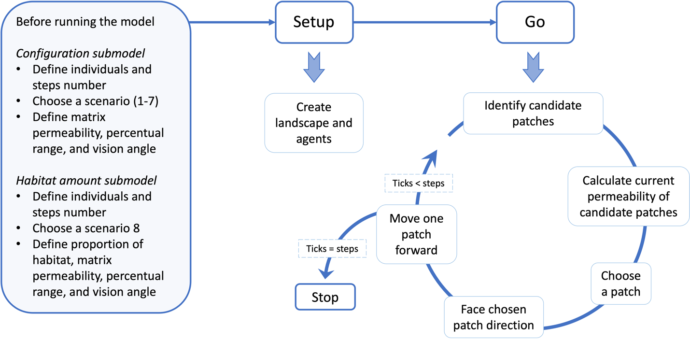Figure 1. Diagram describing the steps in the model simulation.

## Design concepts

Basic principles: this model aims to understand how changes in landscape traits influence the crossings on a road. Agents’ movement is implemented as a correlated random walk, as they will choose a patch based on the current permeability (permeability value and the distance from the individual to each patch) of each patch inside a cone with an angle related to the last step. Individuals will keep moving until the number of ticks is equal to the steps number the users chose.

Emergence: the pattern of crossings emerges from individuals’ movements influenced by scenario type (or habitat proportion in case of submodel 2), patch permeability, perceptual range and vision angle.

Adaptation: individuals do not have adaptative traits, they make decisions to where to move based on the current permeability of candidate patches.

Objectives: there is no objective in the agent’s movement.

Learning: agents do not learn neither from other agents nor from the past.

Prediction: agents cannot predict future information.

Sensing: agents can see all patches inside a cone (with radius based on perceptual range and angle based on vision_angle) and evaluate the patch permeability value and its distance (não sei se faz sentido colocar a distancia aqui, não é medida mas é considerada na hora de escolher o patch para se mover).

Interaction: Not included. Each agent is independent of other.

Stochasticity: in initialization, it is used to place the individuals, and, in scenario 8, it is used to define each patch will be habitat. During simulation, stochasticity is used to choose a patch between candidate_patches.

Collectives: no collectives were implemented as the agents are independent of each other.

Observation: the simulation outputs are the total number of visits in road patches and the proportion of crossings in 25% of road patches with highest number of visits. The outputs are recorded at the end of model running (when ticks are equal to steps number). Additional information of inputs parameters is also recorded with output to posteriori analyses.

## Initialization

Before starting the model, the user should choose individuals number, steps number, matrix permeability (between 0.1 and 0.9), perceptual range (between 5 and 42), and vision angle (between 90 and 180 degrees). For a random generated landscape, the user must choose scenario = 8 and define the proportion of habitat desired (between 10 and 90). For scenarios 1 up to 7, there is no need to choose proportion of habitat. Also, the user should indicate if want to save the results, and if so, indicate a path file and a filename. After made these decisions, the user should setup the model to generate the landscape and to create the individuals. Then, individuals start to move, and ticks number starts to rise.

## Input data

This model does not have input data.

## Sub-models

We have two sub-models to create the landscapes. They have same outputs and same animal movement but have small differences in the inputs and in the way the landscapes are created.

*Sub-model 1: Configuration*

This sub-model was developed to understand the changes caused by *different configurations of patches* in landscape. It has seven scenarios (already defined), varying in patch number and layout, that must be chosen by the user.

Scenario 1 – 1 patch

Scenario 2 – 2 vertical patches

Scenario 3 – 3 horizontal patches

Scenario 4 – 16 patches close to road

Scenario 5 – 16 patches away from road

Scenario 6 – vertical lines

Scenario 7 – horizontal lines

Figure 2. Scenarios of configuration submodel.

*Sub-model 2: Habitat amount*

This sub-model was developed to understand the changes caused *by different proportion of habitat amount* in landscape. In this sub-model the user must define the proportion of habitat (varying from 10 to 90 %), and the landscape is randomly created.

Figure 3. Examples of landscapes of habitat amount submodel. The values refer to proportion of habitat in the landscape.