**Assignment #4. Responsive Web Design (Media Queries + Bootstrap Grid)**

Student: Bibifatima Bekbergen

Group: MT-2405

**Part 1. Media Queries**

**Task 0. Responsive Typography**

Mobile (Default - up to 767px)

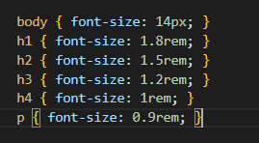

Tablet (768px - 1023px)

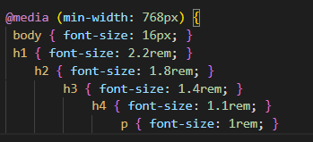

Desktop/Computer (1024px+)

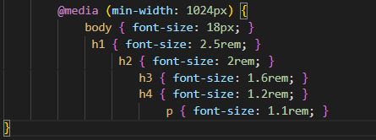

| **Screen Size** | **Body Font** | **h2 Example** | **p Example** |
| --- | --- | --- | --- |
| **Mobile** (< 768px) | 14px | 1.5rem | 0.9rem |
| **Tablet** (768px - 1023px) | 16px | 1.8rem | 1rem |
| **Desktop** (≥ 1024px) | 18px | 2rem | 1.1rem |

**Task 1. Responsive Layout with Media Queries**

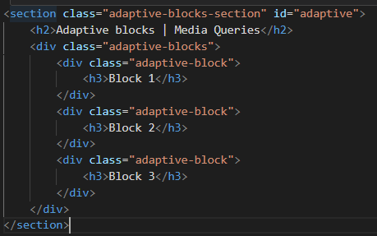

Desktop (default - 1024px+): All 3 boxes side by side

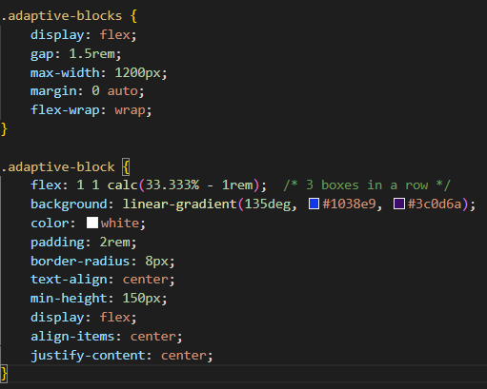

Tablet (768px - 1023px): 2 boxes per row

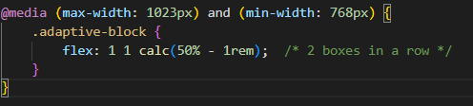

Mobile (< 768px): Stacked vertically

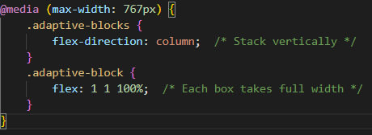

| **Screen Size** | **Layout** | **CSS Used** |
| --- | --- | --- |
| **Desktop** (≥1024px) | [Box1] [Box2] [Box3] | flex: 1 1 calc(33.333% - 1rem) |
| **Tablet** (768-1023px) | [Box1] [Box2]<br>[Box3] | flex: 1 1 calc(50% - 1rem) |
| **Mobile** (<768px) | [Box1]<br>[Box2]<br>[Box3] | flex-direction: column<br>flex: 1 1 100% |

I've implemented a responsive layout beautifully using media queries: on desktops, the blocks line up in a row, on tablets, two per row, and on mobile devices, they're neatly arranged vertically, creating a modern and user-friendly design

**Part 2. Bootstrap Grid System**

**Task 2. Bootstrap Responsive Columns**

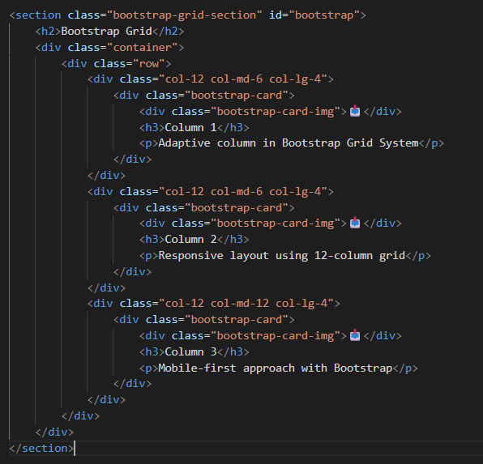

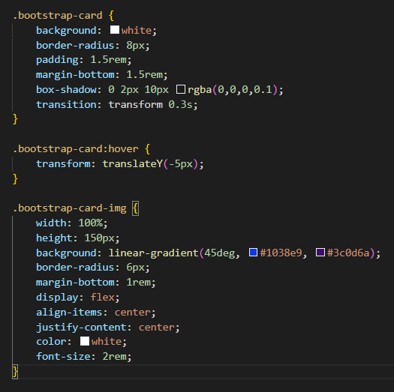

| **Column** | **Classes** | **Behavior** |
| --- | --- | --- |
| **Column 1** | col-12 col-md-6 col-lg-4 | Mobile: 12/12 (full width)<br>Tablet: 6/12 (half width)<br>Desktop: 4/12 (third width) |
| **Column 2** | col-12 col-md-6 col-lg-4 | Mobile: 12/12 (full width)<br>Tablet: 6/12 (half width)<br>Desktop: 4/12 (third width) |
| **Column 3** | col-12 col-md-12 col-lg-4 | Mobile: 12/12 (full width)<br>Tablet: 12/12 (full width)<br>Desktop: 4/12 (third width) |

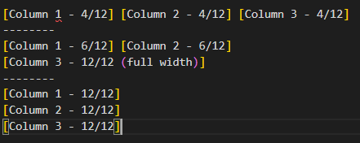

In Task 2, I used the Bootstrap grid to create responsive columns: on desktop, three equal sections, each one-third of the screen width; on tablet, the first two columns occupy half the width, and the third stretches to fill the entire row; and on mobile, all the columns neatly line up, complete with beautiful cards with gradients and hover effects

**Task 3. Bootstrap Navigation Bar**

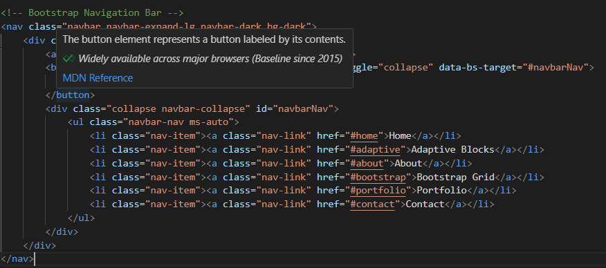

**Logo on the Left:**

Html code

<a class="navbar-brand fw-bold" href="#">MyPortfolio</a>

* navbar-brand - Bootstrap class for logo/brand
* fw-bold - Makes text bold
* Positioned on the left by default

### ****--------------------------------------------------------------------------------------------------------****

### ****Hamburger Menu Button (Mobile):****

Html code

<button class="navbar-toggler" type="button" data-bs-toggle="collapse" data-bs-target="#navbarNav">

<span class="navbar-toggler-icon"></span>

</button>

* navbar-toggler - Creates the hamburger button
* data-bs-toggle="collapse" - Toggle functionality
* data-bs-target="#navbarNav" - Controls which menu to collapse

**----------------------------------------------------------------------**

### ****Navigation Links on the Right:****

Html code

<div class="collapse navbar-collapse" id="navbarNav">

<ul class="navbar-nav ms-auto">

<li class="nav-item"><a class="nav-link" href="#home">Home</a></li>

<li class="nav-item"><a class="nav-link" href="#adaptive">Adaptive Blocks</a></li>

</ul> </div>

* collapse navbar-collapse - Makes menu collapsible
* ms-auto - Pushes navigation to the right (margin-start: auto)
* navbar-nav - Bootstrap styling for nav list
* nav-item and nav-link - Proper link styling

**----------------------------------------------------------------------**

• **Logo on the left** - navbar-brand

• **Links on the right** - ms-auto class

• **Responsive hamburger menu** - navbar-toggler

• **Collapses on small screens** - navbar-expand-lg

• **Anchor links** - Links to different sections of page

• **Dark theme** - Professional dark navbar

**Part 3. Combined Project**

**Task 4. Responsive Portfolio Page**

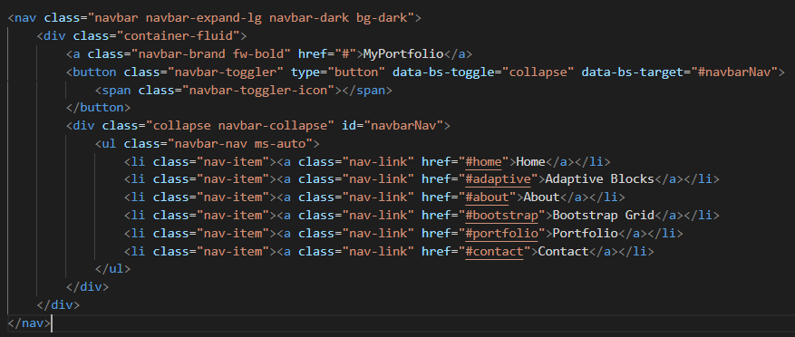

Fully responsive Bootstrap navbar with hamburger menu on mobile

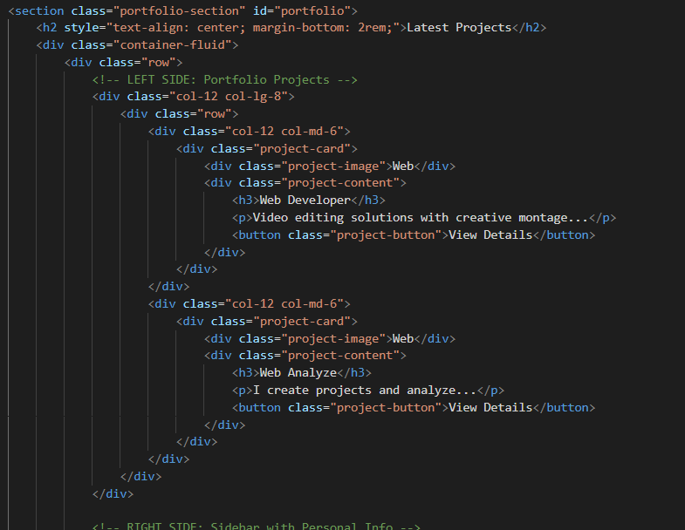

• **Desktop:** col-lg-8 (projects) + col-lg-4 (sidebar) = 12 columns

• **Mobile:** col-12 (both sections stack vertically)

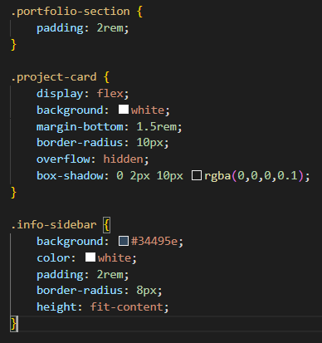

**----------------------------------------------------------------------**

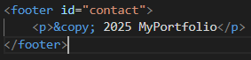

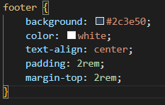

A footer is the area at the bottom of a web page that typically contains information about the site, such as copyright notices, privacy policy links, and contact information. It provides users with access to important information while remaining unobtrusive and not distracting from the main content of the page

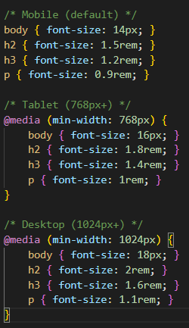

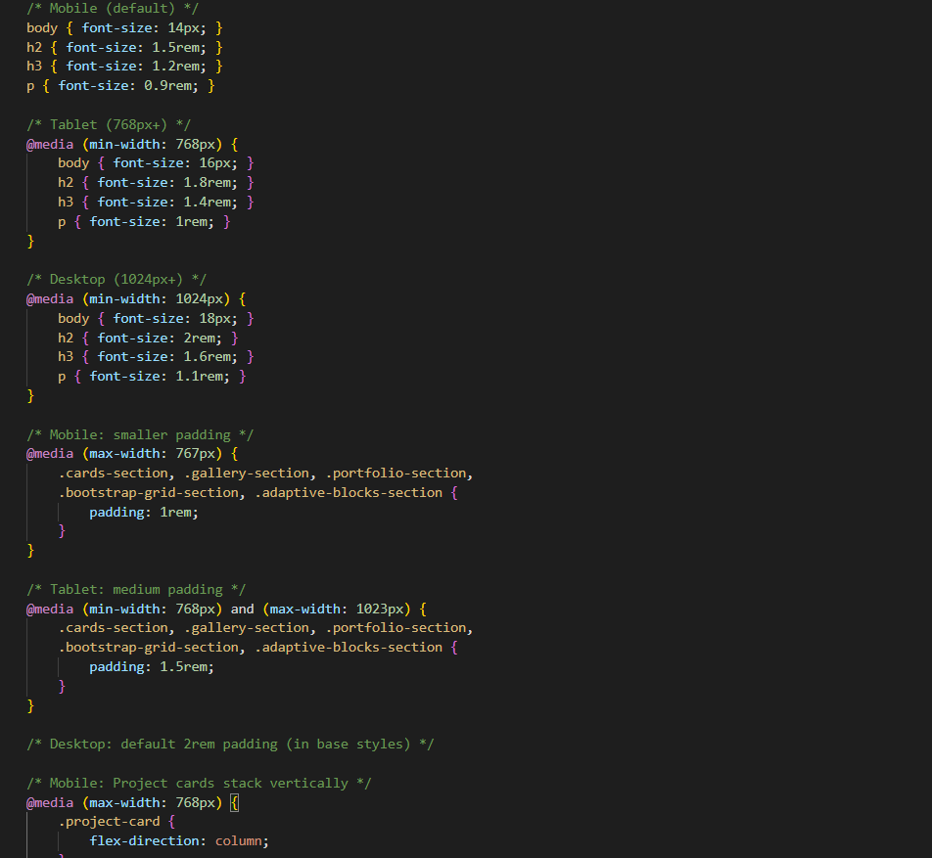

This code configures responsive typography and margins for different screen sizes

On mobile devices, a compact font and reduced margins are used to ensure a neat appearance of text and blocks

For tablets, the fonts become slightly larger, and the margins increase to a medium value, creating a more comfortable reading experience

On desktops, even larger font sizes are used, making the design more expressive and easier to read

Furthermore, on mobile devices, project cards are rearranged into a vertical column, improving viewing on narrow screens

Overall, the code provides a flexible and modern responsive design that adapts to any device

GIT :