**LAB CYCLE 1 Date:10/03/2023**

**EXPERIMENT NO:1**

**HARDWARE FAMILIARISATION**

**Aim**: Introduction to computer hardware: Physical identification of major components of a computer system such as mother board, RAM modules, daughter cards, bus slots, SMPs, internal storage devices, interfacing ports. Specification of desktop and server class computers. Installation of common operating systems for desktops and server use.

**Description:**

**Introduction to Computer hardware**

Components of a computer system are the primary elements which make the functioning of an electronic device smooth and faster. Computer systems consist of three components as shown in below image: **Central Processing Unit, Input devices and Output devices**. Input devices provide data input to processor, which processes data and generates useful information that’s displayed to the user through output devices. This is stored in computer’s memory.

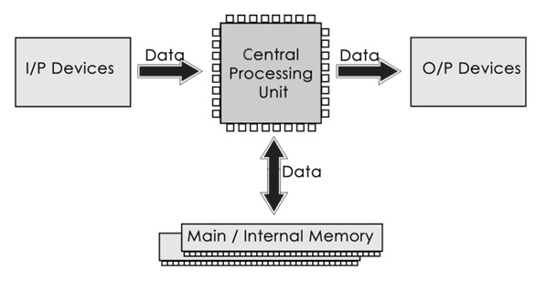

The operations of computer components are given below:

**1) Inputting:** It is the process of entering raw data, instructions and information into the computer. It is performed with the help of input devices.

**2) Storing:** The computer has primary memory and secondary storage to store data and instructions. It stores the data before sending it to CPU for processing and also stores the processed data before displaying it as output.

**3) Processing:** It is the process of converting the raw data into useful information. This process is performed by the CPU of the computer. It takes the raw data from storage, processes it and then sends back the processed data to storage.

**4) Outputting:** It is the process of presenting the processed data through output devices like monitor, printer and speakers.

**5) Controlling:** This operation is performed by the control unit that is part of CPU. The control unit ensures that all basic operations are executed in a right manner and sequence.

**Central Processing Unit (CPU)**

A Central Processing Unit is also called a processor, central processor, or microprocessor. It carries out all the important functions of a computer. It receives instructions from both the hardware and active software and produces output accordingly. It stores all important programs like operating systems and application software. CPU also helps Input and output devices to communicate with each other. Owing to these features of CPU, it is often referred to as the brain of the computer.

CPU has three components:

* ALU (Arithmetic Logic Unit)
* Control Unit
* Memory or Storage Unit

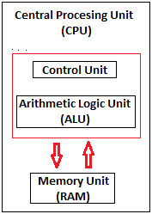

**COMPUTER HARDWARE**

Hardware, which is abbreviated as HW, refers to all physical components of a computer system, including the devices connected to it. You cannot create a computer or use software without using hardware. The screen on which you are reading this information is also a hardware.

**Motherboard:**

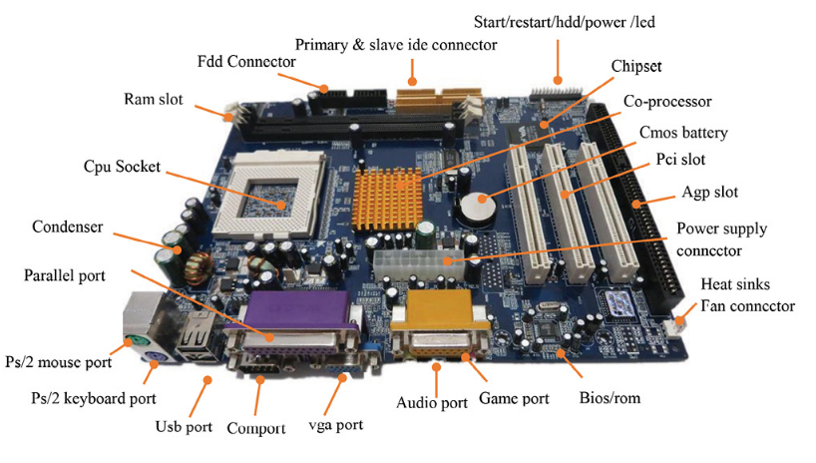

The motherboard is generally a thin circuit board that holds together almost all parts of a computer except input and output devices. All crucial hardware like CPU, memory, hard drive, and ports for input and output devices are located on the motherboard. It is the biggest circuit board in a computer chassis. It allocates power to all hardware located on it and enables them to communicate with each other. It is meant to hold the computer's microprocessor chip and let other components connect to it. Each component that runs the computer or improves its performance is a part of the motherboard or connected to it through a slot or port.

**RAM module**

RAM stands for Random Access Memory. It is also called the main memory. RAM is a temporary data storage device in computers and other devices. SRAM, DRAM SDRAM, DDR etc are the various types of RAMS available. A memory module or RAM stick is a narrow-printed circuit board that holds memory chips (RAM chips).

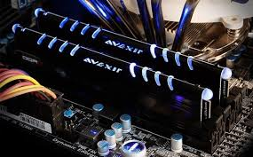

Dynamic random-access memory (DRAM) is a type of semiconductor memory that is typically used for the data or program code needed by a computer processor to function. The advantage of a DRAM is it only requires a single transistor compared to around six in a typical static RAM, SRAM memory cell. The costs of DRAM are much lower than those for SRAM, and they are able to provide much higher levels of memory density (about 1GB).

SDRAM (synchronous DRAM) is a generic name for various kinds of DRAM that are synchronized with the clock speed that the microprocessor is optimized for. That is, same external clock pulse can be used to operate both SRAM and processor. This tends to increase the number of instructions that the processor can perform in a given time.

**Daughter Cards**

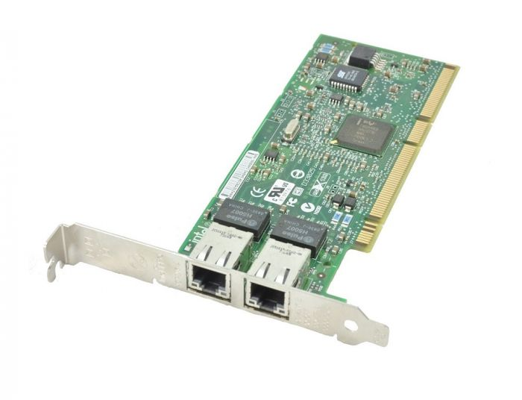

A daughterboard (daughter card) is a type of circuit board that plugs in or is attached to the motherboard or similar expansion card to extend its features and services.

A daughterboard is connected directly to the motherboard. Like a motherboard, a daughterboard has sockets, pins, plugs and connectors to be attached to other boards. Today, these boards are not found or used in desktop computers. They were replaced with ISA card, PCI card and onboard options. With the rise of connective USB ports and other technology, it has become less necessary to upgrade devices with daughtercards or daughterboards

**Bus slots**

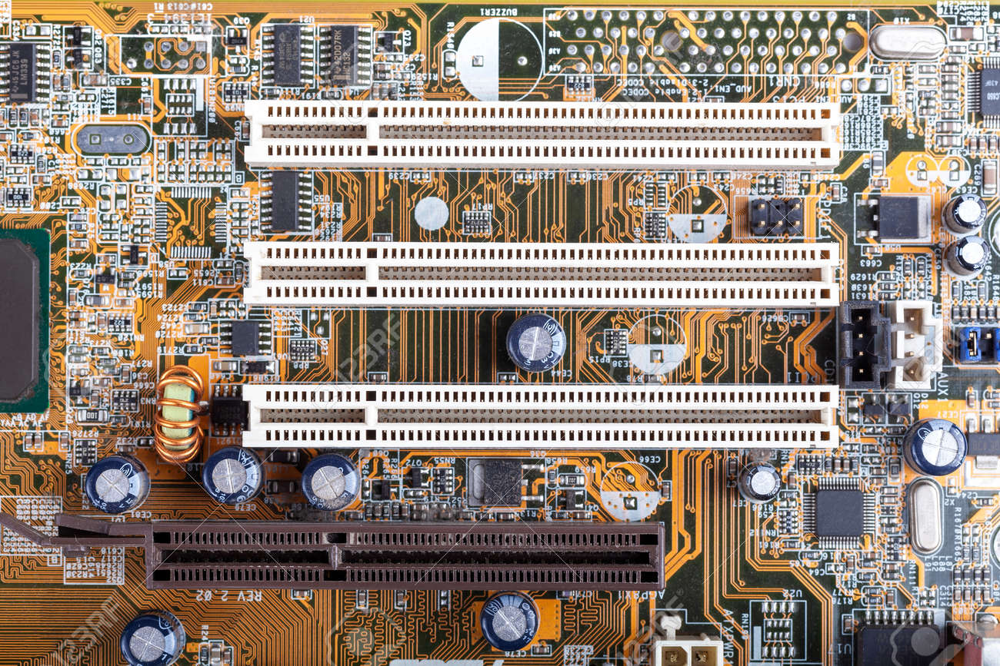

An expansion slot is a socket on the motherboard that is used to insert an expansion card, which provides additional features to a computer such as video, sound, advanced graphics, Ethernet or memory

PATA stands for Parallel Advanced Technology Attachment and SATA stands for Serial Advanced Technology Attachment both are two bus interfaces used for connecting secondary storage devices like hard disks, optical drives

PCI (Peripheral Component Interconnect) is a bus standard that connects the computer motherboard and external devices. PCIe (peripheral component interconnect express) is an interface standard for connecting high-speed component

**SMPS**

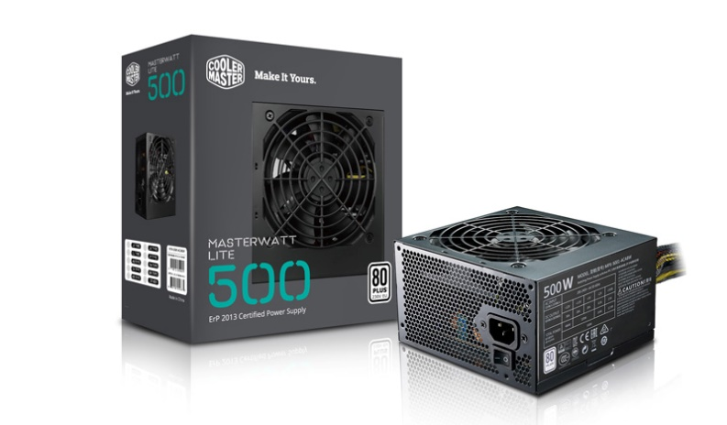

SMPS stands for Switched-Mode Power Supply. It is an electronic power supply that uses a switching regulator to convert electrical power efficiently. It is a power supply unit (PSU) generally used in computers to convert the voltage into the computer acceptable range. Technically briefing, an SMPS in a desktop system that converts 220V AC and 50HZ into +5V, -5V, +12V and +3.3 V DC at various electrical components in the computer.

**Internal Storage Devices**

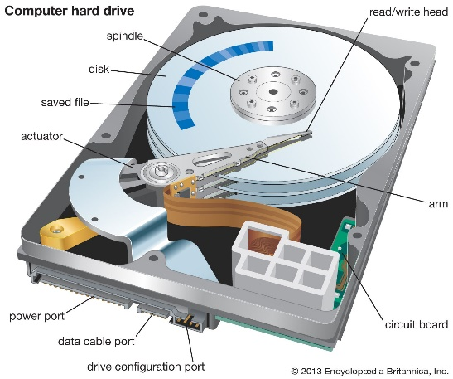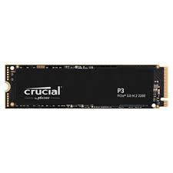

A storage device is an integral part of the computer hardware which stores information or data to process the result of any computational work.

Internal storage is a storage device that's internal (inside the case) and is not a removable storage or external storage. For example, the hard drive inside your computer is an example of internal storage.

HDD (Hard Disk Drive) also known as fixed disk uses magnetic tape for the storage of data. HDD has a moving read/write head to access data from storage like a gramophone player and slower to read and write. Unlike HDD, SSD (Solid State Drive) has no moving parts, and it obtains data from storage instantly. SSD can give faster performance than traditional magnetic-based computer storage devices. Although both of them perform the same task

**Specifications of desktop and server class:**

**Desktop:**

|  |  |
| --- | --- |
| Processor | Core i5 |
| Processor speed | 3.09 GHz |
| Number of Cores | 4 |
| Typical Memory | 32 GB |
| Cache Size | L1:8KB -1MB, L2:256KB - 3MB |
| Memory type | DDR4 |

**Web Server:**

|  |  |
| --- | --- |
| Processor | Intel® Xeon® Bronze 3206R Processor (Multiple Processors) |
| Processor speed | 1.90 GHz |
| Number of cores | 8 |
| Typical Memory | 512 GB |
| Cache size | L1:1-2MB, L2:8MB, L3:32-64MB |
| Memory type | DDR4 |