**LAB CYCLE:1 Date:**

**EXPERIMENT NO:1**

**HARDWARE FAMILIARISATION**

**Aim:** Introduction to Computer hardware: Physical identification of major components of a

computer system such as mother board, RAM modules, daughter cards, bus slots, SMPS,

internal storage devices, interfacing ports. Specifications of desktop and server class

computers. Installation of common operating systems for desktop and server use.

**Description:**

1. **Introduction to Computer hardware**

Components of a computer system are the primary elements which make the functioning of an electronic device smooth and faster. Computer systems consist of three components as shown in below image: **Central Processing Unit, Input devices and Output devices**. Input devices provide data input to processor, which processes data and generates useful information that’s displayed to the user through output devices. This is stored in computer’s memory.

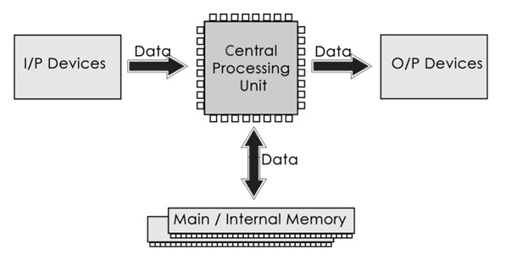

The operations of computer components are given below:

**1) Inputting:** It is the process of entering raw data, instructions and information into the computer. It is performed with the help of input devices.

**2) Storing:** The computer has primary memory and secondary storage to store data and instructions. It stores the data before sending it to CPU for processing and also stores the processed data before displaying it as output.

**3) Processing:** It is the process of converting the raw data into useful information. This process is performed by the CPU of the computer. It takes the raw data from storage, processes it and then sends back the processed data to storage.

**4) Outputting:** It is the process of presenting the processed data through output devices like monitor, printer and speakers.

**5) Controlling:** This operation is performed by the control unit that is part of CPU. The control unit ensures that all basic operations are executed in a right manner and sequence.

**Central Processing Unit (CPU)**

A Central Processing Unit is also called a processor, central processor, or microprocessor. It carries out all the important functions of a computer. It receives instructions from both the hardware and active software and produces output accordingly. It stores all important programs like operating systems and application software. CPU also helps Input and output devices to communicate with each other. Owing to these features of CPU, it is often referred to as the brain of the computer.

CPU has three components:

* ALU (Arithmetic Logic Unit)
* Control Unit
* Memory or Storage Unit

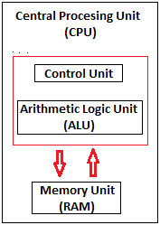

**b)** **Physical identification of major components**

Hardware, which is abbreviated as HW, refers to all physical components of a computer system, including the devices connected to it. You cannot create a computer or use software without using hardware. The screen on which you are reading this information is also a hardware

**Motherboard:**The motherboard is generally a thin circuit board that holds together almost all parts of a computer except input and output devices. All crucial hardware like CPU, memory, hard drive, and ports for input and output devices are located on the motherboard. It is the biggest circuit board in a computer chassis. It allocates power to all hardware located on it and enables them to communicate with each other. It is meant to hold the computer's microprocessor chip and let other components connect to it. Each component that runs the computer or improves its performance is a part of the motherboard or connected to it through a slot or port.

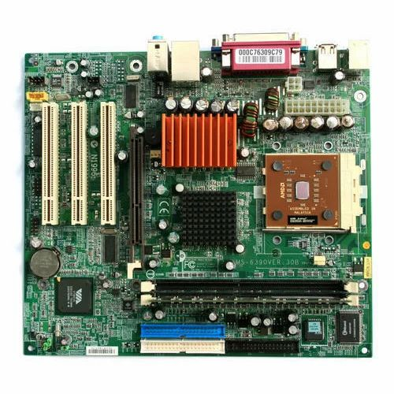

**RAM Modules:** RAM stands for Random Access Memory. It is also called the main memory. RAM is a temporary data storage device in computers and other devices. SRAM,DRAM, SDRAM, DDR etc are the various types of RAM available. A memory module or RAM stick is a narrow printed circuit board that holds memory chips (RAM chips).

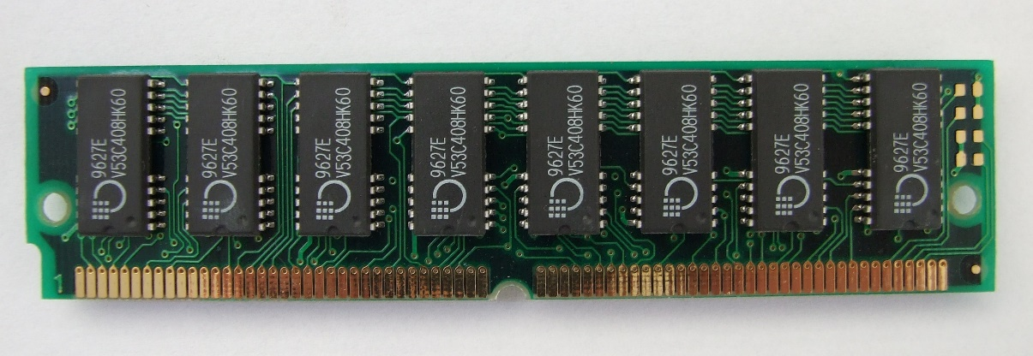

SRAM (static RAM) is random access memory (RAM) that retains data bits in its memory as long as power is being supplied. You can lose data if your SRAM is not powered. SRAM does not offer to refresh programs. SRAM has a low storage capacity(about 1MB).

Dynamic random access memory (DRAM) is a type of semiconductor memory that is typically used for the data or program code needed by a computer processor to function. The advantage of a DRAM is it only requires a single transistor compared to around six in a typical static RAM, SRAM memory cell. The costs of DRAM are much lower than those for SRAM,and they are able to provide much higher levels of memory density(about 1GB).

SDRAM (synchronous DRAM) is a generic name for various kinds of DRAM that are synchronized with the clock speed that the microprocessor is optimized for. That is same external clock pulse can be used to operate both SRAM and processor. This tends to increase the number of instructions that the processor can perform in a given time.

DDR Stands for "Double Data Rate." It is an advanced version of SDRAM, DDR-SDRAM can transfer data twice as fast as regular SDRAM chips. This is because DDR memory can send and receive signals twice per clock cycle. DDR operates about 2.5 V and DDR2 averages about 1.8 V, with DDR3 the voltage is reduced to 1.5 V.DDR3 has transfer rates between 800MT/s and 1600MT/s.DDR4 is the latest generation of DDR. It has the lowest operating voltage of 1.2 V and has higher transfer rates than previous generations.DDR5 launch speeds delivery nearly double the bandwidth of DDR4. It also enables scaling memory performance without degrading channel efficiency at higher speeds under real-world conditions. Crucial DDR5 memory will operate at 4800MT/s at launch, which is 1.5x the maximum standard DDR4 speed.

**Daughter cards:** A daughterboard ( daughter card ) is a type of circuit board that plugs in or is attached to the motherboard or similar expansion card to extend its features and services.



A daughterboard is connected directly to the motherboard. Like a motherboard, a daughterboard has sockets, pins, plugs and connectors to be attached to other boards.Today, these boards are not found or used in desktop computers. They were replaced with ISA card, PCI card and onboard options.With the rise of connective USB ports and other technology, it has become less necessary to upgrade devices with daughtercards or daughterboards.

**Bus Slots:** An expansion slot is a socket on the motherboard that is used to insert an expansion card , which provides additional features to a computer such as video, sound, advanced graphics, Ethernet or memory.



PATA stands for Parallel Advanced Technology Attachment and SATA stands for Serial Advanced Technology Attachment both are two bus interfaces used for connecting secondary storage devices like hard disks, optical drives.

Serial refers to the fact that data is sent one bit at a time down a single connection in each direction. There’s a separate connection for data going in to and out of the device.Parallel refers to the fact that data is sent 16 bits at a time through a single 16-bit connection, which is used for data traveling in both directions.

SCSI stands for Small Computer System Interface is a set of standards for physically connecting and transferring data between computers and peripheral devices.

IDE stands for Integrated Drive Electronics is a standard interface for connecting a motherboard to storage devices such as hard drives and CD/DVD drives.

PCI (Peripheral Component Interconnect)is a bus standard that connects the computer motherboard and external devices. PCIe (peripheral component interconnect express) is an interface standard for connecting high-speed components. Every desktop PC motherboard has a number of PCIe slots.

**SMPS:** SMPS stands for Switched-Mode Power Supply. It is an electronic power supply that uses a switching regulator to convert electrical power efficiently.



It is a power supply unit (PSU) generally used in computers to convert the voltage into the computer acceptable range.Technically briefing, an SMPS in a desktop system that converts 220V AC and 50HZ into +5V, -5V, +12V and +3.3 V DC at various electrical components in the computer.

**Internal Storage:** A storage device is an integral part of the computer hardware which stores information or data to process the result of any computational work. Internal storage is a storage device that's internal (inside the case) and is not a removable storage or external storage. For example, the hard drive inside your computer is an example of internal storage.HDD (Hard Disk Drive) also known as fixed disk uses magnetic tape for the storage of data. HDD has a moving read/write head to access data from storage like a gramophone player and slower to read and write. Unlike HDD, SSD (Solid State Drive) has no moving parts, and it obtains data from storage instantly. SSD can give faster performance than traditional magnetic-based computer storage devices.Although both of them perform the same task.

 

**Specifications of desktop and server class:**

**Desktop:**

|  |  |
| --- | --- |
| Processor | Core i5 |
| Processor speed | 3.90 GHz |
| Number of cores | 4 |
| Typical Memory | 32GB |
| Cache size | L1:8KB -1MB, L2:256KB - 3MB |
| Memory type | DDR4 |

**Web Server:**

|  |  |
| --- | --- |
| Processor | Intel® Xeon® Bronze 3206R  Processor (Multiple Processors) |
| Processor speed | 1.90 GHz |
| Number of cores | 8 |
| Typical Memory | 512GB |
| Cache size | L1:1-2MB, L2:8MB, L3:32-64MB |
| Memory type | DDR4 |

**LAB CYCLE:2 Date:**

**EXPERIMENT NO:4**

**BASIC LINUX COMMANDS**

**Aim:** Familiarity with following commands/operations excepted.

**1.man:** is used to display the user manual of any command that we can run on the terminal. It provides a detailed view of the command which includes NAME, SYNOPSIS, DESCRIPTION, OPTIONS, EXIT STATUS, RETURN VALUES, ERRORS, FILES, VERSIONS, EXAMPLES, AUTHORS and SEE ALSO.

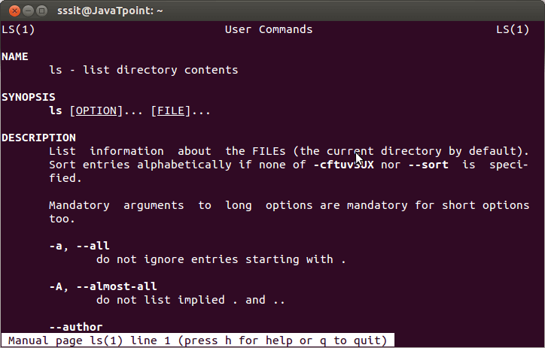

**2. ls, echo, read**

**ls:** is a Linux shell command that lists directory contents of files and directories. Some practical examples of ls command are shown below.

Options:

-t: It sorts the file by modification time, showing the last edited file first.

-l: To show long listing information about the file/directory.

-lh: To display file size in easy-to-read format.

-a: To show all the hidden files in the directory.

**echo:** used for displaying lines of text or string which are passed as arguments on the command line.

**read:** is used to read from a file descriptor.

**3. more, less, cat**

**more**: reads files and displays the text one screen at a time.

**less:** used for filtering and viewing text files one screen page at a time.

**cat:** used to display the content of a file, copy content from one file to another, concatenate the contents of multiple files, display the line number, display $ at the end of the line, etc.

**4. cd, mkdir, pwd, find**

**cd:** cd command in linux known as change directory command. It is used to change current working directory.

Syntax: cd [directory_name]

**mkdir:** mkdir command in Linux allows the user to create directories (also referred to as folders in some operating systems). This command can create multiple directories at once as well as set the permissions for the directories.

Syntax: mkdir [options...] [directories ...]

**pwd:** pwd stands for Print Working Directory. It prints the path of the working directory, starting from the root.

Syntax: pwd -L: Prints the symbolic path.

pwd -P: Prints the actual path.

**find:** The find command in UNIX is a command line utility for walking a file hierarchy. It can be used to find files and directories and perform subsequent operations on them. It supports searching by file, folder, name, creation date, modification date, owner and permissions.

Syntax: find [where to start searching from]

[expression determines what to find] [-options] [what to find]

**5. mv, cp, rm, tar**

mv: mv stands for move. mv is used to move one or more files or directories from one place to another in a file system like UNIX. It has two distinct functions:

(i) It renames a file or folder.

(ii) It moves a group of files to a different directory.

Syntax: mv [Option] source destination

**cp:** cp stands for copy. This command is used to copy files or group of files or directory. It creates an exact image of a file on a disk with different file name. cp command require at least two filenames in its arguments.

Syntax: cp [OPTION] Source Destination

**rm:** rm stands for remove here. rm command is used to remove objects such as files, directories, symbolic links and so on from the file system like UNIX. To be more precise, rm removes references to objects from the filesystem, where those objects might have had multiple references.

Syntax: rm [OPTION]... FILE...

**tar:** The Linux ‘tar’ stands for tape archive, is used to create Archive and extract the Archive files. tar command in Linux is one of the important commands which provides archiving functionality in Linux. We can use Linux tar command to create compressed or uncompressed Archive files and also maintain and modify them.

Syntax: tar [options] [archive-file] [file or directory to be archived]

**6.wc, cut, paste**

**wc:** wc stands for word count.It is used to find out number of lines, word count, byte and characters count in the files specified in the file arguments.

Syntax: wc [OPTION]... [FILE]...

**cut:** The cut command in UNIX is a command for cutting out the sections from each line of files and writing the result to standard output. It can be used to cut parts of a line by byte position, character and field.

Syntax: cut OPTION... [FILE]...

**paste:** paste command is one of the useful commands in Unix or Linux operating system. It is used to join files horizontally (parallel merging) by outputting lines consisting of lines from each file specified, separated by tab as delimiter, to the standard output.

Syntax: paste [OPTION]... [FILES]...

**7. head, tail, grep, expr:**

**head:** it prints the first 10 lines of the specified files. If more than one file name is provided then data from each file is preceded by its file name.

Syntax: head [OPTION]... [FILE]...

**tail:** it prints the last 10 lines of the specified files. If more than one file name is provided then data from each file is precedes by its file name.

Syntax: tail [OPTION]... [FILE]...

**grep:** the grep filter searches a file for a particular pattern of characters, and displays all lines that contain that pattern. The pattern that is searched in the file is referred to as the regular expression (grep stands for global search for regular expression and print out).

Syntax: grep [options] pattern [files]

**8. chmod, chown:**

**chmod:** the chmod command is used to change the access mode of a file.The name is an abbreviation of change mode.

Syntax: chmod [reference][operator][mode] file...

**chown:** it is used to set read, write, execute permission for user. To protect and secure files and directory in Linux we use permissions to control what a user can do with a file or directory.

Syntax: chown [OPTION]… [OWNER][:[GROUP]] FILE…

chown [OPTION]… –reference=RFILE FILE…

**9. Redirections & Piping:**

**Redirection:** whenever an individual runs a command, it can take input, give output, or do both. Redirection helps us redirect these input and output functionalities to the files or folders we want, and we can use special commands or characters to do so.

Append redirection

“>>” standard output

“<<” standard input

Overwrite Redirection

“>” standard output

“<” standard input

**Piping:** Pipe is used to combine two or more commands, and in this, the output of one command acts as input to another command, and this command’s output may act as input to the next command and so on. It can also be visualized as a temporary connection between two or more commands/ programs/ processes. The command line programs that do the further processing are referred to as filters.

Syntax: command_1 | command_2 | command_3 | .... | command_N

**10. useradd, usermod, userdel, passwd:**

**useradd:** is a command in Linux that is used to add user accounts to your system. It is just a symbolic link to adduser command in Linux and the difference between both of them is that useradd is a native binary compiled with system whereas adduser is a Perl script which uses useradd binary in the background.

Syntax: useradd [options] name_of_the_user

**usermod:** is a command in Linux that is used to change the properties of a user in Linux through the command line. After creating a user we have to sometimes change their attributes like password or login directory etc. so in order to do that we use the Usermod command.

Syntax: sudo usermod -c "This is test user" test_user

**userdel:** is used to delete a user account and related files. This command basically modifies the system account files, deleting all the entries which refer to the username LOGIN. It is a low-level utility for removing the users.

Syntax: userdel [options] LOGIN

**passwd:** passwd command in Linux is used to change the user account passwords. The root user reserves the privilege to change the password for any user on the system, while a normal user can only change the account password for his or her own account.

Syntax: passwd [options] [username]

**11. df,top, ps:**

**df:** is used to displays the amount of disk space available on the file system containing each file name argument.

Syntax: df [OPTION]...[FILE]...

**top:** top command is used to show the Linux processes. It provides a dynamic real-time view of the running system. Usually, this command shows the summary information of the system and the list of processes or threads which are currently managed by the Linux Kernel.

**ps:** it allows multiple processes to operate simultaneously without interfering with each other. Process is one of the important fundamental concept of the Linux OS.

Syntax: ps [options]

**12. ssh, scp, ssh-keygen, ssh-copy-id:**

**ssh:** stands for “Secure Shell”. It is a protocol used to securely connect to a remote server/system. ssh is secure in the sense that it transfers the data in encrypted form between the host and the client. It transfers inputs from the client to the host and relays back the output. ssh runs at TCP/IP port 22.

Syntax: ssh user_name@host(IP/Domain_name)

**scp:** scp (secure copy) command in Linux system is used to copy file(s) between servers in a secure way. The SCP command or secure copy allows secure transferring of files in between the local host and the remote host or between two remote hosts. It uses the same authentication and security as it is used in the Secure Shell (SSH) protocol. SCP is known for its simplicity, security and pre-installed availability.

Syntax: scp [-346BCpqrTv] [-c cipher] [-F ssh_config] [-i identity_file] [-l limit] [-o ssh_option] [-P port] [-S program] [[user@]host1:]file1 … [[user@]host2:]file2

ssh-keygen: Secure Shell(SSH) is a cryptographic network protocol used for operating remote services securely. It is used for remote operation of devices on secure channels using a client-server architecture that generally operates on Port 22. SSH is the successor of Telnet. SSH uses public and private keys to validate and authenticate users. ssh-keygen is used to generate these key pairs.

**ssh-copy-id:** is a command that copies the public key of the local host to the authorized keys file of the remote host, allowing password-less and automatic login via SSH

**BASIC LINUX COMMANDS ACTICITY QUESTIONS**

1. Command to display the following message as Use “New line).

“God!Bless us.

We are starting Shell Scripting”

**Command:**

echo -e "\”God! Bless us\n We are starting Shell Scripting \”"

1. Get the manual page of ‘ls’ command. Search for the word “alphabet”. Find the next occurrence and then find the previous occurrence.

Command:

man ls

/alphabet

man ls -N

1. Read your name from the keyboard and display it.

Command:

read -p "enter your name:" n

echo $n

1. Create the directory structure dir1/dir4 and dir1/dir2/dir3 with a single command and then change directory to dir3.

Commands:

mkdir -p dir1/dir4 dir1/dir2/dir3

ls

cd dir1/dir3

1. Create some files using Vim.

creating a file using vim:

Start vim by typing vim filename

To insert text press i

Now start editing text. Add new text or delete unwanted text.

One can press Esc and type :wq to save changes to a file and exit from vim]

Command:

syntax: vim test.txt

1. Display the current directory.

Command:

pwd

1. Listing files and folders.
2. Listing the contents of dir1 (Qn.4) and all its descendants.

Command:

ls -R

1. Listing the contents of dir3 (Qn.4) in
   1. Alphabetical order

Command:

ls -l

* 1. Sorted on Time of modification, newest first

Command:

ls -lt

* 1. Sorted on Size

Commands:

ls -S

* 1. Reverse of all above

Command:

ls -r

* 1. Long listing of files Sorted on Size with smallest first and size

Command:

ls -lSr

* 1. Displayed in human readable form

Command:

ls -lhS

1. Execute **ls** and store the output to a file lsoutput

Command:

ls > lsoutput

cat lsoutput

1. Display the file
2. starting with the first 10 lines and

Command:

head -10 num.txt

1. starting with the 10th line with provision for

tail -n +10 num.txt >> out2.txt

1. Scrolling Up

Command:

more -10 out2.txt

1. Scrolling Up and Down

Command:

less -10 out2.txt

1. Execute **ls -l** and add the output to lsoutput, at the end.

Command:

ls -l >> lsoutput.txt

cat lsoutput.txt

1. Execute **ls -l** and feed the result to less command, to scroll through the directory listing.

Command:

ls -l |less

12. Copy the file file1 to newfile.

1. If newfile already exists, it should be replaced.

Command:

cp file1 newfile

1. If newfile already exists, it should not be replaced.

cp -n file2 newfile

1. If newfile already exists, it should be replaced, but only with the consent of the user.

Command:

cp -i file1 newfile

1. If newfile already exists, it should be replaced only if its contents is older than that of file1.

Command:

cp -u file1 newfile

1. Even if newfile is read only.

Command:

chmod u+wx newfile

1. Create a link instead of copying.

Command:

cp -s file3.txt file4.txt

1. Copy the entire directory tree from dir1 of Qn.4 to a new directory dir5

Command:

cp -R dir1 dir5

13. Create a new directory, dir6 inside dir1

1. Move all files in dir5 into it.

Command:

mv dir5 dir1/dir6

1. Delete all files where the name starts with a vowel character, upper or lower case.

Command:

rm [a,e,i,o,u,A,E,I,O,U]*

1. Delete all files where the name is at least 3 characters long.

Command:

rm ???*

1. Delete all hidden folders, and files.

Command:

rm -rf *

14. Create a file testfile1 using Vim

vim testfile1

1. Set line number

vim testfile1

Press esc

Type :set number

1. Type your name and address with district and pincode
2. Copy paste the contents 10 times
3. Replace all occurrence of your district with a neighbouring district