**Open Canva in your PC**

**Select create design and click logo option**

**Select a template related to the company and the brand name**

**Add the brand name to the template**

**Modify the template by adding extra elements and download the logo**

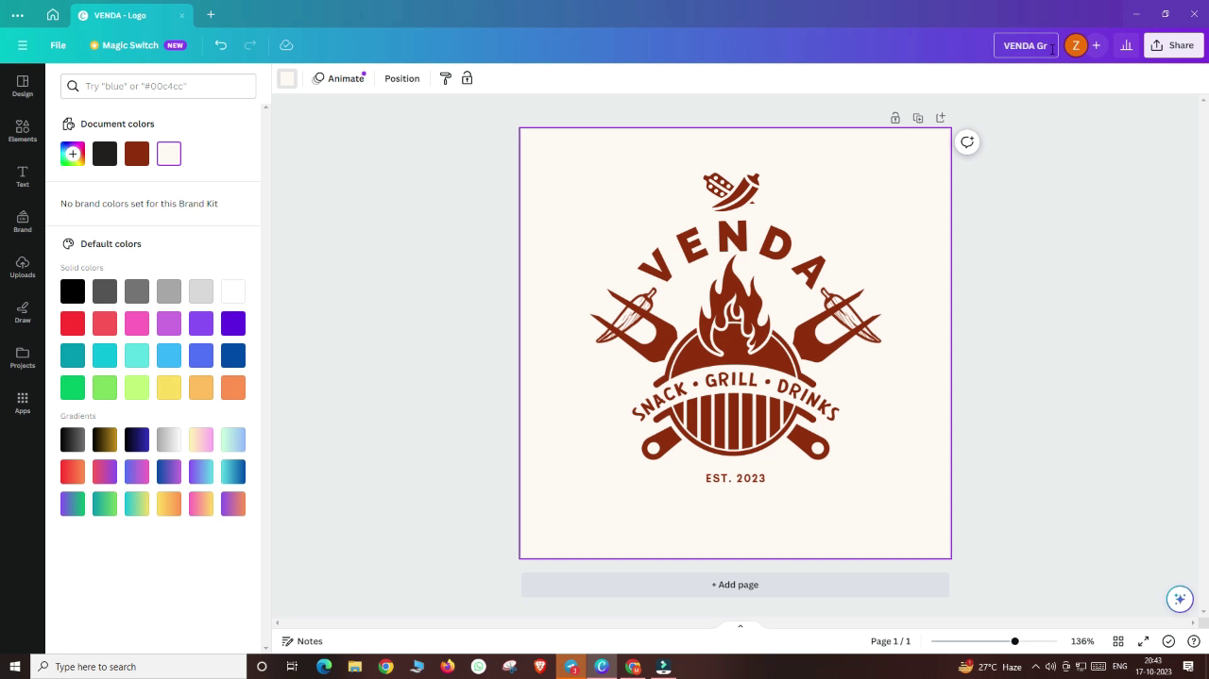

**Demo link:** [**https://drive.google.com/file/d/1W27b-F7UQ8Dr5A2hJQ1YfOEYdjniu7F0/view?usp=sharing**](https://drive.google.com/file/d/1W27b-F7UQ8Dr5A2hJQ1YfOEYdjniu7F0/view?usp=sharing)