1. **Create a SVN or Git directory for you assignment (including word or pdf documents and programming code);**

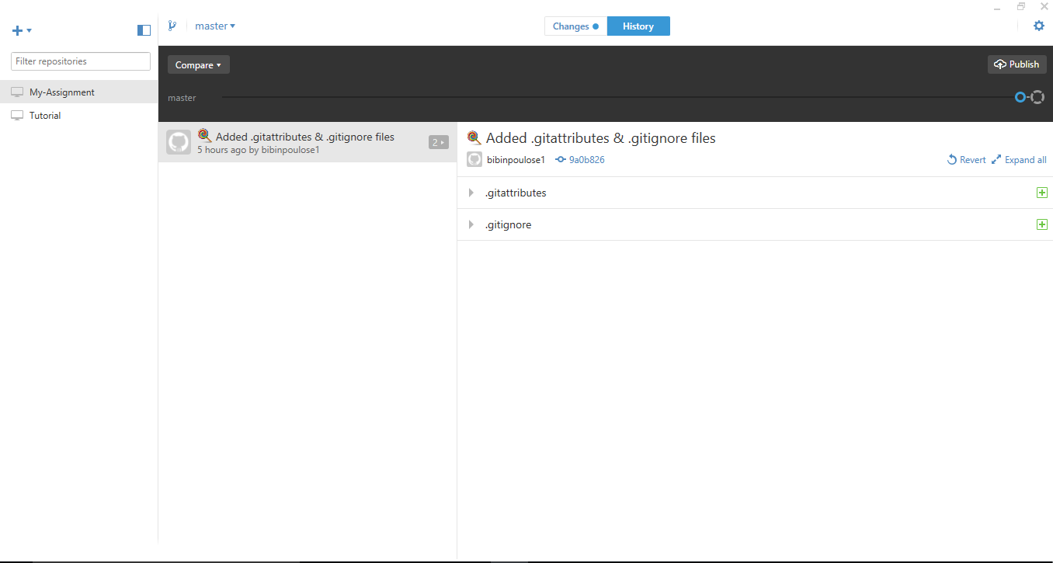

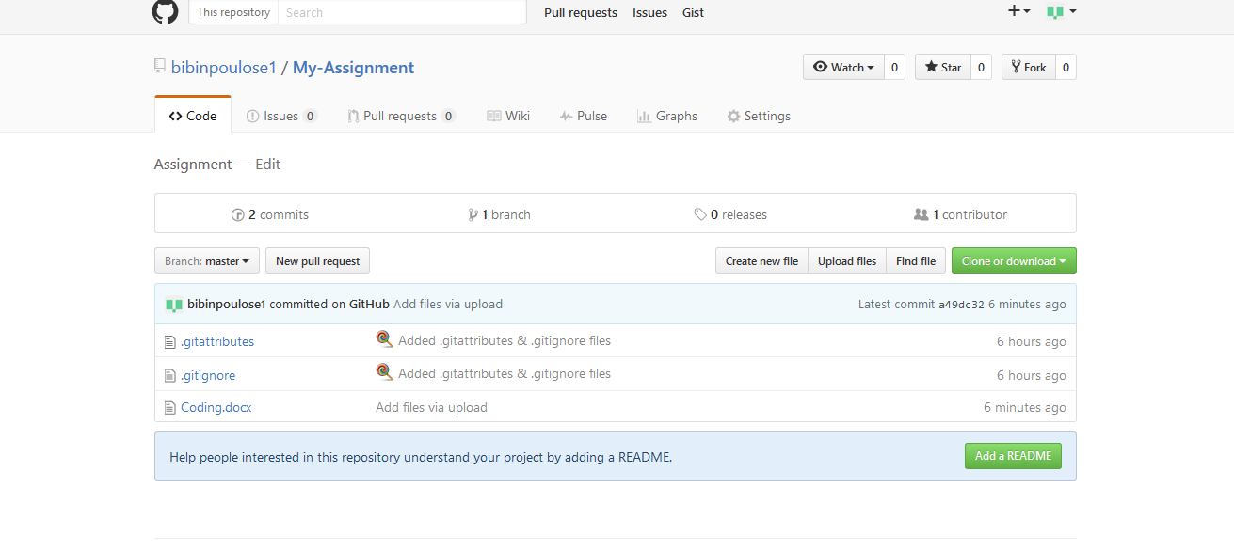

**URL:** https://github.com/bibinpoulose1/My-Assignment

1. **Some English words can be transferred to another one by reorder the letters.**

* **Write a program to group the similar words and print out the number of words in each group and the words in the group ordered by the number of words in the group from the largest to the smallest**
* **Consider different test cases for normal and abnormal operation and inputs**
* **Use test driven development method and present the TDD process in your code environment (not the general flow) in this assignment;**

package javaapplication8;

import java.util.Arrays;

public class NewClass1{

public static void main(String args[]){

char arr1[]=new char[10];

char arr2[]=new char[10];

String name="who";

String name2="how";

int flag=0;

for(int i=0;i<name.length();i++){

arr1[i]=name.charAt(i);

}

for(int i=0;i<name2.length();i++){

arr2[i]=name2.charAt(i);

}

boolean a=Arrays.equals(arr1,arr2);

if(a==true){

System.out.println("first is "+name+"second is"+name2);

}

else

{

System.out.println("not same");

}

}

}

1. **What are the benefits of using change request form as the central document in the change management process?**

Change management is one of the four activities in configuration management. It deals with the request for the changes from the clients and the developers calculate the cost for making changes and decide whether the changes have to apply. The change management process is started with a change request by the customers. This can be submitted by a change request form (CRF).

Change request form shares all information with all groups take place in the change management process. So everyone can share the information between all participants and all the decisions are recorded in each step.   The change request form helps to calculate the average cost for the proposed changes, the date of the change was requested, approved, implemented and validated are mentioned in it. It has a separate section for the developers to express how they implement the changes. The CRF also improves the communication between the team members and provide a better control to the implementation process.