**J2EE**

Create a page to enter the characteristics of four users with the following information:

- name

- first name

- login

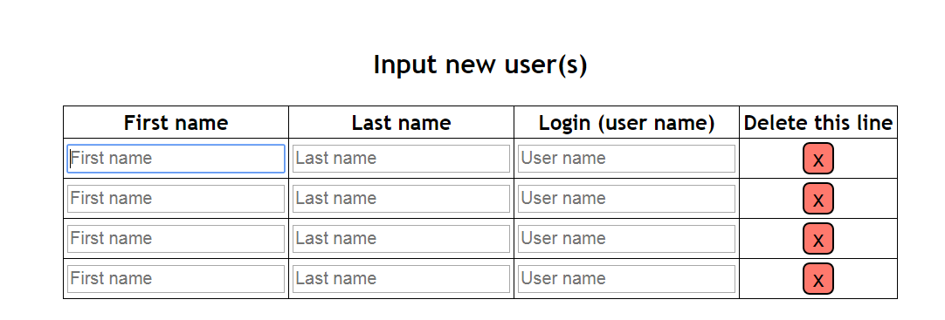

Once created in database, these users will have to appear in a JSP page in tabular form mentioning the total number of users

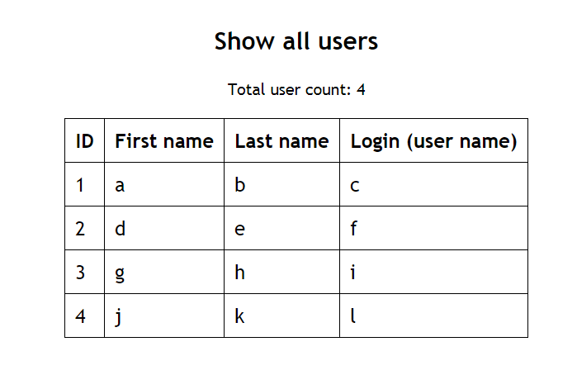

Provide the possibility in a JSP page to search for a particular user based on his name and display all his features in return 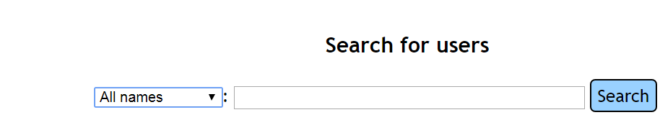

**Create a zip file with your students names, give the sql script used to create your table**